First Free Methodist Church of Saginaw
Thirteenth Sunday after Pentecost
September 4, 2022

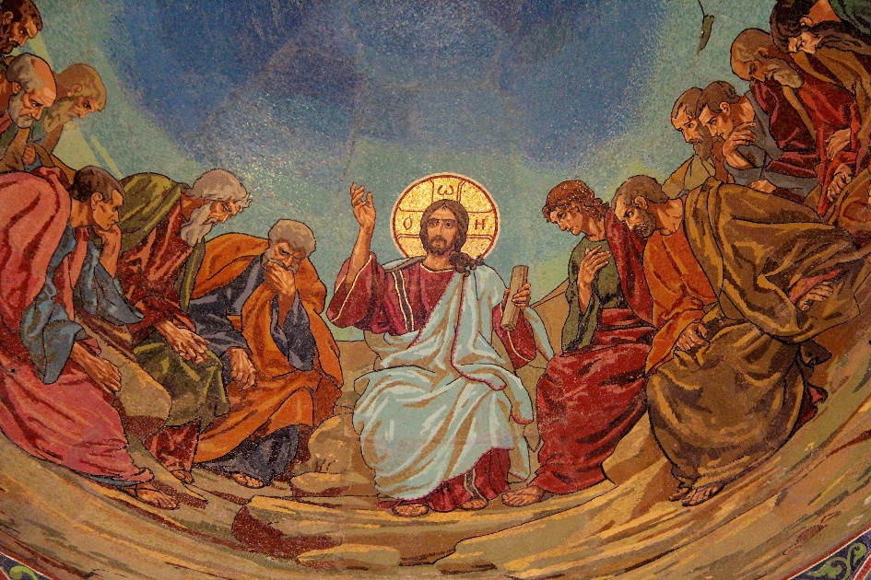
“Whoever does not carry the cross and follow me cannot be my disciple." (Luke 14:27)

Minister: Rev. Jason Evans
First Free Methodist Church
2625 N. Center Rd.
Saginaw, Michigan 48603
Phone: (989) 799-2930
Email: saginawfmc@gmail.com
www.saginawfirstfmc.org

PROPER 18 (23)
September 4, 2022

Prelude
**Greeting/Announcements
*Call to Worship (spoken responsively)
L: Happy are those who delight is in the law of the LORD
P: On God’s law they meditate day and night
L: Who do not follow the advice of the wicked
P: Or sit in the seat of scoffers
L: They are like trees planted by streams of water
P: Which yield their fruit in its season, their leaves do not wither
L: The LORD watches over the way of the righteous
P: But the way of the wicked will perish

*Opening Hymn: “Great Is the Lord” #69 (vv.1-3)
Great is the Lord
He is holy and just
By His power we trust
In His love
Great is the Lord
He is faithful and true
By His mercy He proves
He is love

Great is the Lord
And worthy of glory
Great is the Lord
And worthy of praise
Great is the Lord
Now lift up your voice
Now lift up your voice
Great is the Lord
Great is the Lord

Great is the Lord,
He is holy and just
By His power we trust
In His love
Great is the Lord
He is faithful, and true
By His mercy He proves
He is love

Great is the Lord
And worthy of glory
Great is the Lord
And worthy of praise
Great is the Lord
Now lift up your voice
Now lift up your voice
Great is the Lord
Great is the Lord

Great are you Lord
And worthy of glory
Great are you Lord
And worthy of praise
Great are you Lord
I lift up my voice
I lift up my voice
Great are you Lord
Great are you Lord

*Invocation and Lord’s Prayer
L: Grant us, O Lord, to trust in you with all our hearts; for, as you always resist the proud who confide in their own strength, so you never forsake those who make their boast of your mercy. You are the author and giver of all good things. Graft in our hearts the love of you. Nourish us with all goodness and bring forth un us the fruit of good works, as we pray the prayer that Jesus taught His disciples…

P: Our Father, who art in heaven, hallowed be Your name. Your kingdom come; your will be done in earth as it is in heaven. Give us this day our daily bread and forgive us our debts as we forgive our debtors. And lead us not into temptation but deliver us from evil. For Yours is the kingdom, and the power, and the glory forever. Amen.

*Gloria Patri
Glory be to the Father​
And to the Son and to the Holy Ghost.​
As it was in the beginning​
Is now and ever shall be.​
World without end. ​
Amen. Amen.​

First Scripture Lesson: Jeremiah 18:1-11
The word that came to Jeremiah from the LORD: “Come, go down to the potter's house, and there I will let you hear my words.”
So I went down to the potter's house, and there he was working at his wheel. The vessel he was making of clay was spoiled in the potter’s hand, and he reworked it into another vessel, as seemed good to him.
Then the word of the LORD came to me: Can I not do with you, O house of Israel, just as this potter has done? says the LORD. Just like the clay in the potter’s hand, so are you in my hand, O house of Israel.
At one moment I may declare concerning a nation or a kingdom, that I will pluck up and break down and destroy it, but if that nation, concerning which I have spoken, turns from its evil, I will change my mind about the disaster that I intended to bring on it. And at another moment I may declare concerning a nation or a kingdom that I will build and plant it, but if it does evil in my sight, not listening to my voice, then I will change my mind about the good that I had intended to do to it.
Now, therefore, say to the people of Judah and the inhabitants of Jerusalem: Thus says the LORD: Look, I am a potter shaping evil against you and devising a plan against you. Turn now, all of you from your evil way, and amend your ways and your doings.

Prayer of Confession
L: Lord, by your grace, enlighten our understanding, strengthen our will, purify our hearts, and make us holy...

P: Oh Holy Spirit, beloved of my soul, I adore you. Enlighten me, guide me, strengthen me, console me. Tell me what I should do, give me your orders. I promise to submit myself to that you desire of me and to accept all that you permit to happen to me. Let me only know your will. If I do this, my life will flow along happily, serenely, and full of consolation, even in the midst of trials. Grace will be proportioned to the trial, giving me the strength to carry it, and I will arrive at the gate of paradise, laden with merit. This submission to the Holy Spirit is the secret to sanctity. Amen.

Affirmation of Faith: Psalm 139
P: O LORD, you have searched me and known me. You know when I sit down and when I rise up; you discern my thoughts from far away. You search out my path and my lying down, and are acquainted with all my ways. Even before a word is on my tongue, O LORD, you know it completely. You hem me in, behind and before, and lay your hand upon me. Such knowledge is too wonderful for me; it is so high that I cannot attain it. For it was you who formed my inward parts; you knit me together in my mother's womb. I praise you, for I am fearfully and wonderfully made. Wonderful are your works; that I know very well. My frame was not hidden from you, when I was being made in secret, intricately woven in the depths of the earth.

Hymn of Affirmation: “Change My Heart, O God” (2x)
Change my heart, O God
Make it ever true
Change my heart, O God
May I be like you
You are the Potter
I am the clay
Mold me and make me
This is what I pray

Change my heart, O God
Make it ever true
Change my heart, O God
May I be like you
You are the Potter
I am the clay
Mold me and make me
This is what I pray

Change my heart, O God
Make it ever true
Change my heart, O God
May I be like you

Second Scripture Lesson: Philemon 1:1-21
Paul, a prisoner of Christ Jesus, and Timothy our brother, To Philemon our dear friend and co-worker, to Apphia our sister, to Archippus our fellow soldier, and to the church in your house: Grace to you and peace from God our Father and the Lord Jesus Christ.
When I remember you in my prayers, I always thank my God because I hear of your love for all the saints and your faith toward the Lord Jesus. I pray that the sharing of your faith may become effective when you perceive all the good that we may do for Christ. I have indeed received much joy and encouragement from your love, because the hearts of the saints have been refreshed through you, my brother.
For this reason, though I am bold enough in Christ to command you to do your duty, yet I would rather appeal to you on the basis of love--and I, Paul, do this as an old man, and now also as a prisoner of Christ Jesus. I am appealing to you for my child, Onesimus, whose father I have become during my imprisonment.
Formerly he was useless to you, but now he is indeed useful both to you and to me. I am sending him, that is, my own heart, back to you. I wanted to keep him with me, so that he might be of service to me in your place during my imprisonment for the gospel; but I preferred to do nothing without your consent, in order that your good deed might be voluntary and not something forced.
Perhaps this is the reason he was separated from you for a while, so that you might have him back forever, no longer as a slave but more than a slave, a beloved brother, especially to me but how much more to you, both in the flesh and in the Lord.
So if you consider me your partner, welcome him as you would welcome me. If he has wronged you in any way, or owes you anything, charge that to my account. I, Paul, am writing this with my own hand: I will repay it. I say nothing about your owing me even your own self.
Yes, brother, let me have this benefit from you in the Lord! Refresh my heart in Christ. Confident of your obedience, I am writing to you, knowing that you will do even more than I say.

Communion
MINISTER: THE INVITATION
You who truly and earnestly repent of your sins, who live in love and peace with
your neighbors and who intend to lead a new life, following the commandments
of God and walking in His holy ways, draw near with faith, and take this holy
sacrament to your comfort; and humbly kneeling, make your honest confession
to Almighty God.

IN UNISON: THE GENERAL CONFESSION
Almighty God, Father of our Lord Jesus Christ, maker of all things, judge of all
people, we confess that we have sinned, and we are deeply grieved as we
remember the wickedness of our past lives. We have sinned against You, Your
holiness and Your love, and we deserve only Your indignation and anger.
We sincerely repent, and we are genuinely sorry for all wrongdoing and every
failure to do the things we should. Our hearts are grieved, and we acknowledge
that we are hopeless without Your grace.
Have mercy upon us.
Have mercy upon us, most merciful Father, for the sake of your son, our Savior, Jesus
Christ, who died for us.
Forgive us.
Cleanse us.
Give us strength to serve and please You in newness of life and to honor and praise
Your name, through Jesus Christ our Lord. Amen.

MINISTER: THE AFFIRMATION OF FAITH
O Almighty God, our Heavenly Father, who with great mercy has promised
forgiveness to all who turn to You with hearty repentance and true faith, have
mercy upon us, pardon and deliver us from our sins, make us strong and faithful in
all goodness and bring us to everlasting life, through Jesus Christ our Lord. Amen.

CONGREGATION: THE COLLECT
Almighty God, unto whom all hearts are open, all desires known, and from whom
no secrets are hid: cleanse the thoughts of our hearts, by the inspiration of the
Holy Spirit, that we may perfectly love You and worthily magnify Your holy name,
through Christ our Lord. Amen.

MINISTER: THE SANCTUS
It is always right and proper, and our moral duty, that we should at all times and
in all places give thanks to You, O Lord, holy Father, Almighty and Everlasting God.
Therefore, with angels and archangels, and with all the inhabitants of heaven, we
honor and adore Your glorious name, evermore praising You and saying,

CONGREGATION: THE SANCTUS (CONTINUED)
Holy, Holy, Holy, Lord God of hosts!
Heaven and earth are full of Thy glory.
Glory be to Thee, O Lord, most high. Amen

MINISTER: THE PRAYER FOR SPIRITUAL COMMUNION
We do not come to this Your table, O merciful Lord, with self-confidence and
pride, trusting in our own righteousness, but we trust in Your great and many
mercies. We are not worthy to gather the crumbs from under Your table. But You,
O Lord, are unchanging in Your mercy and Your nature is love; grant us, therefore,
God of mercy, God of grace, so to eat at this Your table that we may receive in
spirit and in truth the body of Your dear Son, Jesus Christ, and the merits of His
shed blood, so that we may live and grow in His likeness and, being washed and
cleansed through His most precious blood, we may evermore live in Him and He
in us. Amen.

MINISTER: THE PRAYER OF CONSECRATION OF THE ELEMENTS
Almighty God, our Heavenly Father, who gave in love Your only Son, Jesus Christ,
to suffer death upon the cross for our redemption, who by His sacrifice, offered
once for all, did provide a full, perfect, and sufficient atonement for the sins of the whole world,
we come now to Your table in obedience to Your Son, Jesus Christ, who in His holy gospel
commanded us to continue a perpetual memory of His precious death until He comes
again. Hear us, O merciful Father, we humbly ask, and grant that we, receiving this bread and this cup,
as He commanded and in the memory of His passion and death, may partake of His most blessed body and blood.

In the night of His betrayal, Jesus took bread, and when He had given thanks, He broke it and gave it to
His disciples, saying, “Take, eat; this is My body which is given for you; do this in remembrance of Me.”

In like manner, after supper He took the cup, and when He had given thanks, He gave it to them, saying, “Drink of
this, all of you, for this is My blood of the New Testament, which is shed for you and for many, for the remission of
sins; do this as often as you drink it, in remembrance of Me.” Amen.

The body of our Lord Jesus Christ, which was given for you, preserve your soul and body unto everlasting
life. Take and eat this in remembrance that Christ died for you, and feed upon Him in your heart, by faith with
thanksgiving.

The blood of our Lord Jesus Christ, which was shed for you, preserve your soul and body unto everlasting life.
Drink this in remembrance that Christ’s blood was shed for you and be thankful.

MINISTER: THE BENEDICTION
May the peace of God, which passes all understanding, keep your hearts and minds in the knowledge and love
of God, and of His Son, Jesus Christ our Lord; and may the blessing of God Almighty, the Father, the Son, and
the Holy Spirit, be yours now and forever. Amen.

Children’s Sermon

Passing of the Peace

Prayers of the People
L: Lord in Your Mercy…
P: Hear our prayer.

Gospel Lesson: Luke 14:25-33
Now large crowds were traveling with him; and he turned and said to them, “Whoever comes to me and does not hate father and mother, wife and children, brothers and sisters, yes, and even life itself, cannot be my disciple. Whoever does not carry the cross and follow me cannot be my disciple.
For which of you, intending to build a tower, does not first sit down and estimate the cost, to see whether he has enough to complete it? Otherwise, when he has laid a foundation and is not able to finish, all who see it will begin to ridicule him, saying, ‘This fellow began to build and was not able to finish.’
Or what king, going out to wage war against another king, will not sit down first and consider whether he is able with ten thousand to oppose the one who comes against him with twenty thousand? If he cannot, then, while the other is still far away, he sends a delegation and asks for the terms of peace. So therefore, none of you can become my disciple if you do not give up all your possessions.

Sermon “Community In Christ”

Prayer of Response

Hymn of Response: “I Have Decided to Follow Jesus” #468 (vv.1-4)
I have decided to follow Jesus
I have decided to follow Jesus
I have decided to follow Jesus
No turning back, no turning back

The world behind me, the cross before me
The world behind me, the cross before me
The world behind me, the cross before me
No turning back, no turning back

Tho’ none go with me, still I will follow
Tho’ none go with me, still I will follow
Tho’ none go with me, still I will follow
No turning back, no turning back

Will you decide now, to follow Jesus?
Will you decide now, to follow Jesus?
Will you decide now, to follow Jesus?
No turning back, no turning back

Invitation of Offering
L: The sustaining love of Christ frees us from the grip of the tomb, that we may desire him as the fullness of life. Make us faithful stewards of the fragile bounty of this earth, as we collect this morning’s tithes and offerings.

*Doxology
Praise God, from whom all blessings flow
Praise Him, all creatures here below
Praise Him above, ye heavenly host
Praise Father Son, and Holy Ghost
Amen

*Prayer

Fiji: Emerging new work begun as an outreach of the Sierra Pacific Annual Conference through connections of members in the U.S., the church in Fiji has grown to include congregations served by indigenous church leaders. FMWM-Asia is working with Sierra Pacific leaders to assist the church in Fiji.
The prayer needs for Fiji are church growth and the strengthening of partnerships between nationals, Sierra Pacific Conference leaders and FMWM-Asia personnel.
*Closing Hymn: “In the Cross of Christ I Glory” #234 (vv.1-4)
In the cross of Christ I glory
Towering o’er the wrecks of time
All the light of sacred story
Gathers round its head sublime

When the woes of life o’ertake me
Hopes deceive, and fears annoy
Never shall the cross forsake me
Lo! it glows with peace and joy

When the sun of bliss is beaming
Light and love upon my way
From the cross the radiance streaming
Adds more luster to the day

Bane and blessing, pain and pleasure
By the cross are sanctified
Peace is there that knows no measure
Joys that through all time abide

*Benediction
L: Let us hold unswervingly to the hope we profess, for he who promised is faithful. Go into the world with the joy of the Lord, the love of Christ, and the grace of the Holy Spirit. Take your cross as you go in peace to love and serve. Amen.

