Saginaw First Free Methodist Church
Twenty-First Sunday after Pentecost
October 30, 2022

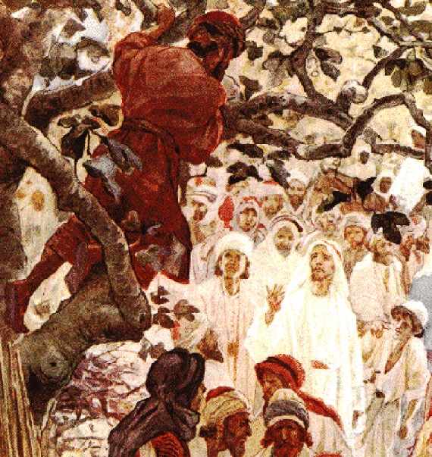
“So he ran ahead and climbed a sycamore tree to see him, because he was going to pass that way.”
(Luke 19:4)

Minister: Rev. Jason Evans
First Free Methodist Church
2625 N. Center Rd.
Saginaw, Michigan 48603
Phone: (989) 799-2930
Email: saginawfmc@gmail.com
www.saginawfirstfmc.org

Proper 26 (31)
October 30, 2022

Prelude
**Greeting/Announcements
*Call to Worship (spoken responsively)
L: O LORD, how manifold are your works
P: In wisdom you have made them all
L: God created the heavens and the earth
P: And gave them to us to use and enjoy
L: And God breathed life into each of us, and set us on the earth
P: And God sent Jesus Christ to save us from the pull of death
L: We have been entrusted with unfathomable riches
P: For all this our God is to be praised

*Opening Hymn: “We Bow Down”
You are Lord of creation
And Lord of my life
Lord of the land and the sea
You were Lord of the heavens
Before there was time
Lord of all lords You will be
We bow down
And we worship You Lord
We bow down
And we worship You Lord
We bow down
And we worship You Lord
King of all kings You will be

You are King of creation
And King of my life
King of the land and the sea
You were King of the heavens
Before there was time
And King of all kings You will be
We bow down
And we crown You the King
We bow down
And we crown You the King
We bow down
And we crown You the King
King of all kings You will be

*Invocation and Lord’s Prayer
L: Almighty God, you are wrapped in light as a garment, clothed with honor and majesty. Grant that those who worship you this day may present their bodies as a living sacrifice, holy and acceptable to you. Enlighten us with true faith and humble obedience that we may seek to serve others in your name. By the power of the Holy Spirit, make us strong to fulfill our calling, as we pray the prayer that Jesus taught His disciples…

P: Our Father, who art in heaven, hallowed be Your name. Your kingdom come; your will be done in earth as it is in heaven. Give us this day our daily bread and forgive us our debts as we forgive our debtors. And lead us not into temptation but deliver us from evil. For Yours is the kingdom, and the power, and the glory forever. Amen.

*Gloria Patri
Glory be to the Father​
And to the Son and to the Holy Ghost.​
As it was in the beginning​
Is now and ever shall be.​
World without end. ​
Amen. Amen.​

First Scripture Lesson: Habakkuk 1:1-4; 2:1-4
The oracle that the prophet Habakkuk saw. O LORD, how long shall I cry for help, and you will not listen? Or cry to you “Violence!” and you will not save? Why do you make me see wrong-doing and look at trouble? Destruction and violence are before me; strife and contention arise. So the law becomes slack and justice never prevails. The wicked surround the righteous-- therefore judgment comes forth perverted.
I will stand at my watchpost, and station myself on the rampart; I will keep watch to see what he will say to me, and what he will answer concerning my complaint. Then the LORD answered me and said: Write the vision; make it plain on tablets, so that a runner may read it. For there is still a vision for the appointed time; it speaks of the end, and does not lie. If it seems to tarry, wait for it; it will surely come, it will not delay. Look at the proud! Their spirit is not right in them, but the righteous live by their faith.

Prayer of Confession
L: Being entrusted with the way of life; May God’s grace enlighten our understanding, strengthen our will, purify our hearts, and make us holy...

P: The man who is proud of anything he thinks he has reached, has not reached it. He is but proud of himself, and imagining a cause for his pride. He who delights in what he has attained, is already in the dirt of self-satisfaction. The one who lives in God’s eternal idea of him, lives eternally. How should there be in him one thought of ruling or commanding or surpassing? He can imagine no bliss, no good in being greater than someone else. He is unable to wish for himself anything other than what God has made him, and what more God wills for him. The thought of standing higher in the favor of God than his brother would make him miserable. He would lift every brother to the embrace of the Father. Blessed are the poor in spirit, for theirs is the Kingdom of God

Affirmation of Faith: Psalm 119
P: You are righteous, O LORD, and your judgments are right. You have appointed your decrees in righteousness and in all faithfulness. My zeal consumes me because my foes forget your words. Your promise is well tried, and your servant loves it. I am small and despised, yet I do not forget your precepts. Your righteousness is an everlasting righteousness, and your law is the truth. Trouble and anguish have come upon me, but your commandments are my delight. Your decrees are righteous forever; give me understanding that I may live.

Hymn of Affirmation: “Jesus Paid it All” #218 (vv.1-4)
I hear the Savior say
Thy strength indeed is small
Child of weakness, watch and pray
Find in Me thine all in all
Jesus paid it all
All to Him I owe
Sin had left a crimson stain
He washed it white as snow

Lord, now indeed I find
Thy pow’r, and Thine alone
Can change the leper’s spots
And melt the heart of stone
Jesus paid it all
All to Him I owe
Sin had left a crimson stain
He washed it white as snow

For nothing good have I
Whereby Thy grace to claim;
I’ll wash my garments white
In the blood of Calv’ry’s Lamb
Jesus paid it all
All to Him I owe
Sin had left a crimson stain
He washed it white as snow

And when before the throne
I stand in Him complete
Jesus died my soul to save
My lips shall still repeat
Jesus paid it all
All to Him I owe
Sin had left a crimson stain
He washed it white as snow

Second Scripture Lesson: 2 Thessalonians 1:1-4, 11-12
Paul, Silvanus, and Timothy, To the church of the Thessalonians in God our Father and the Lord Jesus Christ: Grace to you and peace from God our Father and the Lord Jesus Christ. We must always give thanks to God for you, brothers and sisters, as is right, because your faith is growing abundantly, and the love of everyone of you for one another is increasing.
Therefore we ourselves boast of you among the churches of God for your steadfastness and faith during all your persecutions and the afflictions that you are enduring. To this end we always pray for you, asking that our God will make you worthy of his call and will fulfill by his power every good resolve and work of faith, so that the name of our Lord Jesus may be glorified in you, and you in him, according to the grace of our God and the Lord Jesus Christ.
Children’s Sermon

Passing of the Peace

Prayers of the People
L: Lord in Your Mercy…
P: Hear our prayer.

Gospel Lesson: Luke 19:1-10
He entered Jericho and was passing through it. A man was there named Zacchaeus; he was a chief tax collector and was rich. He was trying to see who Jesus was, but on account of the crowd he could not, because he was short in stature. So he ran ahead and climbed a sycamore tree to see him, because he was going to pass that way.
When Jesus came to the place, he looked up and said to him, “Zacchaeus, hurry and come down; for I must stay at your house today.”
So he hurried down and was happy to welcome him. All who saw it began to grumble and said, “He has gone to be the guest of one who is a sinner.”
Zacchaeus stood there and said to the Lord, “Look, half of my possessions, Lord, I will give to the poor; and if I have defrauded anyone of anything, I will pay back four times as much.”
Then Jesus said to him, “Today salvation has come to this house, because he too is a son of Abraham. For the Son of Man came to seek out and to save the lost.”

Sermon: “”

Prayer of Response

Hymn of Response: “Surely Goodness and Mercy” #386 (vv.1-3)
A pilgrim was I, and a wandering
In the cold night of sin I did roam
When Jesus the kind Shepherd found me
And now I am on my way home
Surely goodness and mercy shall follow me
All the days, all the days of my life
Surely goodness and mercy shall follow me
All the days, all the days of my life

He restoreth my soul when I'm weary
He giveth me strength day by day
He leads me beside the still waters
He guards me each step of the way
Surely goodness and mercy shall follow me
All the days, all the days of my life
Surely goodness and mercy shall follow me
All the days, all the days of my life

When I walk through the dark lonesome valley
My savior will walk with me there
And safely His great hand will lead me
To the mansions He's gone to prepare
Surely goodness and mercy shall follow me
All the days, all the days of my life
Surely goodness and mercy shall follow me
All the days, all the days of my life

Invitation of Offering
L: All lives belong to God. Take courage and hear, we have been saved from eternal death and sin. With grace, use these gifts of ours so the rest of the world may hear and be enlightened. Willingly give, as we collect this morning’s tithes and offerings.

*Doxology
Praise God, from whom all blessings flow
Praise Him, all creatures here below
Praise Him above, ye heavenly host
Praise Father Son, and Holy Ghost.
Amen.

*Prayer
ESWATINI: Pastor Luis Guambe, a member of the Mozambique General Conference Missions Committee, was sent across the border to neighboring Swaziland to begin Free Methodist work in that country. He made some contacts and started a small group but then returned home due to lack of resources and training.
Meanwhile, God was giving a vision to a Free Methodist woman in Michigan. She visited the country and was immediately captivated by its beauty, its people and its need. Her great burden for orphaned children in the HIV/AIDS pandemic was combined with a concern that a Free Methodist church be established.
Pray for people to find freedom in Christ from occult and traditional religion and for expansion of the church and ministry.

*Closing Hymn: “There’s Something About that Name” #148
Jesus Jesus Jesus
There’s something about that name
Master savior Jesus
It's like the fragrance after rain
Jesus Jesus Jesus
Let Heaven and Earth proclaim
Kings and kingdoms will all pass away
There is something about that name

*Benediction
L: Christ be with you, in your mind, in your voice, and in your heart. May Christ’s eye be your eyes, Christ’s ears be your ears. Take this desire, to please God in all you do, as you go in peace to love and serve. Amen.

