Saginaw First Free Methodist Church
ADVENT
November 29, 2020

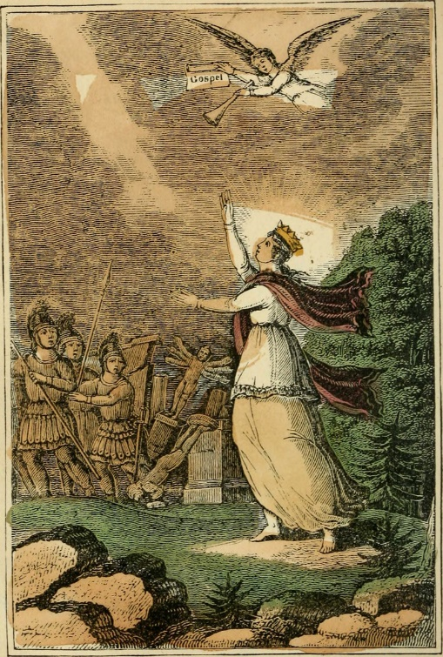
“’Heaven and earth will pass away, but my words will not pass away.'” (Mark 13:31)

Minister: Rev. Jason Evans
First Free Methodist Church
2625 N. Center Rd.
Saginaw, Michigan 48603
Phone: (989) 799-2930
Email: saginawfmc@gmail.com
www.saginawfirstfmc.org

ADVENT
November 29, 2020
The mission of Saginaw First Free Methodist Church is to be faithful to God and to make known to all people everywhere God’s call to wholeness in Jesus Christ.

Prelude
**Greeting/Announcements
*Call to Worship (spoken responsively)
L: A shoot will come up from the stump of Jesse; from his roots a Branch will bear much fruit
P: The Spirit of the Lord will rest on him, the Spirit of wisdom
L: The Spirit of knowledge and of the fear of the Lord
P: And he will delight in the fear of the Lord
L: He will not judge by what he sees with his eyes
P: Or decide by what he hears with his ears
L: But with righteousness he will judge the needy
P: With justice he will give decisions for the poor of the earth

*Opening Hymn: “Come, Thou Long-expected Jesus” #157 (v.1)
Come, thou long expected Jesus
Born to set thy people free
From our fears and sins release us
Let us find our rest in thee
Israel's strength and consolation
Hope of all the earth thou art
Dear desire of every nation
Joy of every longing heart

*Invocation and Lord’s Prayer
L: God of justice and peace, from the heavens you rain down mercy and kindness, that all on earth may stand in awe and wonder before your marvelous deeds. Raise our heads in expectation, that we may yearn for the coming day of the Lord and stand without blame before your Son, Jesus Christ, who lives and reigns for ever and ever. we anticipate the coming of Jesus Christ, as we pray together the prayer that Jesus taught His disciples…

P: Our Father, who art in heaven, hallowed be Your name. Your kingdom come; your will be done in earth as it is in heaven. Give us this day our daily bread and forgive us our debts as we forgive our debtors. And lead us not into temptation but deliver us from evil. For Yours is the kingdom, and the power, and the glory forever. Amen.

*Gloria Patri
Glory be to the Father​
And to the Son and to the Holy Ghost.
As it was in the beginning​
Is now and ever shall be
World without end
Amen. Amen

First Scripture Lesson: Isaiah 64:1-9
O that you would tear open the heavens and come down, so that the mountains would quake at your presence, as when fire kindles brushwood and the fire causes water to boil-- to make your name known to your adversaries, so that the nations might tremble at your presence!
When you did awesome deeds that we did not expect, you came down, the mountains quaked at your presence. From ages past no one has heard, no ear has perceived, no eye has seen any God besides you, who works for those who wait for him. You meet those who gladly do right, those who remember you in your ways. But you were angry, and we sinned; because you hid yourself we transgressed.
We have all become like one who is unclean, and all our righteous deeds are like a filthy cloth. We all fade like a leaf, and our iniquities, like the wind, take us away. There is no one who calls on your name, or attempts to take hold of you; for you have hidden your face from us, and have delivered us into the hand of our iniquity.
Yet, O LORD, you are our Father; we are the clay, and you are our potter; we are all the work of your hand. Do not be exceedingly angry, O LORD, and do not remember iniquity forever. Now consider, we are all your people.

Prayer of Confession
L: The world is full of darkness and we wander blindless and aimlessly. We seek to leave behind our past unfaithfulness, but sometimes latch on to new ways that still lead us away from God. As a new year begins, let us abide in God’s mission for us…

P: We confess the sins that we willfully submit to. In times of doubt and uncertainty, we focus on our own needs and our petty concerns. We get weary of making peace, and return to living negligent lives. Creator of the world, you are the potter, we are the clay, and you form us in your image. Shape our spirits by Christ's transforming power, that as one people we may live out your compassion and justice, whole and sound in the realm of your peace. Amen.

Affirmation of Faith: Psalm80
P: Give ear, O Shepherd of Israel, you who lead Joseph like a flock! You who are enthroned upon the cherubim, shine forth before Ephraim and Benjamin and Manasseh. Stir up your might, and come to save us! Restore us, O God; let your face shine, that we may be saved. O LORD God of hosts, how long will you be angry with your people's prayers? You have fed them with the bread of tears, and given them tears to drink in full measure. You make us the scorn of our neighbors; our enemies laugh among themselves. Restore us, O God of hosts; let your face shine, that we may be saved.

*Hymn of Affirmation: “O Come, O Come, Emmanuel” #163 (v.4)
O come, Desire of nations, bind
All peoples in one heart and mind
Bid envy, strife, and quarrels cease
Fill the whole world with heaven’s peace
Rejoice! Rejoice! Immanuel
Shall come to thee, O Israel

Second Scripture Lesson: 1 Corinthians 1:3-9
Grace to you and peace from God our Father and the Lord Jesus Christ. I give thanks to my God always for you because of the grace of God that has been given you in Christ Jesus, for in every way you have been enriched in him, in speech and knowledge of every kind, just as the testimony of Christ has been strengthened among you, so that you are not lacking in any spiritual gift as you wait for the revealing of our Lord Jesus Christ.
He will also strengthen you to the end, so that you may be blameless on the day of our Lord Jesus Christ. God is faithful; by him you were called into the fellowship of his Son, Jesus Christ our Lord.

Passing of the Peace

Prayers of the People
L: Lord in Your Mercy…
P: Hear our prayer.

Gospel Lesson: Mark 13:24-37
“But in those days, after that suffering, the sun will be darkened, and the moon will not give its light, and the stars will be falling from heaven, and the powers in the heavens will be shaken. Then they will see ‘the Son of Man coming in clouds’ with great power and glory.
Then he will send out the angels, and gather his elect from the four winds, from the ends of the earth to the ends of heaven.
“From the fig tree learn its lesson: as soon as its branch becomes tender and puts forth its leaves, you know that summer is near. So also, when you see these things taking place, you know that he is near, at the very gates. Truly I tell you, this generation will not pass away until all these things have taken place. Heaven and earth will pass away, but my words will not pass away.
“But about that day or hour no one knows, neither the angels in heaven, nor the Son, but only the Father. Beware, keep alert; for you do not know when the time will come. It is like a man going on a journey, when he leaves home and puts his slaves in charge, each with his work, and commands the doorkeeper to be on the watch.
Therefore, keep awake--for you do not know when the master of the house will come, in the evening, or at midnight, or at cockcrow, or at dawn, or else he may find you asleep when he comes suddenly. And what I say to you I say to all: Keep awake.”

Sermon

Prayer of Response

*Hymn of Response: “Of the Father’s Love Begotten” #164 (v.4)
Christ, to Thee with God the Father
And, O Holy Ghost, to Thee
Hymn and chant and high thanksgiving
And unwearied praises be
Honor, glory, and dominion
And eternal victory, Evermore, Evermore

Invitation of Offering
L: We have been sustained and strengthened by the many gifts of God. We have the privilege and responsibility to share these resources for the world. For those who walk in darkness in our community, we can be the light. Give for those in need, as we collect this morning’s tithes and offerings.

*Doxology
Praise God, from whom all blessings flow
Praise Him, all creatures here below
Praise Him above, ye heavenly host
Praise Father Son, and Holy Ghost.
Amen.

*Prayer

*Hymn: “Come, Thou Long-expected Jesus” #157 (v.2)
Born thy people to deliver
Born a child and yet a King
Born to reign in us forever
Now thy gracious kingdom bring
By thine own eternal spirit
Rule in all our hearts alone
By thine all sufficient merit
Raise us to thy glorious throne

*Benediction
L: The time is coming when God will call us to account. Be vigilant, faithfully serving day by day. With hearts full of righteousness, use your spiritual gifts for justice in words and deeds, as you go in peace to love and serve. Amen.

