Saginaw First Free Methodist Church
First Sunday of Advent
November 27, 2022

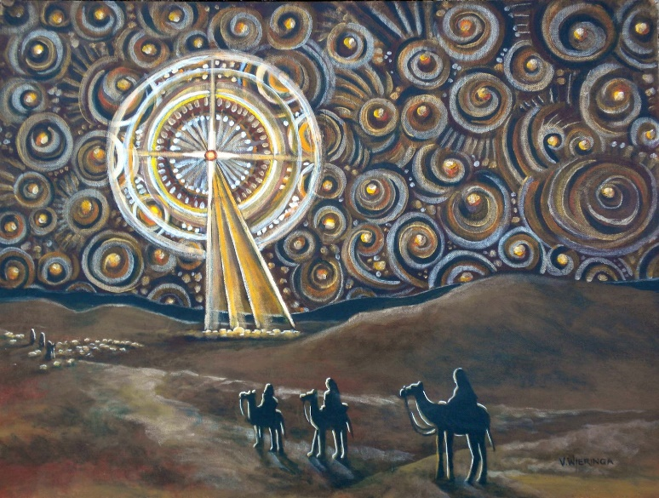
“Therefore you also must be ready, for the Son of Man is coming at an unexpected hour." (Matthew 24:44)

Minister: Rev. Jason Evans
First Free Methodist Church
2625 N. Center Rd.
Saginaw, Michigan 48603
Phone: (989) 799-2930
Email: saginawfmc@gmail.com
www.saginawfirstfmc.org

First Sunday of Advent
November 27, 2022

Prelude
**Greeting/Announcements
*Call to Worship (spoken responsively)
L: The Lord reigns, let the people rejoice
P: God is exalted above the earth
L: God, our God, we earnestly seek you
P: My soul thirsts for you
L: We’ve seen your mighty works
P: I behold your power and glory
L: We will give thanks with our whole heart
P: I will praise the name of the Lord forever

*Opening Hymn: “Come, Thou Almighty King” #3 (vv.1-4)
Come, Thou Almighty King
Help us thy name to sing
Help us to praise
Father all glorious, over all victorious
Come and reign over us
Ancient of days

Come, Thou incarnate Word
Gird on Thy mighty sword
Our prayer attend
Come and Thy people bless
And give thy word success
Spirit of holiness on us descend

Come, holy comforter
Thy sacred witness bear
In this glad hour
Thou who almighty art
Now rule in every heart
And never from us depart Spirit of power

To Thee, great one in three
Eternal praises be, hence ever more
Thy sovereign majesty
May we in glory see
And to eternity love and adore

Advent Reading

*Invocation and Lord’s Prayer
L: Almighty God, give us grace that we may cast away the works of darkness, and put upon us the armor of light, now in the time of this mortal life in which thy Son Jesus Christ came to visit us in great humility; that in the last day, when he shall come again in his glorious majesty to judge both the quick and the dead, we may rise to the life immortal; through him who lives and reigns with thee and the Holy Ghost, one God, now and forevermore, as we pray the prayer that Jesus taught His disciples…

P: Our Father, who art in heaven, hallowed be Your name. Your kingdom come; your will be done in earth as it is in heaven. Give us this day our daily bread and forgive us our debts as we forgive our debtors. And lead us not into temptation but deliver us from evil. For Yours is the kingdom, and the power, and the glory forever. Amen.

*Gloria Patri
Glory be to the Father​
And to the Son and to the Holy Ghost.​
As it was in the beginning​
Is now and ever shall be.​
World without end. ​
Amen. Amen.​

First Scripture Lesson: Isaiah 2:1-5
The word that Isaiah son of Amoz saw concerning Judah and Jerusalem. In days to come the mountain of the Lord’s house shall be established as the highest of the mountains, and shall be raised above the hills; all the nations shall stream to it. Many peoples shall come and say, “Come, let us go up to the mountain of the LORD, to the house of the God of Jacob; that he may teach us his ways and that we may walk in his paths.”
For out of Zion shall go forth instruction, and the word of the LORD from Jerusalem. He shall judge between the nations, and shall arbitrate for many peoples; they shall beat their swords into plowshares, and their spears into pruning hooks; nation shall not lift up sword against nation, neither shall they learn war any more. O house of Jacob, come, let us walk in the light of the LORD!

Prayer of Confession
L: Heaven and earth will pass away, but the word of God will abide forever. Be on guard, and trust in God’s faithfulness. Be alert, so our spirits may grow calm, our vision be clear, and our purpose be unified…

P: Great and gracious God, Father of all mercies, we your unworthy servants give you humble thanks for all your goodness and loving-kindness to us and to all whom you have made. We bless you for our creation, preservation, and all the blessings of this life. But above all for your immeasurable love in the redemption of the world by our Lord Jesus Christ; for the means of grace and for the hope of glory. We pray, give us such an awareness of your mercies, that with truly thankful hearts we may show forth your praise, not only with our lips, but in our lives, by giving up ourselves to your service and by walking for you in holiness and righteousness all our days. Amen.

Affirmation of Faith: Psalm 122
P: I was glad when they said to me, “Let us go to the house of the LORD!” Our feet are standing within your gates, O Jerusalem. Jerusalem built as a city that is bound firmly together. To it the tribes go up, the tribes of the LORD, as was decreed for Israel, to give thanks to the name of the LORD. For there the thrones for judgment were set up, the thrones of the house of David. Pray for the peace of Jerusalem: “May they prosper who love you. Peace be within your walls, and security within your towers.” For the sake of my relatives and friends I will say, “Peace be within you.” For the sake of the house of the LORD our God, I will seek your good.

Hymn of Affirmation: “Come, O Come Emmanuel” #163 (vv.1-4)
O come, O come, Emmanuel
And ransom captive Israel
That mourns in lowly exile here
Until the Son of God appear
Rejoice! Rejoice! Immanuel
Shall come to thee, O Israel

O come, Thou Dayspring come and cheer
Our spirits by Thine advent here
Disperse the gloomy clouds of night
And death’s dark shadows put to flight
Rejoice! Rejoice! Immanuel
Shall come to thee, O Israel

O come, Thou Wisdom from on high
And order all thing far and nigh
To us the path of knowledge show
And cause us in her ways to go
Rejoice! Rejoice! Immanuel
Shall come to thee, O Israel

O come, Desire of nations, bind
All peoples in one heart and mind
Bid envy, strife, and quarrels cease
Fill the whole world with heaven’s peace
Rejoice! Rejoice! Immanuel
Shall come to thee, O Israel

Second Scripture Lesson: Romans 13:11-14
Besides this, you know what time it is, how it is now the moment for you to wake from sleep. For salvation is nearer to us now than when we became believers; the night is far gone, the day is near. Let us then lay aside the works of darkness and put on the armor of light; let us live honorably as in the day, not in reveling and drunkenness, not in debauchery and licentiousness, not in quarreling and jealousy. Instead, put on the Lord Jesus Christ, and make no provision for the flesh, to gratify its desires.

Children’s Sermon

Passing of the Peace

Prayers of the People
L: Lord in Your Mercy…
P: Hear our prayer.

Gospel Lesson: Matthew 24:36-44
“But about that day and hour no one knows, neither the angels of heaven, nor the Son, but only the Father. For as the days of Noah were, so will be the coming of the Son of Man. For as in those days before the flood they were eating and drinking, marrying and giving in marriage, until the day Noah entered the ark, and they knew nothing until the flood came and swept them all away, so too will be the coming of the Son of Man.
Then two will be in the field; one will be taken and one will be left. Two women will be grinding meal together; one will be taken and one will be left.
Keep awake therefore, for you do not know on what day your Lord is coming. But understand this: if the owner of the house had known in what part of the night the thief was coming, he would have stayed awake and would not have let his house be broken into. Therefore you also must be ready, for the Son of Man is coming at an unexpected hour.

Sermon: “Season For Hope”

Prayer of Response

Hymn of Response: “Be Exalted, O God”
I will give thanks to Thee
O Lord, among the people
I will sing praises to Thee
Among the nations
For Thy steadfast love is great
Is great to the heavens
And Thy faithfulness
Thy faithfulness to the clouds

Be exalted, O God
Above the heavens
Let Thy glory be over all the earth
Be exalted, O God
Above the heavens
Let Thy glory be over all the earth

Invitation of Offering
L: Almighty God, who came to us long ago in the birth of Jesus, came as a source of hope to this world. A hope in that which we still haven’t seen. Offer your lives as a home for grace and strength, as we collect this morning’s tithes and offerings.

*Doxology

*Prayer

*Closing Hymn: “We Have Come into His House” #113 (vv.1-3)
We Have Come Into His House
And Gathered In His Name To Worship Him
We Have Come Into His House
And Gathered In His Name To Worship Him
We Have Come Into His House
And Gathered In His Name To Worship Christ The Lord
Worship Him, Christ The Lord

So forget About yourself
And Concentrate On Him, And Worship Him.
So forget About yourself
And Concentrate On Him, And Worship Him.
So forget About yourself
And Concentrate On Him, And Worship Christ The Lord.
Worship Him, Christ The Lord.

Let us lift up holy hands
And magnify His name and worship him
Let us lift up holy hands
And magnify His name and worship him
Let us lift up holy hands
And magnify His name And Worship Christ The Lord.
Worship Him, Christ The Lord

*Benediction
L: You have been reminded that Jesus Christ is your Lord and that you are God’s servant. You are loved; you are forgiven; you are empowered; and now you are sent to live as God’s faithful one. Go in peace to love and serve. Amen.

