First Free Methodist Church of Saginaw
Fifth Sunday in Lent
March 26, 2023

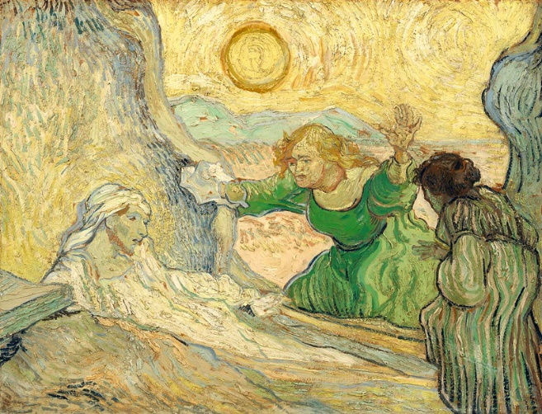
“Then he had said this, he cried with a loud voice, ‘Lazarus, come out!’”
(John 11:43)

Minister: Rev. Jason Evans
First Free Methodist Church
2625 N. Center Rd.
Saginaw, Michigan 48603
Phone: (989) 799-2930
Email: saginawfmc@gmail.com
www.saginawfirstfmc.org

Fifth Sunday in Lent
March 26, 2023

Prelude
**Greeting/Announcements
*Call to Worship (spoken responsively)
L: Out of the depths I cry to you, O LORD
P: Let your ears be attentive to my supplications
L: If you, O LORD, should mark iniquities, Lord, who could stand?
P: But there is forgiveness with you, so that you may be revered
L: For with the LORD there is steadfast love
P: With him is great power to redeem
L: It is he who will redeem Israel from all its iniquities
P: I wait for the LORD and in his word I hope

*Opening Hymn: “We Bow Down” (vv.1-2)
You are Lord of creation
And Lord of my life
Lord of the land and the sea
You were Lord of the heavens
Before there was time
Lord of all lords You will be
We bow down
And we worship You Lord
We bow down
And we worship You Lord
We bow down
And we worship You Lord
King of all kings You will be

You are King of creation
And King of my life
King of the land and the sea
You were King of the heavens
Before there was time
And King of all kings You will be
We bow down
And we crown You the King
We bow down
And we crown You the King
We bow down
And we crown You the King
King of all kings You will be

*Invocation and Lord’s Prayer
L: Almighty God, you alone can bring into order the unruly wills and affections of ours; grant your people grace to love what you command and desire what you promise. Though among the swift and varied changes of the world, our hearts may surely there be fixed where true joys are to be found. May our minds, thoughts, and hearts be inclined to your will, as we pray the prayer that Jesus taught His disciples…

P: Our Father, who art in heaven, hallowed be Your name. Your kingdom come; your will be done in earth as it is in heaven. Give us this day our daily bread and forgive us our debts as we forgive our debtors. And lead us not into temptation but deliver us from evil. For Yours is the kingdom, and the power, and the glory forever. Amen.

*Gloria Patri
Glory be to the Father​
And to the Son and to the Holy Ghost.​
As it was in the beginning​
Is now and ever shall be.​
World without end. ​
Amen. Amen.​

*Passing of the Peace

Hymn: “Breathe on Me, Breath of God” #302 (vv.1-4)
Breathe on me, Breath of God
Fill me with life anew
That I may love what Thou dost love
And do what Thou would do

Breathe on me, Breath of God
Until my heart is pure
Until with Thee, I will one will
To do and to endure

Breathe on me, Breath of God
Till I am wholly Thine
Until this earthly part of me
Glows with Thy fire divine

Breathe on me, Breath of God
So shall I never die
But live with Thee the perfect life
Of Thine eternity

Congregational Reading: Romans 8:6-11
P: To set the mind on the flesh is death, but to set the mind on the Spirit is life and peace. For this reason the mind that is set on the flesh is hostile to God; it does not submit to God's law, indeed it cannot, and those who are in the flesh cannot please God. But you are not in the flesh; you are in the Spirit, since the Spirit of God dwells in you. Anyone who does not have the Spirit of Christ does not belong to him. But if Christ is in you, though the body is dead because of sin, the Spirit is life because of righteousness. If the Spirit of him who raised Jesus from the dead dwells in you, he who raised Christ from the dead will give life to your mortal bodies also through his Spirit that dwells in you.

Special Music: Anne Norman

Children’s Sermon

Gospel Lesson: John 11:1-4, 34-45
Now a certain man was ill, Lazarus of Bethany, the village of Mary and her sister Martha. Mary was the one who anointed the Lord with perfume and wiped his feet with her hair; her brother Lazarus was ill. So the sisters sent a message to Jesus, “Lord, he whom you love is ill.”
But when Jesus heard it, he said, “This illness does not lead to death; rather it is for God’s glory, so that the Son of God may be glorified through it.”
He said, “Where have you laid him?”
They said to him, “Lord, come and see.”
Jesus began to weep. So the Jews said, “See how he loved him!”
But some of them said, “Could not he who opened the eyes of the blind man have kept this man from dying?”
Then Jesus, again greatly disturbed, came to the tomb. It was a cave, and a stone was lying against it. Jesus said, “Take away the stone.”
Martha, the sister of the dead man, said to him, “Lord, already there is a stench because he has been dead four days.”
Jesus said to her, “Did I not tell you that if you believed, you would see the glory of God?”
So they took away the stone. And Jesus looked upward and said, “Father, I thank you for having heard me. I knew that you always hear me, but I have said this for the sake of the crowd standing here, so that they may believe that you sent me.”
When he had said this, he cried with a loud voice, “Lazarus, come out!”
The dead man came out, his hands and feet bound with strips of cloth, and his face wrapped in a cloth. Jesus said to them, “Unbind him, and let him go.”
Many of the Jews therefore, who had come with Mary and had seen what Jesus did, believed in him.

Sermon
Prayers of the People
L: Lord in Your Mercy…
P: Hear our prayer.

Hymn of Response: “I Know That My Redeemer Lives”
I know that my Redeemer lives
What comfort this sweet sentence gives
He lives, he lives, who once was dead
He lives, my ever-living Head

He lives triumphant from the grave
He lives eternally to save
He lives all glorious in the sky
He lives exalted there on high

He lives and grants me daily breath
He lives, and I shall conquer death
He lives my mansion to prepare
He lives to bring me safely there

He lives All glory to his name
He lives my Savior still the same
What joy the blest assurance gives
I know that my Redeemer lives

Invitation of Offering
L: Do nothing out of selfish ambition or vain conceit. Rather, in humility value others above yourselves, not looking to your own interests but each of you to the interests of the others. Be encouraged, as we collect this morning’s tithes and offerings.

*Doxology
Praise God, from whom all blessings flow
Praise Him, all creatures here below
Praise Him above, ye heavenly host
Praise Father Son, and Holy Ghost.
Amen.

*Prayer

*Closing Hymn: “He Lives” #262 (vv.1-3)
I serve a risen Savior, He's in the world today
I know that He is living, whatever men may say
I see His hand of mercy, I hear His voice of cheer
And just the time I need Him, He's always near
He lives! He lives! Christ Jesus lives today!
He walks with me and talks with me along life's narrow way
He lives! He lives! Salvation to impart
You ask me how I know He lives?
He lives within my heart

In all the world around me I see His loving care
And though my heart grows weary I never will despair
I know that He is leading, thro' all the stormy blast
The day of His appearing will come at last
He lives! He lives! Christ Jesus lives today!
He walks with me and talks with me along life's narrow way
He lives! He lives! Salvation to impart
You ask me how I know He lives?
He lives within my heart

Rejoice, rejoice, O Christian! Lift up your voice and sing
Eternal hallelujahs to Jesus Christ, the King
The Hope of all who seek Him, the Help of all who find
None other is so loving, so good and kind
He lives! He lives! Christ Jesus lives today!
He walks with me and talks with me along life's narrow way
He lives! He lives! Salvation to impart
You ask me how I know He lives?
He lives within my heart

*Benediction
L: May the hand of God protect you. May the teaching of Christ instruct you. May the strength of the Holy Spirit carry you. May you have harmony of the soul, as you go in peace to love and serve. Amen.

