Saginaw First Free Methodist Church
Second Sunday after Pentecost
June 6, 2021

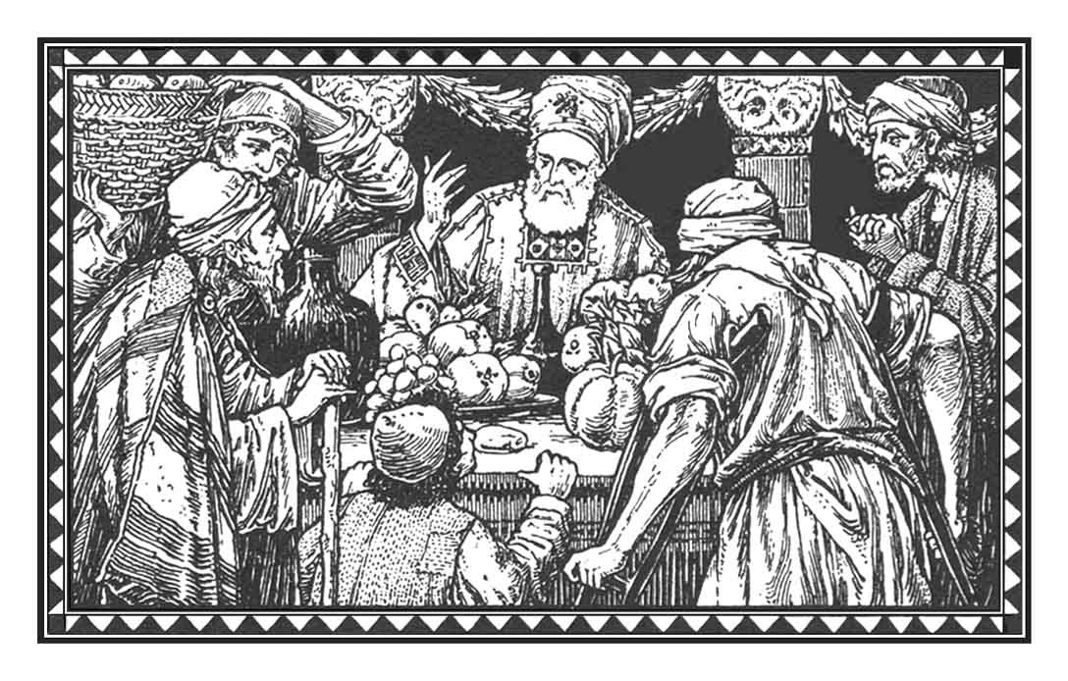
“He said, ‘These will be the ways of the king who will reign over you…He will take your male and female slaves, and the best of your cattle and donkeys, and put them to his work.
(1 Samuel 8:11a, 16)

Minister: Rev. Jason Evans
First Free Methodist Church
2625 N. Center Rd.
Saginaw, Michigan 48603
Phone: (989) 799-2930
Email: saginawfmc@gmail.com
www.saginawfirstfmc.org

PROPER 5 (10)
June 6, 2021
Prelude
**Greeting/Announcements
*Call to Worship (spoken responsively)
L: Bow towards God’s holy temple and give thanks
P: We give thanks to the Lord with our whole hearts
L: Exalt God’s name and word above everything else
P: God’s steadfast love and faithfulness endures forever
L: Do not lose heart, even as our life wastes away
P: Our inner nature is being renewed day by day
L: We are God’s children, born of the Spirit
P: Because we do the will of our God

*Opening Hymn: “Praise Ye the Triune God” #13 (vv.1-3)
Praise ye the Father for His loving kindness
Tenderly cares He for His erring children
Praise Him ye angels
Praise Him in heaven
Praise ye Jehovah

Praise ye the Savior great is His compassion
Graciously cares he for His chosen people
Young men and maidens
Ye old men and children
Praise ye the Savior

Praise ye the Spirit, Comforter of Israel
Sent of the Father and of the Son to bless us
Praise ye the Father
And Son and Holy Spirit
Praise ye the Triune God

*Invocation and Lord’s Prayer
L: O God our ruler and shepherd, you anointed Jesus as the king and servant of your people. Make us attentive to your word, that we may accept your reign over us and serve you alone. Move us to praise your gracious will, for in Christ Jesus you have saved us from the deeds of death and opened for us the hidden ways of your love. Remind us of who we serve, as we pray the prayer that Jesus taught His disciples…

P: Our Father, who art in heaven, hallowed be Your name. Your kingdom come; your will be done in earth as it is in heaven. Give us this day our daily bread and forgive us our debts as we forgive our debtors. And lead us not into temptation but deliver us from evil. For Yours is the kingdom, and the power, and the glory forever. Amen.

*Gloria Patri
Glory be to the Father​
And to the Son and to the Holy Ghost.
As it was in the beginning​
Is now and ever shall be
World without end
Amen. Amen

Old Testament Scripture Lesson: 1 Samuel 8:4-20
Then all the elders of Israel gathered together and came to Samuel at Ramah, and said to him, “You are old and your sons do not follow in your ways; appoint for us, then, a king to govern us, like other nations.”
But the thing displeased Samuel when they said, “Give us a king to govern us.” Samuel prayed to the LORD, and the LORD said to Samuel, “Listen to the voice of the people in all that they say to you; for they have not rejected you, but they have rejected me from being king over them.
Just as they have done to me, from the day I brought them up out of Egypt to this day, forsaking me and serving other gods, so also they are doing to you. Now then, listen to their voice; only--you shall solemnly warn them, and show them the ways of the king who shall reign over them.”
So Samuel reported all the words of the LORD to the people who were asking him for a king. He said, “These will be the ways of the king who will reign over you: he will take your sons and appoint them to his chariots and to be his horsemen, and to run before his chariots; and he will appoint for himself commanders of thousands and commanders of fifties, and some to plow his ground and to reap his harvest, and to make his implements of war and the equipment of his chariots.
He will take your daughters to be perfumers and cooks and bakers. He will take the best of your fields and vineyards and olive orchards and give them to his courtiers. He will take one-tenth of your grain and of your vineyards and give it to his officers and his courtiers. He will take your male and female slaves, and the best of your cattle and donkeys, and put them to his work.
He will take one-tenth of your flocks, and you shall be his slaves. And in that day you will cry out because of your king, whom you have chosen for yourselves; but the LORD will not answer you in that day.”
But the people refused to listen to the voice of Samuel; they said “No! but we are determined to have a king over us, so that we also may be like other nations, and that our king may govern us and go out before us and fight our battles.”

Prayer of Confession
L: Sometimes we take our blessings for granted. We get weary, confused, and discontent. Rely on God’s provisions so our spirits may grow calm, our vision be clear, and our purpose be unified…

P: Creator God, we surrender our willing submission to You, turning to entertainers, politicians, or financial wizards as our hope. Our own convenience and desires are more important to us that your commands. But you do not forsake us, and you lovingly recall us to our primary relationship with you. You have cleansed us of our wrongdoing and lead us a Spirit filled life, loving one another as we love You. Help us recognize our needs and let the coals cleanse us, that we may be free to go as you send us. Amen.

Affirmation of Faith: Psalm 130
P: Out of the depths I cry to you, O LORD. Lord, hear my voice! Let your ears be attentive to the voice of my supplications! If you, O LORD, should mark iniquities, Lord, who could stand? But there is forgiveness with you, so that you may be revered. I wait for the LORD, my soul waits, and in God’s word I hope; my soul waits for the Lord more than those who watch for the morning…hope in the Lord, for with the LORD there is steadfast love, and with God is great power to redeem.

Hymn of Affirmation: “Day by Day” #105 (vv.1,3)
Day by day and with each passing moment
Strength I find to meet my trials here
Trusting in my Father's wise bestowment
I've no cause for worry or for fear
He whose heart is kind beyond all measure
Gives unto each day what he deems best
Lovingly, its part of pain and pleasure
Mingling toil with peace and rest

Help me then in ev'ry tribulation
So to trust your promises, O Lord
That I lose not faith's sweet consolation
Offered me within your holy Word
Help me, Lord, when, toil and trouble meeting
E'er to take, as from a father's hand
One by one, the days, the moments fleeting
Till I reach the promised land

Communion
MINISTER: THE INVITATION
You who truly and earnestly repent of your sins, who live in love and peace with
your neighbors and who intend to lead a new life, following the commandments
of God and walking in His holy ways, draw near with faith, and take this holy
sacrament to your comfort; and humbly kneeling, make your honest confession
to Almighty God.

IN UNISON: THE GENERAL CONFESSION
Almighty God, Father of our Lord Jesus Christ, maker of all things, judge of all
people, we confess that we have sinned, and we are deeply grieved as we
remember the wickedness of our past lives. We have sinned against You, Your
holiness and Your love, and we deserve only Your indignation and anger.
We sincerely repent, and we are genuinely sorry for all wrongdoing and every
failure to do the things we should. Our hearts are grieved, and we acknowledge
that we are hopeless without Your grace.
Have mercy upon us.
Have mercy upon us, most merciful Father, for the sake of your son, our Savior, Jesus
Christ, who died for us.
Forgive us.
Cleanse us.
Give us strength to serve and please You in newness of life and to honor and praise
Your name, through Jesus Christ our Lord. Amen.

MINISTER: THE AFFIRMATION OF FAITH
O Almighty God, our Heavenly Father, who with great mercy has promised
forgiveness to all who turn to You with hearty repentance and true faith, have
mercy upon us, pardon and deliver us from our sins, make us strong and faithful in
all goodness and bring us to everlasting life, through Jesus Christ our Lord. Amen.

CONGREGATION: THE COLLECT
Almighty God, unto whom all hearts are open, all desires known, and from whom
no secrets are hid: cleanse the thoughts of our hearts, by the inspiration of the
Holy Spirit, that we may perfectly love You and worthily magnify Your holy name,
through Christ our Lord. Amen.

MINISTER: THE SANCTUS
It is always right and proper, and our moral duty, that we should at all times and
in all places give thanks to You, O Lord, holy Father, Almighty and Everlasting God.
Therefore, with angels and archangels, and with all the inhabitants of heaven, we
honor and adore Your glorious name, evermore praising You and saying,

CONGREGATION: THE SANCTUS (CONTINUED)
Holy, Holy, Holy, Lord God of hosts!
Heaven and earth are full of Thy glory.
Glory be to Thee, O Lord, most high. Amen

MINISTER: THE PRAYER FOR SPIRITUAL COMMUNION
We do not come to this Your table, O merciful Lord, with self-confidence and
pride, trusting in our own righteousness, but we trust in Your great and many
mercies. We are not worthy to gather the crumbs from under Your table. But You,
O Lord, are unchanging in Your mercy and Your nature is love; grant us, therefore,
God of mercy, God of grace, so to eat at this Your table that we may receive in
spirit and in truth the body of Your dear Son, Jesus Christ, and the merits of His
shed blood, so that we may live and grow in His likeness and, being washed and
cleansed through His most precious blood, we may evermore live in Him and He
in us. Amen.

MINISTER: THE PRAYER OF CONSECRATION OF THE ELEMENTS
Almighty God, our Heavenly Father, who gave in love Your only Son, Jesus Christ,
to suffer death upon the cross for our redemption, who by His sacrifice, offered
once for all, did provide a full, perfect, and sufficient atonement for the sins of the whole world,
we come now to Your table in obedience to Your Son, Jesus Christ, who in His holy gospel
commanded us to continue a perpetual memory of His precious death until He comes
again. Hear us, O merciful Father, we humbly ask, and grant that we, receiving this bread and this cup,
as He commanded and in the memory of His passion and death, may partake of His most blessed body and blood.

In the night of His betrayal, Jesus took bread, and when He had given thanks, He broke it and gave it to
His disciples, saying, “Take, eat; this is My body which is given for you; do this in remembrance of Me.”

In like manner, after supper He took the cup, and when He had given thanks, He gave it to them, saying, “Drink of
this, all of you, for this is My blood of the New Testament, which is shed for you and for many, for the remission of
sins; do this as often as you drink it, in remembrance of Me.” Amen.

The body of our Lord Jesus Christ, which was given for you, preserve your soul and body unto everlasting
life. Take and eat this in remembrance that Christ died for you, and feed upon Him in your heart, by faith with
thanksgiving.

The blood of our Lord Jesus Christ, which was shed for you, preserve your soul and body unto everlasting life.
Drink this in remembrance that Christ’s blood was shed for you and be thankful.

MINISTER: THE BENEDICTION
May the peace of God, which passes all understanding, keep your hearts and minds in the knowledge and love
of God, and of His Son, Jesus Christ our Lord; and may the blessing of God Almighty, the Father, the Son, and
the Holy Spirit, be yours now and forever. Amen.

New Testament Scripture Lesson: 2 Corinthians 4:13-5:1
But just as we have the same spirit of faith that is in accordance with scripture, ”I believed, and so I spoke,” we also believe, and so we speak, because we know that the one who raised the Lord Jesus will raise us also with Jesus, and will bring us with you into his presence. Yes, everything is for your sake, so that grace, as it extends to more and more people, may increase thanksgiving, to the glory of God.
So we do not lose heart. Even though our outer nature is wasting away, our inner nature is being renewed day by day. For this slight momentary affliction is preparing us for an eternal weight of glory beyond all measure, because we look not at what can be seen but at what cannot be seen; for what can be seen is temporary, but what cannot be seen is eternal. For we know that if the earthly tent we live in is destroyed, we have a building from God, a house not made with hands, eternal in the heavens.

Passing of the Peace

Prayers of the People
L: Lord in Your Mercy…
P: Hear our prayer.

Gospel Lesson: Mark 3:20-35
...and the crowd came together again, so that they could not even eat. When his family heard it, they went out to restrain him, for people were saying, “He has gone out of his mind.”
And the scribes who came down from Jerusalem said, “He has Beelzebul, and by the ruler of the demons he casts out demons.”
And he called them to him, and spoke to them in parables, “How can Satan cast out Satan? If a kingdom is divided against itself, that kingdom cannot stand. And if a house is divided against itself, that house will not be able to stand.
And if Satan has risen up against himself and is divided, he cannot stand, but his end has come. But no one can enter a strong man's house and plunder his property without first tying up the strong man; then indeed the house can be plundered.
“Truly I tell you, people will be forgiven for their sins and whatever blasphemies they utter; but whoever blasphemes against the Holy Spirit can never have forgiveness, but is guilty of an eternal sin,” for they had said, “He has an unclean spirit.”
Then his mother and his brothers came; and standing outside, they sent to him and called him. A crowd was sitting around him; and they said to him, “Your mother and your brothers and sisters are outside, asking for you.”
And he replied, “Who are my mother and my brothers?”
And looking at those who sat around him, he said, “Here are my mother and my brothers! Whoever does the will of God is my brother and sister and mother.”

In Better Hands

Prayer of Response

Hymn of Response: “Take My Life, and Let It Be Consecrated” #455 (vv.1-2,4-5)
Take my life and let it be
Consecrated, Lord, to thee
Take my moments and my days
Let them flow in endless praise
Let them flow in endless praise

Take my hands and let them move
At the impulse of thy love
Take my feet and let them be
Swift and beautiful for thee
Swift and beautiful for thee

Take my silver and my gold
Not a mite would I withhold
Take my intellect and use
Every power as thou shalt choose
Every power as thou shalt choose

Take my will and make it Thine
It shall be no longer mine
Take my heart it is Thine own
It shall be Thy royal throne
It shall be Thy royal throne

Invitation of Offering
L: Many look to what can be seen for hope and satisfaction. But we look to what is unseen. We know we have a house eternal in the heavens. Seek what is eternal for the needy, as we collect this morning’s tithes and offerings.

*Doxology
Praise God, from whom all blessings flow
Praise Him, all creatures here below
Praise Him above, ye heavenly host
Praise Father Son, and Holy Ghost.
Amen.

*Prayer

*Closing Hymn: “For the Beauty of the Earth” #776 (vv.1,3-4)
For the beauty of the earth
For the glory of the skies
For the love which from our birth
Over and around us lies
Christ, our Lord, to you we raise
This, our hymn of grateful praise

For the joy of human love
Brother, sister, parent, child
Friends on earth, and friends above
For all gentle thoughts and mild
Christ, our Lord, to you we raise
This, our hymn of grateful praise

For Thy Church that evermore
Lifteth holy hands above
Off’ring up on ev’ry shore
Her pure sacrifice of love

*Benediction
L: As God’s grace extends to all people, the gospel increases thanksgiving of the recipient. We look to build God’s kingdom as we invite the lost to become God’s children. Build prosperity for all, as you go in peace to love and serve. Amen.

