First Free Methodist Church of Saginaw
Fourth Sunday after Pentecost
June 25, 2023

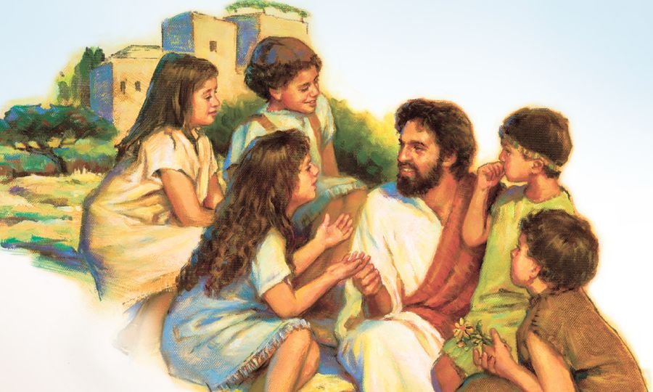
“How often have I desired to gather your children together as a hen gathers her brood under her wings…”
(Matthew 23:37)

Minister: Rev. Jason Evans
First Free Methodist Church
2625 N. Center Rd.
Saginaw, Michigan 48603
Phone: (989) 799-2930
Email: saginawfmc@gmail.com
www.saginawfirstfmc.org

Fourth Sunday after Pentecost
June 25, 2023

Prelude

Announcements

*Call to Worship (spoken responsively)
L: Make a joyful noise to the Lord, all the earth
P: Sing the glory of God’s name
L: Say to God, “How awesome are your deeds!”
P: Give to God glorious praise
L: God turned the sea into dry land
P: All the earth worships you
L: Bless our God, O peoples
P: Let the sound of God’s praise be heard

*Opening Song: “A Might Fortress is Our God” #30 (vv.1-4)
A mighty Fortress is our God
A Bulwark never failing
Our Helper He amid the flood
Of mortal ills prevailing
For still our ancient foe
Doth seek to work us woe
His craft and power are great
And, armed with cruel hate
On earth is not his equal

Did we in our own strength confide
Our striving would be losing
Were not the right Man on our side
The Man of God’s own choosing
Dost ask who that may be? Christ Jesus, it is He
Lord Sabaoth His Name
From age to age the same
And He must win the battle

And though this world, with devils filled
Should threaten to undo us
We will not fear, for God hath willed
His truth to triumph through us
The Prince of Darkness grim
We tremble not for him His rage we can endure
For lo! his doom is sure
One little word shall fell him

That word above all earthly powers
No thanks to them, abideth
The Spirit and the gifts are ours
Through Him who with us sideth
Let goods and kindred go
This mortal life also
The body they may kill
God’s truth abideth still
His Kingdom is forever

*Invocation and Lord’s Prayer
L: O God, who has taught us to keep your commandments by loving you and our neighbor: Grant us the grace of the Holy Spirit, that we may be devoted to thee with our whole heart, and united to one another with pure affection. Help us to welcome each other and serve willingly together, as share your gospel to this world. Bind us all as one, as we pray the prayer that Jesus taught His disciples…

P: Our Father, who art in heaven, hallowed be Your name. Your kingdom come; your will be done in earth as it is in heaven. Give us this day our daily bread and forgive us our debts as we forgive our debtors. And lead us not into temptation but deliver us from evil. For Yours is the kingdom, and the power, and the glory forever. Amen.

*Gloria Patri

Passing of the Peace

Congregational Song: “Graves Into Gardens”
I searched the world
But it couldn't fill me
Man's empty praise
And treasures that fade
Are never enough

Then You came along
And put me back together
And every desire
Is now satisfied
Here in Your love (Hey)

Oh, there's nothing better than You
There's nothing better than You
Lord, there's nothing
Nothing is better than You
(Oh, yes I know it's true)

I'm not afraid
To show You my weakness
My failures and flaws
Lord, You've seen 'em all
And You still call me friend

'Cause the God of the mountain
Is the God of the valley
There's not a place
Your mercy and grace
Won't find me again

Oh, there's nothing better than You
There's nothing better than You
Lord, there's nothing
Nothing is better than You
(I know it's true)

Oh, there's nothing better than You
There's nothing better than You
Lord, there's nothing
Nothing is better than You

You turn mourning to dancing
You give beauty for ashes
You turn shame into glory
You're the only one who can

You turn mourning to dancing
You give beauty for ashes
You turn shame into glory
You're the only one who can

You turn graves into garden
You turn bones into armies
You turn seas into highways
You're the only one who can
You're the only one who can

Oh, there's nothing better than You
There's nothing better than You
Lord, there's nothing
Nothing is better than You

Oh, there's nothing better than You
There's nothing better than You
Lord, there's nothing
Nothing is better than You

You turn graves into gardens
You turn bones into armies
You turn seas into highways
You're the only one who can

You turn graves into gardens
You turn bones into armies
You turn seas into highways
You're the only one who can
You're the only one who can
You're the only one who can

You turn mourning to dancing
You give beauty for ashes
You turn shame into glory
You're the only one who can

You turn graves into gardens
You turn bones into armies
You turn seas into highways
You're the only one who can

You turn graves into gardens
You turn bones into armies
You turn seas into highways
You're the only one who can
You're the only one who can
You're the only one who can

Congregational Reading: Historic Prayer
P: Jesus Christ, the beginning and the end, the resurrection and the life, the perfect man who gave his life for sinners, I worship you, I adore you, I sing aloud your name. I am one of those you have saved, whom you set free, when you died on the cross. You redeemed me from the slavery of sin. I am like the dry sand of a desert thirsting for water. Good people work justice in the world, I pray you reward them. Patient people teach your ways, help breakdown the stubbornness of people. Humble people serve on your behalf, let the prideful appreciate their service. Let me receive your life-giving love and let me be free.

Children’s Sermon
Gospel Lesson: Matthew 23:37-39
“Jerusalem, Jerusalem, the city that kills the prophets and stones those who are sent to it! How often have I desired to gather your children together as a hen gathers her brood under her wings, and you were not willing! See, your house is left to you, desolate. For I tell you, you will not see me again until you say, ‘Blessed is the one who comes in the name of the Lord.’”
Sermon: “Place of God’s Peace”
Prayers of the People
L: Lord in Your Mercy…
P: Hear our prayer.

Hymn of Response: “I am Thine O Lord” #473 (vv.1-4)
I am Thine, O Lord; I have heard Thy voice
And it told Thy love to me
But I long to rise in the arms of faith
And be closer drawn to Thee
Draw me nearer, nearer blessed Lord
To the cross where Thou has died
Draw me nearer, nearer blessed Lord
To Thy precious, bleeding side

Consecrate me now to Thy service, Lord
By the pow’r of grace divine
Let my soul look up with a steadfast hope
And my will be lost in thine
Draw me nearer, nearer blessed Lord
To the cross where Thou has died
Draw me nearer, nearer blessed Lord
To Thy precious, bleeding side

O the pure delight of a single hour
That before Thy throne I spend
When I kneel in prayer and with Thee, my God
I commune as friend with friend
Draw me nearer, nearer blessed Lord
To the cross where Thou has died
Draw me nearer, nearer blessed Lord
To Thy precious, bleeding side

There are depths of love that I can not know
Till I cross the narrow sea
There are heights of joy that I may not reach
Till I rest in peace with Thee
Draw me nearer, nearer blessed Lord
To the cross where Thou has died
Draw me nearer, nearer blessed Lord
To Thy precious, bleeding side

Invitation of Offering
L: When you give alms, do not let your left hand know what your right hand is doing, so that your alms may be done in secret, and your Father who sees in secret will reward you. Seek first the kingdom of God, as we collect this morning’s tithes and offerings.

*Doxology

*Prayer

*Closing Hymn: “Great Is the Lord” #69
Great is the Lord
He is holy and just
By His power we trust
In His love
Great is the Lord
He is faithful and true
By His mercy He proves
He is love

Great is the Lord
And worthy of glory
Great is the Lord
And worthy of praise
Great is the Lord
Now lift up your voice
Now lift up your voice
Great is the Lord
Great is the Lord

Great is the Lord,
He is holy and just
By His power we trust
In His love
Great is the Lord
He is faithful, and true
By His mercy He proves
He is love

Great is the Lord
And worthy of glory
Great is the Lord
And worthy of praise
Great is the Lord
Now lift up your voice
Now lift up your voice
Great is the Lord
Great is the Lord

Great are you Lord
And worthy of glory
Great are you Lord
And worthy of praise
Great are you Lord
I lift up my voice
I lift up my voice
Great are you Lord
Great are you Lord

*Benediction
L: God is sending us on our journey. May we follow as Christ leads us where we may not expect. Christ Jesus be our company and the Holy Spirit surround us with eternal grace. May the Spirit lead you, as you go in peace to love and serve. Amen.

