First Free Methodist Church of Saginaw
Second Sunday after Pentecost
June 11, 2023

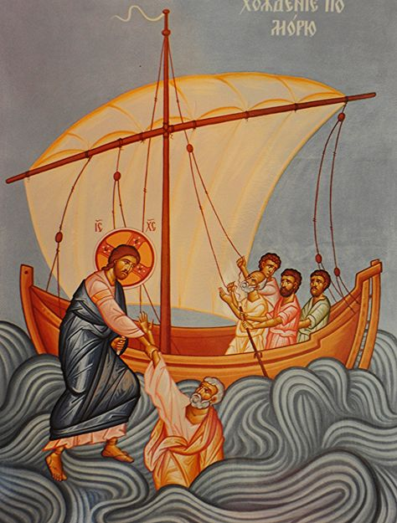
“But when he noticed the wind, he became frightened, and, beginning to sink, he cried out, ‘Lord, save me!’”
(Matthew 14:30)

Minister: Rev. Jason Evans
First Free Methodist Church
2625 N. Center Rd.
Saginaw, Michigan 48603
Phone: (989) 799-2930
Email: saginawfmc@gmail.com
www.saginawfirstfmc.org

Second Sunday after Pentecost
June 11, 2023

Prelude

Announcements

*Call to Worship (spoken responsively)
L: Holy Jesus, our rock and our salvation
P: Direct our ways in your holy light O Lord
L: Send out your light and your truth
P: Let them lead me to your holy hill
L: We will build a life of faith in God
P: Let it bring me to your dwelling O God
L: O Lord, show us your ways
P: O Lord increase our faith

*Opening Song: “Rejoice, Ye Pure in Heart” #59 (vv.1-3,5)
Rejoice, ye pure in heart
Rejoice, give thanks, and sing
Your festal banner wave on high
The cross of Christ your King
Rejoice, rejoice, rejoice, give thanks, and sing

With all the angel choirs
With all the saints on earth
Pour out the strains of joy and bliss
True rapture, noblest mirth!
Rejoice, rejoice, rejoice, give thanks, and sing

Yes, on thro’ life’s long path
Still chanting as ye go
From youth to age, by night and day
In gladness and in woe
Rejoice, rejoice, rejoice, give thanks, and sing

Praise God, who reigns on high
The Lord whom we adore
The Father, Son, and Holy Ghost
One God forevermore
Rejoice, rejoice, rejoice, give thanks, and sing

*Invocation and Lord’s Prayer
L: O Lord, we ask of you, make us to have a perpetual fear and love of your holy name. For you never fail us to help and govern those who you have set upon your sure foundation of your loving-kindness. May we proclaim your grace with truth and boldness as we minister your justice and compassion. May our faith be steadfast, as we pray the prayer that Jesus taught His disciples…

P: Our Father, who art in heaven, hallowed be Your name. Your kingdom come; your will be done in earth as it is in heaven. Give us this day our daily bread and forgive us our debts as we forgive our debtors. And lead us not into temptation but deliver us from evil. For Yours is the kingdom, and the power, and the glory forever. Amen.

*Gloria Patri

Passing of the Peace

Congregational Song: “Oceans”
You call me out upon the waters
The great unknown where feet may fail
And there I find You in the mystery
In oceans deep
My faith will stand

And I will call upon Your name
And keep my eyes above the waves
When oceans rise
My soul will rest in Your embrace
For I am Yours and You are mine

Your grace abounds in deepest waters
Your sovereign hand
Will be my guide
Where feet may fail
And fear surrounds me
You've never failed
And You won't start now

So I will call upon Your name
And keep my eyes above the waves
When oceans rise
My soul will rest in Your embrace

Spirit lead me where my trust is without borders
Let me walk upon the waters
Wherever You would call me
Take me deeper than my feet could ever wander
And my faith will be made stronger
In the presence of my Saviour

Oh, Jesus, You're my God!

I will call upon Your name
Keep my eyes above the waves
My soul will rest in Your embrace
I am Yours and You are mine

Affirmation of Faith: Wesleyan Prayer
P: I am no longer my own, but Yours. Put me to what You will, rank me with whom You will. Put me to doing, put me to suffering. Let me be employed by You or laid aside for You; exalted for You or brought low by You. Let me be full, let me be empty. Let me have all things, let me have nothing. I freely and heartily yield all things to Your pleasure and disposal. And now, O glorious and blessed God, Father, Son, and Holy Spirit, You are mine, and I am Yours. So be it. Amen.

Children’s Sermon

Gospel Lesson: Matthew 14:22-33
Immediately he made the disciples get into the boat and go on ahead to the other side, while he sent the crowds away. And after he sent the crowds away, he went up the mountain by himself to pray; when evening came, he was there alone.
But the boat was already a long distance from the land, battered by the waves; for the wind was contrary. And early in the morning he came to them, walking on the sea. When the disciples saw him walking on the sea, they were terrified, saying, “It is a ghost!” And they cried out in fear. But immediately Jesus spoke to them and said, “Take courage, it is I; do not be afraid.”
Peter said to him, “Lord, if it is you, command me to come to you on the water.”
He said, “Come.”
And Peter got out of the boat, and walked on the water and came toward Jesus. But seeing the wind, he became frightened, and, beginning to sink, he cried out, “Lord, save me!”
Immediately Jesus stretched out his hand and took hold of him, and said, “You of little faith, why did you doubt?”
When they got into the boat, the wind stopped. And those who were in the boat worshiped him, saying, “You are certainly God’s Son.”

Sermon: Case Study “Trust”

Prayers of the People
L: Lord in Your Mercy…
P: Hear our prayer.

Hymn of Response: “Great is thy Faithfulness” #44
Great is Thy faithfulness, O God my Father
There is no shadow of turning with Thee
Thou changest not, Thy compassions, they fail not
As Thou hast been Thou forever wilt be
Great is Thy faithfulness!
Great is Thy faithfulness!
Morning by morning new mercies I see
All I have needed Thy hand hath provided
Great is Thy faithfulness, Lord, unto me!

Summer and winter, and springtime and harvest
Sun, moon, and stars in their courses above
Join with all nature in manifold witness
To Thy great faithfulness, mercy, and love
Great is Thy faithfulness!
Great is Thy faithfulness!
Morning by morning new mercies I see
All I have needed Thy hand hath provided
Great is Thy faithfulness, Lord, unto me!

Pardon for sin and a peace that endureth,
Thine own dear presence to cheer and to guide
Strength for today and bright hope for tomorrow
Blessings all mine, with ten thousand beside!
Great is Thy faithfulness!
Great is Thy faithfulness!
Morning by morning new mercies I see
All I have needed Thy hand hath provided
Great is Thy faithfulness, Lord, unto me!

Invitation of Offering
L: Faith is being sure of what we hope for and certain of we do not see. Let us throw off every weight that hinders and entangles us. Live in faith, as we collect this morning’s tithes and offerings.

*Doxology

*Prayer

*Closing Hymn: “His Name Is Wonderful” #149
His Name is Wonderful, His Name is Wonderful
His Name is Wonderful, Jesus my Lord
He’s the Great Shepherd, The Rock of all Ages
Almighty God is He
Bow down before Him, Love and adore Him
His Name is Wonderful, Jesus my Lord

He is the mighty King, Master of everything
His Name is Wonderful, Jesus my Lord
He’s the Great Shepherd, The Rock of all Ages
Almighty God is He
Bow down before Him, Love and adore Him
His Name is Wonderful, Jesus my Lord

*Benediction
L: God has made its name known to us through the Apostles. The faith of those who intercessions and actions have spread the word by the power of the Holy Spirit. Let your faith continue to grow to increase the God’s kingdom. Go in peace to love and serve. Amen.

