First Free Methodist Church of Saginaw
Baptism of the Lord
January 9, 2022

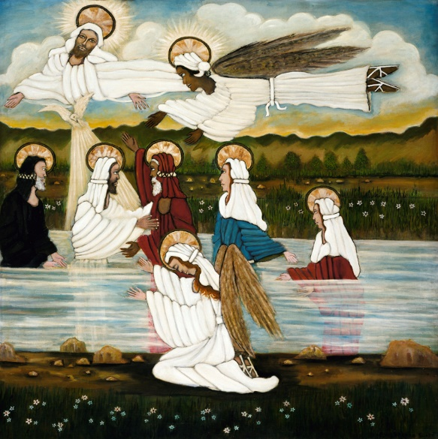
“and the Holy Spirit descended upon him in bodily form like a dove. And a voice came from heaven, ‘You are my Son, the Beloved; with you I am well pleased.’" (Luke 3:22)

Minister: Rev. Jason Evans
First Free Methodist Church
2625 N. Center Rd.
Saginaw, Michigan 48603
Phone: (989) 799-2930
Email: saginawfmc@gmail.com
www.saginawfirstfmc.org

Baptism of the Lord
January 9, 2022

Prelude
**Greeting/Announcements
*Call to Worship (spoken responsively)
L: The Holy One was baptized to fulfill all righteousness
P: And the Spirit came upon him like a dove
L: We’ve been baptized with water for repentance
P: Christ has baptized us with the Holy Spirit and fire
L: Those who’ve been baptized in Christ have been baptized into his death
P: Christ was raised from the dead, so we too might walk in newness of life
L: We’ve been raised with Christ, seek the things that are above
P: We set our minds on things of heaven, not on things of earth

*Opening Hymn: “Children of the Heavenly Father” #93 (vv.1-4)
Children of the heav’nly Father
Safely in His bosom gather
Nestling bird nor star in Heaven
Such a refuge e’er was given

God, His own doth tend and nourish
In His holy courts they flourish
From all evil things He spares them
In His mighty arms He bears them

Neither life nor death shall ever
From the Lord, His children sever
Unto them His grace He showeth
And their sorrows all He knoweth

Though He giveth or He taketh
God His children ne’er forsaketh
His, the loving purpose solely
To preserve them, pure and holy

*Invocation and Lord’s Prayer
L: Father in heaven, who at the baptism of Jesus in the River Jordan did proclaim him thy beloved Son and anoint him with the Holy Spirit: Grant that all who are baptized into his Name may keep the covenant they have made, and boldly confess him as Lord and Savior; who with thee and the same Spirit lives and reigns, one God, in glory everlasting. We pray the prayer that Jesus taught His disciples…

P: Our Father, who art in heaven, hallowed be Your name. Your kingdom come; your will be done in earth as it is in heaven. Give us this day our daily bread and forgive us our debts as we forgive our debtors. And lead us not into temptation but deliver us from evil. For Yours is the kingdom, and the power, and the glory forever. Amen.

*Gloria Patri
Glory be to the Father​
And to the Son and to the Holy Ghost.​
As it was in the beginning​
Is now and ever shall be.​
World without end. ​
Amen. Amen.​

First Scripture Lesson: Isaiah 43:1-7
But now thus says the LORD, he who created you, O Jacob, he who formed you, O Israel: Do not fear, for I have redeemed you; I have called you by name, you are mine. When you pass through the waters, I will be with you; and through the rivers, they shall not overwhelm you; when you walk through fire you shall not be burned, and the flame shall not consume you.
For I am the LORD your God, the Holy One of Israel, your Savior. I give Egypt as your ransom, Ethiopia and Seba in exchange for you. Because you are precious in my sight, and honored, and I love you, I give people in return for you, nations in exchange for your life.
Do not fear, for I am with you; I will bring your offspring from the east, and from the west I will gather you; I will say to the north, “Give them up,” and to the south, “Do not withhold; bring my sons from far away and my daughters from the end of the earth, everyone who is called by my name, whom I created for my glory, whom I formed and made.”

Prayer of Confession
L: The Sovereign God calls us to live daily with clean lips and clean hands. Imitate the steadfast love of our daily, so our spirits may grow calm, our vision be clear, and our purpose be unified…

P: O God, all-powerful and all-knowing, without beginning and without end. You who are the source, the sustainer, and the rewarder of all virtues; Grant that we may abide on the firm ground of faith, be sheltered by an impregnable shield of hope, and be adorned in the bridal garment of charity. Grant that I may through justice be subject to you, through prudence avoid the beguilements of the devil, through temperament exercise restraint, and through fortitude endure adversity with patience. Grant that whatever good things I have, I may share generously with those who have not and that whatever good things I do not have, I may request humbly from those who do. That I never envy my neighbor’s possessions and ever give thanks for your good things.**

Affirmation of Faith: Psalm 29
P: Ascribe to the LORD, O heavenly beings, ascribe to the LORD glory and strength. Ascribe to the LORD the glory of his name; worship the LORD in holy splendor. The voice of the LORD is over the waters; the God of glory thunders, the LORD, over mighty waters. The voice of the LORD is powerful; the voice of the LORD is full of majesty. The voice of the LORD breaks the cedars; the LORD breaks the cedars of Lebanon. He makes Lebanon skip like a calf, and Sirion like a young wild ox.

Hymn of Affirmation: “Adoration” #203 (vv.1-2)
Worship the Lord in the beauty of holiness
Bow down before Him his glory proclaim
With gold of obedience and incense of lowliness
Kneel and adore Him the Lord his name

Fear not to enter His presence in poverty
Bearing no gifts to present as your own
Bring truth in its beauty and love in its purity
These are the offerings to lay at His throne

Second Scripture Lesson: Acts 8:14-17
Now when the apostles at Jerusalem heard that Samaria had accepted the word of God, they sent Peter and John to them. The two went down and prayed for them that they might receive the Holy Spirit (for as yet the Spirit had not come upon any of them; they had only been baptized in the name of the Lord Jesus). Then Peter and John laid their hands on them, and they received the Holy Spirit.

Children’s Sermon

Passing of the Peace

Prayers of the People
L: Lord in Your Mercy…
P: Hear our prayer.

Gospel Lesson: Luke 3:15-17, 21-22
As the people were filled with expectation, and all were questioning in their hearts concerning John, whether he might be the Messiah, John answered all of them by saying, “I baptize you with water; but one who is more powerful than I is coming; I am not worthy to untie the thong of his sandals. He will baptize you with the Holy Spirit and fire. His winnowing fork is in his hand, to clear his threshing floor and to gather the wheat into his granary; but the chaff he will burn with unquenchable fire.”
Now when all the people were baptized, and when Jesus also had been baptized and was praying, the heaven was opened, and the Holy Spirit descended upon him in bodily form like a dove. And a voice came from heaven, “You are my Son, the Beloved; with you I am well pleased.”

Sermon: “Baptized with Christ”

Prayer of Response

Hymn of Response: “How Firm a Foundation” #689 (vv.1-3,5)
How firm a foundation, you saints of the Lord
Is laid for your faith in his excellent Word!
What more can he say than to you he has said
To you who for refuge to Jesus have fled

Fear not, I am with you, O be not dismayed
For I am your God and will still give you aid
I’ll strengthen you, help you, and cause you to stand
Upheld by my righteous, omnipotent hand

When through the deep waters I call you to go
The rivers of sorrow shall not overflow
For I will be with you, your troubles to bless
And sanctify to you your deepest distress

E’en down to old age all my people shall prove
My sov’reign eternal unchangeable love
And when silver hair shall their temples adorn
Like lambs they shall still in my bosom be borne

Invitation of Offering
L: We have been baptized into Christ, engrafted into his royal family tree, made citizens of God’s kingdom. This is the royal banquet spread before us. Celebrate, as we collect this morning’s tithes and offerings.
*Doxology

*Prayer

*Closing Hymn: “I Love Thy Kingdom, Lord” Handout (vv.1-5)
I love thy kingdom, Lord
The house of thine abode
The church our blest Redeemer saved
With his own precious blood

I love thy church, O God
Her walls before thee stand
Dear as the apple of thine eye
And graven on thy hand

For her my tears shall fall
For her my prayers ascend
To her my cares and toils be giv'n
'til toils and cares shall end

Beyond my highest joy
I prize her heav'nly ways
Her sweet communion, solemn vows
Her hymns of love and praise

Sure as thy truth shall last
To Zion shall be giv'n
The brightest glories earth can yield
And brighter bliss of heav'n

*Benediction
L: Go forth into the world to live as those baptized into Christ’s mission. And may the eternal light of God keep you immersed in the life and in the power of the Holy Spirit now and forevermore. Go in peace to love and serve. Amen.

