Saginaw First Free Methodist Church
Third Sunday After The Epiphany
January 31, 2021

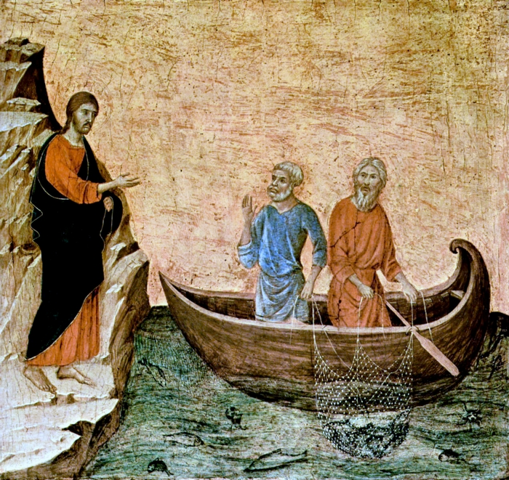
“As Jesus passed along the Sea of Galilee, he saw Simon and his brother Andrew casting a net into the sea--for they were fishermen. And Jesus said to them, ‘Follow me and I will make you fish for people.’ And immediately they left their nets and followed him.” (Mark 1:16-18)

Minister: Rev. Jason Evans
First Free Methodist Church
2625 N. Center Rd.
Saginaw, Michigan 48603
Phone: (989) 799-2930
Email: saginawfmc@gmail.com
www.saginawfirstfmc.org

Third Sunday After The Epiphany
January 31, 2021

The mission of Saginaw First Free Methodist Church is to be faithful to God and to make known to all people everywhere God’s call to wholeness in Jesus Christ.

Prelude
**Greeting/Announcements
*Call to Worship (spoken responsively)
L: God is calling the people together for a purpose
P: We look to God for mission in this life
L: God is sending you to proclaim a message to the peoples
P: We will go in love and peace, sharing what we’ve been given
L: Do not put your confidence in earthly wealth or prosperity
P: God is our rock and salvation; we trust in God for all things
L: Follow God and be holy as God is holy
P: We will be a witness to God’s love and holiness in this world

*Opening Hymn: “Come, We That Love the Lord” #18 (vv.1,3,5)
Come, we that love the Lord
And let our joys be known
Join in a song with sweet accord
And thus, surround the throne

The men of grace have found
Glory begun below
Celestial fruit on earthly ground
From faith and hope may grow

Then let our songs abound
And every tear be dry
We’re marching thro’ Immanuel’s ground
To fairer worlds on high

*Invocation and Lord’s Prayer
L: O God, you spoke your word and revealed your good news in Jesus, the Christ. Fill all creation with that word again, so that by proclaiming your joyful promises to all nations and singing of your glorious hope to all peoples, we may become one living body, your incarnate presence on the earth. Let those around us see our passion for you and follow, as we pray together the prayer that Jesus taught His disciples…

P: Our Father, who art in heaven, hallowed be Your name. Your kingdom come; your will be done in earth as it is in heaven. Give us this day our daily bread and forgive us our debts as we forgive our debtors. And lead us not into temptation but deliver us from evil. For Yours is the kingdom, and the power, and the glory forever. Amen.

*Gloria Patri
Glory be to the Father​
And to the Son and to the Holy Ghost.
As it was in the beginning​
Is now and ever shall be
World without end
Amen. Amen

Old Testament Scripture Lesson: Jonah 3:1-5, 10
The word of the LORD came to Jonah a second time, saying, “Get up, go to Nineveh, that great city, and proclaim to it the message that I tell you.”
So Jonah set out and went to Nineveh, according to the word of the LORD. Now Nineveh was an exceedingly large city, a three days' walk across. Jonah began to go into the city, going a day's walk. And he cried out, “Forty days more, and Nineveh shall be overthrown!”
And the people of Nineveh believed God; they proclaimed a fast, and everyone, great and small, put on sackcloth.
When God saw what they did, how they turned from their evil ways, God changed his mind about the calamity that he had said he would bring upon them; and he did not do it.

Prayer of Confession
L: The present form of this world is passing away, and God has been warning us since the beginning. Sometimes we ignore the warnings we find unpleasant. Sometimes we push away warnings against things we deeply believe. Let us acknowledge our reluctance to understand…

P: Sovereign God, You call us to go and share the good news with the world, yet we often resist loving our enemies. We participate in worldly allegiances and let their understandings dictate our mission. You nudge us towards a greater vision of this world, yet we lament the change it takes. When we do wrong, we resist fasting and being sorrowful. This world is passing away, and You are redeeming those we perceive as wrong. Help us to be hindered by earthly things, but be swept up in following you. Amen.

Affirmation of Faith: Psalm 62
P: For God alone my soul waits in silence, for my hope is from God. God alone is my rock and my salvation, my fortress; I shall not be shaken. On God rests my deliverance and my honor; my mighty rock, my refuge is in God. Trust in God at all times, O people; pour out your heart before God; God is a refuge for us. Those of low estate are but a breath, those of high estate are a delusion; in the balances they go up; they are together lighter than a breath. Put no confidence in extortion, and set no vain hopes on robbery; if riches increase, do not set your heart on them. Once God has spoken; twice have I heard this: that power belongs to God, and steadfast love belongs to you, O Lord. For you repay to all according to their work.

Hymn of Affirmation: “Grace Greater than our Sin” #84 (vv.1,3)
Marvelous grace of our loving Lord
Grace that exceeds our sin and our guilt
Yonder on Calvary's mount out-poured
There where the blood of the Lamb was spilt
Grace, grace, God's grace
Grace that will pardon and cleanse within
Grace, grace, God's grace
Grace that is greater than all our sin

Marvelous, infinite, matchless grace
Freely bestowed on all who believe
You that are longing to see his face
Will you this moment his grace receive?
Grace, grace, God's grace
Grace that will pardon and cleanse within
Grace, grace, God's grace
Grace that is greater than all our sin

New Testament Scripture Lesson: 1 Corinthians 7:29-31
I mean, brothers and sisters, the appointed time has grown short; from now on, let even those who have wives be as though they had none, and those who mourn as though they were not mourning, and those who rejoice as though they were not rejoicing, and those who buy as though they had no possessions, and those who deal with the world as though they had no dealings with it. For the present form of this world is passing away.

Passing of the Peace

Prayers of the People
L: Lord in Your Mercy…
P: Hear our prayer.

Gospel Lesson: Mark 1:14-20
Now after John was arrested, Jesus came to Galilee, proclaiming the good news of God, and saying, “The time is fulfilled, and the kingdom of God has come near; repent, and believe in the good news.”
As Jesus passed along the Sea of Galilee, he saw Simon and his brother Andrew casting a net into the sea--for they were fishermen. And Jesus said to them, “Follow me and I will make you fish for people.”
And immediately they left their nets and followed him. As he went a little farther, he saw James son of Zebedee and his brother John, who were in their boat mending the nets. Immediately he called them; and they left their father Zebedee in the boat with the hired men, and followed him.

Sermon

Prayer of Response

Hymn of Response: “O Jesus, I Have Promised” Handout (vv.1,3)
O Jesus, I have promised to serve Thee to the end
Be Thou forever near me, my master and my friend
I shall not fear the battle if Thou are by my side
Nor wander from the pathway if Thou wilt be my guide

O Jesus, Thou hast promised to all who follow Thee
That where Thou art in glory, there shall Thy servant be
And Jesus I have promised to serve Thee to the end
O give me grace to follow my master and my friend

Invitation of Offering
L: God has called us, and we have responded. When we give our lives to Jesus, we hold nothing back. We give of our time, treasures, and talents. Give to strengthen Christ’s healing presence in your and the world’s lives, as we collect this morning’s tithes and offerings.

*Doxology
Praise God, from whom all blessings flow
Praise Him, all creatures here below
Praise Him above, ye heavenly host
Praise Father Son, and Holy Ghost.
Amen.

*Prayer

*Hymn: “Lead On, O King Eternal” #641 (vv.2,3)
Lead on, O King Eternal, till sin’s fierce war shall cease
And holiness shall whisper the sweet amen of peace
For not with swords’ loud clashing nor roll of stirring drums
With deeds of love and mercy the heav’nly kingdom comes

Lead on, O King Eternal we follow not with fears
For gladness breaks like morning wher-e’er Thy face appears
Thy cross is lifted o’er us we journey in its light
Thy crown awaits the conquest lead on, O God of might

*Benediction
L: Our lives are just a flash in history, fleeting in the winds of change. But we can bring salvation and restoration, when we devote our whole lives to God’s mission. Dedicate your heart, soul, mind, and strength to God’s kingdom, as you go in peace to love and serve. Amen.

