First Free Methodist Church of Saginaw
3rd Sunday After Epiphany
January 22, 2023

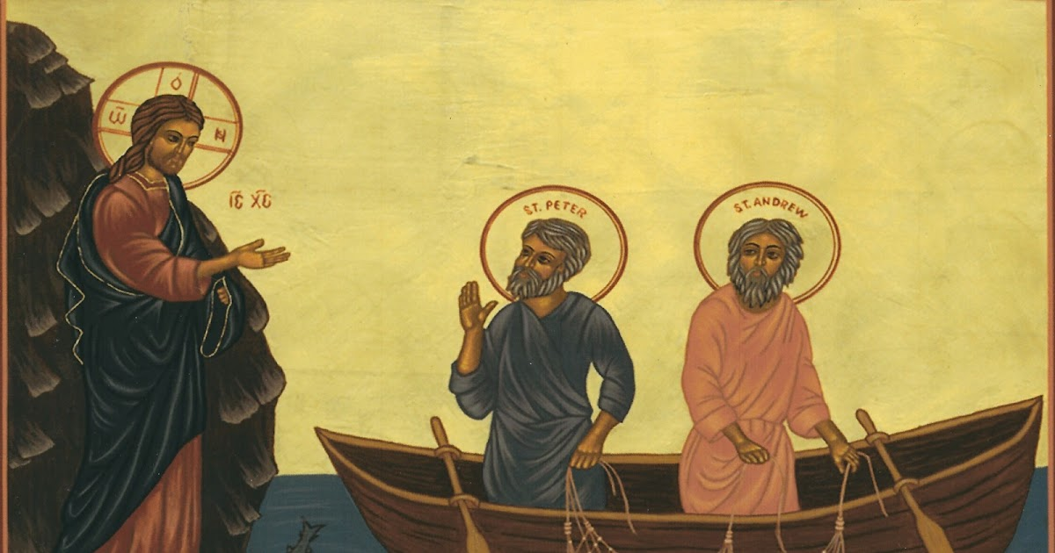
“From that time Jesus began to proclaim, ‘Repent, for the kingdom of heaven has come near.’" (Matthew 4:17)

Minister: Rev. Jason Evans
First Free Methodist Church
2625 N. Center Rd.
Saginaw, Michigan 48603
Phone: (989) 799-2930
Email: saginawfmc@gmail.com
www.saginawfirstfmc.org

3rd Sunday After Epiphany
January 22, 2023

Prelude
**Greeting/Announcements
*Call to Worship (spoken responsively)
L: We are called to gather before the Lord
P: We bow before the Lord and worship the great God
L: Day and night the heavens pour out knowledge of God
P: We see God’s mighty works in creation and in our lives
L: The law of the Lord is perfect, reviving the soul
P: The commandments of God is clear and enlightening
L: Loving God and loving our neighbor is a great reward
P: Let our words and deeds be acceptable to you O Lord

*Opening Hymn: “O Lord, You’re Beautiful” (vv.1-2)
Oh Lord, You're beautiful
Your face is all I seek
For when Your eyes are on this child
Your grace abounds to me

Oh Lord, please light the fire
That once burned bright and clean
Replace the lamp of my first love
That burns with holy fear

*Passing of the Peace

*Invocation and Lord’s Prayer
L: Give us Grace, O Lord, to answer readily the call of our Savior Jesus the Christ and proclaim to all people the Good news of his kingdom and of his salvation, that the whole world may see and perceive the glory of his marvelous works. Lead us, who know you by faith, to your presence, where we may see y our glory face to face. Grant us illumination, as we pray the prayer that Jesus taught His disciples…

P: Our Father, who art in heaven, hallowed be Your name. Your kingdom come; your will be done in earth as it is in heaven. Give us this day our daily bread and forgive us our debts as we forgive our debtors. And lead us not into temptation but deliver us from evil. For Yours is the kingdom, and the power, and the glory forever. Amen.

*Gloria Patri
Glory be to the Father​
And to the Son and to the Holy Ghost
As it was in the beginning​
Is now and ever shall be
World without end
Amen. Amen.​

Congregational Reading: Psalm 19
P: The heavens are telling the glory of God; and the firmament proclaims his handiwork. Day to day pours forth speech, and night to night declares knowledge. In the heavens he has set a tent for the sun, Its rising is from the end of the heavens, and its circuit to the end of them; and nothing is hid from its heat. The law of the LORD is perfect, reviving the soul; the decrees of the LORD are sure, making wise the simple; the precepts of the LORD are right, rejoicing the heart; the commandment of the LORD is clear, enlightening the eyes; the fear of the LORD is pure, enduring forever; the ordinances of the LORD are true and righteous altogether.

Congregational Hymn: Day by Day” #105 (vv.1-3)
Day by day and with each passing moment
Strength I find to meet my trials here
Trusting in my Father's wise bestowment
I've no cause for worry or for fear
He whose heart is kind beyond all measure
Gives unto each day what he deems best
Lovingly, its part of pain and pleasure
Mingling toil with peace and rest

Ev’ry day the Lord Himself is near me
With a special mercy for each hour
All my cares He fain would bear and cheer me
He whose name is counselor and pow’r
The protection of his child and treasure
Is a charge that on Himself He laid
As thy days thy strength shall be in measure
This the pledge to me he made

Help me then in ev'ry tribulation
So to trust your promises, O Lord
That I lose not faith's sweet consolation
Offered me within your holy Word
Help me, Lord, when, toil and trouble meeting
E'er to take, as from a father's hand
One by one, the days, the moments fleeting
Till I reach the promised land

Children’s Sermon

Gospel Lesson: Matthew 4:17-23
From that time Jesus began to proclaim, "Repent, for the kingdom of heaven has come near."
As he walked by the Sea of Galilee, he saw two brothers, Simon, who is called Peter, and Andrew his brother, casting a net into the sea for they were fishermen. And he said to them, "Follow me, and I will make you fish for people."
Immediately they left their nets and followed him.
As he went from there, he saw two other brothers, James son of Zebedee and his brother John, in the boat with their father Zebedee, mending their nets, and he called them. Immediately they left the boat and their father, and followed him. Jesus went throughout Galilee, teaching in their synagogues and proclaiming the good news of the kingdom and curing every disease and every sickness among the people.

Sermon

Prayers of the People
L: Lord in Your Mercy…
P: Hear our prayer.

Hymn of Response: “Our God Reigns” #268 (vv.1-3)
How lovely on the mountains
Are the feet of him
Who brings good news, good news
Announcing peace, proclaiming
News of happiness
Our God reigns; our God reigns
Our God reigns
Our God reigns
Our God reigns
Our God reigns

He had no stately form
He had no majesty
That we should be
drawn to Him
He was despised
and we took no account of Him
Yet now He reigns
With the Most High
Our God reigns
Our God reigns
Our God reigns
Our God reigns

Out of the tomb He came
With grace and majesty
He is alive, He is alive
God loves us so see here His hands
His feet, His side
Yes, we know He is alive
Our God reigns
Our God reigns
Our God reigns
Our God reigns

Invitation of Offering
L: Give your hands to the Lord’s work. Put your feet to the Lord’s path. Give your tongue to speak the Lord’s truth. Give your heart to the love of God, as we collect this morning’s tithes and offerings.

*Doxology
Praise God, from whom all blessings flow
Praise Him, all creatures here below
Praise Him above, ye heavenly host
Praise Father Son, and Holy Ghost
Amen

*Closing Hymn: “In Christ There is No East or West” #678 (vv.1-4)
In Christ there is no east or west
In him no south or north
But one great fellowship of love
Throughout the whole wide earth

In Christ shall true hearts ev’rywhere
Their high communion find
His service is the golden cord
Close binding all mankind

Join hands, then, brothers of the faith
Whate’er your race may be
Who serves my Father as a son
Is surely kin to me

In Christ now meet both east and west
In him meet south and north.
All Christly souls are one in Him
Throughout the whole wide earth

*Benediction
L: Go now, follow where Christ calls you and proclaim the message God gives you. May Christ Jesus give you courage for his mission and passion for his God’s kingdom. Go in peace to love and serve. Amen.

