Saginaw First Free Methodist Church
BAPTISM OF THE LORD
January 17, 2021

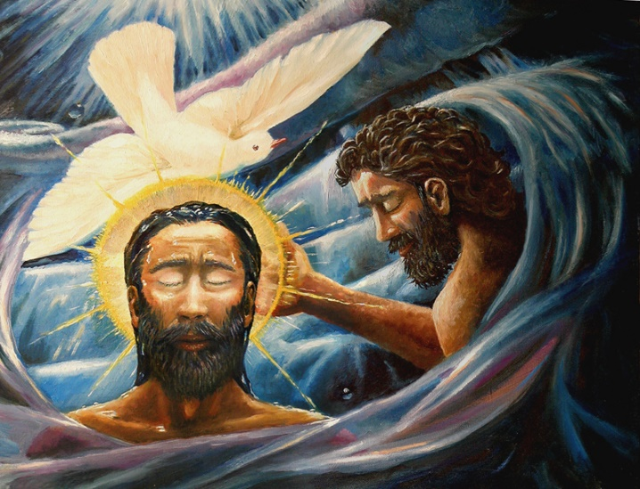
“And just as he was coming up out of the water, he saw the heavens torn apart and the Spirit descending like a dove on him. And a voice came from heaven, ‘You are my Son, the Beloved; with you I am well pleased.’” (Mark 1:10-11)

Minister: Rev. Jason Evans
First Free Methodist Church
2625 N. Center Rd.
Saginaw, Michigan 48603
Phone: (989) 799-2930
Email: saginawfmc@gmail.com
www.saginawfirstfmc.org

BAPTISM OF THE LORD
January 17, 2021

The mission of Saginaw First Free Methodist Church is to be faithful to God and to make known to all people everywhere God’s call to wholeness in Jesus Christ.

Prelude
**Greeting/Announcements
*Call to Worship (spoken responsively)
L: The powerful voice of God created all the world
P: We bow before God’s glorious strength and majesty
L: That same voice offers strength to people of faith
P: We seek the voice that calls us to worship
L: The Spirit that hovered at creation hovers over us today
P: We come remembering the Spirit dwells within us
L: Hear God’s majestic voice calling you today
P: May God bless us with true peace and make us whole

*Opening Hymn: “God of Grace, God of Glory” #720 (vv.1,3)
God of grace and God of glory
On Thy people pour Thy power
Crown Thine ancient church's story
Bring her bud to glorious flower
Grant us wisdom, Grant us courage
For the facing of this hour
For the facing of this hour

Heal Thy people's warring madness
Bend our pride to Thy control
Shame our wanton, selfish gladness
Rich in things and poor in soul
Grant us wisdom, Grant us courage
Lest we miss Thy kingdom's goal
Lest we miss Thy kingdom's goal

*Invocation and Lord’s Prayer
L: God of grace and glory, you call us with your voice of flame to be your people, faithful and courageous. As your beloved Son embraced his mission in the waters of baptism, inspire us with the fire of your Spirit to join in his transforming work. As you anointed Christ Jesus at the Jordan, anoint us with the Spirit, as we pray the prayer that Jesus taught His disciples…

P: Our Father, who art in heaven, hallowed be Your name. Your kingdom come; your will be done in earth as it is in heaven. Give us this day our daily bread and forgive us our debts as we forgive our debtors. And lead us not into temptation but deliver us from evil. For Yours is the kingdom, and the power, and the glory forever. Amen.

*Gloria Patri
Glory be to the Father​
And to the Son and to the Holy Ghost.
As it was in the beginning​
Is now and ever shall be
World without end
Amen. Amen

First Scripture Lesson: Genesis 1:1-5
In the beginning when God created the heavens and the earth, the earth was a formless void and darkness covered the face of the deep, while a wind from God swept over the face of the waters.
Then God said, “Let there be light”; and there was light. And God saw that the light was good; and God separated the light from the darkness. God called the light Day, and the darkness he called Night. And there was evening and there was morning, the first day.

Prayer of Confession
L: As Paul came to Ephesus, he noticed something was off. Instead of forsaking, Paul brought reconciliation. For the times we choose to separate, let us repent…

P: Holy God, with those baptized of every time and generation, may we say yes to your call to repentance and be led to the life of abundance we experience in your kinship and your love. Your mission is to call all people “Beloved” and still we tend to divide humanity. We tend to separate those who do not agree with us, or live-in different ways. Help us to share the grace you gave us to others. Sanctify us by the same Spirit, that we may proclaim the healing power of the gospel by acts of love in your name. Amen.

Affirmation of Faith: Psalm 29
P: Ascribe to the LORD, O heavenly beings, ascribe to the LORD glory and strength. Ascribe to the LORD the glory of his name; worship the LORD in holy splendor. The voice of the LORD is over the waters; the God of glory thunders, the LORD, over mighty waters. The voice of the LORD is powerful; the voice of the LORD is full of majesty. The voice of the LORD breaks the cedars; the LORD breaks the cedars of Lebanon. The voice of the LORD causes the oaks to whirl, and strips the forest bare; and in his temple all say, “Glory!” The LORD sits enthroned over the flood; the LORD sits enthroned as king forever. May the LORD give strength to his people! May the LORD bless his people with peace!

Hymn of Affirmation: “Come, Holy Spirit, Dove Divine” #741 (vv.1,4)
Come, Holy Spirit, Dove divine
on these baptismal waters shine
and teach our hearts, in highest strain
to praise the Lamb for sinners slain

And as we rise with You to live
O let the Holy Spirit give
the sealing blessing from above
the joy of life, the fire of love

Second Scripture Lesson: Acts 19:1-7
While Apollos was in Corinth, Paul passed through the interior regions and came to Ephesus, where he found some disciples. He said to them, “Did you receive the Holy Spirit when you became believers?” They replied, “No, we have not even heard that there is a Holy Spirit.”
Then he said, “Into what then were you baptized?” They answered, “Into John's baptism.”
Paul said, “John baptized with the baptism of repentance, telling the people to believe in the one who was to come after him, that is, in Jesus.”
On hearing this, they were baptized in the name of the Lord Jesus. When Paul had laid his hands on them, the Holy Spirit came upon them, and they spoke in tongues and prophesied altogether there were about twelve of them.

Passing of the Peace

Prayers of the People
L: Lord in Your Mercy…
P: Hear our prayer.

Gospel Lesson: Mark 1:4-11
John the baptizer appeared in the wilderness, proclaiming a baptism of repentance for the forgiveness of sins. And people from the whole Judean countryside and all the people of Jerusalem were going out to him, and were baptized by him in the river Jordan, confessing their sins. Now John was clothed with camel's hair, with a leather belt around his waist, and he ate locusts and wild honey.
He proclaimed, “The one who is more powerful than I is coming after me; I am not worthy to stoop down and untie the thong of his sandals. I have baptized you with water; but he will baptize you with the Holy Spirit.”
In those days Jesus came from Nazareth of Galilee and was baptized by John in the Jordan. And just as he was coming up out of the water, he saw the heavens torn apart and the Spirit descending like a dove on him.
And a voice came from heaven, “You are my Son, the Beloved; with you I am well pleased.”

Sermon

Prayer of Response

*Hymn of Response: “Praise the One Who Breaks the Darkness” #214 (vv.1,3)
Praise the one who breaks the darkness
With a liberating light
Praise the one who frees the prisoners
Turning blindness into sight
Praise the one who preached the Gospel
Healing every dread disease
Calming storms and feeding thousands
With the very bread of peace

Praise the one true love incarnate
Christ who suffered in our place
Jesus died and rose for many
That we may know God by grace
Let us sing for joy and gladness
Seeing what our God has done
Praise the one redeeming glory
Praise the One who makes us one

Invitation of Offering
L: The Holy Spirit works through the faithful. All who submit, receive and know they are “Beloved.” Give for those who have not heard or understood, as we collect this morning’s tithes and offerings.

*Doxology
Praise God, from whom all blessings flow
Praise Him, all creatures here below
Praise Him above, ye heavenly host
Praise Father Son, and Holy Ghost.
Amen.

*Prayer

*Hymn: “Heaven Came Down” #371 (v.3)
Now I've a hope that will surely endure after the passing of time
I have a future in heaven for sure, there in those mansions sublime
And it's because of that wonderful day when at the cross I believed
Riches eternal and blessings supernal from His precious hand I received
Heaven came down and glory filled my soul
When at the cross the Savior made me whole
My sins He washed away, and my night He turned to day
Heaven came down and glory filled my soul

*Benediction
L: You are “Beloved” and have received the Holy Spirit. God will provide the strength and gifts you need for this earthly journey. Go out as a new creation, letting others see how God has changed you, as you go in peace to love and serve. Amen.

