Saginaw First Free Methodist Church
First Sunday of Lent
February 21, 2021

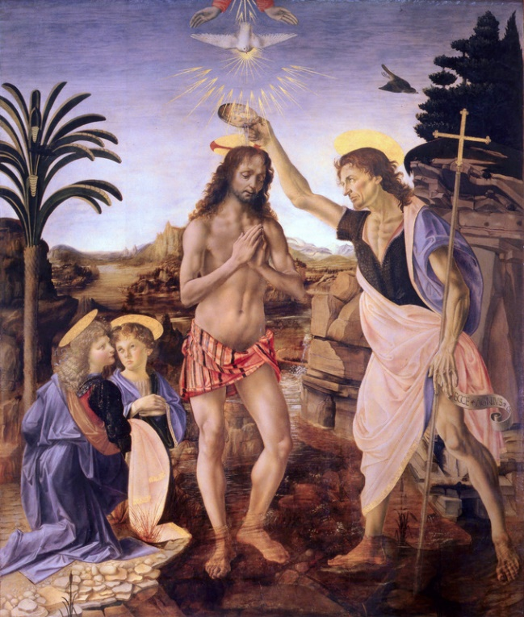
“And just as he was coming up out of the water, he saw the heavens torn apart and the Spirit descending like a dove on him. And a voice came from heaven, ‘You are my Son, the Beloved; with you I am well pleased.’ And the Spirit immediately drove him out into the wilderness.”
(Mark 1:10-12)

Minister: Rev. Jason Evans
First Free Methodist Church
2625 N. Center Rd.
Saginaw, Michigan 48603
Phone: (989) 799-2930
Email: saginawfmc@gmail.com
www.saginawfirstfmc.org

First Sunday of Lent
February 21, 2021

The mission of Saginaw First Free Methodist Church is to be faithful to God and to make known to all people everywhere God’s call to wholeness in Jesus Christ.

Prelude
**Greeting/Announcements
*Call to Worship (spoken responsively)
L: God has established a covenant with us
P: To you, O Lord, we fix our eyes
L: God is patient and loving, waiting for all to understand
P: We follow God in the way of righteousness
L: Jesus came, proclaiming the good news to all
P: We will lead the sinners in the way of salvation
L: Lead us in truth, show us your ways oh God
P: God teaches the humble in the way and we will follow

*Opening Hymn: “Hail to the Lord’s Anointed” Handout (vv.1-2)
Hail to the Lord's anointed, great David's greater Son
Hail in the time appointed, His reign on earth begun
He comes to break oppression, to set the captive free
To take away transgression, and rule in equity

He comes with comfort speedy to those who suffer wrong
To help the poor and needy, and bid the weak be strong
To give them songs for sighing, their darkness turn to light
Whose souls, condemned and dying, are precious in His sight

*Invocation and Lord’s Prayer
L: Gracious God, we come to you longing to know your ways and be guided by your Spirit. We want to grow in likeness of Christ Jesus, to learn and live a pleasing life to you. Direct us on your mission, let us respond to your instruction. Lead us in truth, as we pray the prayer that Jesus taught His disciples…

P: Our Father, who art in heaven, hallowed be Your name. Your kingdom come; your will be done in earth as it is in heaven. Give us this day our daily bread and forgive us our debts as we forgive our debtors. And lead us not into temptation but deliver us from evil. For Yours is the kingdom, and the power, and the glory forever. Amen.

*Gloria Patri
Glory be to the Father​
And to the Son and to the Holy Ghost.
As it was in the beginning​
Is now and ever shall be
World without end
Amen. Amen

Old Testament Scripture Lesson: Genesis 9:8-17
Then God said to Noah and to his sons with him, “As for me, I am establishing my covenant with you and your descendants after you, and with every living creature that is with you, the birds, the domestic animals, and every animal of the earth with you, as many as came out of the ark. I establish my covenant with you, that never again shall all flesh be cut off by the waters of a flood, and never again shall there be a flood to destroy the earth.”
God said, “This is the sign of the covenant that I make between me and you and every living creature that is with you, for all future generations: I have set my bow in the clouds, and it shall be a sign of the covenant between me and the earth. When I bring clouds over the earth and the bow is seen in the clouds, I will remember my covenant that is between me and you and every living creature of all flesh; and the waters shall never again become a flood to destroy all flesh.
When the bow is in the clouds, I will see it and remember the everlasting covenant between God and every living creature of all flesh that is on the earth.”
God said to Noah, “This is the sign of the covenant that I have established between me and all flesh that is on the earth.”

Prayer of Confession
L: God leads the humble in the way, teaches the humble what is right. All the paths of the Lord are steadfast love and faithfulness. But sometimes we don’t keep those decrees or that covenant. For our times of transgression, let us seek God’s forgiveness…

P: God in Christ, you the righteous suffered for the sin of the unrighteous, to bring all people to you. Yet sometimes fear and blindness keep us from keeping full covenant with you. Deeds that bring death are a habit for our society, so common we don’t even recognize their impact. Help us resist temptations and walk in obedience to your righteousness and truth. May we walk your paths with humility, trusting in your steadfast love. Amen.

Affirmation of Faith: Psalm 25
P: To you, O LORD, I lift up my soul. O my God, in you I trust; do not let me be put to shame; do not let my enemies exult over me. Do not let those who wait for you be put to shame; let them be ashamed who are wantonly treacherous. Make me to know your ways, O LORD; teach me your paths. Lead me in your truth, and teach me, for you are the God of my salvation; for you I wait all day long. Be mindful of your mercy, O LORD, and of your steadfast love, for they have been from of old. Do not remember the sins of my youth or my transgressions; according to your steadfast love remember me, for your goodness' sake, O LORD! Good and upright is the LORD; therefore God instructs sinners in the way. God leads the humble in what is right, and teaches the humble the way. All the paths of the LORD are steadfast love and faithfulness, for those who keep God’s covenant and decrees.

Hymn of Affirmation: “And Can It Be?” #225 (vv.1,3)
And can it be that I should gain
An int'rest in the Savior's blood
Died He for me, who caused His pain
For me, who Him to death pursued
Amazing love! how can it be
That Thou, my God, should die for me
Amazing love! how can it be
That Thou, my God, should die for me

Long my imprisoned spirit lay
Fast bound in sin and nature's night
Thine eye diffused a quick'ning ray
I woke, the dungeon flamed with light
My chains fell off, my heart was free
I rose, went forth and followed Thee
My chains fell off, my heart was free
I rose, went forth and followed Thee

New Testament Scripture Lesson: 1 Peter 3:18-22
For Christ also suffered for sins once for all, the righteous for the unrighteous, in order to bring you to God. He was put to death in the flesh, but made alive in the spirit, in which also he went and made a proclamation to the spirits in prison who in former times did not obey, when God waited patiently in the days of Noah, during the building of the ark, in which a few, that is, eight persons, were saved through water.
And baptism, which this prefigured, now saves you--not as a removal of dirt from the body, but as an appeal to God for a good conscience, through the resurrection of Jesus Christ, who has gone into heaven and is at the right hand of God, with angels, authorities, and powers made subject to him.
Passing of the Peace

Prayers of the People
L: Lord in Your Mercy…
P: Hear our prayer.

Gospel Lesson: Mark 1:9-15
In those days Jesus came from Nazareth of Galilee and was baptized by John in the Jordan. And just as he was coming up out of the water, he saw the heavens torn apart and the Spirit descending like a dove on him. And a voice came from heaven, “You are my Son, the Beloved; with you I am well pleased.”
And the Spirit immediately drove him out into the wilderness. He was in the wilderness forty days, tempted by Satan; and he was with the wild beasts; and the angels waited on him.
Now after John was arrested, Jesus came to Galilee, proclaiming the good news of God, and saying, “The time is fulfilled, and the kingdom of God has come near; repent, and believe in the good news.”

Sermon

Prayer of Response

Hymn of Response: “What a Friend We Have in Jesus” #625 (vv.1-2)
What a friend we have in Jesus
All our sins and griefs to bear
What a privilege to carry
Everything to God in prayer
Oh, what peace we often forfeit
Oh, what needless pain we bear
All because we do not carry
Everything to God in prayer

Have we trials and temptations?
Is there trouble anywhere?
We should never be discouraged
Take it to the Lord in prayer
Can we find a friend so faithful
Who will all our sorrows share?
Jesus knows our every weakness
Take it to the Lord in prayer

Invitation of Offering
L: Time has been fulfilled; the Kingdom of heaven has come. We are co-benefactors with God. Help build a covenant community, as we collect this morning’s tithes and offerings.

*Doxology
Praise God, from whom all blessings flow
Praise Him, all creatures here below
Praise Him above, ye heavenly host
Praise Father Son, and Holy Ghost.
Amen.

*Prayer

*Hymn: “The Solid Rock” #436 (vv.1,3)
My hope is built on nothing less
Than Jesus Christ, my righteousness
I dare not trust the sweetest frame
But wholly lean on Jesus’ name
On Christ, the solid Rock, I stand
All other ground is sinking sand
All other ground is sinking sand
His oath, His covenant, His blood
Support me in the whelming flood
When all around my soul gives way
He then is all my hope and stay
On Christ, the solid Rock, I stand
All other ground is sinking sand
All other ground is sinking sand

*Benediction
L: The Hope of the whole world is Christ, the solid rock. The kingdom is near, focus on sharing that with the whole world. We are children of God, beloved, blessed, and on mission. Proclaim the good news, as you go in peace to love and serve. Amen.

