Saginaw First Free Methodist Church
Transfiguration Sunday
February 14, 2021

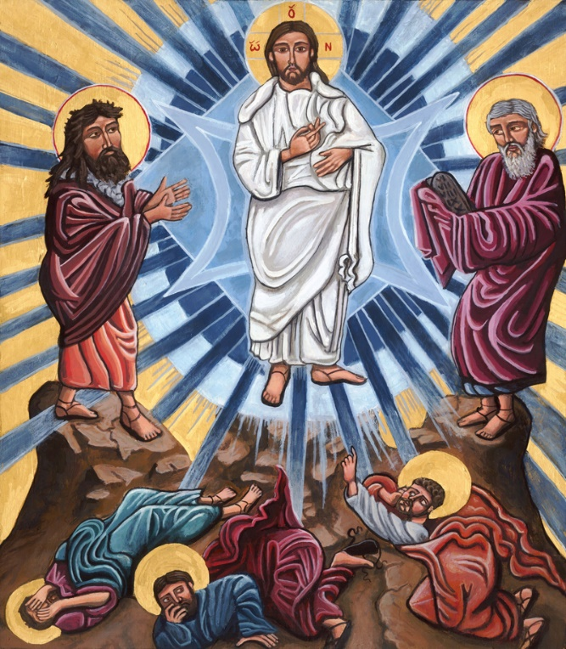
“And he was transfigured before them, and his clothes became dazzling white, such as no one on earth could bleach them. And there appeared to them Elijah with Moses, who were talking with Jesus.” (Mark 9:2b-4)

Minister: Rev. Jason Evans
First Free Methodist Church
2625 N. Center Rd.
Saginaw, Michigan 48603
Phone: (989) 799-2930
Email: saginawfmc@gmail.com
www.saginawfirstfmc.org

Transfiguration Sunday
February 14, 2021

The mission of Saginaw First Free Methodist Church is to be faithful to God and to make known to all people everywhere God’s call to wholeness in Jesus Christ.

Prelude
**Greeting/Announcements
*Call to Worship (spoken responsively)
L: God is glorious and greatly to be praised
P: We come to worship the creator of heaven and earth
L: God invites us to faithful covenant with our creator
P: We seek to abide with Christ through all storms of life
L: God is gathering the people from the four corners of the earth
P: We will respond as fishers of mankind
L: Seek a double portion of the prophet’s spirit
P: We will claim God’s vision for our lives

*Opening Hymn: “My Faith Looks Up to Thee” #433 (vv.1-2)
My faith looks up to thee
Thou Lamb of Calvary
Savior divine
Now hear me while I pray
Take all my guilt away
O let me from this day
Be wholly thine

May thy rich grace impart
Strength to my fainting heart
My zeal inspire
As thou hast died for me
O may my love to thee
Pure, warm, and changeless be
A living fire

*Invocation and Lord’s Prayer
L: Holy God, mighty and immortal, you are beyond our knowing. Yet we see your glory in the face of Jesus Christ, whose compassion illumines the world. Transform us into the likeness and of the love of Christ, who renewed our humanity so that we may share in his divinity. May we join in the same vision and mission of Jesus Christ, our Lord, as we pray the prayer that Jesus taught His disciples…

P: Our Father, who art in heaven, hallowed be Your name. Your kingdom come; your will be done in earth as it is in heaven. Give us this day our daily bread and forgive us our debts as we forgive our debtors. And lead us not into temptation but deliver us from evil. For Yours is the kingdom, and the power, and the glory forever. Amen.

*Gloria Patri
Glory be to the Father​
And to the Son and to the Holy Ghost.
As it was in the beginning​
Is now and ever shall be
World without end
Amen. Amen

Old Testament Scripture Lesson: 2 Kings 2:1-12
Now when the LORD was about to take Elijah up to heaven by a whirlwind, Elijah and Elisha were on their way from Gilgal. Elijah said to Elisha, “Stay here; for the LORD has sent me as far as Bethel.” But Elisha said, “As the LORD lives, and as you yourself live, I will not leave you.” So they went down to Bethel.
The company of prophets who were in Bethel came out to Elisha, and said to him, “Do you know that today the LORD will take your master away from you?” And he said, “Yes, I know; keep silent.”
Elijah said to him, “Elisha, stay here; for the LORD has sent me to Jericho.” But he said, “As the LORD lives, and as you yourself live, I will not leave you.” So they came to Jericho.
The company of prophets who were at Jericho drew near to Elisha, and said to him, “Do you know that today the LORD will take your master away from you?” And he answered, “Yes, I know; be silent.”
Then Elijah said to him, “Stay here; for the LORD has sent me to the Jordan.” But he said, “As the LORD lives, and as you yourself live, I will not leave you.” So the two of them went on.
Fifty men of the company of prophets also went, and stood at some distance from them, as they both were standing by the Jordan. Then Elijah took his mantle and rolled it up, and struck the water; the water was parted to the one side and to the other, until the two of them crossed on dry ground.
When they had crossed, Elijah said to Elisha, “Tell me what I may do for you, before I am taken from you.” Elisha said, “Please let me inherit a double share of your spirit.”
He responded, “You have asked a hard thing; yet, if you see me as I am being taken from you, it will be granted you; if not, it will not.”
As they continued walking and talking, a chariot of fire and horses of fire separated the two of them, and Elijah ascended in a whirlwind into heaven. Elisha kept watching and crying out, “Father, father! The chariots of Israel and its horsemen!” But when he could no longer see him, he grasped his own clothes and tore them in two pieces.

Prayer of Confession
L: The whirlwind of life can easily knock us off track of God’s mission. But God is faithful and just to cleanse us from any unrighteousness. God faithfully abides with us, intent on getting back on mission. Let those who are committed, profess…

P: Mighty God, Light of the world, who illuminates our minds by the Holy Spirit, we come humbly before you. Fear and distress cloud our minds, and our hearts can grow faint, and we lose our zeal. Our earthly strivings only create unneeded stress and strain on our minds and bodies. Breath into us the desire of heavenly peace. May your grace be a balm to our foolish ways. May we who listen to Christ, follow faithfully into the dark places where you send us. Inspire us to reveal the light of your gospel in this fallen world. Help us to abide with you eternally. Amen.

Affirmation of Faith: Psalm 50
P: The mighty one, God the LORD, speaks and summons the earth from the rising of the sun to its setting. Out of Zion, the perfection of beauty, God shines forth. Our God comes and does not keep silence, before God is a devouring fire, and a mighty tempest all around. God calls to the heavens above and to the earth, that God may judge the people: “Gather to me my faithful ones, who made a covenant with me by sacrifice!” The heavens declare God’s righteousness, for God himself is judge.

Hymn of Affirmation: “Dear Lord and Father of Mankind” #472 (vv.1,4)
Dear Lord and Father of mankind
Forgive our foolish ways
Reclothe us in our rightful mind
In purer lives thy service find
In deeper reverence, praise

Breathe through the heats of our desire
Thy coolness and thy balm
Let sense be dumb, let flesh retire
Speak through the earthquake, wind, and fire
O still, small voice of calm

New Testament Scripture Lesson: 2 Corinthians 4:3-6
And even if our gospel is veiled, it is veiled to those who are perishing. In their case the god of this world has blinded the minds of the unbelievers, to keep them from seeing the light of the gospel of the glory of Christ, who is the image of God.
For we do not proclaim ourselves; we proclaim Jesus Christ as Lord and ourselves as your slaves for Jesus’ sake. For it is the God who said, “Let light shine out of darkness,” who has shone in our hearts to give the light of the knowledge of the glory of God in the face of Jesus Christ.

Passing of the Peace

Prayers of the People
L: Lord in Your Mercy…
P: Hear our prayer.

Gospel Lesson: Mark 9:2-9
Six days later, Jesus took with him Peter and James and John, and led them up a high mountain apart, by themselves. And he was transfigured before them, and his clothes became dazzling white, such as no one on earth could bleach them. And there appeared to them Elijah with Moses, who were talking with Jesus.
Then Peter said to Jesus, “Rabbi, it is good for us to be here; let us make three dwellings, one for you, one for Moses, and one for Elijah.” He did not know what to say, for they were terrified.
Then a cloud overshadowed them, and from the cloud there came a voice, “This is my Son, the Beloved; listen to him!”
Suddenly when they looked around, they saw no one with them anymore, but only Jesus. As they were coming down the mountain, he ordered them to tell no one about what they had seen, until after the Son of Man had risen from the dead.

Sermon

Prayer of Response

Hymn of Response: “Be Thou My Vision” #460 (vv.1-3)
Be thou my vision, O Lord of my heart
Naught be all else to me, save that thou art
Thou my best thought, by day or by night
Waking or sleeping, thy presence my light

Be thou my wisdom, and thou my true word
I ever with thee and thou with me, Lord
Thou my great Father, and I thy true son
Thou in me dwelling and I with thee one

Riches I heed not, nor vain, empty praise
Thou mine inheritance, now and always
Thou and thou only first in my heart
High King of heaven, my treasure thou art

Invitation of Offering
L: God does not live in a temple or an altar. God is everywhere. To build to house God is feeble. Therefore, let us give for the benefit of people, the true temple of the Holy Spirit. Give for those in need, as we collect this morning’s tithes and offerings.

*Doxology
Praise God, from whom all blessings flow
Praise Him, all creatures here below
Praise Him above, ye heavenly host
Praise Father Son, and Holy Ghost.
Amen.

*Prayer

*Hymn: “For All the Saints” #685 (vv.1-2,5)
For all the saints
Who from their labors rest
Who Thee by faith
Before the world confessed
Thy Name, O Jesus
Be forever blessed
Alleluia, Alleluia

Thou wast their rock
Their fortress and their might
Thou, Lord, their captain
In the well fought fight
Thou, in the darkness
Drear, their one true Light
Alleluia, Alleluia

But lo! There breaks
A yet more glorious day
The saints triumphant
Rise in bright array
The King of glory
Passes on his way
Alleluia, Alleluia
*Benediction
L: God’s glory has been revealed to us through the Holy Spirit. We have become lights to the world; the gospel of Christ on display for all to see. Dedicate yourselves as prophets, as you go in peace to love and serve. Amen.

