Saginaw First Free Methodist Church
Tenth Sunday after Pentecost
August 9, 2020

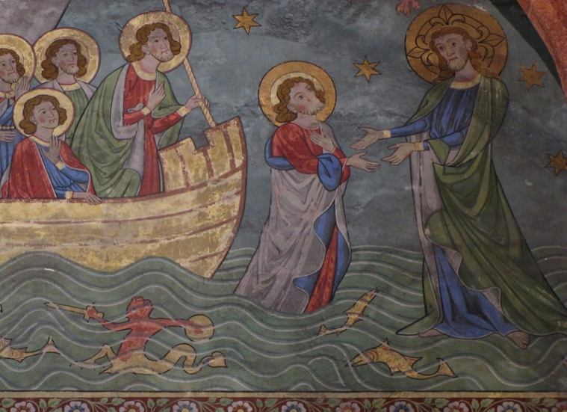
“But when he noticed the strong wind, he became frightened, and beginning to sink, he cried out, ‘Lord, save me!’ Jesus immediately reached out his hand and caught him, saying to him, ‘You of little faith, why did you doubt?’ When they got into the boat, the wind ceased.” (Matthew 14:30-32)

Minister: Jason Evans
First Free Methodist Church
2625 N. Center Rd.
Saginaw, Michigan 48603
Phone: (989) 799-2930
Email: saginawfmc@gmail.com
www.saginawfirstfmc.org

Tenth Sunday after Pentecost
August 9, 2020

The mission of Saginaw First Free Methodist Church is to be faithful to God and to make known to all people everywhere God’s call to wholeness in Jesus Christ.

Prelude
Greeting/Announcements
L: Do not fear, Christ is with us
P: Christ’s life has brought us together
L: The storms of life do not have the last word
P: Our hope keeps us from sinking
L: Let the hearts of all those who seek God rejoice
P: We will share with others God’s marvelous deeds

*Opening Hymn: “Rejoice, the Lord Is King” #276 (vv.1-4)
Rejoice, the Lord is King
Your Lord and King adore
Rejoice, give thanks, and sing
And triumph evermore
Lift up your heart, lift up your voice
Rejoice, again I say, rejoice!

Jesus, the Savior, reigns
The God of truth and love
When He had purged our stains
He took His seat above
Lift up your heart, lift up your voice
Rejoice, again I say, rejoice!

His kingdom cannot fail
He rules o’er earth and Heav’n
The keys of death and hell
Are to our Jesus giv’n
Lift up your heart, lift up your voice
Rejoice, again I say, rejoice!

Rejoice in glorious hope!
Our Lord, the Judge shall come
And take His servants up
To their eternal home
Lift up your heart, lift up your voice
Rejoice, again I say, rejoice!

*Invocation and Lord’s Prayer
L: Holy God, who holds all life together, we come to you in uncertain times. When we are not in control, and are at the mercy of life, fear overcomes us. We need you. We need to feel your presence, and recognize your Spirit is with us. Give us assurance, as we pray together the prayer that Jesus taught His disciples…

P: Our Father, who art in heaven, hallowed be Your name. Your kingdom come; your will be done in earth as it is in heaven. Give us this day our daily bread and forgive us our debts as we forgive our debtors. And lead us not into temptation but deliver us from evil. For Yours is the kingdom, and the power, and the glory forever. Amen.

Gloria Patri
Glory be to the Father​
And to the Son and to the Holy Ghost.
As it was in the beginning​
Is now and ever shall be
World without end
Amen. Amen

First Scripture Lesson: Genesis 37:1-4, 12-28

Jacob settled in the land where his father had lived as an alien, the land of Canaan. This is the story of the family of Jacob. Joseph, being seventeen years old, was shepherding the flock with his brothers; he was a helper to the sons of Bilhah and Zilpah, his father's wives; and Joseph brought a bad report of them to their father.

Now Israel loved Joseph more than any other of his children, because he was the son of his old age; and he had made him a long robe with sleeves. But when his brothers saw that their father loved him more than all his brothers, they hated him, and could not speak peaceably to him. Now his brothers went to pasture their father's flock near Shechem.

And Israel said to Joseph, “Are not your brothers pasturing the flock at Shechem? Come, I will send you to them.” He answered, “Here I am.”

So he said to him, “Go now, see if it is well with your brothers and with the flock; and bring word back to me.” So he sent him from the valley of Hebron. He came to Shechem, and a man found him wandering in the fields; the man asked him, “What are you seeking?”

“I am seeking my brothers,” he said; “tell me, please, where they are pasturing the flock.”

The man said, “They have gone away, for I heard them say, ‘Let us go to Dothan.’” So Joseph went after his brothers, and found them at Dothan.
They saw him from a distance, and before he came near to them, they conspired to kill him. They said to one another, “Here comes this dreamer. Come now, let us kill him and throw him into one of the pits; then we shall say that a wild animal has devoured him, and we shall see what will become of his dreams.”

But when Reuben heard it, he delivered him out of their hands, saying, “Let us not take his life.”

Reuben said to them, “Shed no blood; throw him into this pit here in the wilderness, but lay no hand on him” --that he might rescue him out of their hand and restore him to his father.

So when Joseph came to his brothers, they stripped him of his robe, the long robe with sleeves that he wore; and they took him and threw him into a pit. The pit was empty; there was no water in it. Then they sat down to eat; and looking up they saw a caravan of Ishmaelites coming from Gilead, with their camels carrying gum, balm, and resin, on their way to carry it down to Egypt.

Then Judah said to his brothers, “What profit is it if we kill our brother and conceal his blood? Come, let us sell him to the Ishmaelites, and not lay our hands on him, for he is our brother, our own flesh.” And his brothers agreed.

When some Midianite traders passed by, they drew Joseph up, lifting him out of the pit, and sold him to the Ishmaelites for twenty pieces of silver. And they took Joseph to Egypt.

Prayer of Confession
L: We profess our faith in God’s ways, yet we rely heavily on our own understanding. We say we believe, but our lives show confidence in man’s wisdom. For the times we treat others' lives like Joseph’s brothers treated him, let us confess…

P: God of grace, God of mercy, we confess that we are dreamers more intent on our own importance than on your vision of the world. We favor status and success over other’s wellbeing. We want to walk on water, but send the multitudes away to feed themselves. We want our comfort and security rather than reaching a helping hand to the poor. We want to rise above others and let you pull them up. Give us pardon, greater insight, and another chance to live in faithfulness. Amen.

Affirmation of Faith: Psalm 105
P: O give thanks to the LORD, call on God’s name, make known God’s deeds among the peoples. Sing to God, sing praises to God; tell of all God’s wonderful works. Glory in God’s holy name; let the hearts of those who seek the LORD rejoice. Seek the LORD and God’s strength; seek God’s presence continually. Remember the wonderful works God has done, God’s miracles, and the judgments God uttered.

New Testament Scripture Lesson: Romans 10:5-15

Moses writes concerning the righteousness that comes from the law, that “the person who does these things will live by them.”

But the righteousness that comes from faith says, “Do not say in your heart, ‘Who will ascend into heaven?’” (that is, to bring Christ down) “or ‘Who will descend into the abyss?’” (that is, to bring Christ up from the dead).

But what does it say? “The word is near you, on your lips and in your heart” (that is, the word of faith that we proclaim); because if you confess with your lips that Jesus is Lord and believe in your heart that God raised him from the dead, you will be saved.

For one believes with the heart and so is justified, and one confesses with the mouth and so is saved. The scripture says, “No one who believes in him will be put to shame.”

For there is no distinction between Jew and Greek; the same Lord is Lord of all and is generous to all who call on him. For, “Everyone who calls on the name of the Lord shall be saved.”

But how are they to call on one in whom they have not believed? And how are they to believe in one of whom they have never heard? And how are they to hear without someone to proclaim him? And how are they to proclaim him unless they are sent? As it is written, “How beautiful are the feet of those who bring good news!”

Passing of the Peace

Prayers of the People
L: Lord in Your Mercy…
P: Hear our prayer.

Gospel Lesson: Matthew 14:22-33
Immediately he made the disciples get into the boat and go on ahead to the other side, while he dismissed the crowds. And after he had dismissed the crowds, he went up the mountain by himself to pray. When evening came, he was there alone, but by this time the boat, battered by the waves, was far from the land, for the wind was against them.

And early in the morning he came walking toward them on the sea. But when the disciples saw him walking on the sea, they were terrified, saying, “It is a ghost!” And they cried out in fear.

But immediately Jesus spoke to them and said, “Take heart, it is I; do not be afraid.”

Peter answered him, “Lord, if it is you, command me to come to you on the water.”

He said, “Come.” So Peter got out of the boat, started walking on the water, and came toward Jesus. But when he noticed the strong wind, he became frightened, and beginning to sink, he cried out, “Lord, save me!”

Jesus immediately reached out his hand and caught him, saying to him, “You of little faith, why did you doubt?”

When they got into the boat, the wind ceased. And those in the boat worshiped him, saying, “Truly you are the Son of God.”

Sermon

Invitation of Offering
L: Like Joseph, we’ve been entrusted with the ruler’s possessions. We are only stewards of God’s wealth. We are not our possessions, our success, or our status. Give in Christ’s service, as we collect this morning’s tithes and offerings.

*Doxology

Prayer

Closing Hymn: “To God Be the Glory” #36 (vv.1,3)
To God be the glory, great things he hath done!
So loved he the world that he gave us his Son
Who yielded his life an atonement for sin
And opened the life-gate that all may go in
Praise the Lord, praise the Lord
Let the earth hear his voice
Praise the Lord, praise the Lord
Let the people rejoice
O come to the Father thru Jesus the Son
And give him the glory, great things he hath done!

Great things he hath taught us
Great things he hath done
And great our rejoicing thru Jesus the Son
But purer, and higher, and greater will be
Our wonder, our transport, when Jesus we see
Praise the Lord, praise the Lord
Let the earth hear his voice
Praise the Lord, praise the Lord
Let the people rejoice
O come to the Father thru Jesus the Son
And give him the glory, great things he hath done!

Benediction
L: Christ took on flesh to show God’s saving grace to all. It is in your flesh that we do all things through Christ. Advocate on behalf of the least of these. Carry on Christ’s mission into a frightened world, as you go in peace to love and serve. Amen.

