Saginaw First Free Methodist Church
Eleventh Sunday after Pentecost
August 8, 2021

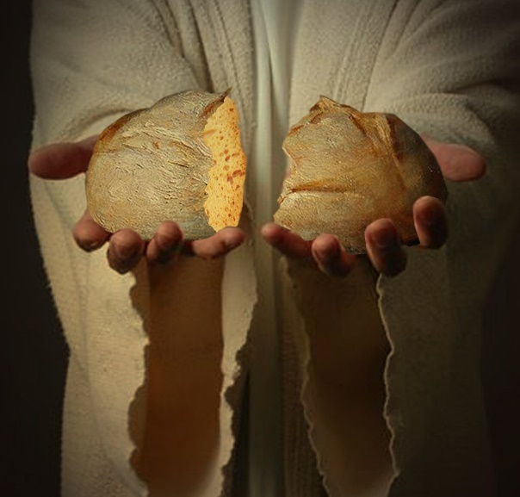
“Jesus said to them, ‘I am the bread of life. Whoever comes to me will never be hungry, and whoever believes in me will never be thirsty.’"
(John 6:35)

Minister: Rev. Jason Evans
First Free Methodist Church
2625 N. Center Rd.
Saginaw, Michigan 48603
Phone: (989) 799-2930
Email: saginawfmc@gmail.com
www.saginawfirstfmc.org

Proper 14 (19)
August 8, 2021

Prelude
**Greeting/Announcements
*Call to Worship (spoken responsively)
L: We behold the breaking dawn
P: The Light that shines over everyone
L: The earth awakes, your hope has come
P: We long for you, O Lord
L: Your name is a light in the darkness
P: Your name is the word of truth
L: O Lord, our Lord
P: How majestic is your name in all the earth

*Opening Hymn: “Praise to the Lord, the Almighty” #20 (vv. 1-4)
Praise to the Lord, the Almighty, the King of creation!
O my soul, praise him, for he is your health and salvation
All ye who hear; now to his temple draw near
Join me in glad adoration

Praise to the Lord, who o’er all things so wondrously reigneth
Shelters thee under His wings, yea, so gently sustaineth
Has thou not seen how thy desires all have been
Granted in what He ordaineth?

Praise to the Lord, who doth prosper thy work and defend thee
Surely His goodness and mercy here daily attend thee
Ponder anew, what the Almighty can do
If with His love he befriend thee

Praise to the Lord! O let all that is in me adore Him!
All that hath life and breath, come now with praises before Him
Let the amen sound from his people again
Gladly forever adore Him

*Invocation and Lord’s Prayer
L: God of power, may we desire you as the fullness of life and proclaim your saving deeds to all the world. Open our eyes, that we may see you in our neighbors. Open our ears, that we may hear the cries of the hungry, the abandoned, and the oppressed. Open our hearts, that we may love each other as you love us. Renew in us your spirit, and free us, make us one, as we pray the prayer that Jesus taught His disciples…

P: Our Father, who art in heaven, hallowed be Your name. Your kingdom come; your will be done in earth as it is in heaven. Give us this day our daily bread and forgive us our debts as we forgive our debtors. And lead us not into temptation but deliver us from evil. For Yours is the kingdom, and the power, and the glory forever. Amen.

*Gloria Patri
Glory be to the Father​
And to the Son and to the Holy Ghost.​
As it was in the beginning​
Is now and ever shall be.​
World without end. ​
Amen. Amen.​

First Scripture Lesson: 2 Samuel 18:5-9, 15, 31-33
The king ordered Joab and Abishai and Ittai, saying, “Deal gently for my sake with the young man Absalom.”
And all the people heard when the king gave orders to all the commanders concerning Absalom. So the army went out into the field against Israel; and the battle was fought in the forest of Ephraim. The men of Israel were defeated there by the servants of David, and the slaughter there was great on that day, twenty thousand men.
The battle spread over the face of all the country; and the forest claimed more victims that day than the sword. Absalom happened to meet the servants of David. Absalom was riding on his mule, and the mule went under the thick branches of a great oak. His head caught fast in the oak, and he was left hanging between heaven and earth, while the mule that was under him went on. And ten young men, Joab's armor-bearers, surrounded Absalom and struck him, and killed him.
Then the Cushite came; and the Cushite said, “Good tidings for my lord the king! For the LORD has vindicated you this day, delivering you from the power of all who rose up against you.”
The king said to the Cushite, “Is it well with the young man Absalom?” The Cushite answered, “May the enemies of my lord the king, and all who rise up to do you harm, be like that young man.”
The king was deeply moved, and went up to the chamber over the gate, and wept; and as he went, he said, “O my son Absalom, my son, my son Absalom! Would I had died instead of you, O Absalom, my son, my son!”

Prayer of Confession
L: God desires truth in the inward being, yet sometimes we do what is evil in God’s sight. Be washed and renewed, so our spirits may grow calm, our vision be clear, and our purpose be unified…

P: Loving you, O God, brings its own reward here on earth, as well as the eternal reward of heaven. And failure to love you, even when we can offer many excuses, brings its own punishment. By becoming mirrors of your love, by wearing the image of your likeness, and by allowing you to make us perfect, we can know the joy of heaven, even while abiding here on earth. Our consciences are sullied by our many sins; cleanse them, that we may reflect your infinite brightness. May we walk in the light, as you are in the light, that we may abide in fellowship with you always. Amen.

Affirmation of Faith: Psalm 130
P: Out of the depths I cry to you, O LORD. Lord, hear my voice! Let your ears be attentive to the voice of my supplications! If you, O LORD, should mark iniquities, Lord, who could stand? But there is forgiveness with you, so that you may be revered. I wait for the LORD, my soul waits, and in his word I hope; my soul waits for the Lord more than those who watch for the morning, more than those who watch for the morning. O Israel, hope in the LORD! For with the LORD there is steadfast love, and with him is great power to redeem. It is God who will redeem Israel from all its iniquities.

Hymn of Affirmation: “Breathe on Me, Breath of God” #302 (vv.1-4)
Breathe on me, Breath of God
Fill me with life anew
That I may love what Thou dost love
And do what Thou would do

Breathe on me, Breath of God
Until my heart is pure
Until with Thee, I will one will
To do and to endure

Breathe on me, Breath of God
Till I am wholly Thine
Until this earthly part of me
Glows with Thy fire divine

Breathe on me, Breath of God
So shall I never die
But live with Thee the perfect life
Of Thine eternity

Second Scripture Lesson: Ephesians 4:25-5:2
So then, putting away falsehood, let all of us speak the truth to our neighbors, for we are members of one another. Be angry but do not sin; do not let the sun go down on your anger, and do not make room for the devil.
Thieves must give up stealing; rather let them labor and work honestly with their own hands, so as to have something to share with the needy. Let no evil talk come out of your mouths, but only what is useful for building up, as there is need, so that your words may give grace to those who hear. And do not grieve the Holy Spirit of God, with which you were marked with a seal for the day of redemption.
Put away from you all bitterness and wrath and anger and wrangling and slander, together with all malice, and be kind to one another, tenderhearted, forgiving one another, as God in Christ has forgiven you. Therefore be imitators of God, as beloved children, and live in love, as Christ loved us and gave himself up for us, a fragrant offering and sacrifice to God.

Passing of the Peace

Prayers of the People
L: Lord in Your Mercy…
P: Hear our prayer.

Gospel Lesson: John 6:35, 41-51
Jesus said to them, “I am the bread of life. Whoever comes to me will never be hungry, and whoever believes in me will never be thirsty.”
Then the Jews began to complain about him because he said, “I am the bread that came down from heaven.”
They were saying, “Is not this Jesus, the son of Joseph, whose father and mother we know? How can he now say, ‘I have come down from heaven’?”
Jesus answered them, “Do not complain among yourselves. No one can come to me unless drawn by the Father who sent me; and I will raise that person up on the last day. It is written in the prophets, ‘And they shall all be taught by God.’ Everyone who has heard and learned from the Father comes to me.
Not that anyone has seen the Father except the one who is from God; he has seen the Father. Very truly, I tell you, whoever believes has eternal life. I am the bread of life. Your ancestors ate the manna in the wilderness, and they died. This is the bread that comes down from heaven, so that one may eat of it and not die. I am the living bread that came down from heaven. Whoever eats of this bread will live forever; and the bread that I will give for the life of the world is my flesh.”

Sermon

Prayer of Response

Hymn of Response: “Be Thou My Vision” #460 (vv.1-4)
Be thou my vision, O Lord of my heart
Naught be all else to me, save that thou art
Thou my best thought, by day or by night
Waking or sleeping, thy presence my light

Be thou my wisdom, and thou my true word
I ever with thee and thou with me, Lord
Thou my great Father, and I thy true son
Thou in me dwelling and I with thee one

Riches I heed not, nor vain, empty praise
Thou mine inheritance, now and always
Thou and thou only first in my heart
High King of heaven, my treasure thou art

High King of heaven, my victory won
May I reach heaven’s joys, bright morning sun
Heart of my own heart, whatever befall
Still be my vision, O ruler of all

Invitation of Offering
L: We have been given eternal life. Expand your hearts to receive the mercy you’ve been given, that, in turn, we may share God’s grace and mercy with others each moment of our lives. Give as love, as we collect this morning’s tithes and offerings.

*Doxology

*Prayer

*Closing Hymn: “To God Be the Glory” #36 (vv.1,3)
To God be the glory, great things he hath done!
So loved he the world that he gave us his Son
Who yielded his life an atonement for sin
And opened the life-gate that all may go in
Praise the Lord, praise the Lord
Let the earth hear his voice
Praise the Lord, praise the Lord
Let the people rejoice
O come to the Father thru Jesus the Son
And give him the glory, great things he hath done!

Great things he hath taught us
Great things he hath done
And great our rejoicing thru Jesus the Son
But purer, and higher, and greater will be
Our wonder, our transport, when Jesus we see
Praise the Lord, praise the Lord
Let the earth hear his voice
Praise the Lord, praise the Lord
Let the people rejoice
O come to the Father thru Jesus the Son
And give him the glory, great things he hath done!

*Benediction
L: We are designed to pursue the enjoyment of God, in time and in eternity. Let every affection, thought, work, and action be to this end. Love all of creation, as it leads to the creator, as you go in peace to love and serve. Amen.

