Saginaw First Free Methodist Church
Twelfth Sunday after Pentecost
August 23, 2020

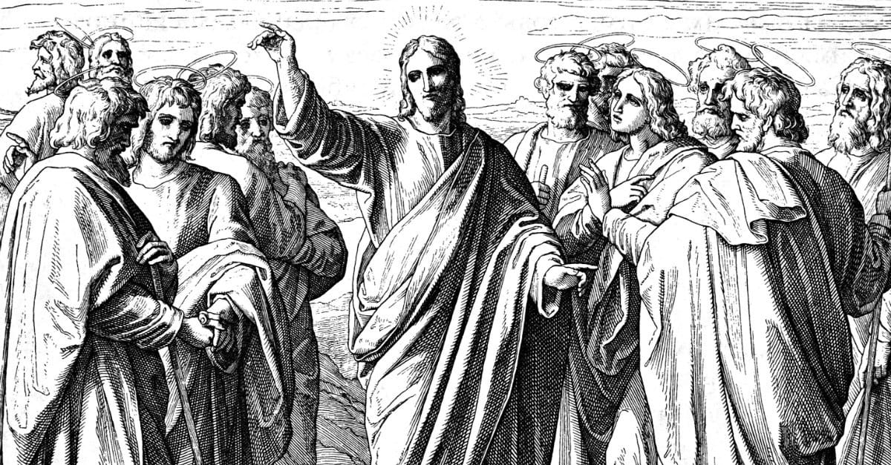
“Then he sternly ordered the disciples not to tell anyone that he was the Messiah.” (Matthew 16:20)

Minister: Rev. Jason Evans
First Free Methodist Church
2625 N. Center Rd.
Saginaw, Michigan 48603
Phone: (989) 799-2930
Email: saginawfmc@gmail.com
www.saginawfirstfmc.org

Twelfth Sunday after Pentecost
August 23, 2020

The mission of Saginaw First Free Methodist Church is to be faithful to God and to make known to all people everywhere God’s call to wholeness in Jesus Christ.

Prelude
Greeting/Announcements
L: Our help comes from God, who made heaven and earth
P: If God was not for us, we would be swept away
L: God has gifted each of us in unique ways
P: We rejoice in God’s love and faithfulness
L: Come and remember that God’s covenant is forever
P: God is bringing all people and all things to resurrection

*Opening Hymn: “Immortal, Invisible, God Only Wise” #65 (vv.1-3)
Immortal, invisible, God only wise
In light inaccessible hid from our eyes
Most blessed, most glorious, the Ancient of Days
Almighty, victorious, thy great name we praise

Unresting, unhasting, and silent as light
Nor wanting, nor wasting, thou rulest in might
Thy justice like mountains high soaring above
Thy clouds which are fountains of goodness and love

To all, life Thou givest, to both great and small
In all life Thou livest, the true life of all
Thy wisdom so boundless, Thy mercy so free
Eternal Thy goodness, for naught changeth Thee

*Invocation and Lord’s Prayer
L: God beyond our knowing, you provide for humble people who seek after your justice. People in power seek their own fame; and are pretentious and proud. You have provided a way to escape those under oppression. Your love never fails. Come and transform us, work within us and renew our minds. Help us build your diverse community, as we pray together the prayer that Jesus taught His disciples…

P: Our Father, who art in heaven, hallowed be Your name. Your kingdom come; your will be done in earth as it is in heaven. Give us this day our daily bread and forgive us our debts as we forgive our debtors. And lead us not into temptation but deliver us from evil. For Yours is the kingdom, and the power, and the glory forever. Amen.

Gloria Patri
Glory be to the Father​
And to the Son and to the Holy Ghost.
As it was in the beginning​
Is now and ever shall be
World without end
Amen. Amen

First Scripture Lesson: Exodus 1:8-2:10
Now a new king arose over Egypt, who did not know Joseph. He said to his people, “Look, the Israelite people are more numerous and more powerful than we. Come, let us deal shrewdly with them, or they will increase and, in the event of war, join our enemies and fight against us and escape from the land.”

Therefore they set taskmasters over them to oppress them with forced labor. They built supply cities, Pithom and Rameses, for Pharaoh. But the more they were oppressed, the more they multiplied and spread, so that the Egyptians came to dread the Israelites. The Egyptians became ruthless in imposing tasks on the Israelites, and made their lives bitter with hard service in mortar and brick and in every kind of field labor. They were ruthless in all the tasks that they imposed on them.

The king of Egypt said to the Hebrew midwives, one of whom was named Shiphrah and the other Puah, “When you act as midwives to the Hebrew women, and see them on the birthstool, if it is a boy, kill him; but if it is a girl, she shall live.”

But the midwives feared God; they did not do as the king of Egypt commanded them, but they let the boys live. So the king of Egypt summoned the midwives and said to them, “Why have you done this, and allowed the boys to live?”

The midwives said to Pharaoh, “Because the Hebrew women are not like the Egyptian women; for they are vigorous and give birth before the midwife comes to them.”

So God dealt well with the midwives; and the people multiplied and became very strong. And because the midwives feared God, he gave them families. Then Pharaoh commanded all his people, “Every boy that is born to the Hebrews you shall throw into the Nile, but you shall let every girl live.”

Now a man from the house of Levi went and married a Levite woman. The woman conceived and bore a son; and when she saw that he was a fine baby, she hid him three months. When she could hide him no longer, she got a papyrus basket for him, and plastered it with bitumen and pitch; she put the child in it and placed it among the reeds on the bank of the river.

His sister stood at a distance, to see what would happen to him. The daughter of Pharaoh came down to bathe at the river, while her attendants walked beside the river. She saw the basket among the reeds and sent her maid to bring it.

When she opened it, she saw the child. He was crying, and she took pity on him, “This must be one of the Hebrews’ children,” she said.

Then his sister said to Pharaoh's daughter, “Shall I go and get you a nurse from the Hebrew women to nurse the child for you?”

Pharaoh's daughter said to her, “Yes.” So the girl went and called the child’s mother.

Pharaoh's daughter said to her, “Take this child and nurse it for me, and I will give you your wages.” So the woman took the child and nursed it.

When the child grew up, she brought him to Pharaoh's daughter, and she took him as her son. She named him Moses, “because,” she said, “I drew him out of the water.”

Prayer of Confession
L: Seeing the horrors of oppression by the pharaohs of Egypt, we can see our own privileged positions. Like ancient rulers, we enjoy the fruits of others’ hard labor. Our indifference builds a wall between us and God. For our need of understanding, let us confess…

P: God of justice and righteousness, we often don’t understand how structures oppress others, yet provide advantage for ourselves. We think we are poor when we do not have everything we want. We put up barriers to maintain our wealth at the expense of others. We ignore others who are being abused as we are comforted by that injustice. We are tempted to conform to these worldly systems, and defend them for our own gain. Teach us Jesus’s higher model of sacrifice. Amen.

Affirmation of Faith: Psalm 124
P: If it had not been the LORD who was on our side, let us now say, if it had not been the LORD who was on our side, when our enemies attacked us, then they would have swallowed us up alive, when their anger was kindled against us; then the flood would have swept us away, the torrent would have gone over us; then over us would have gone the raging waters. Blessed be the LORD, who has not given us as prey to their teeth. We have escaped like a bird from the snare of the fowlers; the snare is broken, and we have escaped. Our help is in the name of the LORD, who made heaven and earth.

*Hymn of Affirmation: “When I Survey the Wondrous Cross” #239 (vv.1-2)
When I survey the wondrous cross
On which the Prince of glory died
My richest gain I count but loss
And pour contempt on all my pride

Forbid it, Lord, that I should boast
Save in the death of Christ, my God!
All the vain things that charm me most
I sacrifice them to his blood

New Testament Scripture Lesson: Romans 12:1-8
I appeal to you therefore, brothers and sisters, by the mercies of God, to present your bodies as a living sacrifice, holy and acceptable to God, which is your spiritual worship. Do not be conformed to this world, but be transformed by the renewing of your minds, so that you may discern what is the will of God--what is good and acceptable and perfect. For by the grace given to me I say to everyone among you not to think of yourself more highly than you ought to think, but to think with sober judgment, each according to the measure of faith that God has assigned.

For as in one body we have many members, and not all the members have the same function, so we, who are many, are one body in Christ, and individually we are members one of another. We have gifts that differ according to the grace given to us: prophecy, in proportion to faith; ministry, in ministering; the teacher, in teaching; the exhorter, in exhortation; the giver, in generosity; the leader, in diligence; the compassionate, in cheerfulness.

Special Music: Micki Marin

Passing of the Peace

Prayers of the People
L: Lord in Your Mercy…
P: Hear our prayer.

Gospel Lesson: Matthew 16:13-20
Now when Jesus came into the district of Caesarea Philippi, he asked his disciples, “Who do people say that the Son of Man is?”

And they said, “Some say John the Baptist, but others Elijah, and still others Jeremiah or one of the prophets.”

He said to them, “But who do you say that I am?”

Simon Peter answered, “You are the Messiah, the Son of the living God.”

And Jesus answered him, “Blessed are you, Simon son of Jonah! For flesh and blood has not revealed this to you, but my Father in heaven. And I tell you, you are Peter, and on this rock I will build my church, and the gates of Hades will not prevail against it. I will give you the keys of the kingdom of heaven, and whatever you bind on earth will be bound in heaven, and whatever you loose on earth will be loosed in heaven.”

Then he sternly ordered the disciples not to tell anyone that he was the Messiah.

Sermon

Prayer of Response

Hymn of Response: “Come Thou Fount” #51 (vv.1,3)
Come, thou Fount of every blessing
Tune my heart to sing thy grace
Streams of mercy, never ceasing
Call for songs of loudest praise
Teach me some melodious sonnet
Sung by flaming tongues above
Praise the mount I'm fixed upon it
Mount of God’s unchanging love

Oh, to grace how great a debtor
Daily I'm constrained to be
Let that grace, now like a fetter
Bind my yielded heart to Thee
Let me know Thee in Thy fullness
Guide me by Thy mighty hand
Till transformed in Thine own image
In Thy presence I shall stand

Invitation of Offering
L: We are called to care for those whose lives are on the line, as Moses’ was. We are privileged and able to supply the needs of others, like Pharaoh's daughter. Use your wealth and status to care for the world, as we collect this morning’s tithes and offerings.

*Doxology
Praise God, from whom all blessings flow
Praise Him, all creatures here below
Praise Him above, ye heavenly host
Praise Father Son, and Holy Ghost.
Amen.

Prayer

Closing Hymn: “All the Way My Savior Leads Me” #559 (vv.1,3)
All the way my Savior leads me
What have I to ask beside?
Can I doubt His tender mercy
Who through life has been my Guide
Heav’nly peace, divinest comfort
Here by faith in Him to dwell
For I know, whate’er befall me
Jesus doeth all things well
For I know, whate’er befall me
Jesus doeth all things well

All the way my Savior leads me
Oh, the fullness of His love
Perfect rest to me is promised
In my Father’s house above
When my spirit, clothed immortal
Wings its flight to realms of day
This my song through endless ages
Jesus led me all the way
This my song through endless ages
Jesus led me all the way
Benediction
L: In Christ we are all one body, and there are no enemies. God calls us into community with every human being. Serve the world as people transformed by God. Use your gifts and energy for the world, as you go in peace to love and serve. Amen.

