First Free Methodist Church of Saginaw
Eleventh Sunday after Pentecost
August 21, 2022

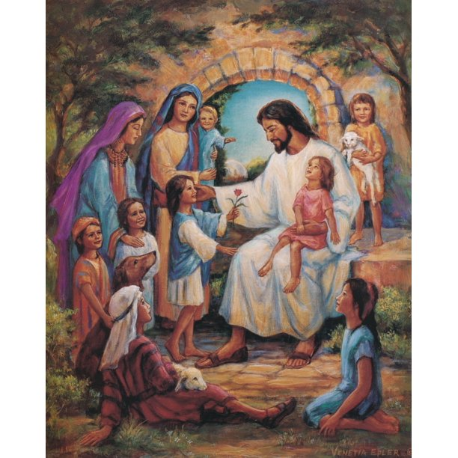
“And ought not this woman, a daughter of Abraham whom Satan bound for eighteen long years, be set free from this bondage on the sabbath day?" (Luke 13:16)

Minister: Rev. Jason Evans
First Free Methodist Church
2625 N. Center Rd.
Saginaw, Michigan 48603
Phone: (989) 799-2930
Email: saginawfmc@gmail.com
www.saginawfirstfmc.org

PROPER 16 (21)
August 21, 2022

Prelude
**Greeting/Announcements
*Call to Worship (spoken responsively)
L: Bless the LORD, O my soul
P: Who redeems your life from the Pit
L: The LORD is merciful and gracious
P: Slow to anger and abounding in steadfast love
L: The LORD works vindication
P: Justice for all who are oppressed
L: The lord satisfies you with good as long as you live
P: So that the people’s youth is renewed like the eagle’s

*Opening Hymn: “Praise to the Lord, the Almighty” #20 (vv.1-4)
Praise to the Lord, the Almighty, the King of creation!
O my soul, praise him, for he is your health and salvation
All ye who hear; now to his temple draw near
Join me in glad adoration

Praise to the Lord, who o’er all things so wondrously reigneth
Shelters thee under His wings, yea, so gently sustaineth
Has thou not seen how thy desires all have been
Granted in what He ordaineth?

Praise to the Lord, who doth prosper thy work and defend thee
Surely His goodness and mercy here daily attend thee
Ponder anew, what the Almighty can do
If with His love he befriend thee

Praise to the Lord! O let all that is in me adore Him!
All that hath life and breath, come now with praises before Him
Let the amen sound from his people again
Gladly forever adore Him

*Invocation and Lord’s Prayer
L: Grant, O merciful God, that your church, being gathered together in unity by your Holy Spirit, may show forth your power among all peoples, to the glory of your Name. Let the whole world see and know that things which were cast down are being raised up, things which had grown old are being made new, and that all things are being brought to their perfection by him through whom all things were made, as we pray the prayer that Jesus taught His disciples…

P: Our Father, who art in heaven, hallowed be Your name. Your kingdom come; your will be done in earth as it is in heaven. Give us this day our daily bread and forgive us our debts as we forgive our debtors. And lead us not into temptation but deliver us from evil. For Yours is the kingdom, and the power, and the glory forever. Amen.

*Gloria Patri
Glory be to the Father​
And to the Son and to the Holy Ghost.​
As it was in the beginning​
Is now and ever shall be.​
World without end. ​
Amen. Amen.​

First Scripture Lesson: Jeremiah 1:4-10
Now the word of the LORD came to me saying, “Before I formed you in the womb I knew you, and before you were born I consecrated you; I appointed you a prophet to the nations.”
Then I said, “Ah, Lord GOD! Truly I do not know how to speak, for I am only a boy.”
But the LORD said to me, “Do not say, ‘I am only a boy’; for you shall go to all to whom I send you, and you shall speak whatever I command you. Do not be afraid of them, for I am with you to deliver you, says the LORD.”
Then the LORD put out his hand and touched my mouth; and the LORD said to me, “Now I have put my words in your mouth. See, today I appoint you over nations and over kingdoms, to pluck up and to pull down, to destroy and to overthrow, to build and to plant.”

Prayer of Confession
L: Lord, by your grace, enlighten our understanding, strengthen our will, purify our hearts, and make us holy...

P: My Lord God, I have no idea where I am going. I do not see the road ahead of me. I cannot know where it will end. Nor do I really know myself, and the fact that I think I am following your will does not mean I am actually doing so. But I believe that the desire to please you does in fact please you. And I hope I have that desire in all I am doing. I hope that I will never do anything apart from that desire. And I know that if I do this, you will lead me by the right road, though I may know nothing about it. Therefore, I will trust you always, though I may seem to be lost in the shadow of death. I will not fear, for you are ever with me, and you will never leave me to face my perils alone. Amen.

Affirmation of Faith: Psalm 71
P: In you, O LORD, I take refuge; let me never be put to shame. In your righteousness deliver me and rescue me; incline your ear to me and save me. Be to me a rock of refuge, a strong fortress, to save me, for you are my rock and my fortress. Rescue me, O my God, from the hand of the wicked, from the grasp of the unjust and cruel. For you, O Lord, are my hope, my trust, O LORD, from my youth. Upon you I have leaned from my birth; it was you who took me from my mother's womb. My praise is continually of you.

Hymn of Affirmation: “Come Thou Fount of Every Blessing” #51 (vv.1-3)
Come, thou Fount of every blessing
Tune my heart to sing thy grace
Streams of mercy, never ceasing
Call for songs of loudest praise
Teach me some melodious sonnet
Sung by flaming tongues above
Praise the mount I'm fixed upon it
Mount of God’s unchanging love

Here I raise my Ebenezer
Hither by thy help I've come
And I hope, by thy good pleasure
Safely to arrive at home
Jesus sought me when a stranger
Wandering from the fold of God
He, to rescue me from danger
Interposed His precious blood

Oh, to grace how great a debtor
Daily I'm constrained to be
Let that grace, now like a fetter
Bind my yielded heart to Thee
Let me know Thee in Thy fullness
Guide me by Thy mighty hand
Till transformed in Thine own image
In Thy presence I shall stand

Second Scripture Lesson: Hebrews 12:18-29
You have not come to something that can be touched, a blazing fire, and darkness, and gloom, and a tempest, and the sound of a trumpet, and a voice whose words made the hearers beg that not another word be spoken to them.
For they could not endure the order that was given, “If even an animal touches the mountain, it shall be stoned to death.” Indeed, so terrifying was the sight that Moses said, “I tremble with fear.”
But you have come to Mount Zion and to the city of the living God, the heavenly Jerusalem, and to innumerable angels in festal gathering, and to the assembly of the firstborn who are enrolled in heaven, and to God the judge of all, and to the spirits of the righteous made perfect, and to Jesus, the mediator of a new covenant, and to the sprinkled blood that speaks a better word than the blood of Abel.
See that you do not refuse the one who is speaking; for if they did not escape when they refused the one who warned them on earth, how much less will we escape if we reject the one who warns from heaven! At that time his voice shook the earth; but now he has promised, “Yet once more I will shake not only the earth but also the heaven.”
This phrase, “Yet once more,” indicates the removal of what is shaken, that is, created things--so that what cannot be shaken may remain. Therefore, since we are receiving a kingdom that cannot be shaken, let us give thanks, by which we offer to God an acceptable worship with reverence and awe; for indeed our God is a consuming fire.

Baptism

Children’s Sermon

Passing of the Peace

Prayers of the People
L: Lord in Your Mercy…
P: Hear our prayer.

Gospel Lesson: Luke 13:10-17
Now he was teaching in one of the synagogues on the sabbath. And just then there appeared a woman with a spirit that had crippled her for eighteen years. She was bent over and was quite unable to stand up straight.
When Jesus saw her, he called her over and said, “Woman, you are set free from your ailment.”
When he laid his hands on her, immediately she stood up straight and began praising God. But the leader of the synagogue, indignant because Jesus had cured on the sabbath, kept saying to the crowd, “There are six days on which work ought to be done; come on those days and be cured, and not on the sabbath day.”
But the Lord answered him and said, “You hypocrites! Does not each of you on the sabbath untie his ox or his donkey from the manger, and lead it away to give it water? And ought not this woman, a daughter of Abraham whom Satan bound for eighteen long years, be set free from this bondage on the sabbath day?”
When he said this, all his opponents were put to shame; and the entire crowd was rejoicing at all the wonderful things that he was doing.

Sermon

Prayer of Response

Hymn of Response: “O, How I Love Jesus” #137 (vv.1-4)
There is a name I love to hear
I love to sing its worth
It sounds like music in my ear
The sweetest name on earth
O how I love Jesus, O how I love Jesus,
O how I love Jesus, because he first loved me!

It tells me of a Savior's love
Who died to set me free
It tells me of his precious blood
The sinner's perfect plea
O how I love Jesus, O how I love Jesus,
O how I love Jesus, because he first loved me!

It tells me what my Father hath
In store for every day
And tho’ I tread a dark-some path
Yields sunshine all the way
O how I love Jesus, O how I love Jesus,
O how I love Jesus, because he first loved me!

It tells of one whose loving heart
Can feel my deepest woe
Who in each sorrow bears a part
That none can bear below
O how I love Jesus, O how I love Jesus,
O how I love Jesus, because he first loved me!

Invitation of Offering
L: He who supplies seed to the sower and bread for food will supply and multiply your seed for sowing and increase the harvest of your righteousness. You will be enriched in every way for your great generosity. Give with thanksgiving, as we collect this morning’s tithes and offerings.

*Doxology
Praise God, from whom all blessings flow
Praise Him, all creatures here below
Praise Him above, ye heavenly host
Praise Father Son, and Holy Ghost
Amen

*Prayer

Bolivia: Leaders from Chile started FM work in Bolivia. The church in Santa Cruz now has about 100 members. A church plant outside Santa Cruz has about 20. The Chilean Conference continues to develop the work in Bolivia under the area director’s leadership. Medical Dr. Teresa Saravia is the new mission district leader. Juan Carlos Rodriguez and Yaneth Aguirre are relocating from Mexico to Bolivia to mentor Dr. Teresa and support the growing church.
The prayer needs for the Bolivian church include the development of healthy leaders, multiplication of committed disciples, and empowerment of transformation churches. Dr. Teresa Saravia looks for wisdom and strength as she leads the new mission district and pastors the local church. Juan Carlos and Yaneth’s relocation and missions support needs are met.

*Closing Hymn: “Now Thank We All our God” #766 (vv.1-3)
Now thank we all our God
With heart and hands and voices
Who wondrous things has done
In whom his world rejoices
Who from our mothers’ arms
Has blessed us on our way
With countless gifts of love
And still is ours today

O may this bounteous God
Through all our life be near us
With ever joyful hearts
And blessed peace to cheer us
And keep us in his grace
And guide us when perplexed
And free us from all ills
In this world in the next

All praise and thanks to God
The Father now be given
The Son and Him who reigns
With them in highest heaven
The one eternal God
Whom earth and heaven adore
For thus it was, is now
And shall be evermore
*Benediction
L: Blessed be the Father of mercies and the God of all consolation. Blessed be Christ who bore all our sorrows. And blessed be the Spirit that empowers us to console those who are in any affliction. Share these blessings as you go in peace to love and serve. Amen.

