First Free Methodist Church of Saginaw
Eleventh Sunday after Pentecost
August 13, 2023

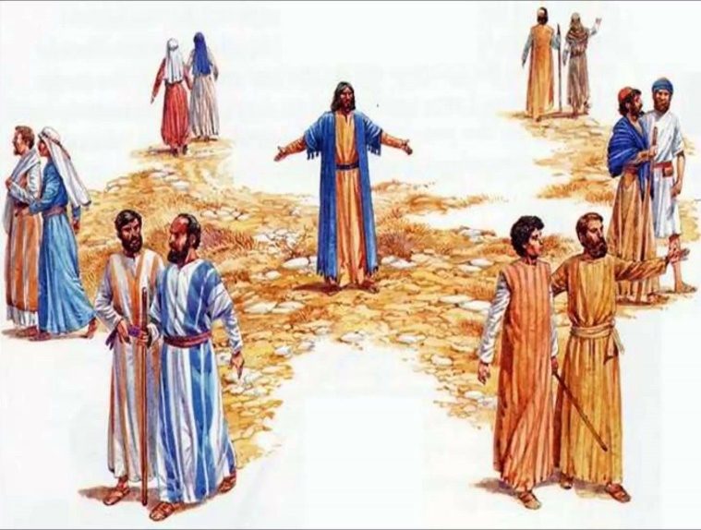
“The harvest is plentiful, but the laborers are few; therefore ask the Lord of the harvest to send out laborers into his harvest."
(Luke 10:02)

Minister: Rev. Jason Evans
First Free Methodist Church
2625 N. Center Rd.
Saginaw, Michigan 48603
Phone: (989) 799-2930
Email: saginawfmc@gmail.com
www.saginawfirstfmc.org

Eleventh Sunday after Pentecost
August 13, 2023

L: O come, let us sing to the Lord
P: Let us make a joyful noise to the rock of our salvation!
L: O come, let us worship and bow down
P: Let us kneel before the Lord, our Maker!
L: For the Lord is a great God
P: A great King above all gods

*Opening Song: “God of Wonders”
Lord of all creation
Of water earth and sky
The heavens are Your Tabernacle
Glory to the Lord on high

God of wonders beyond our galaxy
You are Holy, Holy
The universe declares Your Majesty
And You are Holy Holy
Lord of Heaven and Earth
Lord of Heaven and Earth

Early in the morning
I will celebrate the light
When I stumble in the darkness
I will call Your Name by night

God of wonders beyond our galaxy
You are Holy, Holy
The universe declares Your Majesty
And You are Holy Holy
Lord of Heaven and Earth
Lord of Heaven and Earth

Hallelujah to the Lord of heaven and earth (3X)

God of wonders, beyond our galaxy
You are holy, holy
Precious Lord, reveal Your heart to me
Father holy, holy
The universe declares Your majesty
You are holy, holy, holy, holy
Hallelujah to the Lord of heaven and earth

Congregational Song: “How Great is Our God”
The splendor of a King
Clothed in majesty
Let all the earth rejoice
All the earth rejoice

He wraps Himself in light
And darkness tries to hide
And trembles at His voice
Trembles at His voice

How great is our God
Sing with me
How great is our God
And all will see
How great, how great is our God

Age to age He stands
And time is in His hands
Beginning and the end
Beginning and the end

The Godhead Three in One
Father, Spirit, Son
The Lion and the Lamb
The Lion and the Lamb

How great is our God
Sing with me
How great is our God
And all will see
How great, how great is our God

Name above all names
Worthy of our praise
My heart will sing
How great is our God

Name above all names
You are worthy of our praise
And my heart will sing
How great is our God

How great is our God
Sing with me
How great is our God
And all will see
How great, how great is our God

*Invocation and Lord’s Prayer
L: Grant, O merciful God, that your church, being gathered together in unity by your Holy Spirit, may show forth your power among all peoples, to the glory of your Name. Let the whole world see and know that things which were cast down are being raised up, things which had grown old are being made new, and that all things are being brought to their perfection by him through whom all things were made, as we pray the prayer that Jesus taught His disciples…

P: Our Father, who art in heaven, hallowed be Your name. Your kingdom come; your will be done in earth as it is in heaven. Give us this day our daily bread and forgive us our debts as we forgive our debtors. And lead us not into temptation but deliver us from evil. For Yours is the kingdom, and the power, and the glory forever. Amen.

*Gloria Patri
Glory be to the Father​
And to the Son and to the Holy Ghost​
As it was in the beginning​
Is now and ever shall be
World without end
Amen. Amen.​

*Congregational Reading: Psalm 105
P: O give thanks to the LORD, call on his name, make known his deeds among the peoples. Sing to him, sing praises to him; tell of all his wonderful works. Glory in his holy name; let the hearts of those who seek the LORD rejoice. Seek the LORD and his strength; seek his presence continually. Remember the wonderful works he has done, his miracles, and the judgments he uttered, O offspring of his servant Abraham, children of Jacob, his chosen ones.
Passing of the Peace

Announcements

Children’s Sermon

Gospel Lesson: Luke 10:1-9
After this the Lord appointed seventy-two others and sent them on ahead of him in pairs to every town and place where he himself intended to go. He said to them, “The harvest is plentiful, but the laborers are few; therefore ask the Lord of the harvest to send out laborers into his harvest. Go on your way; I am sending you out like lambs into the midst of wolves. Carry no purse, no bag, no sandals, and greet no one on the road.
Whatever house you enter, first say, ‘Peace to this house!’ And if a person of peace is there, your peace will rest on that person, but if not, it will return to you. Remain in the same house, eating and drinking whatever they provide, for the laborer deserves to be paid. Do not move about from house to house. Whenever you enter a town and its people welcome you, eat what is set before you; cure the sick who are there, and say to them, ‘The kingdom of God is at hand for you.

Sermon: “Begin with Prayer”

Prayers of the People
L: Lord in Your Mercy…
P: Hear our prayer.

Hymn of Response: “All Creatures of Our God and King” #77
All creatures of our God and King
Lift up your voice and with us sing
Alleluia, Alleluia!
Thou burning sun with golden beam
Thou silver moon with softer gleam
O praise him, O praise him
Alleluia, Alleluia, Alleluia!

Thou rushing wind that art so strong
Ye clouds that sail in heav'n along
O praise him, Alleluia!
Thou rising morn, in praise rejoice
Ye lights of evening, find a voice
O praise him, O praise him
Alleluia, Alleluia, Alleluia!

And all ye men of tender heart
Forgiving others, take your part
O sing ye, Alleluia!
Ye who long pain and sorrow bear
Praise God and on Him cast your care
O praise him, O praise him
Alleluia, Alleluia, Alleluia!

Let all things their Creator bless
And worship him in humbleness
O praise him, Alleluia!
Praise, praise the Father, praise the Son
And praise the Spirit, three in one
O praise him, O praise him
Alleluia, Alleluia, Alleluia!

Invitation of Offering
L: He who supplies seed to the sower and bread for food will supply and multiply your seed for sowing and increase the harvest of your righteousness. Be enriched in generosity, as we collect this morning’s tithes and offerings.

*Doxology

*Prayer

*Closing Hymn: “Open the Eyes of My Heart, Lord”
Open the Eyes of My Heart, Lord
Open the Eyes of My Heart
I want to see You
I want to see You
Open the Eyes of My Heart, Lord
Open the Eyes of My Heart
I want to see You
I want to see You

To see you High and Lifted Up
Shining in the light of Your glory
Pour out Your power and love
As we sing, “Holy, Holy, Holy”
To see you high and lifted up
Shining in the light of Your glory
Pour out your power and love
As we sing, “Holy, Holy, Holy”

Holy, holy, holy
Holy, holy, holy
You are holy, holy, holy
I want to see You

Holy, holy, holy
Holy, holy, holy
Holy, holy, holy
I want to see You

*Benediction
L: Blessed be the Father of mercies and the God of all consolation. Blessed be Christ who bore all our sorrows. And blessed be the Spirit that empowers us to console those who are in any affliction. Share these blessings as you go in peace to love and serve. Amen.

