Saginaw First Free Methodist Church
Palm Sunday
April 5, 2020

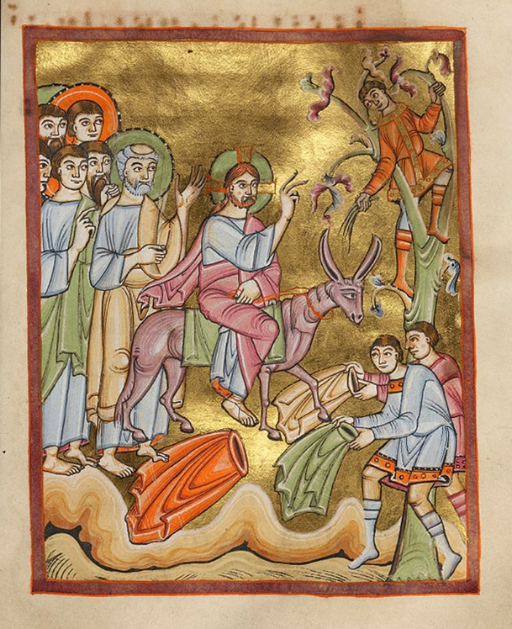

“A very large crowd spread their cloaks on the road, and others cut branches from the trees and spread them on the road. The crowds that went ahead of him and that followed were shouting, ‘Hosanna to the Son of David! Blessed is the one who comes in the name of the Lord! Hosanna in the highest heaven!’” (Matthew 21:8-9)

Minister: Rev. Jason Evans
First Free Methodist Church
2625 N. Center Rd.
Saginaw, Michigan 48603
Phone: (989) 799-2930
Email: saginawfmc@gmail.com
www.saginawfirstfmc.org

Palm Sunday
April 5, 2020

The mission of Saginaw First Free Methodist Church is to be faithful to God and to make known to all people everywhere God’s call to wholeness in Jesus Christ.

Prelude
Greeting/Announcements
Call to Worship (spoken responsively)
L: This is a day of joyous welcome
P: We welcome Christ with waving branches
L: Our leader come humbly, riding on a donkey
P: Jesus rides in our lives at tumultuous times
L: Blessed is the one who coms in the name of the Lord
P: People still oppose the way of love
L: God, open us to the gates of righteousness
P: Let us enter into the light God offers

*Opening Hymn: “Savior of the Nations, Come”

Savior of the nations, come
Virgin's Son, make here thy home!
Marvel now, O heav'n and earth
That the Lord chose such a birth

Not of flesh and blood the Son
By the Spirit of our God
Was the Word of God made flesh
Woman’s offspring, pure and fresh

Wondrous birth! O wondrous Child
Of the Virgin undefiled
Though by all the world disowned
Still to be in heav'n enthroned

From the Father forth he came
And returneth to the same
Captive leading death and hell
High the song of triumph swell

Thou, the Father's only Son
Hast o'er sin the vict'ry won
Boundless shall thy kingdom be
When shall we its glories see?

Praise to God the Father sing
Praise to God the Son, our King
Praise to God the Spirit be
Ever and eternally

Invocation and Lord’s Prayer
L: O merciful, Holy God, in our moments of grief and fear, be gracious with us. Abide with us as we rejoice in the day you have made. As time has slowed down for us, remind us we are in your hands. We are your children both when we mourn and when we celebrate. Guide our thoughts and actions so we may appreciate what you haven given to us. Help us trust in you, as we pray the prayer that Jesus taught His disciples…

P: Our Father, who art in heaven, hallowed be Your name. Your kingdom come; your will be done in earth as it is in heaven. Give us this day our daily bread and forgive us our debts as we forgive our debtors. And lead us not into temptation but deliver
us from evil. For Yours is the kingdom, and the power, and the glory forever. Amen.

Gloria Patri

Old Testament Scripture Lesson: Isaiah 50:4-9
The Lord GOD has given me the tongue of a teacher, that I may know how to sustain the weary with a word. Morning by morning he wakens, wakens my ear to listen as those who are taught. The Lord GOD has opened my ear, and I was not rebellious, I did not turn backward. I gave my back to those who struck me, and my cheeks to those who pulled out the beard; I did not hide my face from insult and spitting.

The Lord GOD helps me; therefore I have not been disgraced; therefore I have set my face like flint, and I know that I shall not be put to shame; he who vindicates me is near. Who will contend with me? Let us stand up together. Who are my adversaries? Let them confront me. It is the Lord GOD who helps me; who will declare me guilty?

Prayer of Confession
L: In the garden, Jesus directed his disciples to watch and pray. But they failed in their support. Have we too, fallen asleep? When we failed to live consistent, persistent lives of faith, let us confess…

P: Merciful God, we cry out to you. Hear our cries as we confess that we neglect your calling for us and instead desire to rule in your place. Our deeds of selfishness cut us off from communion with you. We are like dead people going through the motions. We cry for forgiveness and new life. Heal our infirmities and correct our wayward thinking that we may live abundantly now and in the life to come. By your steadfast love, let us see your light. Amen.

Affirmation of Faith: Psalm 31:9-16
P: Be gracious to me, O LORD, for I am in distress; my eye wastes away from grief, my soul and body also. For my life is spent with sorrow, and my years with sighing; my strength fails because of my misery, and my bones waste away. I am the scorn of all my adversaries, a horror to my neighbors, an object of dread to my acquaintances; those who see me in the street flee from me. I have passed out of mind like one who is dead; I have become like a broken vessel. For I hear the whispering of many, “terror all around!” as they scheme together against me, as they plot to take my life. But I trust in you, O LORD, I say, “You are my God.” My times are in your hand; deliver me from the hand of my enemies and persecutors. Let your face shine upon your servant; save me in your steadfast love.

*Hymn of Affirmation: “Go to dark Gethsemane”

Go to dark Gethsemane
You who feel the tempter's pow'r
Your Redeemer's conflict see
Watch with Him one bitter hour
Turn not from His griefs away
Learn of Jesus Christ to pray

Follow to the judgment hall
View the Lord of life arraigned
O the worm-wood and the gall
O the pangs His soul sustained
Shun not suff'ring, shame, or loss
Learn of Him to bear the cross

Calv'ry's mournful mountain climb
There' adoring at His feet
Mark the miracle of time
God's own sacrifice complete
"It is finished!" Hear the cry
Learn of Jesus Christ to die

Early hasten to the tomb
Where they laid his breathless clay
All is solitude and gloom
Who hath taken Him away
Christ is ris'n! He meets our eyes
Savior, teach us so to rise

New Testament Scripture Lesson: Philippians 2:5-11
Let the same mind be in you that was in Christ Jesus, who, though he was in the form of God, did not regard equality with God as something to be exploited, but emptied himself, taking the form of a slave, being born in human likeness. And being found in human form, he humbled himself and became obedient to the point of death, even death on a cross.

Therefore God also highly exalted him and gave him the name that is above every name, so that at the name of Jesus every knee should bend, in heaven and on earth and under the earth, and every tongue should confess that Jesus Christ is Lord, to the glory of God the Father.

Special Music: Micki Martin

Prayers of the People
L: Lord in Your Mercy…
P: Hear our prayer.

Gospel Lesson: Matthew 21:1-11
When they had come near Jerusalem and had reached Bethphage, at the Mount of Olives, Jesus sent two disciples, saying to them, “Go into the village ahead of you, and immediately you will find a donkey tied, and a colt with her; untie them and bring them to me. If anyone says anything to you, just say this, 'The Lord needs them.' And he will send them immediately.”

This took place to fulfill what had been spoken through the prophet, saying, “Tell the daughter of Zion, Look, your king is coming to you, humble, and mounted on a donkey, and on a colt, the foal of a donkey.”

The disciples went and did as Jesus had directed them; they brought the donkey and the colt, and put their cloaks on them, and he sat on them. A very large crowd spread their cloaks on the road, and others cut branches from the trees and spread them on the road.

The crowds that went ahead of him and that followed were shouting, “Hosanna to the Son of David! Blessed is the one who comes in the name of the Lord! Hosanna in the highest heaven!”

When he entered Jerusalem, the whole city was in turmoil, asking, “Who is this?”

The crowds were saying, “This is the prophet Jesus from Nazareth in Galilee.”

Sermon

Prayer of Response

Hymn of Response: “Tell Me the Story of Jesus”

Tell me the story of Jesus
Write on my heart every word
Tell me the story most precious
Sweetest that ever was heard
Tell how the angels, in chorus
Sang as they welcomed His birth
"Glory to God in the highest!
Peace and good tidings to earth”
Tell me the story of Jesus
Write on my heart every word
Tell me the story most precious
Sweetest that ever was heard

Fasting alone in the desert
Tell of the days that are past
How for our sins He was tempted
Yet was triumphant at last
Tell of the years of His labor
Tell of the sorrow He bore
He was despised and afflicted
Homeless, rejected, and poor
Tell me the story of Jesus
Write on my heart every word
Tell me the story most precious
Sweetest that ever was heard

Tell of the cross where they nailed Him
Writhing in anguish and pain
Tell of the grave where they laid Him
Tell how He liveth again
Love in that story so tender
Clearer than ever I see
Stay, let me weep while you whisper
Love paid the ransom for me
Tell me the story of Jesus
Write on my heart every word
Tell me the story most precious
Sweetest that ever was heard

Invitation of Offering
L: For thirty pieces of silver Jesus was betrayed. And still today he is denied in the way we use the resources entrusted to us. Let our offerings be shouts of joy, as we collect this morning’s tithes and offerings.
Doxology

Prayer

Closing Hymn: “Joy Unspeakable”

I have found His grace is all complete
He supplieth every need
While I sit and learn at Jesus’ feet
I am free, yes, free indeed
It is joy unspeakable and full of glory
Full of glory, full of glory
It is joy unspeakable and full of glory
Oh, the half has never yet been told

I have found the pleasure I once craved
It is joy and peace within
What a wondrous blessing, I am saved
From the awful gulf of sin
It is joy unspeakable and full of glory
Full of glory, full of glory
It is joy unspeakable and full of glory
Oh, the half has never yet been told

I have found that hope so bright and clear
Living in the realm of grace
Oh, the Savior’s presence is so near
I can see His smiling face
It is joy unspeakable and full of glory
Full of glory, full of glory
It is joy unspeakable and full of glory
Oh, the half has never yet been told

I have found the joy no tongue can tell
How its waves of glory roll
It is like a great o’erflowing well
Springing up within my soul
It is joy unspeakable and full of glory
Full of glory, full of glory
It is joy unspeakable and full of glory
Oh, the half has never yet been told

Benediction
L: Good keeps covenant with us in all circumstances. Be committed to God’s call on your life. May love prevail in your lives. Seek to be loyal and courageous to Christ, as you go in peace to love and serve. Amen.

