First Free Methodist Church of Saginaw
Second Sunday of Easter
April 16, 2023

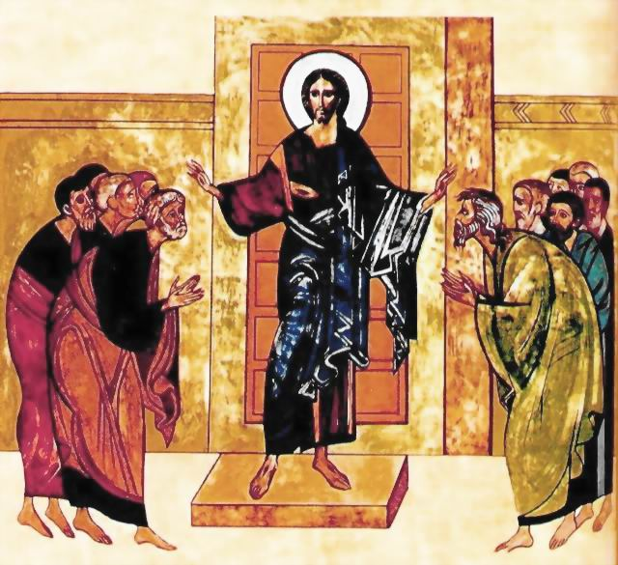
“After he said this, he showed them his hands and his side. Then the disciples rejoiced when they saw the Lord.”
(John 20:20)

Minister: Rev. Jason Evans
First Free Methodist Church
2625 N. Center Rd.
Saginaw, Michigan 48603
Phone: (989) 799-2930
Email: saginawfmc@gmail.com
www.saginawfirstfmc.org

Second Sunday of Easter
April 16, 2023

Prelude
**Greeting/Announcements
*Call to Worship (spoken responsively)
L: Come broken and weary, come battered and bruised
P: My Jesus makes all things new
L: Come lost and abandoned, come blown by the wind
P: He'll bring you back home again
L: The world was good, the world is fallen
P: The world is being redeemed
L: Hold on to the promise, the stories are true
P: Jesus makes all things new; He makes all things new!

*Opening Hymn: “Our God Reigns” #268 (vv.1-3)
How lovely on the mountains
Are the feet of him
Who brings good news, good news
Announcing peace, proclaiming
News of happiness
Our God reigns; our God reigns
Our God reigns
Our God reigns
Our God reigns
Our God reigns

He had no stately form
He had no majesty
That we should be
drawn to Him
He was despised
and we took no account of Him
Yet now He reigns
With the Most High
Our God reigns
Our God reigns
Our God reigns
Our God reigns

Out of the tomb He came
With grace and majesty
He is alive, He is alive
God loves us so see here His hands
His feet, His side
Yes, we know He is alive
Our God reigns
Our God reigns
Our God reigns
Our God reigns

*Invocation and Lord’s Prayer
L: We praise you, O God, we acclaim You as Lord. All creation worships you, Father everlasting. To you all angels, all the powers of heaven, cherubim and seraphim, sing in endless praise. Enlighten us with your wisdom this day. Empower us with your spirit as we worship you. Fill us with your love and mission as we respond to your message. Renew our hope for this world, as we pray the prayer that Jesus taught His disciples…

P: Our Father, who art in heaven, hallowed be Your name. Your kingdom come; your will be done in earth as it is in heaven. Give us this day our daily bread and forgive us our debts as we forgive our debtors. And lead us not into temptation but deliver us from evil. For Yours is the kingdom, and the power, and the glory forever. Amen.

*Gloria Patri
Glory be to the Father​
And to the Son and to the Holy Ghost.​
As it was in the beginning​
Is now and ever shall be.​
World without end. ​
Amen. Amen.​

*Passing of the Peace

Hymn: “One Day #210 (vv.1-2,4-5)
One day when heaven was filled with His praises
One day when sin was as black as could be
Jesus came forth to be born of a virgin
Dwelt among men, my example is He
Living, He loved me; dying, He saved me
Buried, He carried my sins far away
Rising, He justified freely, forever
One day He’s coming O glorious day

One day they led Him up Calvary’s mountain
One day they nailed Him to die on the tree
Suffering anguish, despised and rejected
Bearing our sins, my Redeemer is He
Living, He loved me; dying, He saved me
Buried, He carried my sins far away
Rising, He justified freely, forever
One day He’s coming O glorious day

One day the grave could conceal Him no longer
One day the stone rolled away from the door
Then He arose, over death He had conquered
Now is ascended, my Lord ever more
Living, He loved me; dying, He saved me
Buried, He carried my sins far away
Rising, He justified freely, forever
One day He’s coming O glorious day

One day the trumpet will sound for His coming
One day the skies with His glory will shine
Wonderful day, my beloved ones bringing
Glorious Savior, this Jesus is mine
Living, He loved me; dying, He saved me
Buried, He carried my sins far away
Rising, He justified freely, forever
One day He’s coming O glorious day

Affirmation of Faith
P: Throughout the world the holy Church acclaims You: Father, of majesty unbounded, Your glorious, true, and only Son, and the Holy Spirit, Advocate and Guide. You, Christ, are the King of glory, the eternal Son of the Father. When You became incarnate to set us free You humbly accepted the Virgin’s womb. You overcame the sting of death, and opened the kingdom of heaven to all believers. You are seated at God’s right hand in glory. We believe that You will come to be our judge. Come then, Lord, and help Your people, bought with the price of Your own blood, and bring us with your saints to glory everlasting. Amen.

Baptism
Children’s Sermon

Gospel Lesson: John 20:19-31
When it was evening on that day, the first day of the week, and the doors of the house where the disciples had met were locked for fear of the Jews, Jesus came and stood among them and said, “Peace be with you.”
After he said this, he showed them his hands and his side. Then the disciples rejoiced when they saw the Lord. Jesus said to them again, “Peace be with you. As the Father has sent me, so I send you.”
When he had said this, he breathed on them and said to them, “Receive the Holy Spirit. If you forgive the sins of any, they are forgiven them; if you retain the sins of any, they are retained.”
But Thomas (who was called the Twin), one of the twelve, was not with them when Jesus came. So the other disciples told him, “We have seen the Lord.”
But he said to them, “Unless I see the mark of the nails in his hands, and put my finger in the mark of the nails and my hand in his side, I will not believe.”
A week later his disciples were again in the house, and Thomas was with them. Although the doors were shut, Jesus came and stood among them and said, “Peace be with you.”
Then he said to Thomas, “Put your finger here and see my hands. Reach out your hand and put it in my side. Do not doubt but believe.”
Thomas answered him, “My Lord and my God!”
Jesus said to him, “Have you believed because you have seen me? Blessed are those who have not seen and yet have come to believe.”
Now Jesus did many other signs in the presence of his disciples, which are not written in this book. But these are written so that you may come to believe that Jesus is the Messiah, the Son of God, and that through believing you may have life in his name.

Sermon
Prayers of the People
L: Lord in Your Mercy…
P: Hear our prayer.

Hymn of Response: “Joy Unspeakable” #423 (vv.1,3-4)
I have found His grace is all complete
He supplieth every need
While I sit and learn at Jesus’ feet
I am free, yes, free indeed
It is joy unspeakable and full of glory
Full of glory, full of glory
It is joy unspeakable and full of glory
Oh, the half has never yet been told

I have found that hope so bright and clear
Living in the realm of grace
Oh, the Savior’s presence is so near
I can see His smiling face
It is joy unspeakable and full of glory
Full of glory, full of glory
It is joy unspeakable and full of glory
Oh, the half has never yet been told

I have found the joy no tongue can tell
How its waves of glory roll
It is like a great o’erflowing well
Springing up within my soul
It is joy unspeakable and full of glory
Full of glory, full of glory
It is joy unspeakable and full of glory
Oh, the half has never yet been told

Invitation of Offering
L: Ascribe to the Lord the glory due His name; Bring an offering and come into His courts. Worship the Lord in the splendor of His holiness, as we collect this morning’s tithes and offerings.

*Doxology
Praise God, from whom all blessings flow
Praise Him, all creatures here below
Praise Him above, ye heavenly host
Praise Father Son, and Holy Ghost.
Amen.

*Prayer

*Closing Hymn: “There’s Something About That Name” #148
Jesus Jesus Jesus
There’s something about that name
Master savior Jesus
It's like the fragrance after rain
Jesus Jesus Jesus
Let Heaven and Earth proclaim
Kings and kingdoms will all pass away
There is something about that name

*Benediction
L: And after you have suffered for a little while, the God of all grace, who has called you to his eternal glory in Christ Jesus, will himself restore, support, strengthen, and establish you. To him be the glory and power forever and ever. Go in peace to love and serve. Amen.

