Saginaw First Free Methodist Church
Seventeenth Sunday after Pentecost
September 27, 2020

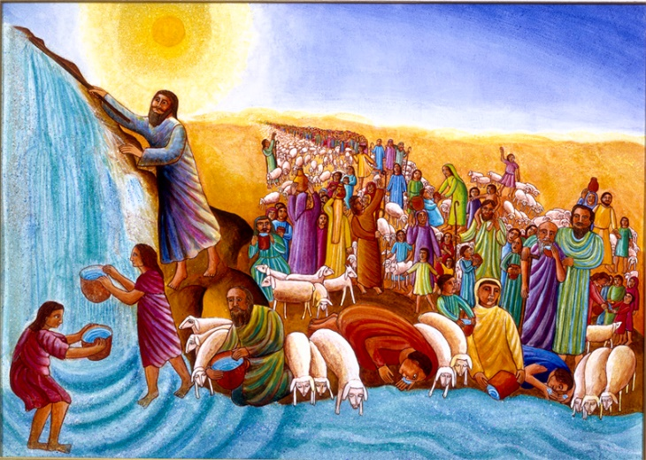
“The LORD said to Moses, ‘Go on ahead of the people, and take some of the elders of Israel with you; take in your hand the staff with which you struck the Nile, and go. I will be standing there in front of you on the rock at Horeb. Strike the rock, and water will come out of it, so that the people may drink.’ Moses did so, in the sight of the elders of Israel. He called the place Massah and Meribah, because the Israelites quarreled and tested the LORD, saying, ‘Is the LORD among us or not?’” (Exodus 17:5-7)

Minister: Rev. Jason Evans
First Free Methodist Church
2625 N. Center Rd.
Saginaw, Michigan 48603
Phone: (989) 799-2930
Email: saginawfmc@gmail.com
www.saginawfirstfmc.org

Seventeenth Sunday after Pentecost
September 27, 2020

The mission of Saginaw First Free Methodist Church is to be faithful to God and to make known to all people everywhere God’s call to wholeness in Jesus Christ.

Prelude
**Greeting/Announcements
*Call to Worship (spoken responsively)
L: Come all you who are weary and burdened
P: We will not grumble, but wait upon the Lord
L: Look to the Lord who has provided for the people in the past
P: Through the sea God provided safe passage
L: God is present and among you
P: In the wilderness of Sinai, God provided water
L: God is the creator and the source of all truth
P: We will embrace truth, and resist the lies of man

*Opening Hymn: “Savior Like a Shepherd Lead Us” #578 (vv.1-2,4)
Savior, like a shepherd lead us
Much we need Thy tender care
In Thy pleasant pastures feed us
For our use Thy folds prepare
Blessèd Jesus, blessèd Jesus
Thou hast bought us, Thine we are
Blessèd Jesus, blessèd Jesus
Thou hast bought us, Thine we are

We are Thine, do Thou befriend us
Be the guardian of our way
Keep Thy flock, from sin defend us
Seek us when we go astray
Blessèd Jesus, blessèd Jesus
Hear, O hear us when we pray
Blessèd Jesus, blessèd Jesus
Hear, O hear us when we pray

Early let us seek Thy favor
Early let us do Thy will
Blessed Lord and only Savior
With Thy love our bosoms fill
Blessèd Jesus, blessèd Jesus
Thou hast loved us, love us still
Blessèd Jesus, blessèd Jesus
Thou hast loved us, love us still

*Invocation and Lord’s Prayer
L: Lord of heaven and earth, we are amazed at the miracles you created for the people of history. You have saved your people by controlling waters. You have saved your people from plagues. Christ teaches us not to manipulate truth, or follow those who do. You teach us to speak plainly with love. Fill us today with the spirit that we may not be deceived by man but faithful to your teachings, as we pray together the prayer that Jesus taught His disciples…

P: Our Father, who art in heaven, hallowed be Your name. Your kingdom come; your will be done in earth as it is in heaven. Give us this day our daily bread and forgive us our debts as we forgive our debtors. And lead us not into temptation but deliver us from evil. For Yours is the kingdom, and the power, and the glory forever. Amen.

*Gloria Patri
Glory be to the Father​
And to the Son and to the Holy Ghost.
As it was in the beginning​
Is now and ever shall be
World without end
Amen. Amen

First Scripture Lesson: Exodus 17:1-7
From the wilderness of Sin the whole congregation of the Israelites journeyed by stages, as the LORD commanded. They camped at Rephidim, but there was no water for the people to drink. The people quarreled with Moses, and said, “Give us water to drink.” Moses said to them, “Why do you quarrel with me? Why do you test the LORD?”
But the people thirsted there for water; and the people complained against Moses and said, “Why did you bring us out of Egypt, to kill us and our children and livestock with thirst?”
So Moses cried out to the LORD, “What shall I do with this people? They are almost ready to stone me.”
The LORD said to Moses, “Go on ahead of the people, and take some of the elders of Israel with you; take in your hand the staff with which you struck the Nile, and go. I will be standing there in front of you on the rock at Horeb. Strike the rock, and water will come out of it, so that the people may drink.” Moses did so, in the sight of the elders of Israel.
He called the place Massah and Meribah, because the Israelites quarreled and tested the LORD, saying, “Is the LORD among us or not?”

Prayer of Confession
L: The Lord has saved the people from foes and plagues in the past. We look to God to do the same for us today. But our grumblings and dishonesties towards others are stumbling blocks. For all the times we follow human, not God, let us repent…

P: Sovereign God, we look to you for provision like you satisfied the people in the wilderness. Christ taught with the integrity of heaven, with full authority. Yet we manipulate for the purpose of gaining the majority. We seek our popularity and power, above answering the call to truth. We grumble we don’t get what we want, even when receiving means others are oppressed. We want others to do the work, so we can be lazy. Then we horde your resources, denying others the opportunity to experience the abundant life you offer. Teach us to carry our cross as you have exampled. Amen.

Affirmation of Faith: Psalm 78
P: Give ear, O my people, to my teaching; incline your ears to the words of my mouth. I will open my mouth in a parable; I will utter dark sayings from of old, things that we have heard and known, that our ancestors have told us. We will not hide them from their children; we will tell to the coming generation the glorious deeds of the LORD, and his might, and the wonders that he has done. In the sight of their ancestors he worked marvels in the land of Egypt, in the fields of Zoan. He divided the sea and let them pass through it, and made the waters stand like a heap. In the daytime he led them with a cloud, and all night long with a fiery light. He split rocks open in the wilderness, and gave them drink abundantly as from the deep. He made streams come out of the rock, and caused waters to flow down like rivers.

*Hymn of Affirmation: “Open My Eyes, That I May See” #461 (1,4)
Open my eyes, that I may see
Glimpses of truth you have for me
Place in my hands the wonderful key
That shall unlock and set me free
Silently now, on bended knee
Ready I wait your will to see
Open my eyes, illumine me
Spirit divine

Open my mind, that I may read
More of Thy love in word and deed
What shall I fear while yet Thou dost lead
Only for light from Thee I plead
Ready I wait your will to see
Open my mind, illumine me
Spirit divine

Second Scripture Lesson: Philippians 2:1-13
If then there is any encouragement in Christ, any consolation from love, any sharing in the Spirit, any compassion and sympathy, make my joy complete: be of the same mind, having the same love, being in full accord and of one mind. Do nothing from selfish ambition or conceit, but in humility regard others as better than yourselves.
Let each of you look not to your own interests, but to the interests of others. Let the same mind be in you that was in Christ Jesus, who, though he was in the form of God, did not regard equality with God as something to be exploited, but emptied himself, taking the form of a slave, being born in human likeness. And being found in human form, he humbled himself and became obedient to the point of death-- even death on a cross.
Therefore God also highly exalted him and gave him the name that is above every name, so that at the name of Jesus every knee should bend, in heaven and on earth and under the earth, and every tongue should confess that Jesus Christ is Lord, to the glory of God the Father.
Therefore, my beloved, just as you have always obeyed me, not only in my presence, but much more now in my absence, work out your own salvation with fear and trembling; for it is God who is at work in you, enabling you both to will and to work for his good pleasure.

Special Music: Micki Marin

Passing of the Peace

Prayers of the People
L: Lord in Your Mercy…
P: Hear our prayer.

Gospel Lesson: Matthew 21:23-32
When he entered the temple, the chief priests and the elders of the people came to him as he was teaching, and said, “By what authority are you doing these things, and who gave you this authority?”
Jesus said to them, “I will also ask you one question; if you tell me the answer, then I will also tell you by what authority I do these things. Did the baptism of John come from heaven, or was it of human origin?”
And they argued with one another, “If we say, ‘From heaven,’ he will say to us, ‘Why then did you not believe him?’
But if we say, ‘Of human origin,’ we are afraid of the crowd; for all regard John as a prophet.”
So they answered Jesus, “We do not know.” And he said to them, “Neither will I tell you by what authority I am doing these things.
“What do you think? A man had two sons; he went to the first and said, ‘Son, go and work in the vineyard today.’ He answered, ‘I will not,’ but later he changed his mind and went.
The father went to the second and said the same; and he answered, ‘I go, sir,’ but he did not go.
Which of the two did the will of his father?” They said, “The first.” Jesus said to them, “Truly I tell you, the tax collectors and the prostitutes are going into the kingdom of God ahead of you. For John came to you in the way of righteousness and you did not believe him, but the tax collectors and the prostitutes believed him; and even after you saw it, you did not change your minds and believe him.”

Sermon

Prayer of Response

*Hymn of Response: “As the Deer” (vv.1-3)
As the deer panteth for the water
So my soul longeth after Thee
You alone are my heart's desire
And I long to worship Thee
You alone are my strength, my shield
To You alone may my spirit yield
You alone are my heart's desire
And I long to worship Thee

You're my friend
And You are my brother
Even though You are a King
I love You more than any other
So much more than anything
You alone are my strength, my shield
To You alone may my spirit yield
You alone are my heart's desire
And I long to worship Thee

I want You more than gold or silver
Only You can satisfy
You alone are the real joy giver
And the apple of my eye
You alone are my strength, my shield
To You alone may my spirit yield
You alone are my heart's desire
And I long to worship Thee

Invitation of Offering
L: Christ gave up worldly possessions for the coming kingdom. And God provides for the people. Our participation affirms our integrity with Christ’s teachings. Give to the King and kingdom you love, as we collect this morning’s tithes and offerings.

*Doxology
Praise God, from whom all blessings flow
Praise Him, all creatures here below
Praise Him above, ye heavenly host
Praise Father Son, and Holy Ghost.
Amen.

*Prayer

*Hymn: “Praise Him! Praise Him!” #117 (vv.1,3)
Praise Him! Praise Him! Jesus, our blessed Redeemer
Sing, O Earth, His wonderful love proclaim
Hail Him! Hail Him! Highest archangels in glory
Strength and honor give to His holy Name
Like a shepherd, Jesus will guard His children
In His arms He carries them all day long
Praise Him! Praise Him! Tell of His excellent greatness
Praise Him! Praise Him! Ever in joyful song

Praise Him! Praise Him! Jesus, our blessed Redeemer
Heav’nly portals loud with hosannas ring
Jesus, Savior, reigneth forever and ever
Crown Him! Crown Him! Prophet, and Priest, ‘n King
Christ is coming! over the world victorious
Pow’r and glory unto the Lord belong
Praise Him! Praise Him! Tell of His excellent greatness
Praise Him! Praise Him! Ever in joyful song

*Benediction
L: God has made a way for humans in the past. But Moses still had to strike the rock. Christ calls us to action, let the world speak in vain. Live in righteousness, as you go in peace to love and serve. Amen.

