Saginaw First Free Methodist Church
Twenty-Third Sunday after Pentecost
October 31, 2021

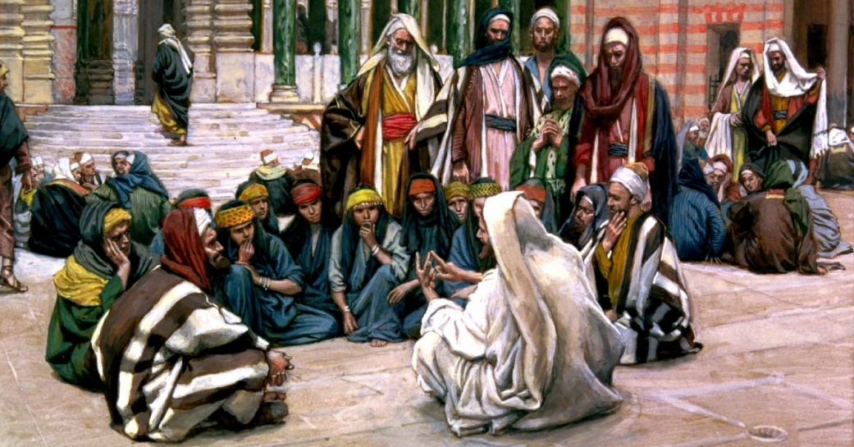
“’and 'to love him with all the heart, and with all the understanding, and with all the strength,' and 'to love one's neighbor as oneself,' --this is much more important than all whole burnt offerings and sacrifices.’" (Mark 12:33)

Minister: Rev. Jason Evans
First Free Methodist Church
2625 N. Center Rd.
Saginaw, Michigan 48603
Phone: (989) 799-2930
Email: saginawfmc@gmail.com
www.saginawfirstfmc.org

Proper 26 (31)
October 31, 2021

Prelude
**Greeting/Announcements
*Call to Worship (spoken responsively)
L: Fix your eyes on God’s commandments
P: We will praise God with sincerity as we learn of these decrees
L: We are people of God, created to love
P: We will love the Lord with our heart, soul, mind, and strength
L: We are people of God, determined to love
P: We will love our neighbors and treat them as we would be treated
L: Friends, believe the good news
P: We are saved by the Spirit through belief in the truth in Christ

*Opening Hymn: “Spirit of God, Descend upon my Heart” #298 (vv.1-4)
Spirit of God, descend upon my heart
Wean it from earth, through all its pulses move
Stoop to my weakness, mighty as Thou art
And make me love Thee as I ought to love

Hast Thou not bid us love Thee God and King
All, all Thine own soul, heart, and strength, and mind
I see Thy cross there teach my heart to cling
O let me seek Thee, and O let me find

Teach me to feel that Thou are always nigh
Teach me the struggles of the soul to bear
To check the rising doubt, the rebel sigh
Teach me the patience of unanswered prayer

Teach me to love Thee as Thine angels love
One holy passion filling all my frame
The baptism of the heaven-descended Dove
My heart an altar, and Thy love the flame

*Invocation and Lord’s Prayer
L: Providing God, You journeyed with Ruth and comforted Hannah when their lives were burdened by grief. Grant us faith to believe you will provide a future where we see none, that bitterness may turn to joy and barrenness may bear life. Guide us to abundant life, as we pray the prayer that Jesus taught His disciples…

P: Our Father, who art in heaven, hallowed be Your name. Your kingdom come; your will be done in earth as it is in heaven. Give us this day our daily bread and forgive us our debts as we forgive our debtors. And lead us not into temptation but deliver us from evil. For Yours is the kingdom, and the power, and the glory forever. Amen.

*Gloria Patri
Glory be to the Father​
And to the Son and to the Holy Ghost.​
As it was in the beginning​
Is now and ever shall be.​
World without end. ​
Amen. Amen.​

First Scripture Lesson: Ruth 1:1-18
In the days when the judges ruled, there was a famine in the land, and a certain man of Bethlehem in Judah went to live in the country of Moab, he and his wife and two sons. The name of the man was Elimelech and the name of his wife Naomi, and the names of his two sons were Mahlon and Chilion; they were Ephrathites from Bethlehem in Judah. They went into the country of Moab and remained there.
But Elimelech, the husband of Naomi, died, and she was left with her two sons. These took Moabite wives; the name of the one was Orpah and the name of the other Ruth. When they had lived there about ten years, both Mahlon and Chilion also died, so that the woman was left without her two sons and her husband.
Then she started to return with her daughters-in-law from the country of Moab, for she had heard in the country of Moab that the LORD had considered his people and given them food. So she set out from the place where she had been living, she and her two daughters-in-law, and they went on their way to go back to the land of Judah.
But Naomi said to her two daughters-in-law, “Go back each of you to your mother's house. May the LORD deal kindly with you, as you have dealt with the dead and with me. The LORD grant that you may find security, each of you in the house of your husband.” Then she kissed them, and they wept aloud.
They said to her, “No, we will return with you to your people.”
But Naomi said, “Turn back, my daughters, why will you go with me? Do I still have sons in my womb that they may become your husbands? Turn back, my daughters, go your way, for I am too old to have a husband. Even if I thought there was hope for me, even if I should have a husband tonight and bear sons, would you then wait until they were grown? Would you then refrain from marrying? No, my daughters, it has been far more bitter for me than for you, because the hand of the LORD has turned against me.”
Then they wept aloud again. Orpah kissed her mother-in-law, but Ruth clung to her. So she said, “See, your sister-in-law has gone back to her people and to her gods; return after your sister-in-law.”
But Ruth said, “Do not press me to leave you or to turn back from following you! Where you go, I will go; Where you lodge, I will lodge; your people shall be my people, and your God my God. Where you die, I will die-- there will I be buried. May the LORD do thus and so to me, and more as well, if even death parts me from you!”
When Naomi saw that she was determined to go with her, she said no more to her.

Prayer of Confession
L: Our God is Almighty, full of splendor and wonder. When our routine is not focused on Christ, we look to spectacle, entertainment, or self-gratification for meaning. Order your life well, so our spirits may grow calm, our vision be clear, and our purpose be unified…

P: Lord of all history, steer the ship of my life to your quiet harbor, where I can be safe from the storms of sin and conflict. Show me the course I should take. Renew in me the gift of discernment, so that I can see the right direction in which I should go. Give me the strength and courage to choose the right course, even when the sea is rough and the future veiled. Teach me true peace and comfort comes from obedience to you. Amen.

Affirmation of Faith: Psalm 146
P: Praise the LORD! Praise the LORD, O my soul! I will praise the LORD as long as I live; I will sing praises to my God all my life long. Do not put your trust in princes, in mortals, in whom there is no help. When their breath departs, they return to the earth; on that very day their plans perish. Happy are those whose help is the God of Jacob, whose hope is in the LORD their God, who made heaven and earth, the sea, and all that is in them; who keeps faith forever; who executes justice for the oppressed; who gives food to the hungry. The LORD sets the prisoners free; the LORD opens the eyes of the blind. The LORD lifts up those who are bowed down; the LORD loves the righteous.

Hymn of Affirmation: “Rock of Ages” #445 (vv.1-3)
Rock of Ages, cleft for me
Let me hide myself in Thee
Let the water and the blood
From Thy wounded side which flowed
Be of sin the double cure
Save from wrath and make me pure

Could my tears forever flow
Could my zeal no languor know
These for sin could not atone
Thou must save, and Thou alone
In my hand no price I bring
Simply to Thy cross I cling

While I draw this fleeting breath
When my eyes shall close in death
When I rise to worlds unknown
And behold Thee on Thy throne
Rock of Ages, cleft for me
Let me hide myself in Thee

Second Scripture Lesson: Hebrews 9:11-14
But when Christ came as a high priest of the good things that have come, then through the greater and perfect tent (not made with hands, that is, not of this creation), he entered once for all into the Holy Place, not with the blood of goats and calves, but with his own blood, thus obtaining eternal redemption.
For if the blood of goats and bulls, with the sprinkling of the ashes of a heifer, sanctifies those who have been defiled so that their flesh is purified, how much more will the blood of Christ, who through the eternal Spirit offered himself without blemish to God, purify our conscience from dead works to worship the living God!

Passing of the Peace

Prayers of the People
L: Lord in Your Mercy…
P: Hear our prayer.

Gospel Lesson: Mark 12:28-34
One of the scribes came near and heard them disputing with one another, and seeing that he answered them well, he asked him, “Which commandment is the first of all?”
Jesus answered, “The first is, ‘Hear, O Israel: the Lord our God, the Lord is one; you shall love the Lord your God with all your heart, and with all your soul, and with all your mind, and with all your strength.’ The second is this, ‘You shall love your neighbor as yourself.’ There is no other commandment greater than these.”
Then the scribe said to him, “You are right, Teacher; you have truly said that ‘he is one, and besides him there is no other’; and ‘to love him with all the heart, and with all the understanding, and with all the strength,’ and ‘to love one’s neighbor as oneself,’ this is much more important than all whole burnt offerings and sacrifices.”
When Jesus saw that he answered wisely, he said to him, “You are not far from the kingdom of God.” After that no one dared to ask him any question.

Sermon: “What is the Church?”

Prayer of Response

Hymn of Response: Day by Day” #105 (vv.1-3)
Day by day and with each passing moment
Strength I find to meet my trials here
Trusting in my Father's wise bestowment
I've no cause for worry or for fear
He whose heart is kind beyond all measure
Gives unto each day what he deems best
Lovingly, its part of pain and pleasure
Mingling toil with peace and rest

Ev’ry day the Lord Himself is near me
With a special mercy for each hour
All my cares He fain would bear and cheer me
He whose name is counselor and pow’r
The protection of his child and treasure
Is a charge that on Himself He laid
As thy days thy strength shall be in measure
This the pledge to me he made

Help me then in ev'ry tribulation
So to trust your promises, O Lord
That I lose not faith's sweet consolation
Offered me within your holy Word
Help me, Lord, when, toil and trouble meeting
E'er to take, as from a father's hand
One by one, the days, the moments fleeting
Till I reach the promised land

Invitation of Offering
L: The timeless God has made a foundation for us to this day. The brave souls who overcame this life and cheer us on from the next. Courageously give to prepare the way for the next generation, as we collect this morning’s tithes and offerings.

*Doxology

*Prayer

*Closing Hymn: “In My Heart There Rings a Melody” #350 (vv.1-3)
I have a song that Jesus gave me
It was sent from heav'n above
There never was a sweeter melody
'Tis a melody of love
In my heart there rings a melody
There rings a melody with heaven's harmony
In my heart there rings a melody
There rings a melody of love

I love the Christ who died on Calv'ry
For He washed my sins away
He put within my heart a melody
And I know it's there to stay
In my heart there rings a melody
There rings a melody with heaven's harmony
In my heart there rings a melody
There rings a melody of love

'Twill be my endless theme in glory
With the angels I will sing
'Twill be a song with glorious harmony
When the courts of heaven ring
In my heart there rings a melody
There rings a melody with heaven's harmony
In my heart there rings a melody
There rings a melody of love

*Benediction
L: Being made strong with God’s endless love, be eager to put your faith into action. We have been filled with the Spirit, united as God’s people. With saintly determination, go in peace to love and serve. Amen.

