Saginaw First Free Methodist Church
Twentieth Sunday after Pentecost
October 10, 2021

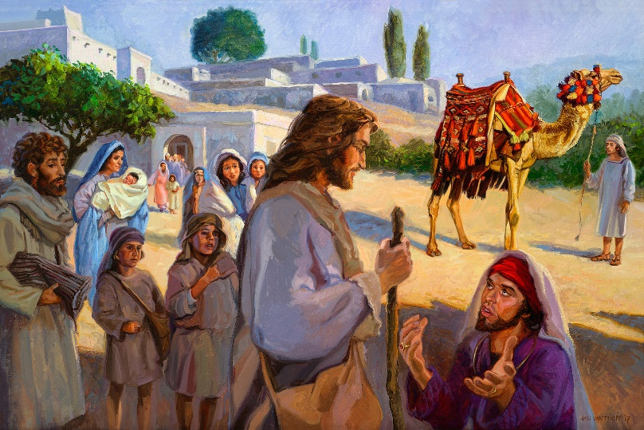
“Jesus, looking at him, loved him and said, "You lack one thing; go, sell what you own, and give the money to the poor, and you will have treasure in heaven; then come, follow me."
(Mark 10:21)

Minister: Rodney Norman
First Free Methodist Church
2625 N. Center Rd.
Saginaw, Michigan 48603
Phone: (989) 799-2930
Email: saginawfmc@gmail.com
www.saginawfirstfmc.org

Proper 23 (28)
October 10, 2021

Prelude
**Greeting/Announcements
*Call to Worship (spoken responsively)
L: Listen, for the voice of God comes near
P: The Spirit of God surrounds us at all times
L: We come to worship the God who became one of us
P: Who took on our pain and suffering
L: The God who is Love incarnate
P: The God who is!
L: Let us gather together in joy and hope
P: We will leave our worries at the foot of the cross

*Opening Hymn: “A Mighty Fortress Is Our God” #30 (vv. 1-4)
A mighty Fortress is our God
A Bulwark never failing
Our Helper He amid the flood
Of mortal ills prevailing
For still our ancient foe
Doth seek to work us woe
His craft and power are great
And, armed with cruel hate
On earth is not his equal

Did we in our own strength confide
Our striving would be losing
Were not the right Man on our side
The Man of God’s own choosing
Dost ask who that may be? Christ Jesus, it is He
Lord Sabaoth His Name
From age to age the same
And He must win the battle

And though this world, with devils filled
Should threaten to undo us
We will not fear, for God hath willed
His truth to triumph through us
The Prince of Darkness grim
We tremble not for him His rage we can endure
For lo! his doom is sure
One little word shall fell him

That word above all earthly powers
No thanks to them, abideth
The Spirit and the gifts are ours
Through Him who with us sideth
Let goods and kindred go
This mortal life also
The body they may kill
God’s truth abideth still
His Kingdom is forever

*Invocation and Lord’s Prayer
L: Almighty God, you are holy and are enthroned upon our praises. In every time and place you have heard our cries; we have placed our trust in you, and we have never been disappointed. We pray that your grace may always precede and follow us, that we may continually be given to good works. Lead us, as we pray the prayer that Jesus taught His disciples…

P: Our Father, who art in heaven, hallowed be Your name. Your kingdom come; your will be done in earth as it is in heaven. Give us this day our daily bread and forgive us our debts as we forgive our debtors. And lead us not into temptation but deliver us from evil. For Yours is the kingdom, and the power, and the glory forever. Amen.

*Gloria Patri
Glory be to the Father​
And to the Son and to the Holy Ghost.​
As it was in the beginning​
Is now and ever shall be.​
World without end. ​
Amen. Amen.​

First Scripture Lesson: Job 23:1-9, 16-17
Then Job answered: “Today also my complaint is bitter; his hand is heavy despite my groaning. Oh, that I knew where I might find him, that I might come even to his dwelling! I would lay my case before him, and fill my mouth with arguments. I would learn what he would answer me, and understand what he would say to me. Would he contend with me in the greatness of his power?
No; but he would give heed to me. There an upright person could reason with him, and I should be acquitted forever by my judge. If I go forward, he is not there; or backward, I cannot perceive him; on the left he hides, and I cannot behold him; I turn to the right, but I cannot see him.
God has made my heart faint; the Almighty has terrified me; If only I could vanish in darkness, and thick darkness would cover my face!

Prayer of Confession
L: We can relate to Job when he says, “today my complaint is bitter; his heavy hand increases my groaning. If only I knew where I might find him” Yet God is Holy. Trust in God who delivers, so our spirits may grow calm, our vision be clear, and our purpose be unified…

P: When nothing is right, when we are weary and lost, when clouds dull the sky, help us to be still. When our cries are unheeded, when no effort bears fruit, when the sun sets, help us to be still. When love is over, when hope is gone, when darkness covers the land, help us to be still. For in being still, in refusing to panic or despair, we shall come to know that God is there, suffering alongside and with us, waiting to show us a way through the waves of life that overwhelm us, and to help us sing a new song. Amen.

Affirmation of Faith: Psalm 22
P: My God, my God, why have you forsaken me? Why are you so far from helping me, from the words of my groaning? O my God, I cry by day, but you do not answer; and by night, but find no rest. Yet you are holy, enthroned on the praises of Israel. In you our ancestors trusted; they trusted, and you delivered them. To you they cried, and were saved; in you they trusted, and were not put to shame. But I am a worm, and not human; scorned by others, and despised by the people. All who see me mock me; they make mouths at me, they shake their heads; “Commit your cause to the LORD; let him deliver, let him rescue the one in whom he delights!” Yet it was you who took me from the womb; you kept me safe on my mother's breast. On you I was cast from my birth, and since my mother bore me you have been my God.

Hymn of Affirmation: “Have Thine Own Way, Lord” #480 (vv.1-4)
Have thine own way, Lord
Have thine own way
Thou art the potter, I am the clay
Mold me and make me, after thy will
While I am waiting, yielded and still

Have thine own way, Lord
Have thine own way
Search me and try me, Savior today
Whiter than snow, Lord, wash me just now
As in thy presence humbly I bow

Have thine own way, Lord
Have thine own way
Wounded and weary, help me I pray
Power, all power, surely is thine
Touch me and heal me, Savior divine

Have thine own way, Lord
Have thine own way
Hold o'er my being, absolute sway
Fill with thy Spirit, till all shall see
Christ only, always, living in me

Second Scripture Lesson: Hebrews 4:12-16
Indeed, the word of God is living and active, sharper than any two-edged sword, piercing until it divides soul from spirit, joints from marrow; it is able to judge the thoughts and intentions of the heart. And before him no creature is hidden, but all are naked and laid bare to the eyes of the one to whom we must render an account.
Since, then, we have a great high priest who has passed through the heavens, Jesus, the Son of God, let us hold fast to our confession. For we do not have a high priest who is unable to sympathize with our weaknesses, but we have one who in every respect has been tested as we are, yet without sin.
Let us therefore approach the throne of grace with boldness, so that we may receive mercy and find grace to help in time of need.

Passing of the Peace

Prayers of the People
L: Lord in Your Mercy…
P: Hear our prayer.

Gospel Lesson: Mark 10:17-31
As he was setting out on a journey, a man ran up and knelt before him, and asked him, “Good Teacher, what must I do to inherit eternal life?”
Jesus said to him, “Why do you call me good? No one is good but God alone. You know the commandments: ‘You shall not murder; You shall not commit adultery; You shall not steal; You shall not bear false witness; You shall not defraud; Honor your father and mother.’”
He said to him, “Teacher, I have kept all these since my youth.”
Jesus, looking at him, loved him and said, “You lack one thing; go, sell what you own, and give the money to the poor, and you will have treasure in heaven; then come, follow me.”
When he heard this, he was shocked and went away grieving, for he had many possessions. Then Jesus looked around and said to his disciples, “How hard it will be for those who have wealth to enter the kingdom of God!”
And the disciples were perplexed at these words. But Jesus said to them again, “Children, how hard it is to enter the kingdom of God! It is easier for a camel to go through the eye of a needle than for someone who is rich to enter the kingdom of God.”
They were greatly astounded and said to one another, “Then who can be saved?”
Jesus looked at them and said, “For mortals it is impossible, but not for God; for God all things are possible.”
Peter began to say to him, “Look, we have left everything and followed you.”
Jesus said, “Truly I tell you, there is no one who has left house or brothers or sisters or mother or father or children or fields, for my sake and for the sake of the good news, who will not receive a hundredfold now in this age--houses, brothers and sisters, mothers and children, and fields with persecutions--and in the age to come eternal life. But many who are first will be last, and the last will be first.”

Sermon: Rodney Norman

Prayer of Response

Hymn of Response: “More Love to Thee” #463 (vv.1-3)
More love to Thee, oh Christ, more love to Thee!
Hear Thou the prayer I make on bended knee.
This is my earnest plea
More love, oh Christ, to Thee
More love to Thee, more love to Thee!

Once earthly joy I craved, sought peace and rest
Now Thee alone I seek, give what is best.
This all my prayer shall be
More love, oh Christ to Thee
More love to Thee, more love to Thee!

Then shall my latest breath whisper Thy praise
This be the parting cry my heart shall raise
Still all my prayer shall be
More love, oh Christ to Thee
More love to Thee, more love to Thee!
More love to Thee, more love to Thee!

Invitation of Offering
L: We are called to be the Church; to celebrate God's presence, to love and serve others, to seek justice and resist evil, to proclaim Jesus, crucified and risen, our judge and our hope. Contemplate this, as we collect this morning’s tithes and offerings.

*Doxology
Praise God, from whom all blessings flow
Praise Him, all creatures here below
Praise Him above, ye heavenly host
Praise Father Son, and Holy Ghost.
Amen.

*Prayer

*Closing Hymn: “Victory in Jesus” #352 (vv.1-3)
I heard an old, old story
How a Savior came from glory
How He gave His life on Calvary
To save a wretch like me
I heard about His groaning
Of His precious blood's atoning
Then I repented of my sins
And won the victory
O victory in Jesus
My Savior, forever
He sought me and bought me
With His redeeming blood
He loved me ere I knew Him
And all my love is due Him
He plunged me to victory
Beneath the cleansing flood

I heard about His healing
Of His cleansing pow'r revealing
How He made the lame to walk again
And caused the blind to see
And then I cried, Dear Jesus
Come and heal my broken spirit
And somehow Jesus came and bro't
To me the victory
O victory in Jesus
My Savior, forever
He sought me and bought me
With His redeeming blood
He loved me ere I knew Him
And all my love is due Him
He plunged me to victory
Beneath the cleansing flood

I heard about a mansion
He has built for me in glory
And I heard about the streets of gold
Beyond the crystal sea
About the angels singing
And the old redemption story
And some sweet day I'll sing up there
The song of victory
O victory in Jesus
My Savior, forever
He sought me and bought me
With His redeeming blood
He loved me ere I knew Him
And all my love is due Him
He plunged me to victory
Beneath the cleansing flood

*Benediction
L: The things of heaven are put into our grasp for we have a high priest who leads us to the throne of grace. We are sent out in the power of your Holy Spirit to proclaim that same grace to all the world. Empowered from high, go in peace to love and serve. Amen.

