Saginaw First Free Methodist Church
All Saints Sunday
November 7, 2021

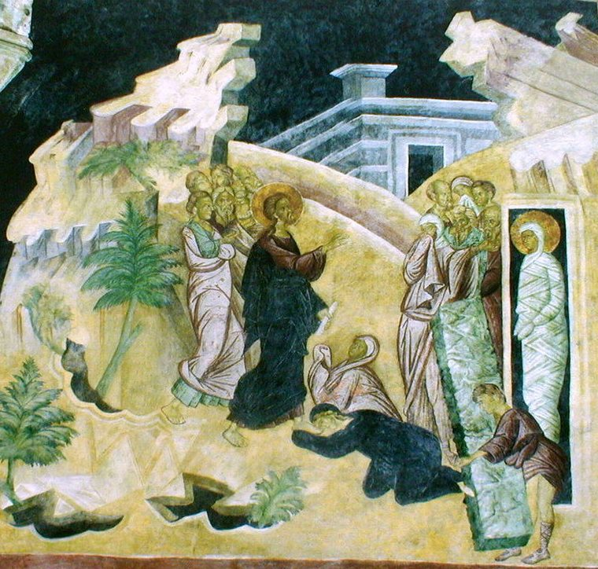
“Jesus said to her, ‘Did I not tell you that if you believed, you would see the glory of God?’" (John 11:40)

Minister: Rev. Jason Evans
First Free Methodist Church
2625 N. Center Rd.
Saginaw, Michigan 48603
Phone: (989) 799-2930
Email: saginawfmc@gmail.com
www.saginawfirstfmc.org

All Saints Day (Observed)
November 7, 2021

Prelude
**Greeting/Announcements
*Call to Worship (spoken responsively)
L: We come to You, O Lord
P: Along with the great cloud of many witnesses
L: To remember the supremacy of the Kingdom of God
P: For which the saints blazed a trail of courage through time
L: To follow Christ to a joyous end
P: To fellowship with the saints of this world
L: By the blessing of God Most Wonderful
P: To whose name be blessing and honor, glory and power forever and ever

*Opening Hymn: “Where He Leads Me” #489 (vv.1-4)
I can hear my Savior calling
I can hear my Savior calling
I can hear my Savior calling
Take Thy cross and follow, follow me
Where He leads me I will follow
Where He leads me I will follow
Where He leads me I will follow
I'll go with Him, with Him all the way

I'll go with Him thro’ the garden
I'll go with Him thro’ the garden
I'll go with Him thro’ the garden
I'll go with Him, with Him all the way
Where He leads me I will follow
Where He leads me I will follow
Where He leads me I will follow
I'll go with Him, with Him all the way

I’ll go with Him thro’ the judgment
I’ll go with Him thro’ the judgment
I’ll go with Him thro’ the judgment
I'll go with Him, with Him all the way
Where He leads me I will follow
Where He leads me I will follow
Where He leads me I will follow
I'll go with Him, with Him all the way

He will give me grace and glory
He will give me grace and glory
He will give me grace and glory
And go with me, with me all the way
Where He leads me I will follow
Where He leads me I will follow
Where He leads me I will follow
I'll go with Him, with Him all the way

*Invocation and Lord’s Prayer
L: Source of all being, beginning and end, we praise you for those who have served you faithfully. For the sake of Jesus Christ, replenish our hope in your eternal kingdom, that we may have life in all its fullness, unfettered by the fear of death. Strengthened by this vision, may we follow in the way of holiness, as we pray the prayer that Jesus taught His disciples…

P: Our Father, who art in heaven, hallowed be Your name. Your kingdom come; your will be done in earth as it is in heaven. Give us this day our daily bread and forgive us our debts as we forgive our debtors. And lead us not into temptation but deliver us from evil. For Yours is the kingdom, and the power, and the glory forever. Amen.

*Gloria Patri
Glory be to the Father​
And to the Son and to the Holy Ghost.​
As it was in the beginning​
Is now and ever shall be.​
World without end. ​
Amen. Amen.​

First Scripture Lesson: Isaiah 25:6-9
On this mountain the LORD of hosts will make for all peoples a feast of rich food, a feast of well-aged wines, of rich food filled with marrow, of well-aged wines strained clear. And he will destroy on this mountain the shroud that is cast over all peoples, the sheet that is spread over all nations; he will swallow up death forever.
Then the Lord GOD will wipe away the tears from all faces, and the disgrace of his people he will take away from all the earth, for the LORD has spoken. It will be said on that day, Lo, this is our God; we have waited for him, so that he might save us. This is the LORD for whom we have waited; let us be glad and rejoice in his salvation.

Prayer of Confession
L: All blessing, honor, and glory, all wisdom, praise, and thanks be yours, O God of our salvation! We seek sanctification, so our spirits may grow calm, our vision be clear, and our purpose be unified…

P: But the souls of the righteous are in the hand of God, and no torment will ever touch them. In the eyes of the foolish they seemed to have died, and their departure was thought to be an affliction, and their going from us to be their destruction; but they are at peace. For though in the sight of men they were punished, their hope is full of immortality. Having been disciplined a little, they will receive great good, because God tested them and found them worthy of himself; like gold in the furnace, he tried them, and like a sacrificial burnt offering he accepted them. Those who trust in him will understand truth, and the faithful will abide with him in love, because grace and mercy are upon his elect, and he watches over his holy ones.

Affirmation of Faith: Psalm 24
P: The earth is the Lord's and all that is in it, the world, and those who live in it; for he has founded it on the seas, and established it on the rivers. Who shall ascend the hill of the LORD? And who shall stand in his holy place? Those who have clean hands and pure hearts, who do not lift up their souls to what is false, and do not swear deceitfully. They will receive blessing from the LORD, and vindication from the God of their salvation. Such is the company of those who seek him, who seek the face of the God of Jacob.

Hymn of Affirmation: “Jesus Calls Us” #541 (vv.1-4)
Jesus calls us o'er the tumult
Of our life's wild, restless sea
Day by day his sweet voice soundeth
Saying Christian, follow me

Jesus calls us from the worship
Of the vain world’s golden store
From each idol that would keep us
Saying Christian love me more

In our joys and in our sorrows
Days of toil and hours of ease
Still he calls in cares and pleasures
Christian love Me more than these

Jesus calls us by thy mercies
Savior, may we hear thy call
Give our hearts to thine obedience
Serve and love thee best of all

Second Scripture Lesson: Revelation 21:1-6
Then I saw a new heaven and a new earth; for the first heaven and the first earth had passed away, and the sea was no more. And I saw the holy city, the new Jerusalem, coming down out of heaven from God, prepared as a bride adorned for her husband.
And I heard a loud voice from the throne saying, “See, the home of God is among mortals. He will dwell with them as their God; they will be his peoples, and God himself will be with them; he will wipe every tear from their eyes. Death will be no more; mourning and crying and pain will be no more, for the first things have passed away.”
And the one who was seated on the throne said, “See, I am making all things new.” Also he said, “Write this, for these words are trustworthy and true.”
Then he said to me, “It is done! I am the Alpha and the Omega, the beginning and the end.”

Communion
MINISTER: THE INVITATION
You who truly and earnestly repent of your sins, who live in love and peace with
your neighbors and who intend to lead a new life, following the commandments
of God and walking in His holy ways, draw near with faith, and take this holy
sacrament to your comfort; and humbly kneeling, make your honest confession
to Almighty God.

IN UNISON: THE GENERAL CONFESSION
Almighty God, Father of our Lord Jesus Christ, maker of all things, judge of all
people, we confess that we have sinned, and we are deeply grieved as we
remember the wickedness of our past lives. We have sinned against You, Your
holiness and Your love, and we deserve only Your indignation and anger.
We sincerely repent, and we are genuinely sorry for all wrongdoing and every
failure to do the things we should. Our hearts are grieved, and we acknowledge
that we are hopeless without Your grace.
Have mercy upon us.
Have mercy upon us, most merciful Father, for the sake of your son, our Savior, Jesus
Christ, who died for us.
Forgive us.
Cleanse us.
Give us strength to serve and please You in newness of life and to honor and praise
Your name, through Jesus Christ our Lord. Amen.

MINISTER: THE AFFIRMATION OF FAITH
O Almighty God, our Heavenly Father, who with great mercy has promised
forgiveness to all who turn to You with hearty repentance and true faith, have
mercy upon us, pardon and deliver us from our sins, make us strong and faithful in
all goodness and bring us to everlasting life, through Jesus Christ our Lord. Amen.

CONGREGATION: THE COLLECT
Almighty God, unto whom all hearts are open, all desires known, and from whom
no secrets are hid: cleanse the thoughts of our hearts, by the inspiration of the
Holy Spirit, that we may perfectly love You and worthily magnify Your holy name,
through Christ our Lord. Amen.

MINISTER: THE SANCTUS
It is always right and proper, and our moral duty, that we should at all times and
in all places give thanks to You, O Lord, holy Father, Almighty and Everlasting God.
Therefore, with angels and archangels, and with all the inhabitants of heaven, we
honor and adore Your glorious name, evermore praising You and saying,

CONGREGATION: THE SANCTUS (CONTINUED)
Holy, Holy, Holy, Lord God of hosts!
Heaven and earth are full of Thy glory.
Glory be to Thee, O Lord, most high. Amen

MINISTER: THE PRAYER FOR SPIRITUAL COMMUNION
We do not come to this Your table, O merciful Lord, with self-confidence and
pride, trusting in our own righteousness, but we trust in Your great and many
mercies. We are not worthy to gather the crumbs from under Your table. But You,
O Lord, are unchanging in Your mercy and Your nature is love; grant us, therefore,
God of mercy, God of grace, so to eat at this Your table that we may receive in
spirit and in truth the body of Your dear Son, Jesus Christ, and the merits of His
shed blood, so that we may live and grow in His likeness and, being washed and
cleansed through His most precious blood, we may evermore live in Him and He
in us. Amen.

MINISTER: THE PRAYER OF CONSECRATION OF THE ELEMENTS
Almighty God, our Heavenly Father, who gave in love Your only Son, Jesus Christ,
to suffer death upon the cross for our redemption, who by His sacrifice, offered
once for all, did provide a full, perfect, and sufficient atonement for the sins of the whole world,
we come now to Your table in obedience to Your Son, Jesus Christ, who in His holy gospel
commanded us to continue a perpetual memory of His precious death until He comes
again. Hear us, O merciful Father, we humbly ask, and grant that we, receiving this bread and this cup,
as He commanded and in the memory of His passion and death, may partake of His most blessed body and blood.

In the night of His betrayal, Jesus took bread, and when He had given thanks, He broke it and gave it to
His disciples, saying, “Take, eat; this is My body which is given for you; do this in remembrance of Me.”

In like manner, after supper He took the cup, and when He had given thanks, He gave it to them, saying, “Drink of
this, all of you, for this is My blood of the New Testament, which is shed for you and for many, for the remission of
sins; do this as often as you drink it, in remembrance of Me.” Amen.

The body of our Lord Jesus Christ, which was given for you, preserve your soul and body unto everlasting
life. Take and eat this in remembrance that Christ died for you, and feed upon Him in your heart, by faith with
thanksgiving.

The blood of our Lord Jesus Christ, which was shed for you, preserve your soul and body unto everlasting life.
Drink this in remembrance that Christ’s blood was shed for you and be thankful.

MINISTER: THE BENEDICTION
May the peace of God, which passes all understanding, keep your hearts and minds in the knowledge and love
of God, and of His Son, Jesus Christ our Lord; and may the blessing of God Almighty, the Father, the Son, and
the Holy Spirit, be yours now and forever. Amen.

Children’s Sermon

Passing of the Peace

Prayers of the People
L: Lord in Your Mercy…
P: Hear our prayer.

Gospel Lesson: John 11:32-44
When Mary came where Jesus was and saw him, she knelt at his feet and said to him, “Lord, if you had been here, my brother would not have died.”
When Jesus saw her weeping, and the Jews who came with her also weeping, he was greatly disturbed in spirit and deeply moved. He said, “Where have you laid him?” They said to him, “Lord, come and see.”
Jesus began to weep. So the Jews said, “See how he loved him!”
But some of them said, “Could not he who opened the eyes of the blind man have kept this man from dying?”
Then Jesus, again greatly disturbed, came to the tomb. It was a cave, and a stone was lying against it. Jesus said, “Take away the stone.” Martha, the sister of the dead man, said to him, “Lord, already there is a stench because he has been dead four days.”
Jesus said to her, “Did I not tell you that if you believed, you would see the glory of God?”
So they took away the stone. And Jesus looked upward and said, “Father, I thank you for having heard me. I knew that you always hear me, but I have said this for the sake of the crowd standing here, so that they may believe that you sent me.”
When he had said this, he cried with a loud voice, “Lazarus come out!”
The dead man came out, his hands and feet bound with strips of cloth, and his face wrapped in a cloth. Jesus said to them, “Unbind him and let him go.”

Sermon: “What Makes A Saint”

Prayer of Response

Hymn of Response: “The Longer I Serve Him” #368 (vv.1-2)
Since I started for the kingdom
Since my life He controls
Since I gave my heart to Jesus
The longer I serve Him, the sweeter He grows
The longer I serve Him the sweeter He grows
The more that I love Him more love He bestows
Each day is like Heaven, my heart overflows
The longer I serve Him the sweeter He grows

Every need He is supplying,
Plenteous grace He bestows.
Every day my way gets brighter
The longer I serve Him, the sweeter He grows
The longer I serve Him the sweeter He grows
The more that I love Him more love He bestows
Each day is like Heaven, my heart overflows
The longer I serve Him the sweeter He grows

Invitation of Offering
L: God of unfailing light, in your realm of glory the poor are blessed, the hungry filled, and every tear is wiped away. Join with the martyrs and the faithful of all ages who gave everything, as we collect this morning’s tithes and offerings.

*Doxology

*Prayer

*Closing Hymn: “Jesus is Coming Again” #281 (vv.1-3)
Marvelous message we bring
Glorious carol we sing
Wonderful word of the King
Jesus is coming again
Coming again, Coming again
May be morning, may be noon
May be evening and may be soon
Coming again, Coming again
O what a wonderful day it will be
Jesus is coming again

Forest and flower exclaim
Mountain and meadow the same
All earth and heaven proclaim
Jesus is coming again
Coming again, Coming again
May be morning, may be noon
May be evening and may be soon
Coming again, Coming again
O what a wonderful day it will be
Jesus is coming again

Standing before Him at last
Trial and trouble all past
Crowns at His feet we will cast
Jesus is coming again
Coming again, Coming again
May be morning, may be noon
May be evening and may be soon
Coming again, Coming again
O what a wonderful day it will be
Jesus is coming again

*Benediction
L: Surrounded as you are by such a great cloud of witnesses, take courage as you face each new challenge. In whatever good you choose to do, precede it with hope, accompany it with prayer, and follow it with thanksgiving. Go in peace to love and serve. Amen.

