Saginaw First Free Methodist Church
Twenty-Fifth Sunday after Pentecost
November 22, 2020

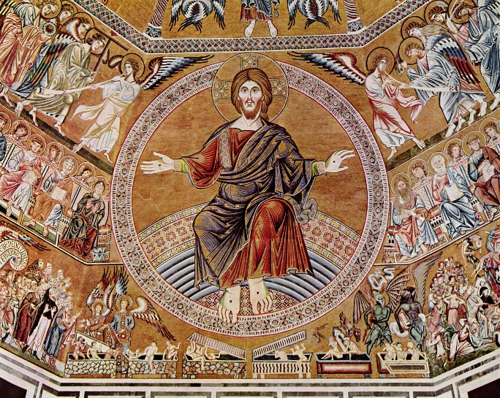
“And the king will answer them, 'Truly I tell you, just as you did it to one of the least of these who are members of my family, you did it to me.'” (Matthew 25:40)

Minister: Rev. Jason Evans
First Free Methodist Church
2625 N. Center Rd.
Saginaw, Michigan 48603
Phone: (989) 799-2930
Email: saginawfmc@gmail.com
www.saginawfirstfmc.org

Proper 29 (34)
November 22, 2020

The mission of Saginaw First Free Methodist Church is to be faithful to God and to make known to all people everywhere God’s call to wholeness in Jesus Christ.

Prelude
**Greeting/Announcements
*Call to Worship (spoken responsively)
L: Come to worship Jesus Christ, Alpha and Omega, the one who is, who was, and is to come
P: We come to worship the one who rules justly
L: Come to worship Jesus Christ, the faithful witness
P: The firstborn of the dead, the ruler of the kings of the earth
L: We come to worship Jesus Christ, King of kings and Lord of lords
P: To him be glory and dominion forever and ever! Amen

*Opening Hymn: “Of the Father’s Love Begotten” #164 (v.1)
Of the Father’s love begotten
Ere the worlds began to be
He is Alpha and Omega
He the source, the ending He
Of the things that are, that have been
And that future years shall see
Evermore and evermore

*Invocation and Lord’s Prayer
L: God of Eternity, we stand with the courage of those who insisted, even in perilous times, that not even the most powerful rulers of this earth hold our eternal destiny in their hands. We are secure in Christ, whose reign is just, whose power is endless, and whose love is unfathomable. God of Eternity, we join the chorus of saints who continue to declare that Christ is our King, as we pray together the prayer that Jesus taught His disciples…

P: Our Father, who art in heaven, hallowed be Your name. Your kingdom come; your will be done in earth as it is in heaven. Give us this day our daily bread and forgive us our debts as we forgive our debtors. And lead us not into temptation but deliver us from evil. For Yours is the kingdom, and the power, and the glory forever. Amen.

*Gloria Patri
Glory be to the Father​
And to the Son and to the Holy Ghost.
As it was in the beginning​
Is now and ever shall be
World without end
Amen. Amen

First Scripture Lesson: Ezekiel 34:11-16, 20-24

For thus says the Lord GOD: I myself will search for my sheep, and will seek them out. As shepherds seek out their flocks when they are among their scattered sheep, so I will seek out my sheep. I will rescue them from all the places to which they have been scattered on a day of clouds and thick darkness.
I will bring them out from the peoples and gather them from the countries, and will bring them into their own land; and I will feed them on the mountains of Israel, by the watercourses, and in all the inhabited parts of the land. I will feed them with good pasture, and the mountain heights of Israel shall be their pasture; there they shall lie down in good grazing land, and they shall feed on rich pasture on the mountains of Israel.
I myself will be the shepherd of my sheep, and I will make them lie down, says the Lord GOD. I will seek the lost, and I will bring back the strayed, and I will bind up the injured, and I will strengthen the weak, but the fat and the strong I will destroy. I will feed them with justice.
Therefore, thus says the Lord GOD to them: I myself will judge between the fat sheep and the lean sheep. Because you pushed with flank and shoulder, and butted at all the weak animals with your horns until you scattered them far and wide, I will save my flock, and they shall no longer be ravaged; and I will judge between sheep and sheep.
I will set up over them one shepherd, my servant David, and he shall feed them: he shall feed them and be their shepherd. And I, the LORD, will be their God, and my servant David shall be prince among them; I, the LORD, have spoken.

Prayer of Confession
L: God seeks out all people relentlessly. God will judge between the lean sheep and the fattened sheep. Do we unify God’s people? Or do we scatter the weak? For our participation in injustice, let us repent…

P: God of overwhelming mercy, you have claimed each generation of people as your family, fellow workers, and heirs of your grace. From the wealth of your storehouses an endless stream of love, mercy, and wisdom has washed over your people. Wave upon wave of endless light sweeps over us. How great are your storehouses, O God, how vast, how varied your gifts! In this hour enable us to open our hearts and receive your gifts. We praise you for the treasure of your love poured out for us and for all, in a thousand ways, through Christ our Lord. Amen.

Affirmation of Faith: Psalm100
P: Make a joyful noise to the LORD, all the earth. Worship the LORD with gladness; come into God’s presence with singing. Know that the LORD is God. It is God that made us, and we are God’s; we are God’s people, and the sheep of God’s pasture. Enter God’s gates with thanksgiving, and God’s courts with praise. Give thanks to God, bless God’s name. For the LORD is good; God’s steadfast love endures forever, and God’s faithfulness to all generations.

*Hymn of Affirmation: “I Know That My Redeemer Lives” #524 (v.3)
Thy love I soon expect to find
In all its depths and height
To comprehend th’eternal mind
And grasp the infinite
The bliss of those that fully dwell
Fully in Thee believe
‘Tis more than angel tongues can tell
Or angel minds conceive

Second Scripture Lesson: Ephesians 1:15-23

I have heard of your faith in the Lord Jesus and your love toward all the saints, and for this reason I do not cease to give thanks for you as I remember you in my prayers.
I pray that the God of our Lord Jesus Christ, the Father of glory, may give you a spirit of wisdom and revelation as you come to know him, so that, with the eyes of your heart enlightened, you may know what is the hope to which he has called you, what are the riches of his glorious inheritance among the saints, and what is the immeasurable greatness of his power for us who believe, according to the working of his great power.
God put this power to work in Christ when he raised him from the dead and seated him at his right hand in the heavenly places, far above all rule and authority and power and dominion, and above every name that is named, not only in this age but also in the age to come. And he has put all things under his feet and has made him the head over all things for the church, which is his body, the fullness of him who fills all in all.

Passing of the Peace

Prayers of the People
L: Lord in Your Mercy…
P: Hear our prayer.

Gospel Lesson: Matthew 25:31-46

“When the Son of Man comes in his glory, and all the angels with him, then he will sit on the throne of his glory. All the nations will be gathered before him, and he will separate people one from another as a shepherd separates the sheep from the goats, and he will put the sheep at his right hand and the goats at the left.
Then the king will say to those at his right hand, ‘Come, you that are blessed by my Father, inherit the kingdom prepared for you from the foundation of the world; for I was hungry and you gave me food, I was thirsty and you gave me something to drink, I was a stranger and you welcomed me, I was naked and you gave me clothing, I was sick and you took care of me, I was in prison and you visited me.’
Then the righteous will answer him, ‘Lord, when was it that we saw you hungry and gave you food, or thirsty and gave you something to drink? And when was it that we saw you a stranger and welcomed you, or naked and gave you clothing? And when was it that we saw you sick or in prison and visited you?’
And the king will answer them, ‘Truly I tell you, just as you did it to one of the least of these who are members of my family, you did it to me.’
Then he will say to those at his left hand, ‘You that are accursed, depart from me into the eternal fire prepared for the devil and his angels; for I was hungry and you gave me no food, I was thirsty and you gave me nothing to drink, I was a stranger and you did not welcome me, naked and you did not give me clothing, sick and in prison and you did not visit me.’
Then they also will answer, ‘Lord, when was it that we saw you hungry or thirsty or a stranger or naked or sick or in prison, and did not take care of you?’
Then he will answer them, ‘Truly I tell you, just as you did not do it to one of the least of these, you did not do it to me.’
And these will go away into eternal punishment, but the righteous into eternal life.”

Sermon

Prayer of Response

*Hymn of Response: “Beautiful Savior”
Beautiful Savior, Lord of the nations
Son of God and Son of Man!
Glory and honor, Praise, adoration
Now and forevermore be Thine

Invitation of Offering
L: God the creator, sustainer of all life, and who brings us together; invites us to give more than our money in the plate, but to give our whole selves. Give for Christ’s ongoing work of compassion and healing, as we collect this morning’s tithes and offerings.

*Doxology
Praise God, from whom all blessings flow
Praise Him, all creatures here below
Praise Him above, ye heavenly host
Praise Father Son, and Holy Ghost.
Amen.

*Prayer

*Hymn: “Crown Him with Many Crowns” #272 (v.1)
Crown Him with many crowns
The Lamb upon the throne
Hark! How the heav’nly anthem drowns
All music but its own
Awake, my soul and sing
Of Him who died for thee
And hail Him as thy matchless King
Thro’ all eternity

*Benediction
L: Celebrate the reign of Christ, our King, not just in the kingdom that is to come, but reign in our hearts. Do not withhold from God, who is our life, our light, and our redemption. Make our loyalty to God’s reign known in our world through our living, as you go in peace to love and serve. Amen.

