Saginaw First Free Methodist Church
DAY OF PENTECOST
May 31, 2020

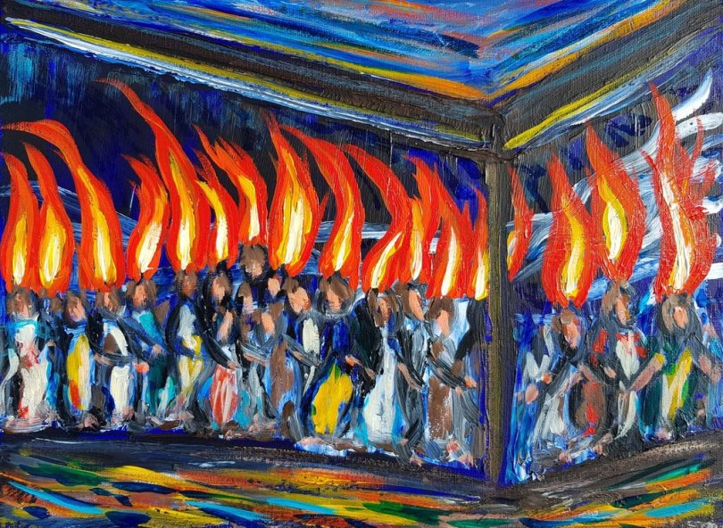

“And suddenly from heaven there came a sound like the rush of a violent wind, and it filled the entire house where they were sitting. Divided tongues, as of fire, appeared among them, and a tongue rested on each of them. All of them were filled with the Holy Spirit and began to speak in other languages, as the Spirit gave them ability.” (Acts 2:2-4)

Minister: Rev. Jason Evans
First Free Methodist Church
2625 N. Center Rd.
Saginaw, Michigan 48603
Phone: (989) 799-2930
Email: saginawfmc@gmail.com
www.saginawfirstfmc.org

DAY OF PENTECOST
May 31, 2020

The mission of Saginaw First Free Methodist Church is to be faithful to God and to make known to all people everywhere God’s call to wholeness in Jesus Christ.

Prelude
Greeting/Announcements
Call to Worship (spoken responsively)
L: How manifold are the works of our Creator
P: We feel the tongues of fire empowering us
L: God blesses us with great power
P: We feel the breath of God filling us with confidence
L: Receive with joy the gift of the Holy Spirit
P: The Spirit creates new life within and among us
L: God gives us a vision of Heaven on earth
P: May the glory of God spread to every heart

*Opening Hymn: “Love Divine, All Loves Excelling” #507 (vv.1-4)
Love divine, all loves excelling, Joy of heav'n to earth come down
Fix in us thy humble dwelling, all thy faithful mercies crown
Jesus, thou art all compassion, pure, unbounded love thou art
Visit us with thy salvation, enter ev'ry trembling heart

Breathe, O breathe thy loving Spirit, into ev'ry troubled breast
Let us all in thee inherit, let us find the second rest
Take away our bent to sinning, Alpha and Omega be
End of faith, as its Beginning, set our hearts at liberty

Come, Almighty, to deliver, Let us all Thy life receive
Suddenly return and never, Nevermore Thy temples leave
Thee we would be always blessing, Serve Thee as Thy hosts above
Pray and praise Thee without ceasing, Glory in Thy perfect love

Finish, then, thy new creation, pure and spotless let us be
Let us see thy great salvation, perfectly restored in thee
Changed from glory into glory, 'til in heav'n we take our place
Til we cast our crowns before thee, lost in wonder, love, and praise

Invocation and Lord’s Prayer
L: Powerful God, whose ways are beyond our knowledge, we seek to grow as disciples. We are thirsty for the living water you promised. We are eager to catch the Spirit and be alive with fire from on high. Inspire us with wisdom, so we may witness to your love and compassion. You have trusted us with gifts, may we use them with courage to further your kingdom, as we pray together the prayer that Jesus taught His disciples…

P: Our Father, who art in heaven, hallowed be Your name. Your kingdom come; your will be done in earth as it is in heaven. Give us this day our daily bread and forgive us our debts as we forgive our debtors. And lead us not into temptation but deliver
us from evil. For Yours is the kingdom, and the power, and the glory forever. Amen.

Gloria Patri

First Scripture Lesson: Numbers 11:24-30
So Moses went out and told the people the words of the LORD; and he gathered seventy elders of the people, and placed them all around the tent. Then the LORD came down in the cloud and spoke to him, and took some of the spirit that was on him and put it on the seventy elders; and when the spirit rested upon them, they prophesied. But they did not do so again.

Two men remained in the camp, one named Eldad, and the other named Medad, and the spirit rested on them; they were among those registered, but they had not gone out to the tent, and so they prophesied in the camp.

And a young man ran and told Moses, “Eldad and Medad are prophesying in the camp.”

And Joshua son of Nun, the assistant of Moses, one of his chosen men, said, “My lord Moses, stop them!”

But Moses said to him, “Are you jealous for my sake? Would that all the Lord’s people were prophets, and that the LORD would put his spirit on them!”

And Moses and the elders of Israel returned to the camp.

Prayer of Confession
L: We know the words of Pentecost; Spirit, wind, fire. We claim an interest in God’s creation. But how much time and effort do we devote to the mission? How open are we to God’s call? For our fear of discomfort, let us confess…

P: Loving God, you teach us to bring heaven to earth, and help all people experience justice and freedom. But we often want to manage our own lives and assure our own safety. We are afraid you will ask us to do more than we are willing. We don’t want to risk our status, savings, or reputation. We don’t want others to consider us strange or fanatical. We are skeptical of dreams and visions. We don’t trust some people you ask us to love. Revive in us a new compassion, and an imagination that overcomes despair and fear. Open us to a more heaven like image of living in this world. Amen.

Affirmation of Faith: Psalm 104
P: O LORD, how manifold are your works! In wisdom you have made them all; the earth is full of your creatures. Yonder is the sea, great and wide, creeping things innumerable are there, living things both small and great. These all look to you to give them their food in due season; when you give to them, they gather it up; when you open your hand, they are filled with good things. When you hide your face, they are dismayed; when you take away their breath, they die and return to their dust. When you send forth your spirit, they are created; and you renew the face of the ground. May the glory of the LORD endure forever; may the LORD rejoice in his works.

*Hymn of Affirmation: “Come, Holy Spirit, Heavenly Dove”
Come, Holy Spirit, heav'nly Dove
With all Thy quickening powers
Kindle a flame of sacred love
In these cold hearts of ours

O raise our thoughts from things below
From vanities and toys
Then shall we with fresh courage to
To reach eternal joys

Awake our souls to joyful songs
Let pure devotion rise
Till praise employs our thankful tongues
And doubt forever dies

Come, Holy Spirit, heav'nly Dove
With all Thy quickening powers
Come, shed abroad a Savior's love
And that shall kindle ours

New Testament Scripture Lesson: Acts 2:1-21
When the day of Pentecost had come, they were all together in one place. And suddenly from heaven there came a sound like the rush of a violent wind, and it filled the entire house where they were sitting. Divided tongues, as of fire, appeared among them, and a tongue rested on each of them.

All of them were filled with the Holy Spirit and began to speak in other languages, as the Spirit gave them ability. Now there were devout Jews from every nation under heaven living in Jerusalem. And at this sound the crowd gathered and was bewildered, because each one heard them speaking in the native language of each.

Amazed and astonished, they asked, “Are not all these who are speaking Galileans? And how is it that we hear, each of us, in our own native language? Parthians, Medes, Elamites, and residents of Mesopotamia, Judea and Cappadocia, Pontus and Asia, Phrygia and Pamphylia, Egypt and the parts of Libya belonging to Cyrene, and visitors from Rome, both Jews and proselytes, Cretans and Arabs--in our own languages we hear them speaking about God's deeds of power.”

All were amazed and perplexed, saying to one another, “What does this mean?”

But others sneered and said, “They are filled with new wine.”

But Peter, standing with the eleven, raised his voice and addressed them, “Men of Judea and all who live in Jerusalem, let this be known to you, and listen to what I say. Indeed, these are not drunk, as you suppose, for it is only nine o'clock in the morning. No, this is what was spoken through the prophet Joel ‘In the last days it will be, God declares, that I will pour out my Spirit upon all flesh, and your sons and your daughters shall prophesy, and your young men shall see visions, and your old men shall dream dreams.

Even upon my slaves, both men and women, in those days I will pour out my Spirit; and they shall prophesy. And I will show portents in the heaven above and signs on the earth below, blood, and fire, and smoky mist. The sun shall be turned to darkness and the moon to blood, before the coming of the Lord's great and glorious day. Then everyone who calls on the name of the Lord shall be saved.’”

Special Music: Micki Martin

Passing of the Peace

Prayers of the People
L: Lord in Your Mercy…
P: Hear our prayer.

Gospel Lesson: John 7:37-39
On the last day of the festival, the great day, while Jesus was standing there, he cried out, “Let anyone who is thirsty come to me, and let the one who believes in me drink. As the scripture has said, ‘Out of the believer's heart shall flow rivers of living water’”

Now he said this about the Spirit, which believers in him were to receive; for as yet there was no Spirit, because Jesus was not yet glorified.

Sermon

Prayer of Response

Hymn of Response: “This Is My Father’s World”
This is my Father's world
And to my listening ears
All nature sings, and round me rings
The music of the spheres
This is my Father's world
I rest me in the thought
Of rocks and trees, of skies and seas
His hand the wonders wrought

This is my Father's world
The birds their carols raise
The morning light, the lily white
Declare their Maker's praise
This is my Father's world
He shines in all that's fair
In the rustling grass I hear Him pass
He speaks to me everywhere

This is my Father's world
O let me ne'er forget
That though the wrong seems oft so strong
God is the Ruler yet
This is my Father's world
Why should my heart be sad?
The Lord is King: let the heavens ring
God reigns; let earth be glad!

Invitation of Offering
L: Your participation in the church makes this world a kingdom of God. We all have our gifts and talents to steward. But sharing what we have equally, distinguishes us from the world. Give out of your abundance of joy, as we collect this morning’s tithes and offerings

*Doxology

Prayer

Closing Hymn: “Christ Arose”
Low in the grave he lay, Jesus my Savior
Waiting the coming day, Jesus my Lord
Up from the grave he arose
With a mighty triumph o'er his foes
He arose a victor from the dark domain
And he lives forever, with his saints to reign
He arose! He arose! Hallelujah! Christ arose

Death cannot keep its prey, Jesus my Savior
He tore the bars away, Jesus my Lord
Up from the grave he arose
With a mighty triumph o'er his foes
He arose a victor from the dark domain
And he lives forever, with his saints to reign
He arose! He arose! Hallelujah! Christ arose

Benediction
L: We have been given our many gifts, let us go use them for the common good of God’s creation. We are sent forth to serve as Christ’s body. Take pleasure in the works of God, as you go in peace to love and serve. Amen.

