First Free Methodist Church of Saginaw
Sixth Sunday of Easter
May 22, 2022

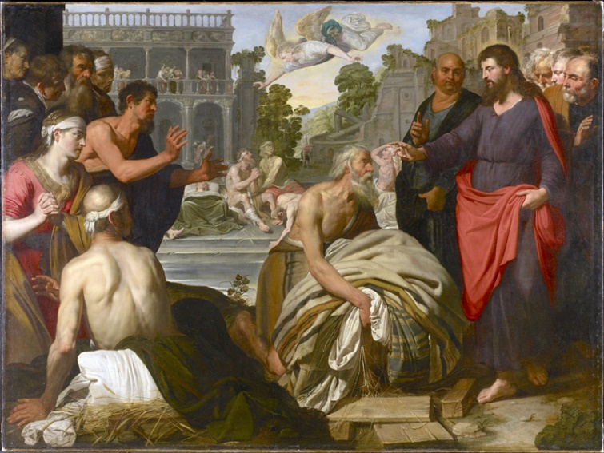
“Jesus said to him, ‘Stand up, take your mat and walk.’"
(John 5:8)

Minister: Rev. Jason Evans
First Free Methodist Church
2625 N. Center Rd.
Saginaw, Michigan 48603
Phone: (989) 799-2930
Email: saginawfmc@gmail.com
www.saginawfirstfmc.org

Sixth Sunday of Easter
May 22, 2022

Prelude
**Greeting/Announcements
*Call to Worship (spoken responsively)
L: Almighty God, maker of heaven and earth
P: My life is your
L: In due time, God gave a son to reconcile all things
P: My hope is in you alone
L: The glory of God is the light of the world
P: The heartbeat of my life is to worship in Your light
L: I fall onto my knees in awe
P: Cause Your glory is so beautiful

*Opening Hymn: “I will Praise Him” #119 (vv.1,4-5)
When I saw the cleansing fountain
Open wide for all my sin
I obeyed the Spirit’s wooing
When He said, wilt thou be clean
I will praise Him! I will praise Him
Praise the Lamb for sinners slain
Give Him glory, all ye people
For His blood can wash away each stain

Blessed be the name of Jesus
I’m so glad He took me in
He’s forgiven my transgressions
He has cleansed my heart from sin
I will praise Him! I will praise Him
Praise the Lamb for sinners slain
Give Him glory, all ye people
For His blood can wash away each stain

Glory, glory to the Father
Glory, glory to the Son
Glory, glory to the Spirit
Glory to the Three in One
I will praise Him! I will praise Him
Praise the Lamb for sinners slain
Give Him glory, all ye people
For His blood can wash away each stain

*Invocation and Lord’s Prayer
L: O God, you have prepared for those who love you such good things that surpass our understanding: Pour into our hearts such love towards you, that we, loving you in all things and above all things, may obtain your promises, which exceed all that we can desire. May our hearts and minds be acceptable to you, as we pray the prayer that Jesus taught His disciples…

P: Our Father, who art in heaven, hallowed be Your name. Your kingdom come; your will be done in earth as it is in heaven. Give us this day our daily bread and forgive us our debts as we forgive our debtors. And lead us not into temptation but deliver us from evil. For Yours is the kingdom, and the power, and the glory forever. Amen.

*Gloria Patri
Glory be to the Father​
And to the Son and to the Holy Ghost.​
As it was in the beginning​
Is now and ever shall be.​
World without end. ​
Amen. Amen.​

First Scripture Lesson: Acts 16:9-15
During the night Paul had a vision: there stood a man of Macedonia pleading with him and saying, “Come over to Macedonia and help us.”
When he had seen the vision, we immediately tried to cross over to Macedonia, being convinced that God had called us to proclaim the good news to them. We set sail from Troas and took a straight course to Samothrace, the following day to Neapolis, and from there to Philippi, which is a leading city of the district of Macedonia and a Roman colony. We remained in this city for some days.
On the sabbath day we went outside the gate by the river, where we supposed there was a place of prayer; and we sat down and spoke to the women who had gathered there. A certain woman named Lydia, a worshiper of God, was listening to us; she was from the city of Thyatira and a dealer in purple cloth. The Lord opened her heart to listen eagerly to what was said by Paul.
When she and her household were baptized, she urged us, saying, “If you have judged me to be faithful to the Lord, come and stay at my home.” And she prevailed upon us.

Prayer of Confession
L: God, who by the light of the Holy Spirit did instruct the hearts of the faithful, also grants in us that same Spirit to be truly wise and ever rejoice in the consolation of Christ. May our hearts be rekindled, our spirits grow calm, our vision be clear, and our purpose be unified...

P: Grant me grace, O merciful God, to desire ardently all that is pleasing to you, to examine it prudently, to acknowledge it truthfully, and to accomplish it perfectly for the praise and glory of your name. Grant that I may always allow myself to be guided by you, always follow your plans, and perfectly accomplish your holy will. Grant that in all things, great and small, today and all the days of my life, I may do whatever you may require of me. Help me to respond to the slightest prompting of your grace, so that I may be your trustworthy instrument for your honor. Amen.

Affirmation of Faith: Psalm 67
P: May God be gracious to us and bless us and make his face to shine upon us, that your way may be known upon earth, your saving power among all nations. Let the peoples praise you, O God; let all the peoples praise you. Let the nations be glad and sing for joy, for you judge the peoples with equity and guide the nations upon earth. Let the peoples praise you, O God; let all the peoples praise you. The earth has yielded its increase; God, our God, has blessed us. May God continue to bless us; let all the ends of the earth revere him.

Hymn of Affirmation: “Take Time to Be Holy” #512 (vv.1-4)
Take time to be holy, speak oft with thy Lord
Abide in Him always, and feed on His Word
Make friends of God’s children, help those who are weak
Forgetting in nothing His blessing to seek

Take time to be holy, the world rushes on
Spend much time in secret, with Jesus alone
By looking to Jesus, like Him thou shalt be
Thy friends in thy conduct His likeness shall see

Take time to be holy, let Him be thy Guide
And run not before Him, whatever betide
In joy or in sorrow, still follow the Lord
And, looking to Jesus, still trust in His Word

Take time to be holy, be calm in thy soul
Each thought and each motive beneath His control
Thus led by His Spirit to fountains of love
Thou soon shalt be fitted for service above

Second Scripture Lesson: Revelation 21:10, 22-22:5
And in the spirit he carried me away to a great, high mountain and showed me the holy city Jerusalem coming down out of heaven from God. I saw no temple in the city, for its temple is the Lord God the Almighty and the Lamb. And the city has no need of sun or moon to shine on it, for the glory of God is its light, and its lamp is the Lamb.
The nations will walk by its light, and the kings of the earth will bring their glory into it. Its gates will never be shut by day--and there will be no night there. People will bring into it the glory and the honor of the nations. But nothing unclean will enter it, nor anyone who practices abomination or falsehood, but only those who are written in the Lamb's book of life.
Then the angel showed me the river of the water of life, bright as crystal, flowing from the throne of God and of the Lamb through the middle of the street of the city. On either side of the river is the tree of life with its twelve kinds of fruit, producing its fruit each month; and the leaves of the tree are for the healing of the nations.
Nothing accursed will be found there anymore. But the throne of God and of the Lamb will be in it, and his servants will worship him; they will see his face, and his name will be on their foreheads. And there will be no more night; they need no light of lamp or sun, for the Lord God will be their light, and they will reign forever and ever.

Children’s Sermon

Passing of the Peace

Prayers of the People
L: Lord in Your Mercy…
P: Hear our prayer.

Gospel Lesson: John 5:1-9
After this there was a festival of the Jews, and Jesus went up to Jerusalem. Now in Jerusalem by the Sheep Gate there is a pool, called in Hebrew Beth-zatha, which has five porticoes. In these lay many invalids--blind, lame, and paralyzed.
One man was there who had been ill for thirty-eight years. When Jesus saw him lying there and knew that he had been there a long time, he said to him, “Do you want to be made well?”
The sick man answered him, “Sir, I have no one to put me into the pool when the water is stirred up; and while I am making my way, someone else steps down ahead of me.”
Jesus said to him, “Stand up, take your mat and walk.”
At once the man was made well, and he took up his mat and began to walk. Now that day was a sabbath.

Sermon: “”

Prayer of Response

Hymn of Response: “I Love to Tell the Story” #696 (vv.1-4)
I love to tell the story, of unseen things above
Of Jesus and his glory, of Jesus and his love
I love to tell the story, because I know 'tis true
It satisfies my longings, as nothing else could do
I love to tell the story, 'twill be my theme in glory
To tell the old, old story of Jesus and his love

I love to tell the story, more wonderful it seems
Than all the golden fancies, of all our golden dreams
I love to tell the story, it did so much for me
And that is just the reason, I tell it now to thee
I love to tell the story, 'twill be my theme in glory
To tell the old, old story of Jesus and his love

I love to tell the story, 'tis pleasant to repeat
What seems, each time I tell it, more wonderfully sweet
I love to tell the story, for some have never heard
The message of salvation from God's own holy Word
I love to tell the story, 'twill be my theme in glory
To tell the old, old story of Jesus and his love

I love to tell the story, for those who know it best
Seem hungering and thirsting, to hear it like the rest
And when in scenes of glory I sing the new, new song
‘Twill be the old, old story, that I have loved so long
I love to tell the story, 'twill be my theme in glory
To tell the old, old story of Jesus and his love

Invitation of Offering
L: May the tribute of our humble ministry be pleasing to the Holy Trinity. Through God’s grace may it further redemption in this world. With prayer make your offering, as we collect this morning’s tithes and offerings.

*Doxology
Praise God, from whom all blessings flow
Praise Him, all creatures here below
Praise Him above, ye heavenly host
Praise Father Son, and Holy Ghost.
Amen.

*Prayer

*Closing Hymn: “Sweet By-and-By” #658 (vv.1-3)
There’s a land that is fairer than day
And by faith we can see it afar
For the Father waits over the way
To prepare us a dwelling place there
In the sweet by and by
We shall meet on that beautiful shore
In the sweet by and by
We shall meet on that beautiful shore

We shall sing on that beautiful shore
The melodious songs of the blest
And our spirits shall sorrow no more
Not a sigh for the blessing of rest
In the sweet by and by
We shall meet on that beautiful shore
In the sweet by and by
We shall meet on that beautiful shore

To our bountiful Father above
We will offer our tribute of praise
For the glorious gift of His love
And the blessings that hallow our days
In the sweet by and by
We shall meet on that beautiful shore
In the sweet by and by
We shall meet on that beautiful shore

*Benediction
L: Almighty God has invited us into the sweet life of redemption in Christ Jesus. Therefore, may the soul of Christ make you holy. May the body of Christ be your salvation. May the mind of Christ be in you at all times and in all manners, as you go in peace to love and serve. Amen.

