First Free Methodist Church of Saginaw
Sixth Sunday of Easter
May 14, 2023

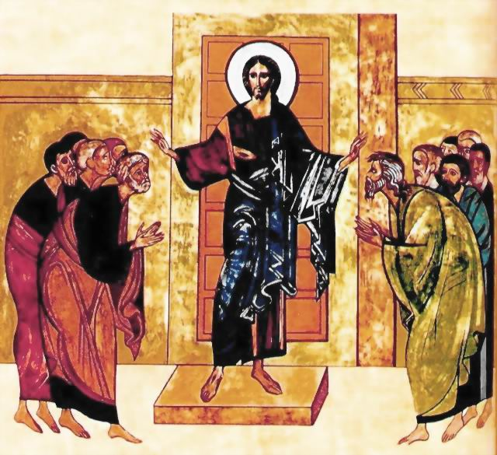
“And he said, “Who are you, Lord?” And he said, “I am Jesus, whom you are persecuting”
(Acts 9:5)

Minister: Rev. Jason Evans
First Free Methodist Church
2625 N. Center Rd.
Saginaw, Michigan 48603
Phone: (989) 799-2930
Email: saginawfmc@gmail.com
www.saginawfirstfmc.org

Sixth Sunday of Easter
May 14, 2023

Prelude
Announcements
*Call to Worship (spoken responsively)
L: A woman of noble character, who can find?
P: She is worth far more than rubies
L: She is like the merchant ships
P: Bringing her food from afar
L: She opens her arms to the poor
P: And extends her hands to the needy
L: Charm is deceptive, and beauty is fleeting
P: But a woman who fears the Lord is to be praised

*Opening Song: “Shout to the Lord”
My Jesus, my Savior
Lord, there is none like You
All of my days, I want to praise
The wonders of Your mighty love

My comfort, my shelter
Tower of refuge and strength
Let every breath, all that I am
Never cease to worship You

Shout to the Lord
All the earth let us sing
Power and majesty praise to the King
Mountains bow down and the seas will roar
At the sound of Your name
I sing for joy at the work of Your hands
Forever I'll love You, forever I'll stand
Nothing compares to the promise I have in You

*Invocation and Lord’s Prayer
L: Almighty God, whose blessed apostles Peter and Paul glorified you by their martyrdom: Grant that our Church, instructed by their teachings and example, and knit together in unity by your Spirit, may ever stand firm upon the one foundation, which is Jesus Christ our Lord. Give us grace to imitate their obedience to your commands, as we pray the prayer that Jesus taught His disciples…

P: Our Father, who art in heaven, hallowed be Your name. Your kingdom come; your will be done in earth as it is in heaven. Give us this day our daily bread and forgive us our debts as we forgive our debtors. And lead us not into temptation but deliver us from evil. For Yours is the kingdom, and the power, and the glory forever. Amen.

*Gloria Patri
Glory be to the Father​
And to the Son and to the Holy Ghost.​
As it was in the beginning​
Is now and ever shall be.​
World without end. ​
Amen. Amen.​

*Passing of the Peace

Congregational Song: “No Longer Slaves”
You unravel me, with a melody
You surround me with a song
Of deliverance, from my enemies
Till all my fears are gone

I’m no longer a slave to fear
I am a child of God
I’m no longer a slave to fear
I am a child of God

From my mothers womb
You have chosen me
Love has called my name
I’ve been born again, into a family
Your blood flows through my veins

I’m no longer a slave to fear
I am a child of God
I’m no longer a slave to fear
I am a child of God

I am surrounded
By the arms of the father
I am surrounded
By songs of deliverance
We've been liberated
From our bondage
We're the sons and the daughters
Let us sing our freedom

You split the sea
So I could walk right through it
My fears were drowned in perfect love
You rescued me
And I will stand and sing
I am the child of God

You split the sea
So I could walk right through it
My fears were drowned in perfect love
You rescued me
And I will stand and sing
I am the child of God

I am a Child of God
I am a Child of God
I am a Child of God
I am a Child of God
I am a Child of God

Affirmation of Faith: Apostle’s Creed
P: I believe in God, the Father Almighty, Maker of heaven and earth. And in Jesus Christ, God’s only Son, our Lord. Who was conceived by the Holy Spirit, born of the Virgin Mary, suffered under Pontius Pilate, was crucified, dead, and was buried. He descended into hades, the third day He rose again from the dead. He ascended into heaven, and sits at the right hand of God the Father Almighty. From thence He shall come to judge the living and the dead. I believe in the Holy Spirit, the holy Church universal, the communion of saints, the forgiveness of sins, the resurrection of the body, and the life everlasting. Amen.

Special Music: Micki Martin

Children’s Sermon

Gospel Lesson: Acts 9:1-9
But Saul, still breathing threats and murder against the disciples of the Lord, went to the high priest and asked him for letters to the synagogues at Damascus, so that if he found any belonging to the Way, men or women, he might bring them bound to Jerusalem.
Now as he journeyed he approached Damascus, and suddenly a light from heaven flashed about him. And he fell to the ground and heard a voice saying to him, “Saul, Saul, why do you persecute me?”
And he said, “Who are you, Lord?” And he said, “I am Jesus, whom you are persecuting; but rise and enter the city, and you will be told what you are to do.”
The men who were traveling with him stood speechless, hearing the voice but seeing no one. Saul arose from the ground; and when his eyes were opened, he could see nothing; so they led him by the hand and brought him into Damascus. And for three days he was without sight, and neither ate nor drank.

Sermon
Prayers of the People
L: Lord in Your Mercy…
P: Hear our prayer.

Hymn of Response: “Because He Lives” #256 (vv.1-3)
God sent His son, they called Him Jesus
He came to love, heal and forgive
He lived and died to buy my pardon
An empty grave is there to prove my savior lives
Because He lives, I can face tomorrow
Because He lives, all fear is gone
Because I know He holds the future
And life is worth the living, just because He lives

How sweet to hold a new born baby
And feel the pride and the joy that he gives
But greater still that calm assurance
This child can face uncertain days because
He lives
Because He lives, I can face tomorrow
Because He lives, all fear is gone
Because I know He holds the future
And life is worth the living, just because He lives

And then one day, I'll cross the river
I'll fight life's final war with pain
And then, as death gives way to victory
I'll see the lights of glory and I'll know He reigns
Because He lives, I can face tomorrow
Because He lives, all fear is gone
Because I know He holds the future
And life is worth the living, just because He lives

Invitation of Offering
L: Offer to God a sacrifice of thanksgiving, and make good your vows to the Most High. Walk in love, as Christ loved us and gave himself for us, an offering and sacrifice to God, as we collect this morning’s tithes and offerings.

*Doxology
Praise God, from whom all blessings flow
Praise Him, all creatures here below
Praise Him above, ye heavenly host
Praise Father Son, and Holy Ghost.
Amen.

*Prayer
*Closing Hymn: “Living for Jesus” #496 (vv.1-2,4)
Living for Jesus, a life that is true
Striving to please Him in all that I do
Yielding allegiance, glad-hearted and free
This is the pathway of blessing for me
O Jesus, Lord and Savior, I give myself to Thee
For Thou, in Thy atonement, didst give Thyself for me
I own no other Master, my heart shall be Thy throne
My life I give, henceforth to live, O Christ, for Thee alone

Living for Jesus, wherever I am
Doing each duty in His holy Name
Willing to suffer affliction and loss
Deeming each trial a part of my cross
O Jesus, Lord and Savior, I give myself to Thee
For Thou, in Thy atonement, didst give Thyself for me
I own no other Master, my heart shall be Thy throne
My life I give, henceforth to live, O Christ, for Thee alone

Living for Jesus through earth’s little while
My dearest treasure, the light of His smile
Seeking the lost ones He died to redeem
Bringing the weary to find rest in Him
O Jesus, Lord and Savior, I give myself to Thee
For Thou, in Thy atonement, didst give Thyself for me
I own no other Master, my heart shall be Thy throne
My life I give, henceforth to live, O Christ, for Thee alone

*Benediction
L: May Christ dwell in your hearts through faith—that you, being rooted and grounded in love, may have strength to comprehend with all the saints the love of Christ that surpasses knowledge, that you may be filled with all the fullness of God. Go in peace to love and serve. Amen.

