Saginaw First Free Methodist Church
LITURGY OF THE PALMS
March 28, 2021

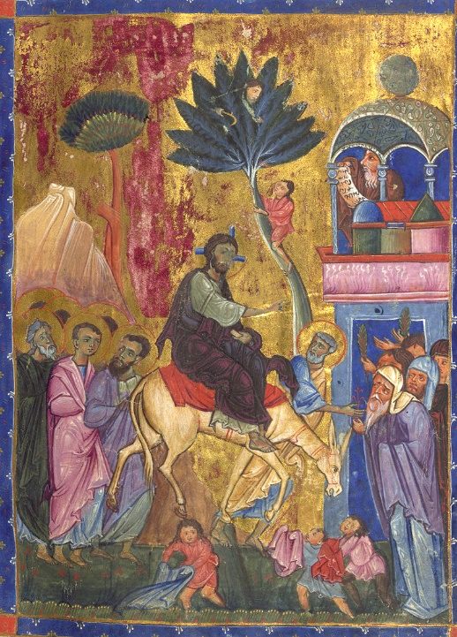
“Many people spread their cloaks on the road, and others spread leafy branches that they had cut in the fields. Then those who went ahead and those who followed were shouting, “Hosanna! Blessed is the one who comes in the name of the Lord!’”
Mark 11:8-9)

Minister: Rev. Jason Evans
First Free Methodist Church
2625 N. Center Rd.
Saginaw, Michigan 48603
Phone: (989) 799-2930
Email: saginawfmc@gmail.com
www.saginawfirstfmc.org

LITURGY OF THE PALMS
March 28, 2021

The mission of Saginaw First Free Methodist Church is to be faithful to God and to make known to all people everywhere God’s call to wholeness in Jesus Christ.

Prelude
**Greeting/Announcements
*Call to Worship (spoken responsively)
L: As the time approached for him, Jesus set out for Jerusalem
P: As he went along, people spread their cloaks on the road
L: The whole crowd of disciples joyfully praised God with loud voices
P: Hosanna! Blessed is he who comes in the name of the Lord
L: Blessed is the coming kingdom of our father David
P: Hosanna in the highest
L: Lift up your heads, all you gates
P: Be lifted up you ancient doors, that the King of glory may enter

*Opening Hymn: “All Glory, Laud, and Honor” #215 (vv.1,3)
All glory, laud, and honor to
Thee, Redeemer, King
To whom the lips of children
Made sweet hosannas ring
Thou art the King of Israel
Thou David’s royal Son
Ho in the Lord’s name comest
The King and Blessed One

To Thee, before Thy passion
They sang their hymns of praise
To Thee, now high exalted
Our melody we raise
Thou didst accept their praises
Accept the praise we bring
Who in all good delightest
Thou good and gracious King

*Invocation and Lord’s Prayer
L: Holy God, day by day you sustain the weary with your word and gently encourage us to place our trust in you. Awaken us this day, that our ears will be open to your truth. Inscribe your law in our hearts, that we may be humble as Christ was. Teach us to be obedient, for your kingdom’s sake. May our hearts be open to your will, as we pray the prayer that Jesus taught His disciples…

P: Our Father, who art in heaven, hallowed be Your name. Your kingdom come; your will be done in earth as it is in heaven. Give us this day our daily bread and forgive us our debts as we forgive our debtors. And lead us not into temptation but deliver us from evil. For Yours is the kingdom, and the power, and the glory forever. Amen.

*Gloria Patri
Glory be to the Father​
And to the Son and to the Holy Ghost.
As it was in the beginning​
Is now and ever shall be
World without end
Amen. Amen

Old Testament Scripture Lesson: Isaiah 50:4-9a
The Lord GOD has given me the tongue of a teacher, that I may know how to sustain the weary with a word. Morning by morning he wakens, wakens my ear to listen as those who are taught. The Lord GOD has opened my ear, and I was not rebellious, I did not turn backward.
I gave my back to those who struck me, and my cheeks to those who pulled out the beard; I did not hide my face from insult and spitting. The Lord GOD helps me; therefore I have not been disgraced; therefore I have set my face like flint, and I know that I shall not be put to shame; he who vindicates me is near. Who will contend with me? Let us stand up together. Who are my adversaries? Let them confront me.
It is the Lord GOD who helps me; who will declare me guilty?

Prayer of Confession
L: In this season of Lent, when we reexamine our lives and find our faith is tested, do we find we’ve been obedient? To remind ourselves of God’s mission for us, let us pray…

P: Gracious God, we come to you knowing we can be fickle. We say “Hosanna” and shout for joy when you are marching for the throne. But where are we when it’s time to humble ourselves? When we are insulted and disgraced, do we wait on you to vindicate us? Awaken us to the suffering of those around us; save us from hiding in denials or taunts that deepen the hurt; give us grace to share one another's burdens in humble service. May our hearts, minds, and souls be rooted in Kingdom principles. Amen.

Affirmation of Faith: Psalm 118
P: Have mercy on me, O God, according to your steadfast love; according to your abundant mercy blot out my transgressions. Wash me thoroughly from my iniquity, and cleanse me from my sin. For I know my transgressions, and my sin is ever before me. Against you, you alone, have I sinned, and done what is evil in your sight, so that you are justified in your sentence and blameless when you pass judgment. Indeed, I was born guilty, a sinner when my mother conceived me. You desire truth in the inward being; therefore teach me wisdom in my secret heart. Purge me with hyssop, and I shall be clean; wash me, and I shall be whiter than snow. Let me hear joy and gladness; let the bones that you have crushed rejoice. Hide your face from my sins, and blot out all my iniquities. Create in me a clean heart, O God, and put a new and right spirit within me. Do not cast me away from your presence, and do not take your holy spirit from me. Restore to me the joy of your salvation, and sustain in me a willing spirit.

Hymn of Affirmation: “Blessed Be the Name” #116 (vv.1,3)
O for a thousand tongues to sing
Blessed be the name of the Lord!
The glories of my God and King
Blessed be the name of the Lord!
Blessed be the name! Blessed be the name!
Blessed be the name of the Lord!
Blessed be the name! Blessed be the name!
Blessed be the name of the Lord!

He breaks the power of cancelled sin
Blessed be the name of the Lord!
His blood can make the foulest clean
Blessed be the name of the Lord!
Blessed be the name! Blessed be the name!
Blessed be the name of the Lord!
Blessed be the name! Blessed be the name!
Blessed be the name of the Lord!

New Testament Scripture Lesson: Philippians 2:5-11
Let the same mind be in you that was in Christ Jesus, who, though he was in the form of God, did not regard equality with God as something to be exploited, but emptied himself, taking the form of a slave, being born in human likeness. And being found in human form, he humbled himself and became obedient to the point of death-- even death on a cross.
Therefore God also highly exalted him and gave him the name that is above every name, so that at the name of Jesus every knee should bend, in heaven and on earth and under the earth, and every tongue should confess that Jesus Christ is Lord, to the glory of God the Father.

Passing of the Peace

Prayers of the People
L: Lord in Your Mercy…
P: Hear our prayer.

Gospel Lesson: Mark 11:1-11
When they were approaching Jerusalem, at Bethphage and Bethany, near the Mount of Olives, he sent two of his disciples and said to them, “Go into the village ahead of you, and immediately as you enter it, you will find tied there a colt that has never been ridden; untie it and bring it. If anyone says to you, ‘Why are you doing this?’ just say this, ‘The Lord needs it and will send it back here immediately.’”
They went away and found a colt tied near a door, outside in the street. As they were untying it, some of the bystanders said to them, “What are you doing, untying the colt?”
They told them what Jesus had said; and they allowed them to take it. Then they brought the colt to Jesus and threw their cloaks on it; and he sat on it. Many people spread their cloaks on the road, and others spread leafy branches that they had cut in the fields. Then those who went ahead and those who followed were shouting, “Hosanna! Blessed is the one who comes in the name of the Lord!

Sermon

Prayer of Response

Hymn of Response: “Hosanna, Loud Hosanna” #217 (vv.1,3)
Hosanna, Loud hosanna
The little children sing
Thro’ pillared court and temple
The lovely anthem rang
To Jesus, who had blessed them
Close folded to His breast
The children sang their praises
The simplest and the best

Hosanna in the highest
That ancient song we sing
For Christ is our Redeemer
The Lord of Heav’n, our King
O may we ever praise Him
With heart and life and voice
And in His blissful presence
Eternally rejoice

Invitation of Offering
L: Christ Jesus humbled himself and gave up everything for us and the whole world. We are invited to give a tithe to continue the spreading of this good news. May your giving come from a willing heart, as we collect this morning’s tithes and offerings.

*Doxology
Praise God, from whom all blessings flow
Praise Him, all creatures here below
Praise Him above, ye heavenly host
Praise Father Son, and Holy Ghost.
Amen.

*Prayer

*Hymn: “Lift Up Your Heads, Ye Mighty Gates” (vv.1-2,4)
Lift up your heads ye mighty gates
Behold, the king of glory waits
The king of kings is drawing near
The savior of the world is here

Fling wide the portals of your heart
Make it a temple, set apart
From earthly use for heaven’s employ
Adorned with prayer and love and joy

Thy Holy Spirit lead us on
Until our glorious goal is won
Eternal praise, eternal fame
Be offered, Savior, to thy name

*Benediction
L: We have spread our cloaks and waved our palm branches; signaling our commitment to our king. Remain obedient to this action. Confess that Jesus is Christ in word and deed. Carry the light of the world, as you go in peace to love and serve. Amen.

