Saginaw First Free Methodist Church
TRINITY SUNDAY
June 7, 2020
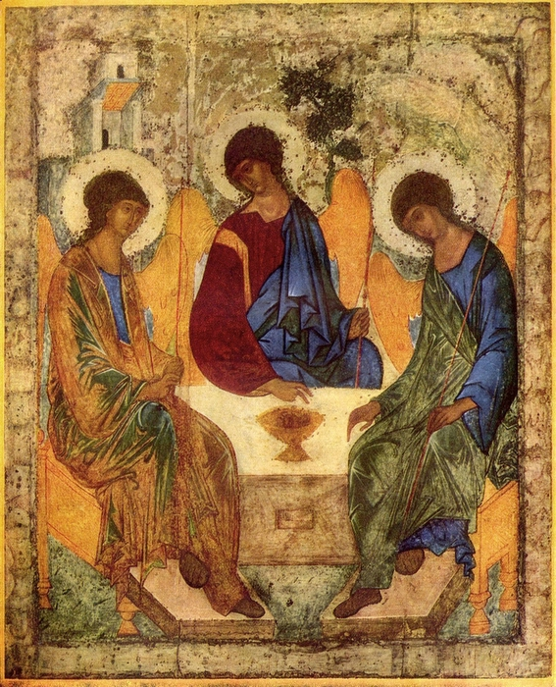
“And Jesus came and said to them, ‘All authority in heaven and on earth has been given to me. Go therefore and make disciples of all nations, baptizing them in the name of the Father and of the Son and of the Holy Spirit, and teaching them to obey everything that I have commanded you. And remember, I am with you always, to the end of the age.’” (Matthew 28:18-20)

Minister: Rev. Jason Evans
First Free Methodist Church
2625 N. Center Rd.
Saginaw, Michigan 48603
Phone: (989) 799-2930
Email: saginawfmc@gmail.com
www.saginawfirstfmc.org

TRINITY SUNDAY
June 7, 2020

The mission of Saginaw First Free Methodist Church is to be faithful to God and to make known to all people everywhere God’s call to wholeness in Jesus Christ.

Prelude
Greeting/Announcements
L: How majestic is God’s name in all the earth
P: God has made all created things and names them “Good”
L: We receive great care from the creator and sustainer of life
P: We are created in God’s image, sharing the Holy Spirit with all
L: God blesses us with good things
P: We rejoice in Christ’s promise of the Holy Spirit
L: Celebrate God by how you live your lives
P: We will share and care for all of God’s creations

*Opening Hymn: “Come, Thou Almighty King” #3

Come, Thou Almighty King
Help us thy name to sing
Help us to praise
Father all glorious, over all victorious
Come and reign over us
Ancient of days

Come, Thou incarnate Word
Gird on Thy mighty sword
Our prayer attend
Come and Thy people bless
And give thy word success
Spirit of holiness on us descend

Come, holy comforter
Thy sacred witness bear in this glad hour
Thou who almighty art
Now rule in every heart
And never from us depart Spirit of power

To Thee, great one in three
Eternal praises be, hence ever more
Thy sovereign majesty
May we in glory see
And to eternity love and adore

Invocation and Lord’s Prayer
L: God of delight, creation sings praises to you, and you are delighted in creation. Invite us into your joyful being where you know and are known in each beginning, in all sustenance, in every redemption, that we may manifest your unity in the diverse ministries you entrust to us, truly reflecting your triune majesty in the faith that acts, in the hope that does not disappoint, and in the love that endures. Remind us we are all connected, as we pray together the prayer that Jesus taught His disciples…

P: Our Father, who art in heaven, hallowed be Your name. Your kingdom come; your will be done in earth as it is in heaven. Give us this day our daily bread and forgive us our debts as we forgive our debtors. And lead us not into temptation but deliver
us from evil. For Yours is the kingdom, and the power, and the glory forever. Amen.

Gloria Patri

First Scripture Lesson: Genesis 1:1-2:4

In the beginning when God created the heavens and the earth, the earth was a formless void and darkness covered the face of the deep, while a wind from God swept over the face of the waters. Then God said, “Let there be light”; and there was light.

And God saw that the light was good; and God separated the light from the darkness. God called the light Day, and the darkness he called Night. And there was evening and there was morning, the first day.

And God said, “Let there be a dome in the midst of the waters, and let it separate the waters from the waters.” So God made the dome and separated the waters that were under the dome from the waters that were above the dome. And it was so. God called the dome Sky. And there was evening and there was morning, the second day.

And God said, “Let the waters under the sky be gathered together into one place, and let the dry land appear.” And it was so. God called the dry land Earth, and the waters that were gathered together he called Seas. And God saw that it was good.

Then God said, “Let the earth put forth vegetation: plants yielding seed, and fruit trees of every kind on earth that bear fruit with the seed in it.” And it was so. The earth brought forth vegetation: plants yielding seed of every kind, and trees of every kind bearing fruit with the seed in it. And God saw that it was good. And there was evening and there was morning, the third day.

And God said, “Let there be lights in the dome of the sky to separate the day from the night; and let them be for signs and for seasons and for days and years, and let them be lights in the dome of the sky to give light upon the earth.” And it was so. God made the two great lights--the greater light to rule the day and the lesser light to rule the night--and the stars.

God set them in the dome of the sky to give light upon the earth, to rule over the day and over the night, and to separate the light from the darkness. And God saw that it was good. And there was evening and there was morning, the fourth day.

And God said, “Let the waters bring forth swarms of living creatures, and let birds fly above the earth across the dome of the sky.” So God created the great sea monsters and every living creature that moves, of every kind, with which the waters swarm, and every winged bird of every kind. And God saw that it was good.

God blessed them, saying, “Be fruitful and multiply and fill the waters in the seas, and let birds multiply on the earth.” And there was evening and there was morning, the fifth day.

And God said, “Let the earth bring forth living creatures of every kind: cattle and creeping things and wild animals of the earth of every kind.” And it was so. God made the wild animals of the earth of every kind, and the cattle of every kind, and everything that creeps upon the ground of every kind. And God saw that it was good.

Then God said, “Let us make humankind in our image, according to our likeness; and let them have dominion over the fish of the sea, and over the birds of the air, and over the cattle, and over all the wild animals of the earth, and over every creeping thing that creeps upon the earth.” So God created humankind in his image, in the image of God he created them; male and female he created them.

God blessed them, and God said to them, “Be fruitful and multiply, and fill the earth and subdue it; and have dominion over the fish of the sea and over the birds of the air and over every living thing that moves upon the earth.” God said, “See, I have given you every plant yielding seed that is upon the face of all the earth, and every tree with seed in its fruit; you shall have them for food. And to every beast of the earth, and to every bird of the air, and to everything that creeps on the earth, everything that has the breath of life, I have given every green plant for food.” And it was so.

God saw everything that he had made, and indeed, it was very good. And there was evening and there was morning, the sixth day. Thus the heavens and the earth were finished, and all their multitude. And on the seventh day God finished the work that he had done, and he rested on the seventh day from all the work that he had done. So God blessed the seventh day and hallowed it, because on it God rested from all the work that he had done in creation. These are the generations of the heavens and the earth when they were created.

Prayer of Confession
L: God has called all things “Good,” and all life is interrelated. Human life precious and marvelously linked. But we stand idly by and let others be mistreated. Let’s admit our neglect as we confess…

P: God of all creation, Lord of Heaven and earth. You created all things good. You made mankind in your image. But we destroy your earth and neglect your people. You have provided for us abundantly; and instead of caring for our neighbors, we horde what we possess. We prefer our comfort instead of working to provide justice for those created in your image. We are unwilling to risk that which will not last, for the wellbeing of your beloved. May we put things back in proper order. Amen.

Affirmation of Faith: Psalm 8
P: O LORD, our Sovereign, how majestic is your name in all the earth! You have set your glory above the heavens. Out of the mouths of babes and infants you have founded a bulwark because of your foes, to silence the enemy and the avenger. When I look at your heavens, the work of your fingers, the moon and the stars that you have established; what are human beings that you are mindful of them, mortals that you care for them? Yet you have made them a little lower than God, and crowned them with glory and honor. You have given them dominion over the works of your hands; you have put all things under their feet, all sheep and oxen, and also the beasts of the field, the birds of the air, and the fish of the sea, whatever passes along the paths of the seas. O LORD, our Sovereign, how majestic is your name in all the earth!

*Hymn of Affirmation: “Seek Ye First” #90 (vv.1-2)
Seek ye first the kingdom of God
And His righteousness
And all these things shall be added unto you
Hallelu, Hallelujah!

Ask, and it shall be given unto you
Seek, and you shall find
Knock, and it shall be opened unto you
Hallelu, Hallelujah!

New Testament Scripture Lesson: 2 Corinthians 13:11-13

Finally, brothers and sisters, farewell. Put things in order, listen to my appeal, agree with one another, live in peace; and the God of love and peace will be with you. Greet one another with a holy kiss. All the saints greet you. The grace of the Lord Jesus Christ, the love of God, and the communion of the Holy Spirit be with all of you.

Special Music: Micki Martin

Passing of the Peace

Prayers of the People
L: Lord in Your Mercy…
P: Hear our prayer.

Gospel Lesson: Matthew 28:16-20

Now the eleven disciples went to Galilee, to the mountain to which Jesus had directed them. When they saw him, they worshiped him; but some doubted. And Jesus came and said to them, “All authority in heaven and on earth has been given to me. Go therefore and make disciples of all nations, baptizing them in the name of the Father and of the Son and of the Holy Spirit, and teaching them to obey everything that I have commanded you. And remember, I am with you always, to the end of the age.”

Sermon

Prayer of Response

Hymn of Response: “For the Beauty of the Earth” #776 (vv.1,3-5)
For the beauty of the earth
For the glory of the skies
For the love which from our birth
Over and around us lies
Lord, our Lord, to you we raise
This, our hymn of grateful praise

For the joy of human love
Brother, sister, parent, child
Friends on earth, and friends above
For all gentle thoughts and mild
Lord, our Lord, to you we raise
This, our hymn of grateful praise

For the church that evermore
Lifteth holy hands above
Offering up on every shore
Her pure sacrifice of love
Lord, our Lord, to you we raise
This, our hymn of grateful praise

For yourself, best gift divine
To the world so freely given
For that great, great love of Thine
Peace on earth and joy in heaven
Lord, our Lord, to you we raise
This, our hymn of grateful praise

Invitation of Offering
L: How will we return to God the blessings we’ve been given? Will we use our gifts to make disciples and provide for those in need? Trust God’s provisions, as we collect this morning’s tithes and offerings.

*Doxology

Prayer

Closing Hymn: “Crown Him with Many Crowns” #272 (vv.1,4)
Crown him with many crowns
The Lamb upon his throne
Hark! how the heavenly anthem drowns
All music but its own, awake, my soul, and sing
Of him who died for thee
And hail him as thy matchless king
Through all eternity

Crown him the Lord of heaven
One with the Father known
One with the Spirit, through him given
From yonder glorious throne
To Thee be endless praise
For Thou for us hast died
Be Thou, O Lord, thro’ endless days
Adored and magnified

Benediction
L: Generations before have passed on God’s gifts; it’s our turn to make the path for the future. As God has cared for you, care for one another without preference. Serve justice, seek unity, live humbly, as you go in peace to love and serve. Amen.

