First Free Methodist Church of Saginaw
Third Sunday after Pentecost
June 26, 2022

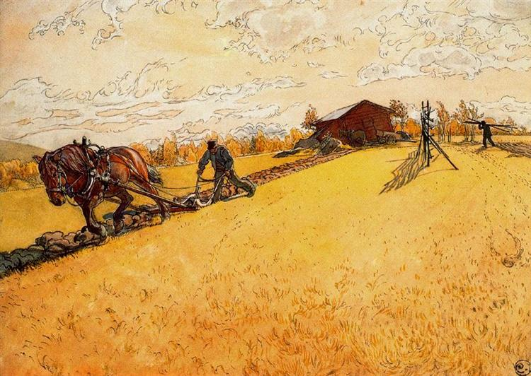
“Jesus said to him, ‘No one who puts a hand to the plow and looks back is fit for the kingdom of God.’”
(Luke 9:62)

Minister: Rev. Jason Evans
First Free Methodist Church
2625 N. Center Rd.
Saginaw, Michigan 48603
Phone: (989) 799-2930
Email: saginawfmc@gmail.com
www.saginawfirstfmc.org

PROPER 8 (13)
June 26, 2022

Prelude
**Greeting/Announcements
*Call to Worship (spoken responsively)
L: God you are my God, I have no good apart from you
P: Blessed the LORD who gives me counsel
L: The LORD is my chosen portion
P: My soul rejoices and my body also rests secure
L: I keep the LORD always before me
P: Therefore, my heart is glad
L: You show me the path of life
P: In your presence there is fullness of joy

*Opening Hymn: “Jesus, the Very Thought of Thee” #139 (vv.1-3,5)
Jesus the very thought of Thee
With sweetness fills my breast
But sweeter far Thy face to see
And in Thy presence rest

No voice can sing, no heart can frame
Nor can the mem’ry find
A sweeter sound than Thy blest name
O savior of mankind

O hope of every contrite heart
O joy of all the meek
To those who fall, how kind Thou art
How good to those who seek

Jesus, our only joy be Thou
As Thou our prize wilt be
Jesus, be Thou our glory now
And thro’ eternity

*Invocation and Lord’s Prayer
L: O Almighty God, who has built your church upon the foundation of the apostles and prophets, Jesus Christ himself being the chief cornerstone. Grant us so to be joined together in unity of spirit by their doctrine, that we may be made a holy temple acceptable unto you. May we think those things that are right, and by your merciful guiding we may perform the same, as we pray the prayer that Jesus taught His disciples…

P: Our Father, who art in heaven, hallowed be Your name. Your kingdom come; your will be done in earth as it is in heaven. Give us this day our daily bread and forgive us our debts as we forgive our debtors. And lead us not into temptation but deliver us from evil. For Yours is the kingdom, and the power, and the glory forever. Amen.

*Gloria Patri
Glory be to the Father​
And to the Son and to the Holy Ghost.​
As it was in the beginning​
Is now and ever shall be.​
World without end. ​
Amen. Amen.​

First Scripture Lesson: 2 Kings 2:1-2, 6-14
Now when the LORD was about to take Elijah up to heaven by a whirlwind, Elijah and Elisha were on their way from Gilgal. Elijah said to Elisha, “Stay here; for the LORD has sent me as far as Bethel.”
But Elisha said, “As the LORD lives, and as you yourself live, I will not leave you.”
So they went down to Bethel. Then Elijah said to him, “Stay here; for the LORD has sent me to the Jordan.”
But he said, “As the LORD lives, and as you yourself live, I will not leave you.
So the two of them went on. Fifty men of the company of prophets also went, and stood at some distance from them, as they both were standing by the Jordan. Then Elijah took his mantle and rolled it up, and struck the water; the water was parted to the one side and to the other, until the two of them crossed on dry ground.
When they had crossed, Elijah said to Elisha, “Tell me what I may do for you, before I am taken from you.”
Elisha said, “Please let me inherit a double share of your spirit.”
He responded, “You have asked a hard thing; yet, if you see me as I am being taken from you, it will be granted you; if not, it will not.”
As they continued walking and talking, a chariot of fire and horses of fire separated the two of them, and Elijah ascended in a whirlwind into heaven. Elisha kept watching and crying out, “Father, father! The chariots of Israel and its horsemen!”
But when he could no longer see him, he grasped his own clothes and tore them in two pieces. He picked up the mantle of Elijah that had fallen from him, and went back and stood on the bank of the Jordan.
He took the mantle of Elijah that had fallen from him, and struck the water, saying, “Where is the LORD, the God of Elijah?”
When he had struck the water, the water was parted to the one side and to the other, and Elisha went over.

Prayer of Confession
L: Lord, by your grace, enlighten our understanding, strengthen our will, purify our hearts, and make us holy...

P: My God, I present myself to you as a living sacrifice, to offer anew the homage of my heart. I humbly adore you, the Creator, my redeemer, and my sanctifier. I believe in you because you are truth itself. I hope in you, because you are faithful to your promises. I love you with my whole heart, because you are infinitely worthy of being loved; and for your sake I love my neighbor as myself. Enable me, O my God, to return you thanks as I ought for all your inestimable blessings and favors. You have formed me out of nothing, yet you have delivered up your son to death on the cross for my redemption. You have made me a member of your holy church. You have preserved me from falling into the eternal abyss. You have graciously continued to spare me, even though I have not ceased to offend you. God of mercy, you have united me with all the saints and angels who bountifully praise your name. Amen.

Affirmation of Faith: Psalm 77
P: I cry aloud to God, aloud to God, that he may hear me. In the day of my trouble, I seek the Lord; in the night my hand is stretched out without wearying; my soul refuses to be comforted. I will call to mind the deeds of the LORD; I will remember your wonders of old. I will meditate on all your work, and muse on your mighty deeds. Your way, O God, is holy. What god is so great as our God? You are the God who works wonders; you have displayed your might among the peoples. With your strong arm you redeemed your people. When the waters saw you, O God, when the waters saw you, they were afraid; the very deep trembled. Your way was through the sea, your path, through the mighty waters; yet your footprints were unseen. You led your people like a flock by the hand of Moses and Aaron.

Hymn of Affirmation: “O Master, Let Me Walk with Thee” #552 (vv.1-4)
O Master, let me walk with Thee
In lowly paths of service free
Tell me Thy secret, help me bear
The strain of toil, the fret of care

Help me the slow of heart to move
By some clear winning word of love
Teach me the wayward feet stay
And guide them in the homeward way

Teach me Thy patience still with Thee
In closer dearer company
In work that keeps faith sweet and strong
In trust that triumphs over wrong

In hope that sends a shining ray
Far down the future's broadening way
In peace that only Thou canst give
With Thee, O Master, let me live

Second Scripture Lesson: Galatians 5:1, 13-25
For freedom Christ has set us free. Stand firm, therefore, and do not submit again to a yoke of slavery.
For you were called to freedom, brothers and sisters; only do not use your freedom as an opportunity for self-indulgence, but through love become slaves to one another. For the whole law is summed up in a single commandment, “You shall love your neighbor as yourself.”
If, however, you bite and devour one another, take care that you are not consumed by one another. Live by the Spirit, I say, and do not gratify the desires of the flesh. For what the flesh desires is opposed to the Spirit, and what the Spirit desires is opposed to the flesh; for these are opposed to each other, to prevent you from doing what you want.
But if you are led by the Spirit, you are not subject to the law. Now the works of the flesh are obvious: fornication, impurity, licentiousness, idolatry, sorcery, enmities, strife, jealousy, anger, quarrels, dissensions, factions, envy, drunkenness, carousing, and things like these. I am warning you, as I warned you before: those who do such things will not inherit the kingdom of God.
By contrast, the fruit of the Spirit is love, joy, peace, patience, kindness, generosity, faithfulness, gentleness, and self-control. There is no law against such things. And those who belong to Christ Jesus have crucified the flesh with its passions and desires. If we live by the Spirit, let us also be guided by the Spirit.

Children’s Sermon

Passing of the Peace

Prayers of the People
L: Lord in Your Mercy…
P: Hear our prayer.

Gospel Lesson: Luke 9:51-62
When the days drew near for him to be taken up, he set his face to go to Jerusalem. And he sent messengers ahead of him. On their way they entered a village of the Samaritans to make ready for him; but they did not receive him, because his face was set toward Jerusalem.
When his disciples James and John saw it, they said, “Lord, do you want us to command fire to come down from heaven and consume them?”
But he turned and rebuked them. Then they went on to another village.
As they were going along the road, someone said to him, “I will follow you wherever you go.”
And Jesus said to him, “Foxes have holes, and birds of the air have nests; but the Son of Man has nowhere to lay his head.”
To another he said, “Follow me.” But he said, “Lord, first let me go and bury my father.”
But Jesus said to him, "Let the dead bury their own dead; but as for you, go and proclaim the kingdom of God."
Another said, “I will follow you, Lord; but let me first say farewell to those at my home.”
Jesus said to him, “No one who puts a hand to the plow and looks back is fit for the kingdom of God.”

Sermon: “New Life”

Prayer of Response

Hymn of Response: “Stand Up, Stand Up for Jesus” #646 (vv.1,3-4)
Stand up, stand up for Jesus
Ye soldiers of the cross
Lift high his royal banner
It must not suffer loss
From victory unto victory
His army shall he lead
Till every foe is vanquished
And Christ is Lord indeed

Stand up, stand up for Jesus
Stand in his strength alone
The arm of flesh will fail you
Ye dare not trust your own
Put on the gospel armor
And watching unto prayer
Where duty calls or danger
Be never wanting there

Stand up, stand up for Jesus,
The strife will not be long;
This day the noise of battle,
The next the victor's song
To those who over cometh
A crown of life shall be
He with the King of Glory
Shall reign eternally

Offering
L: God leads us into the future, towards the new Jerusalem. We are called to bring the world with us, leading other to salvation and away from sin. Give for the sake of mission, as we collect this morning’s tithes and offerings.

*Doxology

*Prayer

*Closing Hymn: “When We All Get to Heaven” #650 (vv. 1-4)
Sing the wondrous love of Jesus
Sing his mercy and his grace
In the mansions bright and blessed
He'll prepare for us a place
When we all get to heaven
What a day of rejoicing that will be!
When we all see Jesus
We'll sing and shout the victory

While we walk the pilgrim pathway
Clouds will over spread the sky
But when traveling days are over
Not a shadow not a sigh
When we all get to heaven
What a day of rejoicing that will be!
When we all see Jesus
We'll sing and shout the victory

Let us then be true and faithful
Trusting, serving every day
Just one glimpse of Him in glory
Will the toils of life repay
When we all get to heaven
What a day of rejoicing that will be!
When we all see Jesus
We'll sing and shout the victory

Onward to the prize before us
Soon His beauty we’ll behold
Soon the pearly gates will open
We shall tread the streets of gold
When we all get to heaven
What a day of rejoicing that will be!
When we all see Jesus
We'll sing and shout the victory

*Benediction
L: Since the love of God has brought us all together, let us be one in the Lord. May the heart of God direct your paths. May the mind of God by your wisdom. May the spirit of God fuel your mission, as you go in peace to love and serve. Amen.

