First Free Methodist Church of Saginaw
Third Sunday after Pentecost
June 18, 2023

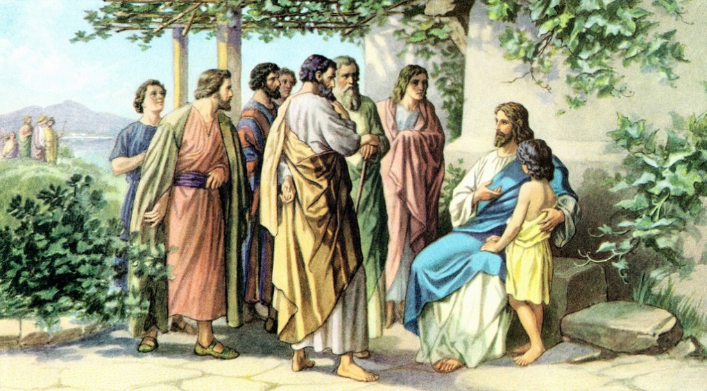
“Jesus said to him, ‘Not seven times, but, I tell you, seventy-seven times.’”
(Matthew 18:22)

Minister: Rev. Jason Evans
First Free Methodist Church
2625 N. Center Rd.
Saginaw, Michigan 48603
Phone: (989) 799-2930
Email: saginawfmc@gmail.com
www.saginawfirstfmc.org

Third Sunday after Pentecost
June 18, 2023

Prelude

Announcements

*Call to Worship (spoken responsively)
L: God you are my God, I have no good apart from you
P: Blessed the LORD who gives me counsel
L: The LORD is my chosen portion
P: My soul rejoices and my body also rests secure
L: I keep the LORD always before me
P: Therefore, my heart is glad
L: You show me the path of life
P: In your presence there is fullness of joy

*Opening Song: “Here I am To Worship”
Light of the world
You stepped down into darkness
Opened my eyes and let me see
Beauty that made this heart adore You
Hope of a life spent with You

Here I am to worship, here I am to bow down
Here I am to say that You're my God
Altogether lovely, altogether worthy
Altogether wonderful to me

King of all days, oh so highly exalted
You're glorious in heaven above, yes You are
Humbly You came to this Earth You created
All for love's sake became poor

Here I am to worship, here I am to bow down
Here I am to say that You're my God
Altogether lovely, altogether worthy
Altogether wonderful to me

I'll never know how much it cost
To see my sin up on that cross
I'll never know how much it cost
To see my sin up on that cross

Here I am to worship, here I am to bow down
Here I am to say that You're my God
Altogether lovely, altogether worthy
Altogether wonderful to me

*Invocation and Lord’s Prayer
L: O Almighty God, who has built your church upon the foundation of the apostles and prophets, Jesus Christ himself being the chief cornerstone. Grant us so to be joined together in unity of spirit by their doctrine, that we may be made a holy temple acceptable unto you. May we think those things that are right, and by your merciful guiding we may perform the same, as we pray the prayer that Jesus taught His disciples…

P: Our Father, who art in heaven, hallowed be Your name. Your kingdom come; your will be done in earth as it is in heaven. Give us this day our daily bread and forgive us our debts as we forgive our debtors. And lead us not into temptation but deliver us from evil. For Yours is the kingdom, and the power, and the glory forever. Amen.

*Gloria Patri

Passing of the Peace

Congregational Song: “Majesty”
Majesty, worship His majesty
Unto Jesus, be all glory, honor, and praise
Majesty, kingdom authority
Flow from His throne unto His own, His anthem raise
So exalt, lift up on high, the name of Jesus
Magnify, come glorify, Christ Jesus the King
Majesty, worship His majesty
Jesus who died, now glorified, King of all Kings
Coming after me

Congregational Reading: Apostle’s Creed
P: I believe in God, the Father Almighty, Maker of heaven and earth. And in Jesus Christ, God’s only Son, our Lord. Who was conceived by the Holy Spirit, born of the Virgin Mary, suffered under Pontius Pilate, was crucified, dead, and was buried. He descended into hades, the third day He rose again from the dead. He ascended into heaven, and sits at the right hand of God the Father Almighty. From thence He shall come to judge the living and the dead. I believe in the Holy Spirit, the holy Church universal, the communion of saints, the forgiveness of sins, the resurrection of the body, and the life everlasting. Amen.

Children’s Sermon

Gospel Lesson: Matthew 18:15-22
If your brother or sister sins, go and point out the fault when the two of you are alone. If you are listened to, you have regained that one. But if you are not listened to, take one or two others along with you, so that every word may be confirmed by the evidence of two or three witnesses. If that person refuses to listen to them, tell it to the church, and if the offender refuses to listen even to the church, let such a one be to you as a gentile and a tax collector.
Truly I tell you, whatever you bind on earth will be bound in heaven, and whatever you loose on earth will be loosed in heaven. Again, truly I tell you, if two of you agree on earth about anything you ask, it will be done for you by my Father in heaven. For where two or three are gathered in my name, I am there among them.”
Then Peter came and said to him, “Lord, if my brother or sister sins against me, how often should I forgive? As many as seven times?” Jesus said to him, “Not seven times, but, I tell you, seventy times seven times.

Sermon: Case Study “Forgiveness”

Prayers of the People
L: Lord in Your Mercy…
P: Hear our prayer.

Hymn of Response: “O for a Thousand Tongues to Sing” #147
O for a thousand tongues to sing
My great Redeemer’s praise
The glories of my God and King
The triumphs of his grace

Jesus! the name that charms our fears
That bids our sorrows cease
‘Tis music in the sinner’s ears
‘Tis life and health and peace
My gracious Master and my God
Assist me to proclaim
To spread thro’ all the earth abroad
The honors of Thy name

Invitation of Offering
L: God leads us into the future, towards the new Jerusalem. We are called to bring the world with us, leading other to salvation and away from sin. Give for the sake of mission, as we collect this morning’s tithes and offerings.

*Doxology

*Prayer

*Closing Hymn: “Love Divine, All Loves Excelling” #507 (vv.1-4)
Love divine, all loves excelling, Joy of heav'n to earth come down
Fix in us thy humble dwelling, all thy faithful mercies crown
Jesus, thou art all compassion, pure, unbounded love thou art
Visit us with thy salvation, enter ev'ry trembling heart

Breathe, O breathe Thy loving Spirit, Into every troubled breast
Let us all in Thee inherit, Let us find that second rest
Take away our bent to sinning, Alpha and Omega be
End of faith, as its beginning, Set our hearts at liberty

Come, Almighty, to deliver, Let us all Thy life receive
Suddenly return and never, Nevermore Thy temples leave
Thee we would be always blessing, Serve Thee as Thy hosts above
Pray and praise Thee without ceasing, Glory in Thy perfect love

Finish, then, thy new creation, pure and spotless let us be
Let us see thy great salvation, perfectly restored in thee
Changed from glory into glory, 'til in heav'n we take our place
Til we cast our crowns before thee, lost in wonder, love, and praise

*Benediction
L: Since the love of God has brought us all together, let us be one in the Lord. May the heart of God direct your paths. May the mind of God by your wisdom. May the spirit of God fuel your mission, as you go in peace to love and serve. Amen.

