Saginaw First Free Methodist Church
Second Sunday after Pentecost
June 14, 2020
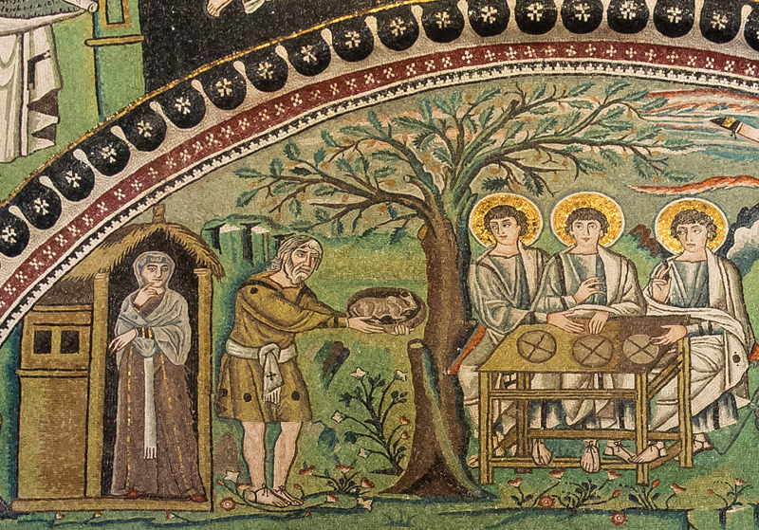
“And Abraham hastened into the tent to Sarah, and said, ‘Make ready quickly three measures of choice flour, knead it, and make cakes.’ Abraham ran to the herd, and took a calf, tender and good, and gave it to the servant, who hastened to prepare it. Then he took curds and milk and the calf that he had prepared, and set it before them; and he stood by them under the tree while they ate.” (Genesis 18:6-8)

Minister: Rev. Jason Evans
First Free Methodist Church
2625 N. Center Rd.
Saginaw, Michigan 48603
Phone: (989) 799-2930
Email: saginawfmc@gmail.com
www.saginawfirstfmc.org

Second Sunday after Pentecost
June 14, 2020

The mission of Saginaw First Free Methodist Church is to be faithful to God and to make known to all people everywhere God’s call to wholeness in Jesus Christ.

Prelude
Greeting/Announcements
L: God has appeared to saints in the past
P: Today the Spirit is present with us all
L: God has promised life where there seems only death
P: God is with us when all seems lost
L: God works on behalf of God’s creation
P: God is our advocate in this life
L: When we were still weak, Christ came to us
P: We will be hospitable to all on Christ’s behalf

*Opening Hymn: “Now Thank We All Our God” #766 (vv.1-3)

Now thank we all our God
With heart and hands and voices
Who wondrous things has done
In whom his world rejoices
Who from our mothers' arms
Has blessed us on our way
With countless gifts of love
And still is ours today

O may this bounteous God
Through all our life be near us
With ever joyful hearts
And blessed peace to cheer us
And keep us in his grace
And guide us when perplexed
And free us from all ills
In this world in the next

All praise and thanks to God
The Father now be given
The Son and Him who reigns
With them in highest heaven
The one eternal God
Whom earth and heaven adore
For thus it was, is now
And shall be evermore

Invocation and Lord’s Prayer
L: God of Compassion and Care, You fulfill your promises to your people. You promise a new life, full of liberation for all people. In this season where we celebrate your eternal presence, fill us with love for your world. Teach us to be hospitable to your creation; people, creatures, and the earth. Fill us with hope that is to come, as we live in this cursed world. Reveal your glory to us as we serve you, and as we pray together the prayer that Jesus taught His disciples…

P: Our Father, who art in heaven, hallowed be Your name. Your kingdom come; your will be done in earth as it is in heaven. Give us this day our daily bread and forgive us our debts as we forgive our debtors. And lead us not into temptation but deliver
us from evil. For Yours is the kingdom, and the power, and the glory forever. Amen.

Gloria Patri

First Scripture Lesson: Genesis 18:1-15, 21:1-7

The LORD appeared to Abraham by the oaks of Mamre, as he sat at the entrance of his tent in the heat of the day. He looked up and saw three men standing near him. When he saw them, he ran from the tent entrance to meet them, and bowed down to the ground.

He said, “My lord, if I find favor with you, do not pass by your servant. Let a little water be brought, and wash your feet, and rest yourselves under the tree. Let me bring a little bread, that you may refresh yourselves, and after that you may pass on--since you have come to your servant.” So they said, “Do as you have said.”

And Abraham hastened into the tent to Sarah, and said, “Make ready quickly three measures of choice flour, knead it, and make cakes.” Abraham ran to the herd, and took a calf, tender and good, and gave it to the servant, who hastened to prepare it. Then he took curds and milk and the calf that he had prepared, and set it before them; and he stood by them under the tree while they ate.

They said to him, “Where is your wife Sarah?” And he said, “There, in the tent.” Then one said, “I will surely return to you in due season, and your wife Sarah shall have a son.”

And Sarah was listening at the tent entrance behind him. Now Abraham and Sarah were old, advanced in age; it had ceased to be with Sarah after the manner of women. So Sarah laughed to herself, saying, “After I have grown old, and my husband is old, shall I have pleasure?”

The LORD said to Abraham, “Why did Sarah laugh, and say, ‘Shall I indeed bear a child, now that I am old?’ Is anything too wonderful for the LORD? At the set time I will return to you, in due season, and Sarah shall have a son.”

But Sarah denied, saying, “I did not laugh,” for she was afraid. He said, “Oh yes, you did laugh.”

The LORD dealt with Sarah as he had said, and the LORD did for Sarah as he had promised. Sarah conceived and bore Abraham a son in his old age, at the time of which God had spoken to him. Abraham gave the name Isaac to his son whom Sarah bore him.

And Abraham circumcised his son Isaac when he was eight days old, as God had commanded him. Abraham was a hundred years old when his son Isaac was born to him. Now Sarah said, “God has brought laughter for me; everyone who hears will laugh with me.”

And she said, “Who would ever have said to Abraham that Sarah would nurse children? Yet I have borne him a son in his old age.”

Prayer of Confession
L: The service God calls us to can be frightening. At times the fear of stepping out of our comfort zone can cripple us. It is easy to resist answering our call when other voices encourage us in other directions. It is easy to resist when we believe others will respond. For the times of disobedience, let us confess…
P: Humble God, who is hospitable to all, we come admitting our compliance with division. We laugh and mock the dignity of those we disagree with. We dishonor You and your creation when we villainize with no warrant. We disgrace your creation when we are complicit with unjust people and systems. Impure spirits are abundant outside the church, and sometimes we partake in their ways. We tend to abide with the unclean spirits of society. The promise of Your Gospel is liberation for all people. Forgive us when we fail to promote justice and help us in this new vision You have for the world. Amen.
Affirmation of Faith: Psalm 116
P: I love the LORD, because God has heard my voice and my supplications. Because God inclined an ear to me, therefore I will call on God as long as I live. What shall I return to the LORD for all his bounty to me? I will lift up the cup of salvation and call on the name of the LORD, I will pay my vows to the LORD in the presence of all people. Precious in the sight of the LORD is the death of his faithful ones. O LORD, I am your servant. You have loosed my bonds. I will offer to you a thanksgiving sacrifice and call on the name of the LORD. I will pay my vows to the LORD in the presence of all the people

*Hymn of Affirmation: “My Faith Looks Up to Thee” #433
My faith looks up to thee
Thou Lamb of Calvary
Savior divine
Now hear me while I pray
Take all my guilt away
O let me from this day
Be wholly thine

May thy rich grace impart
Strength to my fainting heart
My zeal inspire
As thou hast died for me
O may my love to thee
Pure, warm, and changeless be
A living fire

When life's dark maze I tread
And griefs around me spread
Be thou my guide
Bid darkness turn to day
Wipe sorrow's tears away
Nor let me ever stray
From thee aside

New Testament Scripture Lesson: Romans 5:1-8

Therefore, since we are justified by faith, we have peace with God through our Lord Jesus Christ, through whom we have obtained access to this grace in which we stand; and we boast in our hope of sharing the glory of God.

And not only that, but we also boast in our sufferings, knowing that suffering produces endurance, and endurance produces character, and character produces hope, and hope does not disappoint us, because God's love has been poured into our hearts through the Holy Spirit that has been given to us.

For while we were still weak, at the right time Christ died for the ungodly. Indeed, rarely will anyone die for a righteous person, though perhaps for a good person someone might actually dare to die. But God proves his love for us in that while we still were sinners Christ died for us.

Special Music: Micki Martin

Passing of the Peace

Prayers of the People
L: Lord in Your Mercy…
P: Hear our prayer.

Gospel Lesson: Matthew 9:35-10:1, 10:7-20

Then Jesus went about all the cities and villages, teaching in their synagogues, and proclaiming the good news of the kingdom, and curing every disease and every sickness. When he saw the crowds, he had compassion for them, because they were harassed and helpless, like sheep without a shepherd.

Then he said to his disciples, “The harvest is plentiful, but the laborers are few; therefore ask the Lord of the harvest to send out laborers into his harvest.”

Then Jesus summoned his twelve disciples and gave them authority over unclean spirits, to cast them out, and to cure every disease and every sickness. As you go, proclaim the good news, ‘The kingdom of heaven has come near.’ Cure the sick, raise the dead, cleanse the lepers, cast out demons. You received without payment; give without payment.

Take no gold, or silver, or copper in your belts, no bag for your journey, or two tunics, or sandals, or a staff; for laborers deserve their food. Whatever town or village you enter, find out who in it is worthy, and stay there until you leave. As you enter the house, greet it.

If the house is worthy, let your peace come upon it; but if it is not worthy, let your peace return to you. If anyone will not welcome you or listen to your words, shake off the dust from your feet as you leave that house or town. Truly I tell you, it will be more tolerable for the land of Sodom and Gomorrah on the day of judgment than for that town.

“See, I am sending you out like sheep into the midst of wolves; so be wise as serpents and innocent as doves. Beware of them, for they will hand you over to councils and flog you in their synagogues, and you will be dragged before governors and kings because of me, as a testimony to them and the Gentiles.

When they hand you over, do not worry about how you are to speak or what you are to say; for what you are to say will be given to you at that time; for it is not you who speak, but the Spirit of your Father speaking through you.”

Sermon

Prayer of Response

Hymn of Response: “Spirit of the Living God” #297 (2x)
Spirit of The Living God
Fall Afresh on Me
Spirit of The Living God
Fall Afresh on Me
Melt Me, Mold Me
Fill Me, Use Me
Spirit of The Living God
Fall Afresh on Me

Invitation of Offering
L: God came to us, before we knew God was there. God fulfills promises, regardless of our participation. But our faithful works and giving brings the kingdom of Heaven to our souls. Rejoice, as we collect this morning’s tithes and offerings.

*Doxology

Prayer

Closing Hymn: “Standing on the Promises” #687 (vv.1,5)

Standing on the promises of Christ my king
Through eternal ages let his praises ring
Glory in the highest, I will shout and sing
Standing on the promises of God
Standing, standing,
Standing on the promises of God my Savior
Standing, standing
I’m standing on the promises of God

Standing on the promises I cannot fall
Listening every moment to the Spirit’s call
Resting in my Savior as my all in all
Standing on the promises of God
Standing, standing,
Standing on the promises of God my Savior
Standing, standing
I’m standing on the promises of God

Benediction
L: We are filled with the Spirit, God is with you. God answers our prayers and keeps promises. Fulfill your duty, answering the call to ministry in your everyday lives. Share as you’ve been blessed, as you go in peace to love and serve. Amen.

