**First Free Methodist Church of Saginaw**

Sixth Sunday after Pentecost

July 9, 2023

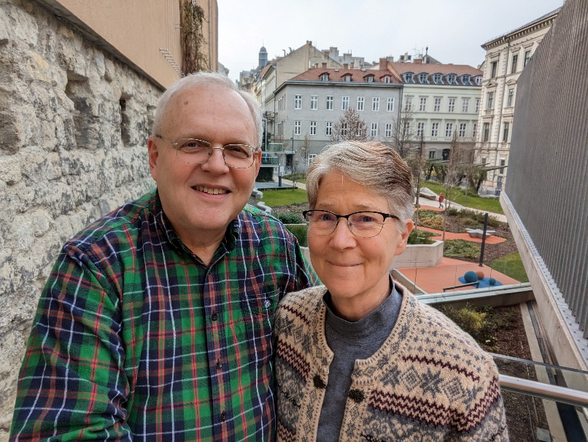

*“Rejoice in hope; be patient in affliction; persevere in prayer.”*

*(Romans 12:12)*

Guest Speaker: Rev. Larry and Katie Winckles

First Free Methodist Church

2625 N. Center Rd.

Saginaw, Michigan 48603

Phone: (989) 799-2930

Email: saginawfmc@gmail.com

[www.saginawfirstfmc.org](http://www.saginawfirstfmc.org)

Sixth Sunday after Pentecost

July 9, 2023

**Prelude**

**Announcements**

**\*Call to Worship** (*spoken responsively*)

L: O LORD, who may abide in your tent?

**P: Those who walk blamelessly, and do what is right**

L: Who do not take up a reproach against their neighbors

**P: Who do not lend money at interest**

L: O LORD, who may dwell on your holy hill?

**P: Those who speak the truth from their heart**

L: Who stand by their oath even to their hurt

**P: Those who do not slander with their tongue**

L: Those who do these things shall never be moved

**P: Your love never fails**

**\*Opening Song:** “Come, Thou Almighty King” #3 (vv.1-4)

**Come, Thou Almighty King**

**Help us thy name to sing**

**Help us to praise**

**Father all glorious, over all victorious**

**Come and reign over us**

**Ancient of days**

**Come, Thou incarnate Word**

**Gird on Thy mighty sword**

**Our prayer attend**

**Come and Thy people bless**

**And give thy word success**

**Spirit of holiness on us descend**

**Come, holy comforter**

**Thy sacred witness bear**

**In this glad hour**

**Thou who almighty art**

**Now rule in every heart**

**And never from us depart Spirit of power**

**To Thee, great one in three**

**Eternal praises be, hence ever more**

**Thy sovereign majesty**

**May we in glory see**

**And to eternity love and adore**

**\*Invocation and Lord’s Prayer**

L: Almighty God, the fountain of all wisdom, who knows our necessities before we ask and our ignorance in asking: Have compassion, we beg you, upon our infirmities, and those things which for our unworthiness we dare not, and for our blindness we cannot ask, mercifully give us for the worthiness of your Son Christ Jesus our Lord. Reveal your mysteries to us, as we pray the prayer that Jesus taught His disciples…

**P: Our Father, who art in heaven, hallowed be Your name. Your kingdom come; your will be done in earth as it is in heaven. Give us this day our daily bread and forgive us our debts as we forgive our debtors. And lead us not into temptation but deliver us from evil. For Yours is the kingdom, and the power, and the glory forever. Amen.**

**\*Gloria Patri**

**Glory be to the Father​**

**And to the Son and to the Holy Ghost​**

**As it was in the beginning​**

**Is now and ever shall be**

**World without end**

**Amen. Amen.​**

**Passing of the Peace**

**Congregational Song:** “Graves Into Gardens”

I searched the world

But it couldn't fill me

Man's empty praise

And treasures that fade

Are never enough

Then You came along

And put me back together

And every desire

Is now satisfied

Here in Your love (Hey)

Oh, there's nothing better than You

There's nothing better than You

Lord, there's nothing

Nothing is better than You

(Oh, yes I know it's true)

I'm not afraid

To show You my weakness

My failures and flaws

Lord, You've seen 'em all

And You still call me friend

'Cause the God of the mountain

Is the God of the valley

There's not a place

Your mercy and grace

Won't find me again

Oh, there's nothing better than You

There's nothing better than You

Lord, there's nothing

Nothing is better than You

(I know it's true)

Oh, there's nothing better than You

There's nothing better than You

Lord, there's nothing

Nothing is better than You

You turn mourning to dancing

You give beauty for ashes

You turn shame into glory

You're the only one who can

You turn mourning to dancing

You give beauty for ashes

You turn shame into glory

You're the only one who can

You turn graves into garden

You turn bones into armies

You turn seas into highways

You're the only one who can

You're the only one who can

Oh, there's nothing better than You

There's nothing better than You

Lord, there's nothing

Nothing is better than You

Oh, there's nothing better than You

There's nothing better than You

**Children’s Sermon**

**Gospel Lesson**: Matthew 11:27-30

All things have been handed over to me by my Father; and no one knows the Son except the Father, and no one knows the Father except the Son and anyone to whom the Son chooses to reveal him.

"Come to me, all you that are weary and are carrying heavy burdens, and I will give you rest. Take my yoke upon you, and learn from me; for I am gentle and humble in heart, and you will find rest for your souls. For my yoke is easy, and my burden is light."

**Guest Speaker:** Rev.Larry and Katie Winckles

**Prayers of the People**

L: Lord in Your Mercy…

**P: Hear our prayer.**

**Hymn of Response:** “What a Friend We Have in Jesus” #625 (vv.1-3)

**What a friend we have in Jesus**

**All our sins and griefs to bear**

**What a privilege to carry**

**Everything to God in prayer**

**Oh, what peace we often forfeit**

**Oh, what needless pain we bear**

**All because we do not carry**

**Everything to God in prayer**

**Have we trials and temptations?**

**Is there trouble anywhere?**

**We should never be discouraged**

**Take it to the Lord in prayer**

**Can we find a friend so faithful**

**Who will all our sorrows share?**

**Jesus knows our every weakness**

**Take it to the Lord in prayer**

**Are we weak and heavy laden**

**Cumbered with a load of care?**

**Precious Savior, still our refuge**

**Take it to the Lord in prayer**

**Do thy friends despise, forsake thee?**

**Take it to the Lord in prayer**

**In His arms he’ll take and shield thee**

**Thou wilt find a solace there**

**Invitation of Offering**

L: Each of you must give as you have made up your mind. Give as the Lord has given you. ‘Open your hand to the poor and needy neighbor in your land.’ Give joyfully, as we collect this morning’s tithes and offerings.

**\*Doxology**

**\*Prayer**

**\*Closing Hymn:** “Great is the Lord” #69

**Great is the Lord**

**He is holy and just**

**By His power we trust**

**In His love**

**Great is the Lord**

**He is faithful and true**

**By His mercy He proves**

**He is love**

**Great is the Lord**

**And worthy of glory**

**Great is the Lord**

**And worthy of praise**

**Great is the Lord**

**Now lift up your voice**

**Now lift up your voice**

**Great is the Lord**

**Great is the Lord**

**Great is the Lord,**

**He is holy and just**

**By His power we trust**

**In His love**

**Great is the Lord**

**He is faithful, and true**

**By His mercy He proves**

**He is love**

**Great is the Lord**

**And worthy of glory**

**Great is the Lord**

**And worthy of praise**

**Great is the Lord**

**Now lift up your voice**

**Now lift up your voice**

**Great is the Lord**

**Great is the Lord**

**Great are you Lord**

**And worthy of glory**

**Great are you Lord**

**And worthy of praise**

**Great are you Lord**

**I lift up my voice**

**I lift up my voice**

**Great are you Lord**

**Great are you Lord**

**\*Benediction**

L: Go into your week as a disciple of Jesus the Christ. May the perfect love of God be in your heart. May the eternal salvation of Christ be in your heart. May the faithful empowerment of the Spirit be your guide, as you go in peace to love and serve. Amen.