Saginaw First Free Methodist Church
Eighth Sunday after Pentecost
July 26, 2020

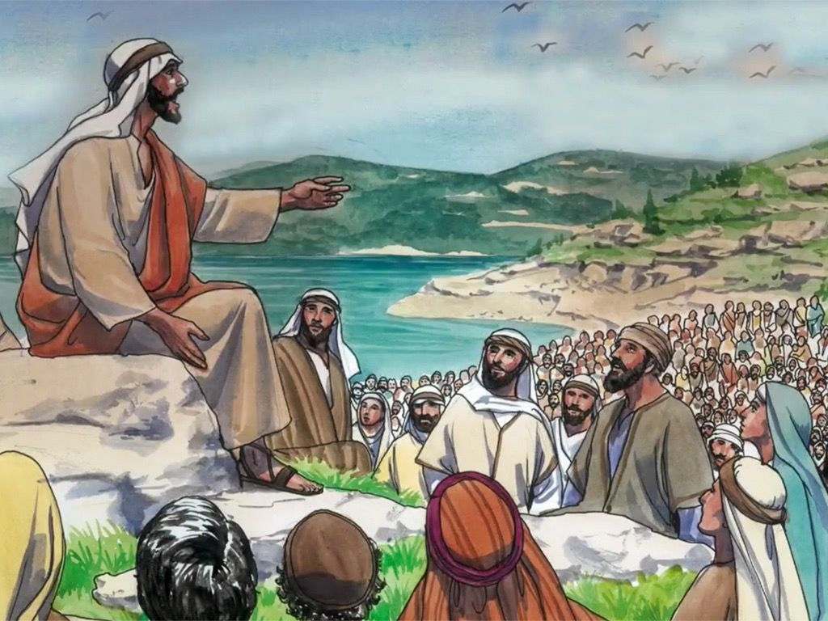
“And he said to them, ‘Therefore every scribe who has been trained for the kingdom of heaven is like the master of a household who brings out of his treasure what is new and what is old.’” (Matthew 13:52)

Minister: Rev. Jason Evans
First Free Methodist Church
2625 N. Center Rd.
Saginaw, Michigan 48603
Phone: (989) 799-2930
Email: saginawfmc@gmail.com
www.saginawfirstfmc.org

Eighth Sunday after Pentecost
July 26, 2020

The mission of Saginaw First Free Methodist Church is to be faithful to God and to make known to all people everywhere God’s call to wholeness in Jesus Christ.

Prelude
Greeting/Announcements
L: Let us call on God and give thanks
P: Let all people tell of God’s wonderful works
L: Let us seek the strength that God alone provides
P: Surely the Spirit helps us in our weakness
L: Let us open ourselves continually to God’s presence
P: The Spirit searches our hearts and enlarges our prayers

*Opening Hymn: “Guide Me, O Thou Great Jehovah” #96 (vv.1-3)
Guide me, O my great Jehovah
Pilgrim through this barren land
I am weak, but you are mighty
Hold me with your powerful hand
Bread of heaven, bread of heaven
Feed me till I want no more
Feed me till I want no more

Open now the crystal fountain
Where the healing streams doth flow
Let the fire and cloudy pillar
Lead me all my journey through
Strong Deliverer, strong Deliverer
Be Thou still my strength and shield
Be Thou still my strength and shield

When I tread the verge of Jordan
Bid my anxious fears subside
Death of death, and hell's Destruction
Land me safe on Canaan's side
Songs of praises, songs of praises
I will ever give to Thee
I will ever give to Thee

Invocation and Lord’s Prayer
L: God of resurrection, who restores life and strength to this world, we seek your presence in this time. We need your wisdom when the world presents us folly. We need comfort when the world deceives us. We need your assurance when we are discouraged. Lead us into the new, abundant life Jesus exemplified for us. Transform us to trust your ways, as we pray together the prayer that Jesus taught His disciples…

P: Our Father, who art in heaven, hallowed be Your name. Your kingdom come; your will be done in earth as it is in heaven. Give us this day our daily bread and forgive us our debts as we forgive our debtors. And lead us not into temptation but deliver
us from evil. For Yours is the kingdom, and the power, and the glory forever. Amen.

Gloria Patri
Glory be to the Father​
And to the Son and to the Holy Ghost.
As it was in the beginning​
Is now and ever shall be
World without end
Amen. Amen

First Scripture Lesson: Genesis 29:15-28

Then Laban said to Jacob, “Because you are my kinsman, should you therefore serve me for nothing? Tell me, what shall your wages be?”

Now Laban had two daughters; the name of the elder was Leah, and the name of the younger was Rachel. Leah's eyes were lovely, and Rachel was graceful and beautiful. Jacob loved Rachel; so he said, “I will serve you seven years for your younger daughter Rachel.”

Laban said, “It is better that I give her to you than that I should give her to any other man; stay with me.”

So Jacob served seven years for Rachel, and they seemed to him but a few days because of the love he had for her. Then Jacob said to Laban, “Give me my wife that I may go in to her, for my time is completed.”

So Laban gathered together all the people of the place, and made a feast. But in the evening he took his daughter Leah and brought her to Jacob; and he went in to her. (Laban gave his maid Zilpah to his daughter Leah to be her maid.) When morning came, it was Leah! And Jacob said to Laban, “What is this you have done to me? Did I not serve with you for Rachel? Why then have you deceived me?”

Laban said, “This is not done in our country--giving the younger before the firstborn. Complete the week of this one, and we will give you the other also in return for serving me another seven years.” Jacob did so, and completed her week; then Laban gave him his daughter Rachel as a wife.

Prayer of Confession
L: We often profess our faith, yet live inactive lives towards God’s kingdom. Our pretense of concern for others is tainted by our self-interests. For our times of disobedience, let us confess…
P: Almighty God, we intend to live lives that glorify you. We seek you continually. But times we use you to scheme and manipulate for our own self gain. We see what we can possess, and use it to gain earthly riches. We get our new life in you, then neglect to help others obtain their new life. We complain about others sin instead of helping them cultivate fertile soil. Our negligence is in our words that do not lead to action; and in action that is meaningless to those in need. Save us, O God. Amen.

Affirmation of Faith: Psalm 105
P: O give thanks to the LORD, call on his name, make known his deeds among the peoples. Sing to him, sing praises to him; tell of all his wonderful works. Glory in his holy name; let the hearts of those who seek the LORD rejoice. Seek the LORD and his strength; seek his presence continually. Remember the wonderful works he has done, his miracles, and the judgments he uttered. He is the LORD our God; his judgments are in all the earth. He is mindful of his covenant forever, of the word that he commanded, for a thousand generations, the covenant that he made with Abraham. Praise the LORD!

*Hymn of Affirmation: “My Faith Looks up to Thee” #433 (vv.1-2)
My faith looks up to Thee
Thou Lamb of Calvary
Savior divine
Now hear me while I pray
Take all my guilt away
O let me from this day
Be wholly Thine

May thy rich grace impart
Strength to my fainting heart
My zeal inspire
As thou hast died for me
O may my love to thee
Pure, warm, and changeless be
A living fire

New Testament Scripture Lesson: Romans 8:26-39

Likewise the Spirit helps us in our weakness; for we do not know how to pray as we ought, but that very Spirit intercedes with sighs too deep for words. And God, who searches the heart, knows what is the mind of the Spirit, because the Spirit intercedes for the saints according to the will of God. We know that all things work together for good for those who love God, who are called according to his purpose.

For those whom he foreknew he also predestined to be conformed to the image of his Son, in order that he might be the firstborn within a large family. And those whom he predestined he also called; and those whom he called he also justified; and those whom he justified he also glorified. What then are we to say about these things? If God is for us, who is against us?

He who did not withhold his own Son, but gave him up for all of us, will he not with him also give us everything else? Who will bring any charge against God's elect? It is God who justifies. Who is to condemn? It is Christ Jesus, who died, yes, who was raised, who is at the right hand of God, who indeed intercedes for us.

Who will separate us from the love of Christ? Will hardship, or distress, or persecution, or famine, or nakedness, or peril, or sword? As it is written, “For your sake we are being killed all day long; we are accounted as sheep to be slaughtered.”

No, in all these things we are more than conquerors through him who loved us. For I am convinced that neither death, nor life, nor angels, nor rulers, nor things present, nor things to come, nor powers, nor height, nor depth, nor anything else in all creation, will be able to separate us from the love of God in Christ Jesus our Lord.

Special Music: Micki Martin

Passing of the Peace

Prayers of the People
L: Lord in Your Mercy…
P: Hear our prayer.

Gospel Lesson: Matthew 13:31-33, 44-52
He put before them another parable: “The kingdom of heaven is like a mustard seed that someone took and sowed in his field; it is the smallest of all the seeds, but when it has grown it is the greatest of shrubs and becomes a tree, so that the birds of the air come and make nests in its branches.”

He told them another parable: “The kingdom of heaven is like yeast that a woman took and mixed in with three measures of flour until all of it was leavened.”

“The kingdom of heaven is like treasure hidden in a field, which someone found and hid; then in his joy he goes and sells all that he has and buys that field.

“Again, the kingdom of heaven is like a merchant in search of fine pearls; on finding one pearl of great value, he went and sold all that he had and bought it.

“Again, the kingdom of heaven is like a net that was thrown into the sea and caught fish of every kind; when it was full, they drew it ashore, sat down, and put the good into baskets but threw out the bad. So it will be at the end of the age. The angels will come out and separate the evil from the righteous and throw them into the furnace of fire, where there will be weeping and gnashing of teeth.

“Have you understood all this?” They answered, “Yes.”

And he said to them, “Therefore every scribe who has been trained for the kingdom of heaven is like the master of a household who brings out of his treasure what is new and what is old.”

Sermon

Prayer of Response

Hymn of Response: “God of the Ages” #754 (vv.1-4)
God of the ages, history's Maker
Planning our pathway, holding us fast
Shaping in mercy, all that concerns us
Father, we praise you, Lord of the past

God of this morning, gladly your children
Worship before you, trustingly bow
Teach us to know you, always among us
Quietly sovereign, Lord of our now

God of tomorrow, strong overcomer
Princes of darkness, own your command
What then can harm us? We are your people
Now and forever, kept by your hand

Lord of past ages, Lord of this morning
Lord of the future, help us, we pray
Teach us to trust you, love and obey you
Crown you each moment, Lord of today!

Invitation of Offering
L: We have been taught by God through Christ Jesus. And we have been given so much. Give so that all may see your witness and experience your love, as we collect this morning’s tithes and offerings.
*Doxology

Prayer

Closing Hymn: “Trust and Obey” #437 (vv.1,5)
When we walk with the Lord
In the light of his word
What a glory he sheds on our way
While we do his good will
He abides with us still
And with all who will trust and obey
Trust and obey, for there's no other way
To be happy in Jesus, but to trust and obey

Then in fellowship sweet
We will sit at his feet
Or we'll walk by his side in the way
What he says we will do
Where he sends we will go
Never fear, only trust and obey
Trust and obey, for there's no other way
To be happy in Jesus, but to trust and obey

Benediction
L: God’s kingdom is a place for all to seek shelter. We have experienced comfort and love from God. Share this new life so all may experience salvation in Christ, as you go in peace to love and serve. Amen.

