Saginaw First Free Methodist Church
Seventh Sunday after Pentecost
July 19, 2020

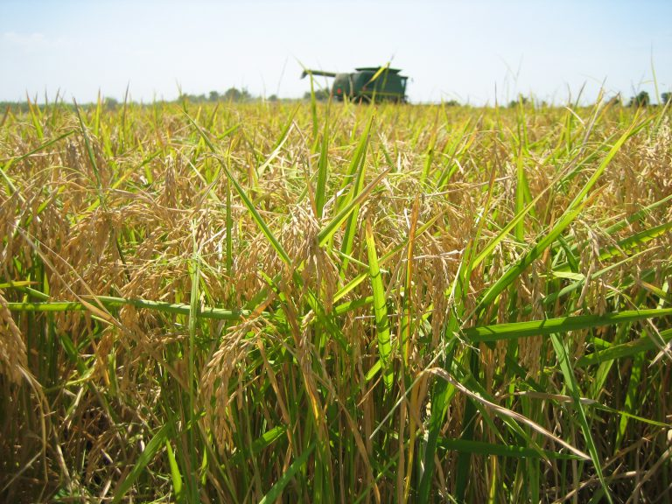
“He answered, 'An enemy has done this.' The slaves said to him, 'Then do you want us to go and gather them?' But he replied, 'No; for in gathering the weeds you would uproot the wheat along with them. Let both of them grow together until the harvest; and at harvest time I will tell the reapers, Collect the weeds first and bind them in bundles to be burned, but gather the wheat into my barn.'" (Matthew 13:28-30)

Minister: Rev. Jason Evans
First Free Methodist Church
2625 N. Center Rd.
Saginaw, Michigan 48603
Phone: (989) 799-2930
Email: saginawfmc@gmail.com
www.saginawfirstfmc.org

Seventh Sunday after Pentecost
July 19, 2020

The mission of Saginaw First Free Methodist Church is to be faithful to God and to make known to all people everywhere God’s call to wholeness in Jesus Christ.

Prelude
Greeting/Announcements
L: God searches us and knows us
P: God is acquainted with all our ways
L: God’s hand is ever available to guide us
P: Such knowledge is too wonderful to understand
L: We cannot escape from God’s spirit
P: There is nowhere to flee from God’s presence

*Opening Hymn: “The God of Abraham Praise” #73 (vv.1,4)
The God of Abraham praise
Who reigns enthroned above
Ancient of Everlasting Days
And God of Love
Jehovah, great I AM
By earth and heaven confessed
I bow and bless the sacred name
Forever blest

The whole triumphant host
Give thanks to God on high
Hail Father, Son and Holy Ghost
They ever cry
Hail, Abr’ham’s God and mine
With heav’n our song we raise
All might and majesty are Thine
And endless praise

Invocation and Lord’s Prayer
L: Search us O God, and know our hearts. We gather, longing to know you and feel your presence continually. Let us be comforted by your knowledge, understanding that you know our inmost being. Remind us of your abiding Spirit, that we may have hope. Move us to awe, as we pray together the prayer that Jesus taught His disciples…

P: Our Father, who art in heaven, hallowed be Your name. Your kingdom come; your will be done in earth as it is in heaven. Give us this day our daily bread and forgive us our debts as we forgive our debtors. And lead us not into temptation but deliver
us from evil. For Yours is the kingdom, and the power, and the glory forever. Amen.

Gloria Patri
Glory be to the Father​
And to the Son and to the Holy Ghost.​
As it was in the beginning​
Is now and ever shall be.​
World without end. ​
Amen. Amen.​

First Scripture Lesson: Genesis 28:10-19a
Jacob left Beer-sheba and went toward Haran. He came to a certain place and stayed there for the night, because the sun had set. Taking one of the stones of the place, he put it under his head and lay down in that place. And he dreamed that there was a ladder set up on the earth, the top of it reaching to heaven; and the angels of God were ascending and descending on it.

And the LORD stood beside him and said, “I am the LORD, the God of Abraham your father and the God of Isaac; the land on which you lie I will give to you and to your offspring; and your offspring shall be like the dust of the earth, and you shall spread abroad to the west and to the east and to the north and to the south; and all the families of the earth shall be blessed in you and in your offspring. Know that I am with you and will keep you wherever you go, and will bring you back to this land; for I will not leave you until I have done what I have promised you.”

Then Jacob woke from his sleep and said, “Surely the LORD is in this place--and I did not know it!”

And he was afraid, and said, “How awesome is this place! This is none other than the house of God, and this is the gate of heaven.”

So Jacob rose early in the morning, and he took the stone that he had put under his head and set it up for a pillar and poured oil on the top of it. He called that place Bethel; but the name of the city was Luz at the first.

Prayer of Confession
L: We often run away from our problems, and ignore our misdeeds. Yet we cannot escape God’s presence. Let’s not hide from our sins, but confess them so we can claim the promise of reconciliation and wholeness…
P: Search us and test us, O God, that we might be purged from our sin and wickedness. We often run from our actions, separating ourselves from our misdeeds. We refuse to claim them as our own, and pass responsibility on to others. We believe the best in ourselves, thinking that brings us closer to you. But you have hemmed us into your presence. We cannot escape You, teach us to confront our actions and learn from them. Turn us from bondage to our sin and lead us to bear fruit for you. Amen.

Affirmation of Faith: Psalm 139
P: O LORD, you have searched me and known me. You know when I sit down and when I rise up; you discern my thoughts from far away. You search out my path and my lying down, and are acquainted with all my ways. Even before a word is on my tongue, O LORD, you know it completely. Where can I go from your spirit? Or where can I flee from your presence? If I ascend to heaven, you are there; if I make my bed in the pit, you are there. If I take the wings of the morning and settle at the farthest limits of the sea, even there your hand shall lead me, and your right hand shall hold me fast. If I say, “Surely the darkness shall cover me, and the light around me become night,” even the darkness is not dark to you; the night is as bright as the day, for darkness is as light to you. Search me, O God, and know my heart; test me and know my thoughts. See if there is any wicked way in me, and lead me in the way everlasting.

*Hymn of Affirmation: “Come, Thou Long-expected Jesus” #157 (vv.1-2)
Come, thou long expected Jesus
Born to set thy people free
From our fears and sins release us
Let us find our rest in thee
Israel's strength and consolation
Hope of all the earth thou art
Dear desire of every nation
Joy of every longing heart

Born thy people to deliver
Born a child and yet a King
Born to reign in us forever
Now thy gracious kingdom bring
By thine own eternal spirit
Rule in all our hearts alone
By thine all sufficient merit
Raise us to thy glorious throne

New Testament Scripture Lesson: Romans 8:12-25
So then, brothers and sisters, we are debtors, not to the flesh, to live according to the flesh, for if you live according to the flesh, you will die; but if by the Spirit you put to death the deeds of the body, you will live. For all who are led by the Spirit of God are children of God.
For you did not receive a spirit of slavery to fall back into fear, but you have received a spirit of adoption. When we cry, “Abba! Father!” it is that very Spirit bearing witness with our spirit that we are children of God, and if children, then heirs, heirs of God and joint heirs with Christ--if, in fact, we suffer with him so that we may also be glorified with him.
I consider that the sufferings of this present time are not worth comparing with the glory about to be revealed to us. For the creation waits with eager longing for the revealing of the children of God; for the creation was subjected to futility, not of its own will but by the will of the one who subjected it, in hope that the creation itself will be set free from its bondage to decay and will obtain the freedom of the glory of the children of God.
We know that the whole creation has been groaning in labor pains until now; and not only the creation, but we ourselves, who have the first fruits of the Spirit, groan inwardly while we wait for adoption, the redemption of our bodies. For in hope we were saved. Now hope that is seen is not hope. For who hopes for what is seen?
But if we hope for what we do not see, we wait for it with patience.

Special Music: Micki Martin

Passing of the Peace

Prayers of the People
L: Lord in Your Mercy…
P: Hear our prayer.

Gospel Lesson: Matthew 13:24-30, 36-43
He put before them another parable: “The kingdom of heaven may be compared to someone who sowed good seed in his field; but while everybody was asleep, an enemy came and sowed weeds among the wheat, and then went away.

So when the plants came up and bore grain, then the weeds appeared as well. And the slaves of the householder came and said to him, ‘Master, did you not sow good seed in your field? Where, then, did these weeds come from?’

He answered, ‘An enemy has done this.’ The slaves said to him, ‘Then do you want us to go and gather them?’

But he replied, ‘No; for in gathering the weeds you would uproot the wheat along with them. Let both of them grow together until the harvest; and at harvest time I will tell the reapers, Collect the weeds first and bind them in bundles to be burned, but gather the wheat into my barn.’”
Then he left the crowds and went into the house. And his disciples approached him, saying, “Explain to us the parable of the weeds of the field.”

He answered, “The one who sows the good seed is the Son of Man; the field is the world, and the good seed are the children of the kingdom; the weeds are the children of the evil one, and the enemy who sowed them is the devil; the harvest is the end of the age, and the reapers are angels. Just as the weeds are collected and burned up with fire, so will it be at the end of the age.

The Son of Man will send his angels, and they will collect out of his kingdom all causes of sin and all evildoers, and they will throw them into the furnace of fire, where there will be weeping and gnashing of teeth. Then the righteous will shine like the sun in the kingdom of their Father. Let anyone with ears listen!”

Sermon

Prayer of Response

Hymn of Response: “Be Thou My Vision” #460 (vv.1-3)
Be Thou my vision, O Lord of my heart
Naught be all else to me, save that Thou art
Thou my best Thought, by day or by night
Waking or sleeping, Thy presence my light

Be Thou my Wisdom, and Thou my true Word
I ever with Thee and Thou with me, Lord
Thou my great Father, I Thy true son
Thou in me dwelling, and I with Thee one

Riches I heed not, nor man’s empty praise
Thou mine Inheritance, now and always
Thou and Thou only, first in my heart
High King of heaven, my Treasure Thou art

Invitation of Offering
L: Being grateful of God’s Spirit that is ever with us, we are assured of our acceptance in God’s presence. May our offering be good news to those who have not heard this gospel. Give willfully, as we collect this morning’s tithes and offerings.

*Doxology

Prayer

Closing Hymn: “Come We That Love the Lord” #389 (vv.1,4)
Come, we that love the Lord
And let our joys be known
Join in a song with sweet accord
Join in a song with sweet accord
And thus surround the throne
And thus surround the throne
We’re marching to Zion, Beautiful, beautiful Zion
We’re marching upward to Zion, The beautiful city of God

Then let our songs abound
And ev'ry tear be dry
We're marching through Emmanuel's ground
We're marching through Emmanuel's ground
To fairer worlds on high
To fairer worlds on high
We’re marching to Zion, Beautiful, beautiful Zion
We’re marching upward to Zion, The beautiful city of God

Benediction
L: The Spirit of God leads us every day. God claims us and is with us on our journey. Look to the future with hope and patience. Be first fruits of God’s love, as you go in peace to love and serve. Amen.

