First Free Methodist Church of Saginaw
Third Sunday after the Epiphany
January 23, 2022

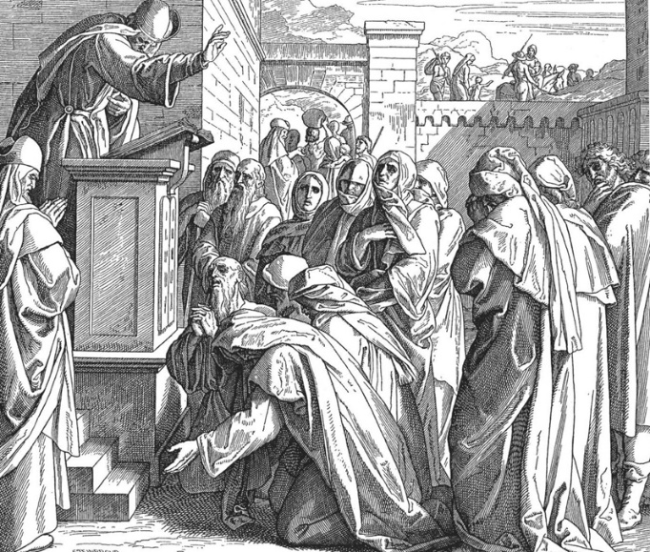
“He stood up to read, and the scroll of the prophet Isaiah was given to him." (Luke 4:16-17)

Minister: Rev. Jason Evans
First Free Methodist Church
2625 N. Center Rd.
Saginaw, Michigan 48603
Phone: (989) 799-2930
Email: saginawfmc@gmail.com
www.saginawfirstfmc.org

Third Sunday after the Epiphany
January 23, 2022

Prelude
**Greeting/Announcements
*Call to Worship (spoken responsively)
L: We are called to gather before the Lord
P: We bow before the Lord and worship the great God
L: Day and night the heavens pour out knowledge of God
P: We see God’s mighty works in creation and in our lives
L: The law of the Lord is perfect, reviving the soul
P: The commandments of God is clear and enlightening
L: Loving God and loving our neighbor is a great reward
P: Let our words and deeds be acceptable to you O Lord

*Opening Hymn: “Stand Up and Bless the Lord” #54 (vv.1-5)
Stand up, and bless the Lord
Ye people of His choice
Stand up, and bless the Lord your God
With heart, and soul, and voice

Tho' high above all praise
Above all blessing high
Who would not fear His holy Name
And laud and magnify?

O for the living flame
From His own altar brought
To touch our lips, our mind inspire
And wing to heav'n our thought

God is our strength and song
And His salvation ours
Then be His love in Christ proclaimed
With all our ransomed pow'rs

Stand up and bless the Lord
The Lord your God adore
Stand up, and bless His glorious Name
Henceforth for evermore

*Invocation and Lord’s Prayer
L: Blessed are you, O Lord, the God of our ancestor, forever and ever. Yours, O Lord, are the greatness, the power, the glory, the victory, and the majesty; for all that is in the heavens and on the earth is yours; yours is the kingdom, O Lord, and you are exalted as head above all. Riches and honor come from you, and you rule over all. In your hand are power and might; and it is in your hand to make great and to give strength to all. And now, our God, we give thanks to you and praise your glorious name, as we pray the prayer that Jesus taught His disciples…

P: Our Father, who art in heaven, hallowed be Your name. Your kingdom come; your will be done in earth as it is in heaven. Give us this day our daily bread and forgive us our debts as we forgive our debtors. And lead us not into temptation but deliver us from evil. For Yours is the kingdom, and the power, and the glory forever. Amen.

*Gloria Patri
Glory be to the Father​
And to the Son and to the Holy Ghost.​
As it was in the beginning​
Is now and ever shall be.​
World without end. ​
Amen. Amen.​

First Scripture Lesson: Nehemiah 8:1-3, 5-6, 8-10
All the people gathered together into the square before the Water Gate. They told the scribe Ezra to bring the book of the law of Moses, which the LORD had given to Israel. Accordingly, the priest Ezra brought the law before the assembly, both men and women and all who could hear with understanding. This was on the first day of the seventh month. He read from it facing the square before the Water Gate from early morning until midday, in the presence of the men and the women and those who could understand; and the ears of all the people were attentive to the book of the law.
And Ezra opened the book in the sight of all the people, for he was standing above all the people; and when he opened it, all the people stood up. Then Ezra blessed the LORD, the great God, and all the people answered, “Amen, Amen,” lifting up their hands. Then they bowed their heads and worshiped the LORD with their faces to the ground.
So they read from the book, from the law of God, with interpretation. They gave the sense, so that the people understood the reading. And Nehemiah, who was the governor, and Ezra the priest and scribe, and the Levites who taught the people said to all the people, “This day is holy to the LORD your God; do not mourn or weep.” For all the people wept when they heard the words of the law.
Then he said to them, “Go your way, eat the fat and drink sweet wine and send portions of them to those for whom nothing is prepared, for this day is holy to our LORD; and do not be grieved, for the joy of the LORD is your strength.”

Prayer of Confession
L: We are sent into the world to preach the word. Often the problems of the problems in the world seem complex and intricate, and the gospel so simple. But it does not come back void.

P: O Lord God, holy Father, be you now and forever blessed. For as you will, be it done; and what you do is good. Let your servant rejoice in you, not in myself or any other. You alone are my true joy. You are my hope and my crown. You are my gladness and my honor. O Lord, what is your servant but what has been received from you without deserving it? Yours are all things you have given and that you have made. Amen.

Affirmation of Faith: Psalm 19
P: The heavens are telling the glory of God; and the firmament proclaims his handiwork. Day to day pours forth speech, and night to night declares knowledge. In the heavens he has set a tent for the sun, which comes out like a bridegroom from his wedding canopy, and like a strong man runs its course with joy. Its rising is from the end of the heavens, and its circuit to the end of them; and nothing is hid from its heat. The law of the LORD is perfect, reviving the soul; the decrees of the LORD are sure, making wise the simple; the precepts of the LORD are right, rejoicing the heart; the commandment of the LORD is clear, enlightening the eyes; the fear of the LORD is pure, enduring forever; the ordinances of the LORD are true and righteous altogether.

Hymn of Affirmation: “O For a Thousand Tongues to Sing” #147 (vv.1-4,7)
O for a thousand tongues to sing
My great Redeemer's praise
The glories of my God and King
The triumphs of his grace!

Jesus! the name that charms our fears,
That bids our sorrows cease,
'Tis music in the sinner's ears,
'Tis life and health and peace

He breaks the power of cancelled sin
He sets the prisoner free
His blood can make the foulest clean
His blood availed for me

He speaks, and list’ning to His voice
New life the dead receive
The mournful, broken hearts rejoice
The humble poor believe

My gracious Master and my God
Assist me to proclaim
To spread thro' all the earth abroad
The honors of Thy name

Second Scripture Lesson: 1 Corinthians 12:12-31
For just as the body is one and has many members, and all the members of the body, though many, are one body, so it is with Christ. For in the one Spirit we were all baptized into one body, Jews or Greeks, slaves or free, and we were all made to drink of one Spirit. Indeed, the body does not consist of one member but of many.
If the foot would say, “Because I am not a hand, I do not belong to the body,” that would not make it any less a part of the body. And if the ear would say, “Because I am not an eye, I do not belong to the body,” that would not make it any less a part of the body.
If the whole body were an eye, where would the hearing be? If the whole body were hearing, where would the sense of smell be? But as it is, God arranged the members in the body, each one of them, as he chose. If all were a single member, where would the body be? As it is, there are many members, yet one body.
The eye cannot say to the hand, “I have no need of you,” nor again the head to the feet, “I have no need of you.”
On the contrary, the members of the body that seem to be weaker are indispensable, and those members of the body that we think less honorable we clothe with greater honor, and our less respectable members are treated with greater respect; whereas our more respectable members do not need this. But God has so arranged the body, giving the greater honor to the inferior member, that there may be no dissension within the body, but the members may have the same care for one another.
If one member suffers, all suffer together with it; if one member is honored, all rejoice together with it. Now you are the body of Christ and individually members of it. And God has appointed in the church first apostles, second prophets, third teachers; then deeds of power, then gifts of healing, forms of assistance, forms of leadership, various kinds of tongues. Are all apostles? Are all prophets? Are all teachers? Do all work miracles? Do all possess gifts of healing? Do all speak in tongues? Do all interpret? But strive for the greater gifts.

Children’s Sermon

Passing of the Peace

Prayers of the People
L: Lord in Your Mercy…
P: Hear our prayer.

Gospel Lesson: Luke 4:14-21
Then Jesus, filled with the power of the Spirit, returned to Galilee, and a report about him spread through all the surrounding country. He began to teach in their synagogues and was praised by everyone. When he came to Nazareth, where he had been brought up, he went to the synagogue on the sabbath day, as was his custom. He stood up to read, and the scroll of the prophet Isaiah was given to him.
He unrolled the scroll and found the place where it was written: “The Spirit of the Lord is upon me, because he has anointed me to bring good news to the poor. He has sent me to proclaim release to the captives and recovery of sight to the blind, to let the oppressed go free, to proclaim the year of the Lord’s favor.”
And he rolled up the scroll, gave it back to the attendant, and sat down. The eyes of all in the synagogue were fixed on him. Then he began to say to them, “Today this scripture has been fulfilled in your hearing.”

Sermon: “Redeeming the Body”

Prayer of Response

Hymn of Response: Hymn of Response: “His Name Is Wonderful” #149
His Name is Wonderful, His Name is Wonderful
His Name is Wonderful, Jesus my Lord
He is the mighty King, Master of everything
His Name is Wonderful, Jesus my Lord
He’s the Great Shepherd, The Rock of all Ages
Almighty God is He
Bow down before Him, Love and adore Him
His Name is Wonderful, Jesus my Lord

Invitation of Offering
L: Give your hands to the Lord’s work. Put your feet to the Lord’s path. Give your tongue to speak the Lord’s truth. Give your heart to the love of God, as we collect this morning’s tithes and offerings.

*Doxology

*Prayer

*Closing Hymn: “Brightest and Best are the Sons of the Morning” Handout (vv.1-4)
Brightest and best of the sons of the morning
Dawn on our darkness and lend us your aid
Star of the east, the horizon adorning
Guide where our infant Redeemer is laid

Cold on his cradle the dewdrops are shining
Low lies his head with the beasts of the stall
Angels adore him in slumber reclining
Maker and monarch and Savior of all

Shall we yield him in costly devotion
Rarest of fragrances, tribute divine
Gems of the mountain and pearls of the ocean
Myrrh from the forest and gold from the mine

Vainly we offer each ample oblation
Vainly with gifts would his favor secure
Richer by far is the heart's adoration
Dearer to God are the prayers of the poor

*Benediction
L: Go now, follow where Christ calls you and proclaim the message God gives you. And may God be your haven and your glory; May Christ Jesus give you courage for his mission; And may the Spirit embrace your soul in God’s kingdom. Go in peace to love and serve. Amen.

