Saginaw First Free Methodist Church
Fourth Sunday After The Epiphany
February 7, 2021

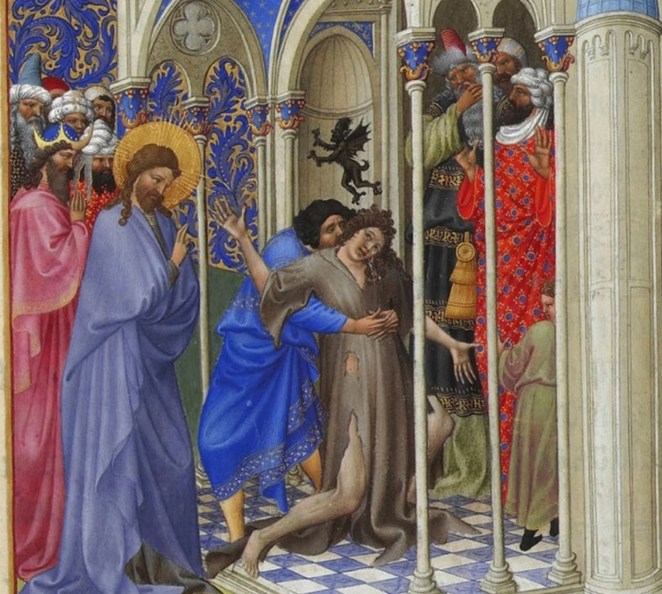
“But Jesus rebuked him, saying, ‘Be silent, and come out of him!’
And the unclean spirit, convulsing him and crying with a loud voice, came out of him. They were all amazed…” (Mark 1:25-27a)

Minister: Rev. Jason Evans
First Free Methodist Church
2625 N. Center Rd.
Saginaw, Michigan 48603
Phone: (989) 799-2930
Email: saginawfmc@gmail.com
www.saginawfirstfmc.org

Fourth Sunday After The Epiphany
February 7, 2021

The mission of Saginaw First Free Methodist Church is to be faithful to God and to make known to all people everywhere God’s call to wholeness in Jesus Christ.

Prelude
**Greeting/Announcements
*Call to Worship (spoken responsively)
L: Great are the works of the Lord, and greatly to be praised
P: We come to celebrate the new life God has given us
L: God’s covenant is gracious, merciful, and trustworthy
P: We can count on God’s righteousness and faithfulness
L: The works of God’s hands are established among us
P: We will build in love, not by pride or self-importance
L: Awe before God is the beginning of wisdom
P: May God keep us holy to serve in love

*Opening Hymn: “Immortal, Invisible, God Only Wise” #65 (vv.1,3)
Immortal, invisible, God only wise
In light inaccessible hid from our eyes
Most blessed, most glorious, the Ancient of Days
Almighty, victorious, thy great name we praise

To all, life Thou givest, to both great and small
In all life Thou livest, the true life of all
Thy wisdom so boundless, Thy mercy so free
Eternal Thy goodness, for naught changeth Thee

*Invocation and Lord’s Prayer
L: Holy God, you gather the whole universe into your radiant presence and continually reveal your Son as our Savior. Bring healing to all wounds, make whole all that is broken, speak truth to all illusion, and shed light in every darkness. May that all creation will see your glory and know your Christ. Ignite the Holy Spirit in us, as we pray the prayer that Jesus taught His disciples…

P: Our Father, who art in heaven, hallowed be Your name. Your kingdom come; your will be done in earth as it is in heaven. Give us this day our daily bread and forgive us our debts as we forgive our debtors. And lead us not into temptation but deliver us from evil. For Yours is the kingdom, and the power, and the glory forever. Amen.

*Gloria Patri
Glory be to the Father​
And to the Son and to the Holy Ghost.
As it was in the beginning​
Is now and ever shall be
World without end
Amen. Amen

Old Testament Scripture Lesson: Deuteronomy 18:15-20
The LORD your God will raise up for you a prophet like me from among your own people; you shall heed such a prophet. This is what you requested of the LORD your God at Horeb on the day of the assembly when you said: “If I hear the voice of the LORD my God any more, or ever again see this great fire, I will die.”
Then the LORD replied to me: “They are right in what they have said. I will raise up for them a prophet like you from among their own people; I will put my words in the mouth of the prophet, who shall speak to them everything that I command. Anyone who does not heed the words that the prophet shall speak in my name, I myself will hold accountable. But any prophet who speaks in the name of other gods, or who presumes to speak in my name a word that I have not commanded the prophet to speak--that prophet shall die.”

Prayer of Confession
L: God calls us to be authentic witnesses to the truth. God’s prophets in the world. We join in confession with the church universal, because we are not yet the perfect body of Christ. Let us seek God’s forgiveness…

P: Faithful God, we often are scared of the change your resurrected life brings. We are not always ready to give up habits or beliefs we’ve held for much of our lives. We think you have come to destroy us and our world, when you come to teach us a better way. We allow our knowledge to inflate our egos, instead of using love to build up your world. We think our ways are better than the new life you call us to. Call out of us the sin that so easily entangles us, that we may know how to abide in you. Amen.

Affirmation of Faith: Psalm 111
P: Praise the LORD! I will give thanks to the LORD with my whole heart, in the company of the upright, in the congregation. Great are the works of the LORD, studied by all who delight in them. Full of honor and majesty are God’s work, and God’s righteousness endures forever. God has gained renown by wonderful deeds; the LORD is gracious and merciful. God provides food for those who fear; God is ever mindful of the covenant. God has shown the people the power of God’s works, in giving them the heritage of the nations. The works of God’s hands are faithful and just; all God’s precepts are trustworthy. They are established forever and ever, to be performed with faithfulness and uprightness. God sent redemption to the people; God has commanded the covenant forever. Holy and awesome is God’s name.

Hymn of Affirmation: “Jesus, Lover of My Soul” #636 (vv.1,3)
Jesus, lover of my soul
Let me to thy bosom fly
While the nearer waters roll
While the tempest still is high
Hide me, O my Savior, hide
Till the storm of life is past
Safe into the haven guide
O receive my soul at last

Thou, O Christ, art all I want
More than all in Thee I find
Raise the fallen, cheer the faint
Heal the sick and lead the blind
Just and holy is Thy name
I am all unrighteousness
False and full of sin I am
Thou are full of truth and grace

New Testament Scripture Lesson: 1 Corinthians 8:1-13
Now concerning food sacrificed to idols: we know that “all of us possess knowledge.” Knowledge puffs up, but love builds up. Anyone who claims to know something does not yet have the necessary knowledge; but anyone who loves God is known by him.
Hence, as to the eating of food offered to idols, we know that “no idol in the world really exists," and that "there is no God but one.”
Indeed, even though there may be so-called gods in heaven or on earth--as in fact there are many gods and many lords--yet for us there is one God, the Father, from whom are all things and for whom we exist, and one Lord, Jesus Christ, through whom are all things and through whom we exist.
It is not everyone, however, who has this knowledge. Since some have become so accustomed to idols until now, they still think of the food they eat as food offered to an idol; and their conscience, being weak, is defiled. “Food will not bring us close to God.”
We are no worse off if we do not eat, and no better off if we do. But take care that this liberty of yours does not somehow become a stumbling block to the weak. For if others see you, who possess knowledge, eating in the temple of an idol, might they not, since their conscience is weak, be encouraged to the point of eating food sacrificed to idols?
So by your knowledge those weak believers for whom Christ died are destroyed. But when you thus sin against members of your family, and wound their conscience when it is weak, you sin against Christ. Therefore, if food is a cause of their falling, I will never eat meat, so that I may not cause one of them to fall.

Communion
MINISTER: THE INVITATION
You who truly and earnestly repent of your sins, who live in love and peace with
your neighbors and who intend to lead a new life, following the commandments
of God and walking in His holy ways, draw near with faith, and take this holy
sacrament to your comfort; and humbly kneeling, make your honest confession
to Almighty God.

IN UNISON: THE GENERAL CONFESSION
Almighty God, Father of our Lord Jesus Christ, maker of all things, judge of all
people, we confess that we have sinned, and we are deeply grieved as we
remember the wickedness of our past lives. We have sinned against You, Your
holiness and Your love, and we deserve only Your indignation and anger.
We sincerely repent, and we are genuinely sorry for all wrongdoing and every
failure to do the things we should. Our hearts are grieved, and we acknowledge
that we are hopeless without Your grace.
Have mercy upon us.
Have mercy upon us, most merciful Father, for the sake of your son, our Savior, Jesus
Christ, who died for us.
Forgive us.
Cleanse us.
Give us strength to serve and please You in newness of life and to honor and praise
Your name, through Jesus Christ our Lord. Amen.

MINISTER: THE AFFIRMATION OF FAITH
O Almighty God, our Heavenly Father, who with great mercy has promised
forgiveness to all who turn to You with hearty repentance and true faith, have
mercy upon us, pardon and deliver us from our sins, make us strong and faithful in
all goodness and bring us to everlasting life, through Jesus Christ our Lord. Amen.

CONGREGATION: THE COLLECT
Almighty God, unto whom all hearts are open, all desires known, and from whom
no secrets are hid: cleanse the thoughts of our hearts, by the inspiration of the
Holy Spirit, that we may perfectly love You and worthily magnify Your holy name,
through Christ our Lord. Amen.

MINISTER: THE SANCTUS
It is always right and proper, and our moral duty, that we should at all times and
in all places give thanks to You, O Lord, holy Father, Almighty and Everlasting God.
Therefore, with angels and archangels, and with all the inhabitants of heaven, we
honor and adore Your glorious name, evermore praising You and saying,

CONGREGATION: THE SANCTUS (CONTINUED)
Holy, Holy, Holy, Lord God of hosts!
Heaven and earth are full of Thy glory.
Glory be to Thee, O Lord, most high. Amen

MINISTER: THE PRAYER FOR SPIRITUAL COMMUNION
We do not come to this Your table, O merciful Lord, with self-confidence and
pride, trusting in our own righteousness, but we trust in Your great and many
mercies. We are not worthy to gather the crumbs from under Your table. But You,
O Lord, are unchanging in Your mercy and Your nature is love; grant us, therefore,
God of mercy, God of grace, so to eat at this Your table that we may receive in
spirit and in truth the body of Your dear Son, Jesus Christ, and the merits of His
shed blood, so that we may live and grow in His likeness and, being washed and
cleansed through His most precious blood, we may evermore live in Him and He
in us. Amen.

MINISTER: THE PRAYER OF CONSECRATION OF THE ELEMENTS
Almighty God, our Heavenly Father, who gave in love Your only Son, Jesus Christ,
to suffer death upon the cross for our redemption, who by His sacrifice, offered
once for all, did provide a full, perfect, and sufficient atonement for the sins of the whole world,
we come now to Your table in obedience to Your Son, Jesus Christ, who in His holy gospel
commanded us to continue a perpetual memory of His precious death until He comes
again. Hear us, O merciful Father, we humbly ask, and grant that we, receiving this bread and this cup,
as He commanded and in the memory of His passion and death, may partake of His most blessed body and blood.

In the night of His betrayal, Jesus took bread, and when He had given thanks, He broke it and gave it to
His disciples, saying, “Take, eat; this is My body which is given for you; do this in remembrance of Me.”

In like manner, after supper He took the cup, and when He had given thanks, He gave it to them, saying, “Drink of
this, all of you, for this is My blood of the New Testament, which is shed for you and for many, for the remission of
sins; do this as often as you drink it, in remembrance of Me.” Amen.

The body of our Lord Jesus Christ, which was given for you, preserve your soul and body unto everlasting
life. Take and eat this in remembrance that Christ died for you, and feed upon Him in your heart, by faith with
thanksgiving.

The blood of our Lord Jesus Christ, which was shed for you, preserve your soul and body unto everlasting life.
Drink this in remembrance that Christ’s blood was shed for you and be thankful.

MINISTER: THE BENEDICTION
May the peace of God, which passes all understanding, keep your hearts and minds in the knowledge and love
of God, and of His Son, Jesus Christ our Lord; and may the blessing of God Almighty, the Father, the Son, and
the Holy Spirit, be yours now and forever. Amen.

Passing of the Peace

Prayers of the People
L: Lord in Your Mercy…
P: Hear our prayer.

Gospel Lesson: Mark 1:21-28
They went to Capernaum; and when the sabbath came, he entered the synagogue and taught. They were astounded at his teaching, for he taught them as one having authority, and not as the scribes.
Just then there was in their synagogue a man with an unclean spirit, and he cried out, “What have you to do with us, Jesus of Nazareth? Have you come to destroy us? I know who you are, the Holy One of God.”
But Jesus rebuked him, saying, “Be silent, and come out of him!”
And the unclean spirit, convulsing him and crying with a loud voice, came out of him. They were all amazed, and they kept on asking one another, “What is this? A new teaching--with authority! He commands even the unclean spirits, and they obey him.”
At once his fame began to spread throughout the surrounding region of Galilee.

Sermon

Prayer of Response

Hymn of Response: “He Leadeth Me” #99 (vv.1,3)
He leadeth me: O blessed thought
O words with heavenly comfort fraught
Whate'er I do, where'er I be
Still 'tis God's hand that leadeth me
He leadeth me, he leadeth me
By his own hand he leadeth me
His faithful follower I would be
For by his hand he leadeth me

Lord, I would clasp thy hand in mine
Nor ever murmur nor repine
Content, whatever lot I see
Since 'tis my God that leadeth me
He leadeth me, he leadeth me
By his own hand he leadeth me
His faithful follower I would be
For by his hand he leadeth me

Invitation of Offering
L: All power and authority has been given to Christ; we can rest assured as we abide with Jesus. But the sharing of our earthly resources is a prophetic action in the world; seen as unusual. Be a powerful force in the world, as we collect this morning’s tithes and offerings.

*Doxology
Praise God, from whom all blessings flow
Praise Him, all creatures here below
Praise Him above, ye heavenly host
Praise Father Son, and Holy Ghost.
Amen.

*Prayer

*Hymn: “Standing on the Promises” #687 (vv.1,5)
Standing on the promises of Christ my king
Through eternal ages let his praises ring
Glory in the highest, I will shout and sing
Standing on the promises of God
Standing, standing,
Standing on the promises of God my Savior
Standing, standing
I’m standing on the promises of God

Standing on the promises I cannot fall
Listening every moment to the Spirit’s call
Resting in my Savior as my all in all
Standing on the promises of God
Standing, standing,
Standing on the promises of God my Savior
Standing, standing
I’m standing on the promises of God

*Benediction
L: God has empowered us for service, and continues to remove obstacles from our path. God is raising us up as prophets of love. Follow the Holy Spirit's guidance and insight, as you go in peace to love and serve. Amen.

