Saginaw First Free Methodist Church
ADVENT
December 13, 2020

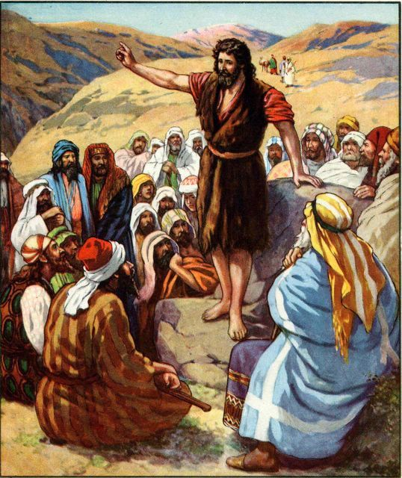
“There was a man sent from God, whose name was John. He came as a witness to testify to the light, so that all might believe through him. He himself was not the light, but he came to testify to the light.” (John 1:6-8)

Minister: Rev. Jason Evans
First Free Methodist Church
2625 N. Center Rd.
Saginaw, Michigan 48603
Phone: (989) 799-2930
Email: saginawfmc@gmail.com
www.saginawfirstfmc.org

THIRD SUNDAY OF ADVENT
December 13, 2020

The mission of Saginaw First Free Methodist Church is to be faithful to God and to make known to all people everywhere God’s call to wholeness in Jesus Christ.

Prelude
**Greeting/Announcements
*Call to Worship (spoken responsively)
L: Come to worship Jesus Christ, and proclaim good news to the poor
P: We are sent to bring good news to the oppressed
L: We proclaim the year of the Lord’s favor
P: Christ comforts those who mourn, binds up the broken-hearted
L: We proclaim liberty to the captive’s freedom to the prisoner
P: For those who mourn, we will give oil of gladness instead of mourning

*Opening Hymn: “O Come, O Come, Emmanuel” #163 (v.3)
O come, Thou Wisdom from on high
And order all thing far and nigh
To us the path of knowledge show
And cause us in her ways to go
Rejoice! Rejoice! Immanuel
Shall come to thee, O Israel

*Invocation and Lord’s Prayer
L: God of hope, you call us home from the exile of selfish oppression to the freedom of justice, the balm of healing, and the joy of sharing. Make us strong to join you in your holy work, as friends of strangers and victims, companions of those whom others shun, and as the happiness of those whose hearts are broken. Let us joyfully wait for the glorious coming of Christ, as we pray together the prayer that Jesus taught His disciples…

P: Our Father, who art in heaven, hallowed be Your name. Your kingdom come; your will be done in earth as it is in heaven. Give us this day our daily bread and forgive us our debts as we forgive our debtors. And lead us not into temptation but deliver us from evil. For Yours is the kingdom, and the power, and the glory forever. Amen.

*Gloria Patri
Glory be to the Father​
And to the Son and to the Holy Ghost.
As it was in the beginning​
Is now and ever shall be
World without end
Amen. Amen
Advent Reading

First Scripture Lesson: Isaiah 61:1-4, 8-11
The spirit of the Lord GOD is upon me, because the LORD has anointed me; he has sent me to bring good news to the oppressed, to bind up the brokenhearted, to proclaim liberty to the captives, and release to the prisoners; to proclaim the year of the Lord's favor, and the day of vengeance of our God; to comfort all who mourn; to provide for those who mourn in Zion-- to give them a garland instead of ashes, the oil of gladness instead of mourning, the mantle of praise instead of a faint spirit. They will be called oaks of righteousness, the planting of the LORD, to display his glory.
They shall build up the ancient ruins, they shall raise up the former devastations; they shall repair the ruined cities, the devastations of many generations.
For I the LORD love justice, I hate robbery and wrongdoing; I will faithfully give them their recompense, and I will make an everlasting covenant with them. Their descendants shall be known among the nations, and their offspring among the peoples; all who see them shall acknowledge that they are a people whom the LORD has blessed.
I will greatly rejoice in the LORD, my whole being shall exult in my God; for he has clothed me with the garments of salvation, he has covered me with the robe of righteousness, as a bridegroom decks himself with a garland, and as a bride adorns herself with her jewels.
For as the earth brings forth its shoots, and as a garden causes what is sown in it to spring up, so the Lord GOD will cause righteousness and praise to spring up before all the nations.

Prayer of Confession
L: Mighty One has done great things for us. The Lord has scattered the proud in the thoughts of their hearts and brought down the powerful from their thrones. God has lifted up the lowly. For the times we forget what’s been done for us, let’s repent...

P: God our Savior, you have looked with favor on the lowliness of your servant, we come to you. You have filled the hungry with good things, and sent the rich away empty. You have helped your servants in times past. In your mercy, remember us. When we are tempted by evil, help us to hold fast to what is good. When we are dismayed, remind us to rejoice. May we welcome your peace so that we can be entirely sanctified. May our spirit and soul and body be kept sound and blameless until the coming of our Lord Jesus Christ. Amen.

Affirmation of Faith: Psalm 126
P: When the LORD restored the fortunes of Zion, we were like those who dream. Then our mouth was filled with laughter, and our tongue with shouts of joy; then it was said among the nations, “The LORD has done great things for them.” The LORD has done great things for us, and we rejoiced. Restore our fortunes, O LORD, like the watercourses in the Negeb. May those who sow in tears reap with shouts of joy. Those who go out weeping, bearing the seed for sowing, shall come home with shouts of joy, carrying their sheaves.

*Hymn of Affirmation: “All Praise to Our Redeeming Lord” #684 (v.1)
All praise to our redeeming Lord
Who joins us by His grace
And bids us, each to each restored
Together seek His face

Second Scripture Lesson: 1 Thessalonians 5:16-24
Rejoice always, pray without ceasing, give thanks in all circumstances; for this is the will of God in Christ Jesus for you. Do not quench the Spirit. Do not despise the words of prophets, but test everything; hold fast to what is good; abstain from every form of evil.
May the God of peace himself sanctify you entirely; and may your spirit and soul and body be kept sound and blameless at the coming of our Lord Jesus Christ. The one who calls you is faithful, and he will do this.

Passing of the Peace

Prayers of the People
L: Lord in Your Mercy…
P: Hear our prayer.

Gospel Lesson: John 1:6-8, 19-28
There was a man sent from God, whose name was John. He came as a witness to testify to the light, so that all might believe through him. He himself was not the light, but he came to testify to the light.
This is the testimony given by John when the Jews sent priests and Levites from Jerusalem to ask him, “Who are you?” He confessed and did not deny it, but confessed, “I am not the Messiah.”
And they asked him, “What then? Are you Elijah?” He said, “I am not.” “Are you the prophet?” He answered, “No.”
Then they said to him, “Who are you? Let us have an answer for those who sent us. What do you say about yourself?”
He said, “I am the voice of one crying out in the wilderness, ‘Make straight the way of the Lord,’” as the prophet Isaiah said.
Now they had been sent from the Pharisees. They asked him, “Why then are you baptizing if you are neither the Messiah, nor Elijah, nor the prophet?” John answered them, “I baptize with water. Among you stands one whom you do not know, the one who is coming after me; I am not worthy to untie the thong of his sandal.”
This took place in Bethany across the Jordan where John was baptizing.

Sermon

Prayer of Response

*Hymn of Response: “It Came upon the Midnight Clear” #168 (v.4)
For lo! the days are hastening on
By prophet bards foretold
When with the ever-circling years
Comes round the age of gold
When peace shall over all the earth
Its ancient splendors fling
And the whole world give back the song
Which now the angels sing

Invitation of Offering
L: John the Baptist came many years ago to bring light where there was darkness. We can share love where there it is absent. May we witness through our giving and our compassion, as we collect this morning’s tithes and offerings.

*Doxology
Praise God, from whom all blessings flow
Praise Him, all creatures here below
Praise Him above, ye heavenly host
Praise Father Son, and Holy Ghost.
Amen.

*Prayer

*Hymn: “Joy to the World” #173 (v.3)
No more let sins and sorrows grow
Nor thorns infest the ground
He comes to make his blessings flow
Far as the curse is found
Far as the curse is found
Far as, far as the curse is found

*Benediction
L: May Christ the Son pour the riches of his grace upon you. May the Holy Spirit be your advocate as you advocate for the vulnerable. Care for one another, as you go in peace to love and serve. Amen.

