Saginaw First Free Methodist Church
Third Sunday of Advent
December 11, 2022

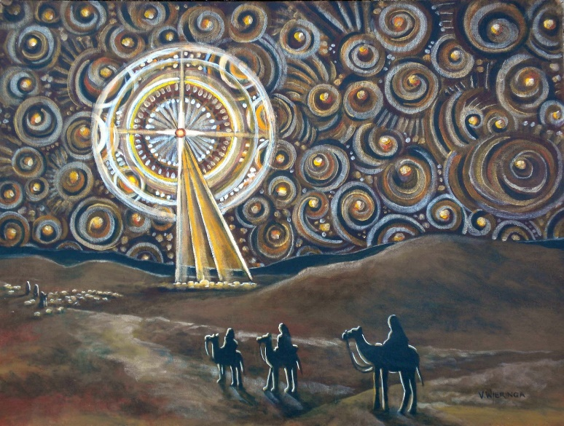
“Jesus answered them, ‘Go and tell John what you hear and see: the blind receive their sight, the lame walk, the lepers are cleansed, the deaf hear, the dead are raised, and the poor have good news brought to them.’" (Matthew 11:4-5)

Minister: Rev. Jason Evans
First Free Methodist Church
2625 N. Center Rd.
Saginaw, Michigan 48603
Phone: (989) 799-2930
Email: saginawfmc@gmail.com
www.saginawfirstfmc.org

Third Sunday of Advent
December 11, 2022

Prelude
**Greeting/Announcements
*Call to Worship (spoken responsively)
L: We come to reflect on God the creator heaven and earth
P: Who was the word made flesh
L: We seek the return to the joy of our salvation
P: To walk in the light of God’s kingdom
L: Advent is a time of waiting
P: We patiently wait for the return of Christ
L: How do we prepare for the coming of Christ?
P: I will serve God in joy by doing good works

*Opening Hymn: “Joy To The World” #173 (vv.1-4)
Joy to the World, the Lord is come!
Let earth receive her King
Let every heart prepare Him room
And Heaven and nature sing
And Heaven and nature sing
And Heaven, and Heaven, and nature sing

Joy to the World, the Savior reigns!
Let men their songs employ
While fields and floods, rocks, hills and plains
Repeat the sounding joy
Repeat the sounding joy
Repeat, repeat, the sounding joy

No more let sins and sorrows grow
Nor thorns infest the ground
He comes to make His blessings flow
Far as the curse is found
Far as the curse is found
Far as, far as, the curse is found

He rules the world with truth and grace
And makes the nations prove
The glories of His righteousness
And wonders of His love
And wonders of His love
And wonders, wonders, of His love

*Advent Reading
The longer we wait for the coming of Christ, the more our hope is put to the test. Like the ancient Israelites wondering if Moses would ever return, will we look for something else to satisfy our desires?

Where is Joy to be found?

Isaiah tells us that Joy is coming to the most unexpected places. Like water in the desert and health to the crippled, there is a place where relief is found.

Our Psalm tells us that place is God’s kingdom, the God of Jacob. It is the kingdom where our God is king.

Therefore we are to be patient and strengthen our hearts, as James instructs. As a farmer waits for the harvest that comes in due time, so we wait for Christ who will come at the appointed time.

Light the candle
As we light this candle of Joy, let us not look for the end of the world, but the coming of the Kingdom. Where God breaks through, “the blind receive their sight, the lame walk, the lepers are cleansed, the deaf hear, the dead are raised, and the poor have good news brought to them.” Amen and Amen.

*Invocation and Lord’s Prayer
L: Stir up thy power, O Lord, and with great might come among us; and, because we are sorely hindered by our sin, let thy bountiful grace and mercy speedily help and deliver us. Plant in every heart, love for you and our neighbor, as we seek to share good news with everyone. May we model the love of Christ, as we pray the prayer that Jesus taught His disciples…

P: Our Father, who art in heaven, hallowed be Your name. Your kingdom come; your will be done in earth as it is in heaven. Give us this day our daily bread and forgive us our debts as we forgive our debtors. And lead us not into temptation but deliver us from evil. For Yours is the kingdom, and the power, and the glory forever. Amen.

*Gloria Patri
Glory be to the Father​
And to the Son and to the Holy Ghost.​
As it was in the beginning​
Is now and ever shall be.​
World without end. ​
Amen. Amen.​

First Scripture Lesson: Isaiah 35:1-10
The wilderness and the dry land shall be glad, the desert shall rejoice and blossom; like the crocus it shall blossom abundantly, and rejoice with joy and singing. The glory of Lebanon shall be given to it, the majesty of Carmel and Sharon. They shall see the glory of the LORD, the majesty of our God.
Strengthen the weak hands, and make firm the feeble knees. Say to those who are of a fearful heart, “Be strong, do not fear! Here is your God. He will come with vengeance, with terrible recompense. He will come and save you.”
Then the eyes of the blind shall be opened, and the ears of the deaf unstopped; then the lame shall leap like a deer, and the tongue of the speechless sing for joy. For waters shall break forth in the wilderness, and streams in the desert; the burning sand shall become a pool, and the thirsty ground springs of water; the haunt of jackals shall become a swamp, the grass shall become reeds and rushes.
A highway shall be there, and it shall be called the Holy Way; the unclean shall not travel on it, but it shall be for God's people; no traveler, not even fools, shall go astray. No lion shall be there, nor shall any ravenous beast come up on it; they shall not be found there, but the redeemed shall walk there. And the ransomed of the LORD shall return, and come to Zion with singing; everlasting joy shall be upon their heads; they shall obtain joy and gladness, and sorrow and sighing shall flee away.

Prayer of Confession
L: In this world we seek joy and gladness, for ourselves, our loved ones, and also for neighbors and enemies. Bear good fruit, in accordance with the gospel, so our spirits may grow calm, our vision be clear, and our purpose be unified…

P: I believe in God, the Father Almighty, Maker of heaven and earth. And in Jesus Christ, God’s only Son, our Lord. Who was conceived by the Holy Spirit, born of the Virgin Mary, suffered under Pontius Pilate, was crucified, dead, and was buried. He descended into hades, the third day He rose again from the dead. He ascended into heaven, and sits at the right hand of God the Father Almighty. From thence He shall come to judge the living and the dead. I believe in the Holy Spirit, the holy Church universal, the communion of saints, the forgiveness of sins, the resurrection of the body, and the life everlasting. Amen.
Affirmation of Faith: Psalm 146
P: Happy are those whose help is the God of Jacob, whose hope is in the LORD their God, who made heaven and earth, the sea, and all that is in them; who keeps faith forever; who executes justice for the oppressed; who gives food to the hungry. The LORD sets the prisoners free; the LORD opens the eyes of the blind. The LORD lifts up those who are bowed down; the LORD loves the righteous. The LORD watches over the strangers; he upholds the orphan and the widow, but the way of the wicked he brings to ruin. The LORD will reign forever, your God, O Zion, for all generations. Praise the LORD!

Hymn of Affirmation: “Angels from the Realms of Glory” #192 (vv.1-4)
Angels from the realms of glory
Wing your flight o'er all the earth
Ye who sang creation's story
Now proclaim Messiah's birth
Come and worship, come and worship
Worship Christ, the newborn king

Shepherds in the field abiding
Watching o’er our flocks by night
God with man is now residing
Yonder shines the infant light
Come and worship, come and worship
Worship Christ, the newborn king

Sages leave your contemplations
Brighter visions beam afar
Seek the great desire of nations
Ye have seen His natal star
Come and worship, come and worship
Worship Christ, the newborn king

Saints before the altar bending
Watching long in hope and fear
Suddenly the Lord descending
In His temple shall appear
Come and worship, come and worship
Worship Christ, the newborn king

Second Scripture Lesson: James 5:7-10
Be patient, therefore, beloved, until the coming of the Lord. The farmer waits for the precious crop from the earth, being patient with it until it receives the early and the late rains. You also must be patient. Strengthen your hearts, for the coming of the Lord is near.
Beloved, do not grumble against one another, so that you may not be judged. See, the Judge is standing at the doors! As an example of suffering and patience, beloved, take the prophets who spoke in the name of the Lord.

Children’s Sermon

Passing of the Peace

Prayers of the People
L: Lord in Your Mercy…
P: Hear our prayer.

Gospel Lesson: Matthew 11:2-11
When John heard in prison what the Messiah was doing, he sent word by his disciples and said to him, “Are you the one who is to come, or are we to wait for another?”
Jesus answered them, “Go and tell John what you hear and see: the blind receive their sight, the lame walk, the lepers are cleansed, the deaf hear, the dead are raised, and the poor have good news brought to them. And blessed is anyone who takes no offense at me.”
As they went away, Jesus began to speak to the crowds about John: “What did you go out into the wilderness to look at? A reed shaken by the wind? What then did you go out to see? Someone dressed in soft robes? Look, those who wear soft robes are in royal palaces. What then did you go out to see? A prophet? Yes, I tell you, and more than a prophet. This is the one about whom it is written, ‘See, I am sending my messenger ahead of you, who will prepare your way before you.’ Truly I tell you, among those born of women no one has arisen greater than John the Baptist; yet the least in the kingdom of heaven is greater than he.

Sermon: “Joy for the Kingdom”

Prayer of Response

Hymn of Response: “Open My Eyes, That I May See” #461 (vv.1-4)
Open my eyes, that I may see
Glimpses of truth you have for me
Place in my hands the wonderful key
That shall unlock and set me free
Silently now, on bended knee
Ready I wait your will to see
Open my eyes, illumine me
Spirit divine

Open my ears, that I may hear
Voices of truth Thou sendest clear
And while the wave-notes fall on my ear
Ev’rything false will disappear
Silently now, on bended knee
Ready I wait your will to see
Open my ears, illumine me
Spirit divine

Open my mouth and let me bear
Gladly the warm truth ev’rywhere
Open my heart and let me prepare
Love with Thy children thus to share
Silently now, on bended knee
Ready I wait your will to see
Open my mouth, illumine me
Spirit divine

Open my mind, that I may read
More of Thy love in word and deed
What shall I fear while yet Thou dost lead
Only for light from Thee I plead
Ready I wait your will to see
Open my mind, illumine me
Spirit divine
Invitation of Offering
L: Rejoice! The Lord is King. And our heavenly Father knows all our needs. Do not fret, but give to the heavenly Kingdom. Seek the kingdom of God, and this righteousness, as we collect this morning’s tithes and offerings.

*Doxology

*Prayer

*Closing Hymn: “Shout to the Lord” (2x)
My Jesus, my Savior
Lord, there is none like You
All of my days
I want to praise
The wonders of Your mighty love

My comfort, my shelter
Tower of refuge and strength
Let every breath, all that I am
Never cease to worship You

Shout to the Lord, all the earth, let us sing
Power and majesty, praise to the King
Mountains bow down and the seas will roar
At the sound of Your name

I sing for joy at the work of Your hands
Forever I'll love You, forever I'll stand
Nothing compares to the promise I have in You

*Benediction
L: May God come to us quickly. May Christ give you everlasting joy and gladness. May the Holy Spirit strengthen your hearts and lead you on the way. Go in peace to love and serve. Amen.

