Saginaw First Free Methodist Church
Twelfth Sunday after Pentecost
August 15, 2021

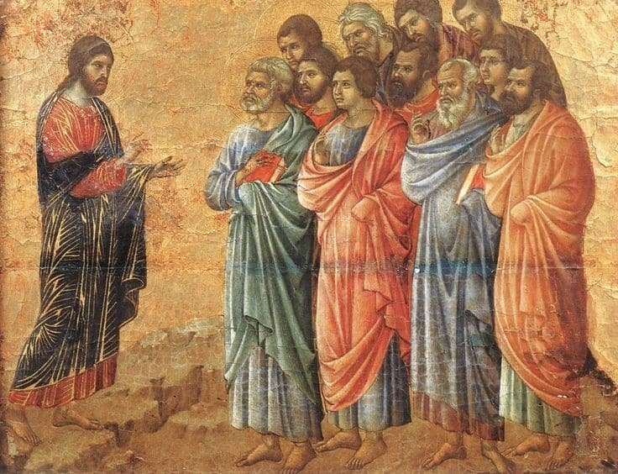
“’Give your servant therefore an understanding mind to govern your people, able to discern between good and evil; for who can govern this your great people?’"
(I Kings 3:9)

Minister: Rev. Jason Evans
First Free Methodist Church
2625 N. Center Rd.
Saginaw, Michigan 48603
Phone: (989) 799-2930
Email: saginawfmc@gmail.com
www.saginawfirstfmc.org

Proper 15 (20)
August 15, 2021

Prelude
**Greeting/Announcements
*Call to Worship (spoken responsively)
L: All praises to the One from whom all creation began
P: The One who formed the stars and who gave life to man
L: Who set the world in motion, created sky and ocean
P: Here I stand beloved and called by name
L: Be praised, O Lord
P: Listen to Your people lifting up Your Name
L: The One who conquered death and who will come again
P: The nations will behold You as everything becomes new

*Opening Hymn: "Great is Thy Faithfulness" #44 (vv. 1-3)
Great is Thy faithfulness, O God my Father
There is no shadow of turning with Thee
Thou changest not, Thy compassions, they fail not
As Thou hast been Thou forever wilt be
Great is Thy faithfulness!
Great is Thy faithfulness!
Morning by morning new mercies I see
All I have needed Thy hand hath provided
Great is Thy faithfulness, Lord, unto me!

Summer and winter, and springtime and harvest
Sun, moon, and stars in their courses above
Join with all nature in manifold witness
To Thy great faithfulness, mercy, and love
Great is Thy faithfulness!
Great is Thy faithfulness!
Morning by morning new mercies I see
All I have needed Thy hand hath provided
Great is Thy faithfulness, Lord, unto me!

Pardon for sin and a peace that endureth,
Thine own dear presence to cheer and to guide
Strength for today and bright hope for tomorrow
Blessings all mine, with ten thousand beside!
Great is Thy faithfulness!
Great is Thy faithfulness!
Morning by morning new mercies I see
All I have needed Thy hand hath provided
Great is Thy faithfulness, Lord, unto me!

*Invocation and Lord’s Prayer
L: Holy God of all Wisdom, you granted Solomon’s request for an understanding mind and the knowledge to discern good from evil. Fill us with such understanding and knowledge that we may act as instruments of loving for creation. Teach us to work with you to transform our fear into love, our violence into peace, and our brokenness into wholeness, as we pray the prayer that Jesus taught His disciples…

P: Our Father, who art in heaven, hallowed be Your name. Your kingdom come; your will be done in earth as it is in heaven. Give us this day our daily bread and forgive us our debts as we forgive our debtors. And lead us not into temptation but deliver us from evil. For Yours is the kingdom, and the power, and the glory forever. Amen.

*Gloria Patri
Glory be to the Father​
And to the Son and to the Holy Ghost.​
As it was in the beginning​
Is now and ever shall be.​
World without end. ​
Amen. Amen.​

First Scripture Lesson: 1 Kings 2:10-12; 3:3-14
Then David slept with his ancestors, and was buried in the city of David. The time that David reigned over Israel was forty years; he reigned seven years in Hebron, and thirty-three years in Jerusalem. So Solomon sat on the throne of his father David; and his kingdom was firmly established.
Solomon loved the LORD, walking in the statutes of his father David; only, he sacrificed and offered incense at the high places. The king went to Gibeon to sacrifice there, for that was the principal high place; Solomon used to offer a thousand burnt offerings on that altar.
At Gibeon the LORD appeared to Solomon in a dream by night; and God said, “Ask what I should give you.”
And Solomon said, “You have shown great and steadfast love to your servant my father David, because he walked before you in faithfulness, in righteousness, and in uprightness of heart toward you; and you have kept for him this great and steadfast love, and have given him a son to sit on his throne today.
And now, O LORD my God, you have made your servant king in place of my father David, although I am only a little child; I do not know how to go out or come in. And your servant is in the midst of the people whom you have chosen, a great people, so numerous they cannot be numbered or counted. Give your servant therefore an understanding mind to govern your people, able to discern between good and evil; for who can govern this your great people?”
It pleased the Lord that Solomon had asked this. God said to him, “Because you have asked this, and have not asked for yourself long life or riches, or for the life of your enemies, but have asked for yourself understanding to discern what is right, I now do according to your word.
Indeed I give you a wise and discerning mind; no one like you has been before you and no one like you shall arise after you. I give you also what you have not asked, both riches and honor all your life; no other king shall compare with you. If you will walk in my ways, keeping my statutes and my commandments, as your father David walked, then I will lengthen your life.”

Prayer of Confession
L: God calls us to make a better world, but many make false claims for self-interest. Let us seek God’s wisdom and knowledge, so our spirits may grow calm, our vision be clear, and our purpose be unified…

P: Pardon us, O Lord, pardon us. We shift the blame for our sins; we make excuses. But we cannot hide ourselves from the light of your truth. Even our blood and bones are visible to you, who created us out of dust. How feeble we are to think that we can rule our own lives, satisfying our own desires, without thought of you. Since you see into our hearts, your light exposes our failures. But you are gracious and merciful. May your judgment give new shape to our soul. May your power mold our hearts to reflect your love. May your grace infuse our minds, so that our thoughts reflect you will. Amen.

Affirmation of Faith: Psalm 111
P: Praise the LORD! I will give thanks to the LORD with my whole heart, in the company of the upright, in the congregation. Great are the works of the LORD, studied by all who delight in them. Full of honor and majesty is his work, and his righteousness endures forever. He has gained renown by his wonderful deeds; the LORD is gracious and merciful. He provides food for those who fear him; he is ever mindful of his covenant. He has shown his people the power of his works, in giving them the heritage of the nations. The works of his hands are faithful and just; all his precepts are trustworthy. They are established forever and ever, to be performed with faithfulness and uprightness. He sent redemption to his people; he has commanded his covenant forever. Holy and awesome is his name.

Hymn of Affirmation: “Lead On, O King Eternal” #641 (vv.1-3)
Lead on, O King Eternal the day of march is come
Hence-forth in fields of conquest Thy tents shall be our home
Thro’ days of preparation Thy grace has made us strong
And now, O King Eternal, we lift our battle song

Lead on, O King Eternal, till sin’s fierce war shall cease
And holiness shall whisper the sweet amen of peace
For not with swords’ loud clashing nor roll of stirring drums
With deeds of love and mercy the heav’nly kingdom comes

Lead on, O King Eternal we follow not with fears
For gladness breaks like morning wher-e’er Thy face appears
Thy cross is lifted o’er us we journey in its light
Thy crown awaits the conquest lead on, O God of might

Second Scripture Lesson: Ephesians 5:15-20
Be careful then how you live, not as unwise people but as wise, making the most of the time, because the days are evil. So do not be foolish, but understand what the will of the Lord is. Do not get drunk with wine, for that is debauchery; but be filled with the Spirit, as you sing psalms and hymns and spiritual songs among yourselves, singing and making melody to the Lord in your hearts. Giving thanks to God the Father at all times and for everything in the name of our Lord Jesus Christ.

Passing of the Peace

Prayers of the People
L: Lord in Your Mercy…
P: Hear our prayer.

Gospel Lesson: John 6:51-58
“I am the living bread that came down from heaven. Whoever eats of this bread will live forever; and the bread that I will give for the life of the world is my flesh.”
The Jews then disputed among themselves, saying, “How can this man give us his flesh to eat?”
So Jesus said to them, “Very truly, I tell you, unless you eat the flesh of the Son of Man and drink his blood, you have no life in you. Those who eat my flesh and drink my blood have eternal life, and I will raise them up on the last day; for my flesh is true food and my blood is true drink. Those who eat my flesh and drink my blood abide in me, and I in them.
Just as the living Father sent me, and I live because of the Father, so whoever eats me will live because of me. This is the bread that came down from heaven, not like that which your ancestors ate, and they died. But the one who eats this bread will live forever.”

Sermon

Prayer of Response

Hymn of Response: “God Will Take Care of You” #107 (vv.1-2,4)
Be not dismayed whate'er betide
God will take care of you
Beneath His wings of love abide
God will take care of you
God will take care of you
Through every day, o'er all the way
He will take care of you
God will take care of you

Thro’ days of toil when heart doth fail
God will take care of you
When dangers fierce your path assail
God will take care of you
God will take care of you
Through every day, o'er all the way
He will take care of you
God will take care of you

No matter what may be the test
God will take care of you
Lean, weary one, upon His breast
God will take care of you
God will take care of you
Through every day, o'er all the way
He will take care of you
God will take care of you

Invitation of Offering
L: Now is the time we offer ourselves and the fruits of our labor that God may bless and multiply that good may be accomplished through them and us. Work together, as we collect this morning’s tithes and offerings.

*Doxology

*Prayer

*Closing Hymn: “Come, We That Love the Lord” #18 (vv.1,3,5)
Come, we that love the Lord
And let our joys be known
Join in a song with sweet accord
And thus surround the throne

The men of grace have found
Glory begun below
Celestial fruit on earthly ground
From faith and hope may grow

Then let our songs abound
And ev’ry tear be dry
We’re marching thro’ Immanuel’s ground
To fairer worlds on high

*Benediction
L: May the strength of God pilot us; May the wisdom of God instruct us, May the hand of God protect us, May the word of God direct us. Let this be your guide, as you go in peace to love and serve. Amen.

