Saginaw First Free Methodist Church
Third Sunday Of Easter
April 26, 2020

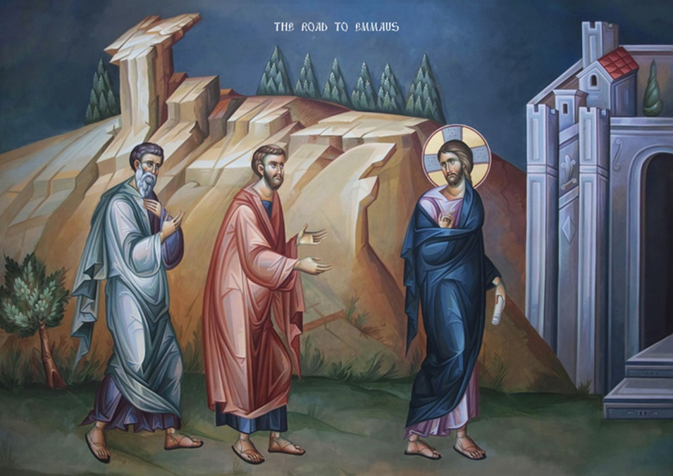

“Then one of them, whose name was Cleopas, answered, ‘Are you the only stranger in Jerusalem who does not know the things that have taken place there in these days?’ He asked, ‘What things?’ They replied, ‘The things about Jesus of Nazareth, who was a prophet mighty in deed and word before God and all the people, and how our chief priests and leaders handed him over to be condemned to death and crucified him. But we had hoped that he was the one to redeem Israel.’” (Luke 24:18-21)

Minister: Rev. Jason Evans
First Free Methodist Church
2625 N. Center Rd.
Saginaw, Michigan 48603
Phone: (989) 799-2930
Email: saginawfmc@gmail.com
www.saginawfirstfmc.org

THIRD SUNDAY OF EASTER
April 26, 2020

The mission of Saginaw First Free Methodist Church is to be faithful to God and to make known to all people everywhere God’s call to wholeness in Jesus Christ.

Prelude
Greeting/Announcements
Call to Worship (spoken responsively)
L: God has called us to this time of worship
P: God listens to hearts and our words
L: We think are independent in our lives
P: Christ walks along side us, the Spirit abides with us
L: We walk from fear into trust
P: Our hearts are unchained and we share love in the world
L: Christ continues to abide with us as we break bread in this life
P: We offer thanks for God’s everlasting gift of the Spirit

*Opening Hymn: “Sing Praise to God Who Reigns Above”

Sing praise to God who reigns above
The God of all creation
The God of power, the God of love
The God of our salvation
With healing balm my soul is filled
And every faithless murmur stilled
To God all praise and glory

Thus all my toilsome way along
I sing aloud thy praises
That earth may hear the grateful song
My voice unwearied raises
Be joyful in the Lord, my heart
Both soul and body bear your part
To God all praise and glory

Let all who name Christ's holy name
Give God all praise and glory
Let all who own his power proclaim
Aloud the wondrous story
Cast each false idol from its throne
For Christ is Lord, and Christ alone
To God all praise and glory

Invocation and Lord’s Prayer
L: God of mighty revelation and quiet closeness, open our eyes and hearts to recognize you here. May we feel your presence at this time, hear your voice in our ears, feel your touch souls, and see your beauty everywhere. May your omnipotence emerge as we realize the transforming power of your love and care, as we pray the prayer that Jesus taught His disciples…
P: Our Father, who art in heaven, hallowed be Your name. Your kingdom come; your will be done in earth as it is in heaven. Give us this day our daily bread and forgive us our debts as we forgive our debtors. And lead us not into temptation but deliver
us from evil. For Yours is the kingdom, and the power, and the glory forever. Amen.

Gloria Patri

First Scripture Lesson: Acts 2:14, 36-41

But Peter, standing with the eleven, raised his voice and addressed them, “Therefore let the entire house of Israel know with certainty that God has made him both Lord and Messiah, this Jesus whom you crucified.”

Now when they heard this, they were cut to the heart and said to Peter and to the other apostles, “Brothers, what should we do?”

Peter said to them, “Repent, and be baptized every one of you in the name of Jesus Christ so that your sins may be forgiven; and you will receive the gift of the Holy Spirit. For the promise is for you, for your children, and for all who are far away, everyone whom the Lord our God calls to him.”

And he testified with many other arguments and exhorted them, saying, “Save yourselves from this corrupt generation.”

So those who welcomed his message were baptized, and that day about three thousand persons were added.

Prayer of Confession
L: We live in a crooked generation, that thrives on alienating people from God’s presence. We at times join those who seek power and privilege, instead of comforting the oppressed. For out times of poor judgment, let us confess…

P: God of Resurrection, we confess that we rush through our days, forgetful that you are with us. We follow diversions that distract us from following you. We suppress our need to seek you in prayer. We strive for personal and financial success and recognition, while you call us to obedience to truth and genuine mutual love. Remind us to pursue clean hands and pure hearts, instead of following big names and powerful people. May we be faithful to your living and unending word. Amen.

Affirmation of Faith: Psalm 116
P: I love the LORD, because he has heard my voice and my supplications. Because he inclined his ear to me, therefore I will call on him as long as I live. The snares of death encompassed me; the pangs of death laid hold on me; I suffered distress and anguish. Then I called on the name of the LORD: “O LORD, I pray, save my life!” What shall I return to the LORD for all his bounty to me? I will lift up the cup of salvation and call on the name of the LORD, I will pay my vows to the LORD in the presence of all his people. Precious in the sight of the LORD is the death of his faithful ones. O LORD, I am your servant. You have loosed my bonds. I will offer to you a thanksgiving sacrifice and call on the name of the LORD. I will pay my vows to the LORD in the presence of all the people, in the courts of the house of the LORD, in your midst. Praise the LORD!

*Hymn of Affirmation: “When I Survey the Wondrous Cross”
When I survey the wondrous cross
On which the Prince of glory died
My richest gain I count but loss
And pour contempt on all my pride

Forbid it, Lord, that I should boast
Save in the death of Christ, my God!
All the vain things that charm me most
I sacrifice them to his blood

Were the whole realm of nature mine
That were a present far too small
Love so amazing, so divine
Demands my soul, my life, my all

New Testament Scripture Lesson: 1 Peter 1: 17-23
If you invoke as Father the one who judges all people impartially according to their deeds, live in reverent fear during the time of your exile. You know that you were ransomed from the futile ways inherited from your ancestors, not with perishable things like silver or gold, but with the precious blood of Christ, like that of a lamb without defect or blemish.

He was destined before the foundation of the world, but was revealed at the end of the ages for your sake. Through him you have come to trust in God, who raised him from the dead and gave him glory, so that your faith and hope are set on God. Now that you have purified your souls by your obedience to the truth so that you have genuine mutual love, love one another deeply from the heart. You have been born anew, not of perishable but of imperishable seed, through the living and enduring word of God.

Special Music: Micki Martin

Passing of the Peace

Prayers of the People
L: Lord in Your Mercy…
P: Hear our prayer.

Gospel Lesson: Luke 24:13-35

Now on that same day two of them were going to a village called Emmaus, about seven miles from Jerusalem, and talking with each other about all these things that had happened. While they were talking and discussing, Jesus himself came near and went with them, but their eyes were kept from recognizing him.

And he said to them, “What are you discussing with each other while you walk along?”

They stood still, looking sad. Then one of them, whose name was Cleopas, answered him, “Are you the only stranger in Jerusalem who does not know the things that have taken place there in these days?”

He asked them, “What things?”

They replied, “The things about Jesus of Nazareth, who was a prophet mighty in deed and word before God and all the people, and how our chief priests and leaders handed him over to be condemned to death and crucified him. But we had hoped that he was the one to redeem Israel. Yes, and besides all this, it is now the third day since these things took place.

‘Moreover, some women of our group astounded us. They were at the tomb early this morning, and when they did not find his body there, they came back and told us that they had indeed seen a vision of angels who said that he was alive. Some of those who were with us went to the tomb and found it just as the women had said; but they did not see him.”

Then he said to them, “Oh, how foolish you are, and how slow of heart to believe all that the prophets have declared! Was it not necessary that the Messiah should suffer these things and then enter into his glory?”

Then beginning with Moses and all the prophets, he interpreted to them the things about himself in all the scriptures. As they came near the village to which they were going, he walked ahead as if he were going on.
But they urged him strongly, saying, “Stay with us, because it is almost evening and the day is now nearly over.”

So he went in to stay with them. When he was at the table with them, he took bread, blessed and broke it, and gave it to them. Then their eyes were opened, and they recognized him; and he vanished from their sight.

They said to each other, “Were not our hearts burning within us while he was talking to us on the road, while he was opening the scriptures to us?”

That same hour they got up and returned to Jerusalem; and they found the eleven and their companions gathered together.

They were saying, “The Lord has risen indeed, and he has appeared to Simon!”

Then they told what had happened on the road, and how he had been made known to them in the breaking of the bread.

Sermon

Prayer of Response

Hymn of Response: “I Will Sing of My Redeemer”

I will sing of my Redeemer
And his wondrous love to me
On the cruel cross he suffered
From the curse to set me free
Sing, O sing of my Redeemer
With his blood he purchased me
On the cross he sealed my pardon
Paid the debt, and made me free

I will praise my dear Redeemer,
His triumphant power I'll tell:
How the victory he gives me
Over sin and death and hell
Sing, O sing of my Redeemer
With his blood he purchased me
On the cross he sealed my pardon
Paid the debt, and made me free

I will sing of my Redeemer
And his heavenly love for me
He from death to life has brought me
Son of God, with him to be
Sing, O sing of my Redeemer
With his blood he purchased me
On the cross he sealed my pardon
Paid the debt, and made me free
Invitation of Offering
L: God gave us everything, even Christ Jesus. Christ sacrificed everything to proclaim God’s unbound less love. Place your life a living sacrifice and count it joy, as we collect this morning’s tithes and offerings.
*Doxology

Prayer

Closing Hymn: “Heavenly Sunlight”

Walking in sunlight all of my journey
Over the mountains, through the deep vale
Jesus has said, “I’ll never forsake thee,”
Promise divine that never can fail
Heavenly sunlight, heavenly sunlight
Flooding my soul with glory divine
Hallelujah, I am rejoicing
Singing His praises, Jesus is mine

Shadows around me, shadows above me
Never conceal my Savior and Guide
He is the light, in Him is no darkness
Ever I’m walking close to His side
Heavenly sunlight, heavenly sunlight
Flooding my soul with glory divine
Hallelujah, I am rejoicing
Singing His praises, Jesus is mine

In the bright sunlight, ever rejoicing
Pressing my way to mansions above
Singing His praises gladly I’m walking
Walking in sunlight, sunlight of love
Heavenly sunlight, heavenly sunlight
Flooding my soul with glory divine
Hallelujah, I am rejoicing
Singing His praises, Jesus is mine

Benediction
L: Christ is alive in our midst; he walks along all life’s roads with us. Life’s meaning is not found in silver or gold, but in sharing love with all the world. Live this new life in faith, as you go in peace to love and serve. Amen.

