First Free Methodist Church of Saginaw
Second Sunday of Easter
April 24, 2022

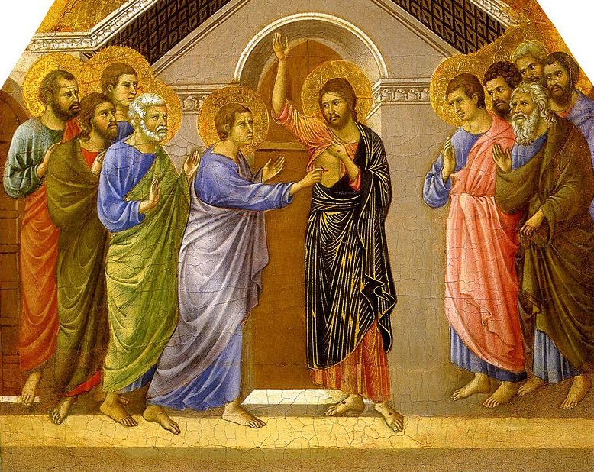
“Then he said to Thomas, ‘Put your finger here and see my hands. Reach out your hand and put it in my side. Do not doubt but believe.’"
(John 20:27)

Minister: Rev. Jason Evans
First Free Methodist Church
2625 N. Center Rd.
Saginaw, Michigan 48603
Phone: (989) 799-2930
Email: saginawfmc@gmail.com
www.saginawfirstfmc.org

Second Sunday of Easter
April 24, 2022
Prelude
**Greeting/Announcements
*Call to Worship (spoken responsively)
L: Come broken and weary, come battered and bruised
P: My Jesus makes all things new
L: Come lost and abandoned, come blown by the wind
P: He'll bring you back home again
L: The world was good, the world is fallen
P: The world is being redeemed
L: Hold on to the promise, the stories are true
P: Jesus makes all things new; He makes all things new!

*Opening Hymn: “Jesus Shall Reign” #271 (vv.1-4)
Jesus shall reign where'er the sun
Does its successive journeys run,
His kingdom stretch from shore to shore
Till moons shall wax and wane no more

To him shall endless prayer be made,
And praises throng to crown his head.
His name like sweet perfume shall rise
With every morning sacrifice

People and realms of every tongue
Dwell on his love with sweetest song,
And infant voices shall proclaim
Their early blessings on his name

Let every creature rise and bring
The highest honors to our King,
Angels descend with songs again,
And earth repeat the loud amen

*Invocation and Lord’s Prayer
L: We praise you, O God, we acclaim You as Lord. All creation worships you, Father everlasting. To you all angels, all the powers of heaven, cherubim and seraphim, sing in endless praise. Enlighten us with your wisdom this day. Empower us with your spirit as we worship you. Fill us with your love and mission as we respond to your message. Renew our hope for this world, as we pray the prayer that Jesus taught His disciples…

P: Our Father, who art in heaven, hallowed be Your name. Your kingdom come; your will be done in earth as it is in heaven. Give us this day our daily bread and forgive us our debts as we forgive our debtors. And lead us not into temptation but deliver us from evil. For Yours is the kingdom, and the power, and the glory forever. Amen.

*Gloria Patri
Glory be to the Father​
And to the Son and to the Holy Ghost.​
As it was in the beginning​
Is now and ever shall be.​
World without end. ​
Amen. Amen.​

First Scripture Lesson: Acts 5:27-32
When they had brought them, they had them stand before the council. The high priest questioned them, saying, “We gave you strict orders not to teach in this name, yet here you have filled Jerusalem with your teaching and you are determined to bring this man's blood on us.”
But Peter and the apostles answered, “We must obey God rather than any human authority. The God of our ancestors raised up Jesus, whom you had killed by hanging him on a tree. God exalted him at his right hand as Leader and Savior that he might give repentance to Israel and forgiveness of sins. And we are witnesses to these things, and so is the Holy Spirit whom God has given to those who obey him.”

Prayer of Confession
L: God, who by the light of the Holy Spirit did instruct the hearts of the faithful, also grants in us that same Spirit to be truly wise and ever rejoice in the consolation of Christ. May our hearts be rekindled, our spirits grow calm, our vision be clear, and our purpose be unified...

P: Throughout the world the holy Church acclaims You: Father, of majesty unbounded, Your glorious, true, and only Son, and the Holy Spirit, Advocate and Guide. You, Christ, are the King of glory, the eternal Son of the Father. When You became incarnate to set us free You humbly accepted the Virgin’s womb. You overcame the sting of death, and opened the kingdom of heaven to all believers. You are seated at God’s right hand in glory. We believe that You will come to be our judge. Come then, Lord, and help Your people, bought with the price of Your own blood, and bring us with your saints to glory everlasting. Amen.

Affirmation of Faith: Psalm 150
P: Praise the LORD! Praise God in his sanctuary; praise him in his mighty firmament! Praise him for his mighty deeds; praise him according to his surpassing greatness! Praise him with trumpet sound; praise him with lute and harp! Praise him with tambourine and dance; praise him with strings and pipe! Praise him with clanging cymbals; praise him with loud clashing cymbals! Let everything that breathes praise the LORD! Praise the LORD!

Hymn of Affirmation: “Breath on Me Breath of God” #302 (vv.1-4)
Breathe on me, Breath of God
Fill me with life anew
That I may love what Thou dost love
And do what Thou would do

Breathe on me, Breath of God
Until my heart is pure
Until with Thee, I will one will
To do and to endure

Breathe on me, Breath of God
Till I am wholly Thine
Until this earthly part of me
Glows with Thy fire divine

Breathe on me, Breath of God
So shall I never die
But live with Thee the perfect life
Of Thine eternity

Second Scripture Lesson: Revelation 1:4-8
John to the seven churches that are in Asia: Grace to you and peace from him who is and who was and who is to come, and from the seven spirits who are before his throne, and from Jesus Christ, the faithful witness, the firstborn of the dead, and the ruler of the kings of the earth. To him who loves us and freed us from our sins by his blood, and made us to be a kingdom, priests serving his God and Father, to him be glory and dominion forever and ever. Amen.
Look! He is coming with the clouds; every eye will see him, even those who pierced him; and on his account all the tribes of the earth will wail. So it is to be. Amen. “I am the Alpha and the Omega,” says the Lord God, who is and who was and who is to come, the Almighty.

Special Music: Don Gingrich

Children’s Sermon

Passing of the Peace

Prayers of the People
L: Lord in Your Mercy…
P: Hear our prayer.

Gospel Lesson: John 20:19-31
When it was evening on that day, the first day of the week, and the doors of the house where the disciples had met were locked for fear of the Jews, Jesus came and stood among them and said, “Peace be with you.”
After he said this, he showed them his hands and his side. Then the disciples rejoiced when they saw the Lord. Jesus said to them again, “Peace be with you. As the Father has sent me, so I send you.”
When he had said this, he breathed on them and said to them, “Receive the Holy Spirit. If you forgive the sins of any, they are forgiven them; if you retain the sins of any, they are retained.”
But Thomas (who was called the Twin), one of the twelve, was not with them when Jesus came. So the other disciples told him, “We have seen the Lord.”
But he said to them, “Unless I see the mark of the nails in his hands, and put my finger in the mark of the nails and my hand in his side, I will not believe.”
A week later his disciples were again in the house, and Thomas was with them. Although the doors were shut, Jesus came and stood among them and said, “Peace be with you.”
Then he said to Thomas, “Put your finger here and see my hands. Reach out your hand and put it in my side. Do not doubt but believe.”
Thomas answered him, “My Lord and my God!”
Jesus said to him, “Have you believed because you have seen me? Blessed are those who have not seen and yet have come to believe.”
Now Jesus did many other signs in the presence of his disciples, which are not written in this book. But these are written so that you may come to believe that Jesus is the Messiah, the Son of God, and that through believing you may have life in his name.

Sermon:

Prayer of Response

Hymn of Response: “Thou Art Worthy” #66
Thou art worthy, thou art worthy
Thou art worthy, O Lord
To receive glory, glory and honor
Glory and honor and power
For Thou hast created, hast all things created
Thou hast created all things
And for thy pleasure they are created
For Thou are worthy O Lord

Invitation of Offering
L: Ascribe to the Lord the glory due His name; Bring an offering and come into His courts. Worship the Lord in the splendor of His holiness, as we collect this morning’s tithes and offerings.

*Doxology

*Prayer

*Closing Hymn: “He Lives” #262 (vv.1-3)
I serve a risen Savior, He's in the world today
I know that He is living, whatever men may say
I see His hand of mercy, I hear His voice of cheer
And just the time I need Him, He's always near
He lives! He lives! Christ Jesus lives today!
He walks with me and talks with me along life's narrow way
He lives! He lives! Salvation to impart
You ask me how I know He lives?
He lives within my heart

In all the world around me I see His loving care
And though my heart grows weary I never will despair
I know that He is leading, thro' all the stormy blast
The day of His appearing will come at last
He lives! He lives! Christ Jesus lives today!
He walks with me and talks with me along life's narrow way
He lives! He lives! Salvation to impart
You ask me how I know He lives?
He lives within my heart

Rejoice, rejoice, O Christian! Lift up your voice and sing
Eternal hallelujahs to Jesus Christ, the King
The Hope of all who seek Him, the Help of all who find
None other is so loving, so good and kind
He lives! He lives! Christ Jesus lives today!
He walks with me and talks with me along life's narrow way
He lives! He lives! Salvation to impart
You ask me how I know He lives?
He lives within my heart

*Benediction
L: May the God of peace redeem your pain. May the God of grace renew your spirit. May the God of mercy, revive your soul. Be inspired by the hope of the kingdom, as you go in peace to love and serve. Amen.

