First Free Methodist Church of Saginaw
Third Sunday of Easter
April 23, 2023

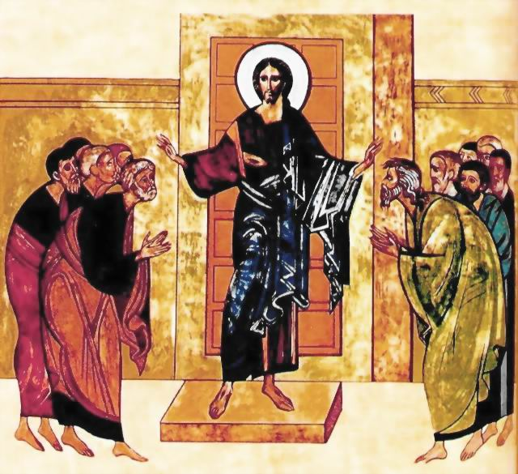
“Do you not believe that I am in the Father and the Father is in me?”
(John 14:10)

Minister: Rev. Jason Evans
First Free Methodist Church
2625 N. Center Rd.
Saginaw, Michigan 48603
Phone: (989) 799-2930
Email: saginawfmc@gmail.com
www.saginawfirstfmc.org

Third Sunday of Easter
April 23, 2023

Prelude
**Greeting/Announcements
*Call to Worship (spoken responsively)
L: God has given us the victory through our Lord Jesus Christ
P: Where, O death, is your victory?
L: Death has been swallowed up in resurrection
P: Where, O death, is your sting?
L: Christ has indeed been raised from the dead
P: The first fruits of those who have fallen asleep
L: For this very reason Christ died and returned to life
P: So that He might be the Lord of both the living and the dead

*Opening Hymn: “Praise to the Lord, the Almighty” #20 (vv.1-4)
Praise to the Lord, the Almighty, the King of creation!
O my soul, praise him, for he is your health and salvation
All ye who hear; now to his temple draw near
Join me in glad adoration

Praise to the Lord, who o’er all things so wondrously reigneth
Shelters thee under His wings, yea, so gently sustaineth
Has thou not seen how thy desires all have been
Granted in what He ordaineth?

Praise to the Lord, who doth prosper thy work and defend thee
Surely His goodness and mercy here daily attend thee
Ponder anew, what the Almighty can do
If with His love he befriend thee

Praise to the Lord! O let all that is in me adore Him!
All that hath life and breath, come now with praises before Him
Let the amen sound from his people again
Gladly forever adore Him

*Invocation and Lord’s Prayer
L: O Great Invisible God, we give you praise. All the works that you have made, are clearly seen and plain as day. Your power eternal, your nature divine; All creation tells the tale of your love for us. In the seed that descends to the old earth, and rises again with a new birth; the sweet story of resurrection. Mighty and tender God, let me remember whose grace makes us clean, as we pray the prayer that Jesus taught His disciples…

P: Our Father, who art in heaven, hallowed be Your name. Your kingdom come; your will be done in earth as it is in heaven. Give us this day our daily bread and forgive us our debts as we forgive our debtors. And lead us not into temptation but deliver us from evil. For Yours is the kingdom, and the power, and the glory forever. Amen.

*Gloria Patri
Glory be to the Father​
And to the Son and to the Holy Ghost.​
As it was in the beginning​
Is now and ever shall be.​
World without end. ​
Amen. Amen.​

*Passing of the Peace

Hymn: “More Love to Thee” #463 (vv.1-3)
More love to Thee, oh Christ, more love to Thee!
Hear Thou the prayer I make on bended knee.
This is my earnest plea
More love, oh Christ, to Thee
More love to Thee, more love to Thee!

Once earthly joy I craved, sought peace and rest
Now Thee alone I seek, give what is best.
This all my prayer shall be
More love, oh Christ to Thee
More love to Thee, more love to Thee!

Then shall my latest breath whisper Thy praise
This be the parting cry my heart shall raise
Still all my prayer shall be
More love, oh Christ to Thee
More love to Thee, more love to Thee!
More love to Thee, more love to Thee!

Affirmation of Faith: I Peter 1
P: You know that you were ransomed from the futile ways inherited from your ancestors, not with perishable things like silver or gold, but with the precious blood of Christ, like that of a lamb without defect or blemish. He was destined before the foundation of the world, but was revealed at the end of the ages for your sake. Through him you have come to trust in God, who raised him from the dead and gave him glory, so that your faith and hope are set on God. Now that you have purified your souls by your obedience to the truth so that you have genuine mutual love, love one another deeply from the heart. You have been born anew, not of perishable but of imperishable seed, through the living and enduring word of God.

Children’s Sermon

Gospel Lesson: John 14:1-14
“Do not let your hearts be troubled. You believe in God; believe also in me. In my Father’s house there are many dwelling places. If it were not so, I would have told you, for I go to prepare a place for you. And if I go and prepare a place for you, I will come again and will take you to myself, so that where I am, there you may be also. Where I am going you know, and the way you know.
Thomas said to him, “Lord, we do not know where you are going. How can we know the way?”
Jesus said to him, “I am the way and the truth and the life. No one comes to the Father except through me. If you had known me, you would have known my Father also. From now on you do know him and have seen him.”
Philip said to him, “Lord, show us the Father, and we will be satisfied.”
Jesus said to him, “Have I been with you all this time, Philip, and you still do not know me? Whoever has seen me has seen the Father. How can you say, ‘Show us the Father’? Do you not believe that I am in the Father and the Father is in me? The words that I say to you I do not speak on my own, but the Father who dwells in me does his works. Believe me that I am in the Father and the Father is in me, but if you do not, then believe me because of the works themselves. Very truly, I tell you, the one who believes in me will also do the works that I do and, in fact, will do greater works than these, because I am going to the Father. I will do whatever you ask in my name, so that the Father may be glorified in the Son. If in my name you ask for anything, I will do it.

Sermon: “The Unifying Messiah”
Prayers of the People
L: Lord in Your Mercy…
P: Hear our prayer.

Hymn of Response: “My Tribute” #35
How can I say thanks
For the things You have done for me?
Things so undeserved
Yet You gave to prove Your love for me
The voices of a million angels
Could not express my gratitude
All that I am and ever hope to be
I owe it all to Thee

To God be the glory
To God be the glory
To God be the glory
For the things He has done

With His blood He has saved me
With His power He has raised me
To God be the glory
For the things He has done

Just let me live my life
Let it pleasing, Lord to Thee
And if I gain any praise
Let it go to Calvary

With His blood He has saved me
With His power He has raised me
To God be the glory
For the things He has done

Invitation of Offering
L: Come, Holy Ghost, Creator come. From thy bright heavenly throne, take possession of our souls and make them all thy own. May we in turn give all our possessions as our act of worship, as we collect this morning’s tithes and offerings.

*Doxology
Praise God, from whom all blessings flow
Praise Him, all creatures here below
Praise Him above, ye heavenly host
Praise Father Son, and Holy Ghost.
Amen.

*Prayer

*Closing Hymn: “O Christians, Haste” #712 (vv.1-4)
O Zion, haste, thy mission high fulfilling
To tell to all the world that God is light
That He who made all nations is not willing
One soul should perish, lost in shades of night
Publish glad tidings, tidings of peace
Tidings of Jesus, redemption, and release

Behold how many thousands still are lying
Bound in the darksome prison house of sin
With none to tell them of the Savior’s dying
Or of the life He died for them to win
Publish glad tidings, tidings of peace
Tidings of Jesus, redemption, and release

Proclaim to every people, tongue, and nation
That God, in Whom they live and move, is love
Tell how He stooped to save His lost creation
And died on earth that we might live above
Publish glad tidings, tidings of peace
Tidings of Jesus, redemption, and release

Give of your young to bear the message glorious
Give of your wealth to speed them on their way
Pour out thy soul for them in prayer victorious
And all your spending Jesus will repay
Publish glad tidings, tidings of peace
Tidings of Jesus, redemption, and release

*Benediction
L: The resurrection has given us new life and renewed hope. Be granted the wisdom to know what we must do, the will to want to do it, the courage to undertake it, the perseverance to continue to do it, and the strength to complete it, as you go in peace to love and serve. Amen.

