Saginaw First Free Methodist Church
SECOND SUNDAY OF EASTER
April 11, 2021

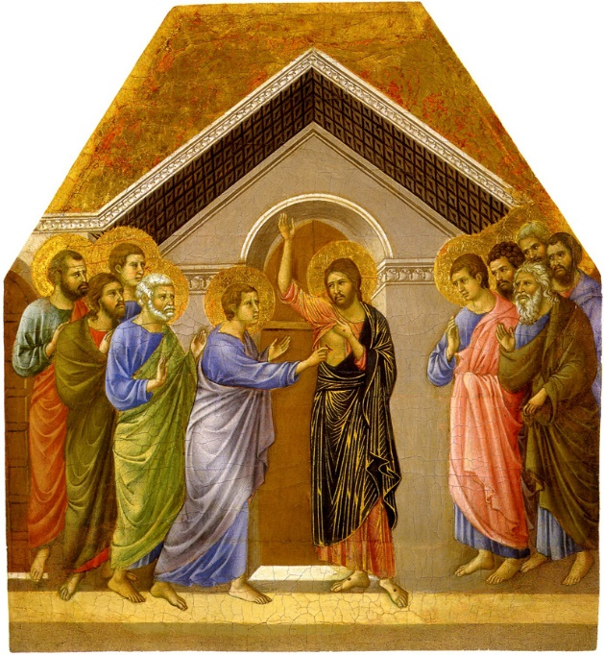
“A week later his disciples were again in the house, and Thomas was with them. Although the doors were shut, Jesus came and stood among them and said, ‘Peace be with you.’ Then he said to Thomas, ‘Put your finger here and see my hands. Reach out your hand and put it in my side. Do not doubt but believe.’”
(John 20:26-27)

Minister: Rev. Jason Evans
First Free Methodist Church
2625 N. Center Rd.
Saginaw, Michigan 48603
Phone: (989) 799-2930
Email: saginawfmc@gmail.com
www.saginawfirstfmc.org

SECOND SUNDAY OF EASTER
April 11, 2021
Prelude
**Greeting/Announcements
*Call to Worship (spoken responsively)
L: He has risen!
P: He has risen indeed!
L: Death came to all, through the sin of one man
P: So in Christ, all will be made alive again
L: The body that is sown is perishable, sown in weakness
P: The body raised is imperishable, raised in power
L: For this reason, Christ died and was resurrected
P: So that we might be in him, and he in us

*Opening Hymn: “O for a Thousand Tongues to Sing” #147 (vv.1,4,6-7)
O for a thousand tongues to sing
My great Redeemer's praise
The glories of my God and King
The triumphs of his grace!

He speaks, and list’ning to His voice
New life the dead receive
The mournful, broken hearts rejoice
The humble poor believe

In Christ, your Head, ye then shall know
Shall feel your sins forgiv’n
Anticipate your heav’n below
And own that love is heav’n

My gracious Master and my God
Assist me to proclaim
To spread thro' all the earth abroad
The honors of Thy name

*Invocation and Lord’s Prayer
L: Mighty God, in whom we know the power of redemption, you stand among us in the shadows of our time. As we move through every sorrow and trial of this life, uphold us with knowledge of the final morning when, in the glorious presence of your risen Son, we will share in his resurrection, redeemed and restored to the fullness of life and forever freed to be your people. May we live in unity, as we pray the prayer that Jesus taught His disciples…

P: Our Father, who art in heaven, hallowed be Your name. Your kingdom come; your will be done in earth as it is in heaven. Give us this day our daily bread and forgive us our debts as we forgive our debtors. And lead us not into temptation but deliver us from evil. For Yours is the kingdom, and the power, and the glory forever. Amen.

*Gloria Patri
Glory be to the Father​
And to the Son and to the Holy Ghost.
As it was in the beginning​
Is now and ever shall be
World without end
Amen. Amen

Old Testament Scripture Lesson: Psalm 133
How very good and pleasant it is when kindred live together in unity! It is like the precious oil on the head, running down upon the beard, on the beard of Aaron, running down over the collar of his robes. It is like the dew of Hermon, which falls on the mountains of Zion. For there the LORD ordained his blessing, life forevermore.

Prayer of Confession
L: Through the resurrection, Christ destroyed the power of death and made us at one with God. Let us rejoice in God and with one another…

P: Now the whole group of those who believed were of one heart and soul, and no one claimed private ownership of any possessions, but everything they owned was held in common. With great power the apostles gave their testimony to the resurrection of the Lord Jesus, and great grace was upon them all. There was not a needy person among them, for as many as owned lands or houses sold them and brought the proceeds of what was sold. They laid it at the apostles' feet, and it was distributed to each as any had need.

Affirmation of Faith: Apostle’s Creed
P: I believe in God, the Father Almighty, Maker of heaven and earth. And in Jesus Christ, God’s only Son, our Lord. Who was conceived by the Holy Spirit, born of the Virgin Mary, suffered under Pontius Pilate, was crucified, dead, and was buried. He descended into hades, the third day He rose again from the dead. He ascended into heaven, and sits at the right hand of God the Father Almighty. From thence He shall come to judge the living and the dead. I believe in the Holy Spirit, the holy Church universal, the communion of saints, the forgiveness of sins, the resurrection of the body, and the life everlasting. Amen.

Hymn of Affirmation: “Spirit of the Living God” #297 (x2)
Spirit of the Living God, fall fresh on me
Spirit of the Living God, fall fresh on me
Melt me, mold me, fill me, use me
Spirit of the Living God, fall fresh on me

New Testament Scripture Lesson: 1 John 1:1-2:2
We declare to you what was from the beginning, what we have heard, what we have seen with our eyes, what we have looked at and touched with our hands, concerning the word of life; this life was revealed, and we have seen it and testify to it, and declare to you the eternal life that was with the Father and was revealed to us; we declare to you what we have seen and heard so that you also may have fellowship with us; and truly our fellowship is with the Father and with his Son Jesus Christ.
We are writing these things so that our joy may be complete. This is the message we have heard from him and proclaim to you, that God is light and in him there is no darkness at all. If we say that we have fellowship with him while we are walking in darkness, we lie and do not do what is true; but if we walk in the light as he himself is in the light, we have fellowship with one another, and the blood of Jesus his Son cleanses us from all sin.
If we say that we have no sin, we deceive ourselves, and the truth is not in us. If we confess our sins, he who is faithful and just will forgive us our sins and cleanse us from all unrighteousness. If we say that we have not sinned, we make him a liar, and his word is not in us.
My little children, I am writing these things to you so that you may not sin. But if anyone does sin, we have an advocate with the Father, Jesus Christ the righteous; and he is the atoning sacrifice for our sins, and not for ours only but also for the sins of the whole world.

Passing of the Peace

Prayers of the People
L: Lord in Your Mercy…
P: Hear our prayer.

Gospel Lesson: John 20:19-31
When it was evening on that day, the first day of the week, and the doors of the house where the disciples had met were locked for fear of the Jews, Jesus came and stood among them and said, “Peace be with you.”
After he said this, he showed them his hands and his side. Then the disciples rejoiced when they saw the Lord. Jesus said to them again, “Peace be with you. As the Father has sent me, so I send you.”
When he had said this, he breathed on them and said to them, “Receive the Holy Spirit. If you forgive the sins of any, they are forgiven them; if you retain the sins of any, they are retained.”
But Thomas (who was called the Twin), one of the twelve, was not with them when Jesus came. So the other disciples told him, “We have seen the Lord.” But he said to them, “Unless I see the mark of the nails in his hands, and put my finger in the mark of the nails and my hand in his side, I will not believe.”
A week later his disciples were again in the house, and Thomas was with them. Although the doors were shut, Jesus came and stood among them and said, “Peace be with you.”
Then he said to Thomas, “Put your finger here and see my hands. Reach out your hand and put it in my side. Do not doubt but believe.”
Thomas answered him, “My Lord and my God!”
Jesus said to him, “Have you believed because you have seen me? Blessed are those who have not seen and yet have come to believe.”
Now Jesus did many other signs in the presence of his disciples, which are not written in this book. But these are written so that you may come to believe that Jesus is the Messiah, the Son of God, and that through believing you may have life in his name.
Sermon

Prayer of Response

Hymn of Response: “Rejoice the Lord is King” #276 (vv.1-3)
Rejoice, the Lord is King
Your Lord and King adore
Rejoice, give thanks and sing
And triumph evermore
Lift up your heart
Lift up your voice, Rejoice
Again I say, rejoice

Jesus, the Savior, reigns
The God of truth and love
When He had purged our stains
He took his seat above
Lift up your heart
Lift up your voice, Rejoice
Again I say, rejoice

His kingdom cannot fail
He rules o'er earth and heav'n
The keys of death and hell
Are to our Jesus giv’n
Lift up your heart
Lift up your voice, Rejoice
Again I say, rejoice

Invitation of Offering
L: Truly our fellowship is with the Father and with the Son, Jesus Christ. At one with God, we have one heart, soul, and everything in common. Give, so there is not one needy person among us, as we collect this morning’s tithes and offerings.

*Doxology
Praise God, from whom all blessings flow
Praise Him, all creatures here below
Praise Him above, ye heavenly host
Praise Father Son, and Holy Ghost.
Amen.

*Prayer

*Closing Hymn: “Trust and Obey” #437 (vv.1,4-5)
When we walk with the Lord
In the light of his word
What a glory he sheds on our way
While we do his good will
He abides with us still
And with all who will trust and obey
Trust and obey, for there's no other way
To be happy in Jesus, but to trust and obey

But we never can prove
The delights of his love
Until all on the altar we lay
For the favor he shows
For the joy he bestows
Are for them who will trust and obey
Trust and obey, for there's no other way
To be happy in Jesus, but to trust and obey

Then in fellowship sweet
We will sit at his feet
Or we'll walk by his side in the way
What he says we will do
Where he sends we will go
Never fear, only trust and obey
Trust and obey, for there's no other way
To be happy in Jesus, but to trust and obey

*Benediction
L: Christ has given us peace and unbreakable fellowship with God. As the Father sent Christ, so Christ sends us. Receive the Holy Spirit and take it to those in need, as you go in peace to love and serve. Amen.

