First Free Methodist Church of Saginaw
Palm Sunday
April 10, 2022

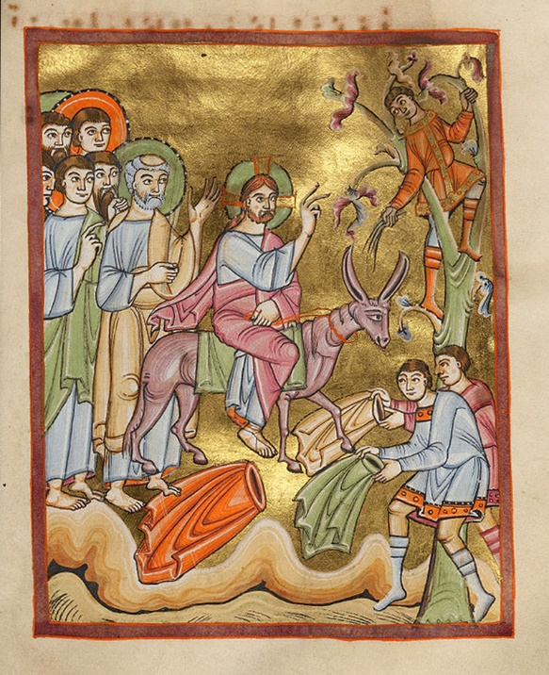
“Then they brought it to Jesus; and after throwing their cloaks on the colt, they set Jesus on it. As he rode along, people kept spreading their cloaks on the road."
(Luke 19:35-36)

Minister: Rev. Jason Evans
First Free Methodist Church
2625 N. Center Rd.
Saginaw, Michigan 48603
Phone: (989) 799-2930
Email: saginawfmc@gmail.com
www.saginawfirstfmc.org

Palm Sunday
April 10, 2022
Prelude
**Greeting/Announcements
*Call to Worship (spoken responsively)
L: Those who belong to Christ Jesus have crucified the flesh
P: We walk by the Spirit as God is spirit
L: We hand over the desires of the flesh
P: So that our spirit may be saved on the day of the Lord
L: Just as we have borne the image of the earthly man
P: So shall we bear the image of the heavenly man
L: The mind governed by the Spirit is life and peace
P: By the spirit we will put away the misdeeds of the body

*Opening Hymn: “All Glory, Laud, and Honor” #215 (vv.1-3)
All glory, laud, and honor to
Thee, Redeemer, King
To whom the lips of children
Made sweet hosannas ring
Thou art the King of Israel
Thou David’s royal Son
Ho in the Lord’s name comest
The King and Blessed One

The company of angels
Are praising Thee on high
And mortal men and all things
Created make reply
The people of the Hebrew
With palms before Thee went
Our praise and prayer and anthems
Before Thee we present

To Thee, before Thy passion
They sang their hymns of praise
To Thee, now high exalted
Our melody we raise
Thou didst accept their praises
Accept the praise we bring
Who in all good delightest
Thou good and gracious King

*Invocation and Lord’s Prayer
L: Almighty and everlasting God, who of thy tender love towards mankind, has sent thy Son our savior Jesus Christ to take upon him our flesh, and to suffer death upon the cross, that all mankind should follow the example of his great humility: Mercifully grant that we may both follow the example of his patience, and also be made partakers of his resurrection. Mercifully grant that we, walking in the way of the cross, may find it none other than the way of life and peace, as we pray the prayer that Jesus taught His disciples…

P: Our Father, who art in heaven, hallowed be Your name. Your kingdom come; your will be done in earth as it is in heaven. Give us this day our daily bread and forgive us our debts as we forgive our debtors. And lead us not into temptation but deliver us from evil. For Yours is the kingdom, and the power, and the glory forever. Amen.

*Gloria Patri
Glory be to the Father​
And to the Son and to the Holy Ghost.​
As it was in the beginning​
Is now and ever shall be.​
World without end. ​
Amen. Amen.​

First Scripture Lesson: Isaiah 50:4-9
The Lord GOD has given me the tongue of a teacher, that I may know how to sustain the weary with a word. Morning by morning he wakens, wakens my ear to listen as those who are taught. The Lord GOD has opened my ear, and I was not rebellious, I did not turn backward. I gave my back to those who struck me, and my cheeks to those who pulled out the beard; I did not hide my face from insult and spitting.
The Lord GOD helps me; therefore I have not been disgraced; therefore I have set my face like flint, and I know that I shall not be put to shame; he who vindicates me is near. Who will contend with me? Let us stand up together. Who are my adversaries? Let them confront me. It is the Lord GOD who helps me; who will declare me guilty?

Prayer of Confession
L: We confess to the Lord so we are reminded of that which is heavenly and that which is earthly. While all things around us pass away, we may hold fast those things which abide forever. May our spirits may grow calm, our vision be clear, and our purpose be unified...

P: To you, eternal God, fountain of mercy, I come, a sinner. May you wash away my impurity. O son of justice, give sight to the blind. O eternal healer, cure the wounded. O king of kings, restore the despoiled. O mediator of God and man, reconcile the sinful. O good shepherd, lead back the straying. O God, have pity on the wretched, show leniency to the guilty, bestow life on the dead, reform the impious, and give the balm of grace to the hard of heart. O more merciful God, call back the one who flees, draw back the one who resists, lift up the one who falls, support the one who stands, and accompany the one who walks. Do not forget those who forget you. Do not desert those who desert you. Do not despise those who despise you. Amen.

Affirmation of Faith: Psalm 118
P: O give thanks to the LORD, for he is good; his steadfast love endures forever! Open to me the gates of righteousness, that I may enter through them and give thanks to the LORD. This is the gate of the LORD; the righteous shall enter through it. I thank you that you have answered me and have become my salvation. The stone that the builders rejected has become the chief cornerstone. This is the Lord's doing; it is marvelous in our eyes. This is the day that the LORD has made; let us rejoice and be glad in it. Blessed is the one who comes in the name of the LORD. We bless you from the house of the LORD. The LORD is God, and he has given us light. Bind the festal procession with branches, up to the horns of the altar. You are my God, and I will give thanks to you; you are my God, I will extol you.

Hymn of Affirmation: “O Sacred Head, Now Wounded” #249 (vv.1-3)
O sacred Head, now wounded
With grief and shame weighed down
Now scornfully surrounded
With thorns, thine only crown
O sacred Head, what glory
What bliss till now was thine
Yet, though despised and gory
I joy to call thee mine

What thou, my Lord, hast suffered
Was all for sinners’ gain
Mine, mine was the transgression
But thine the deadly pain
Lo, here I fall, my Savior
’Tis I deserve thy place
Look on me with thy favor
And grant to me thy grace

What language shall I borrow
To thank thee, dearest Friend
For this, thy dying sorrow
Thy pity without end
Oh, make me thine forever
And should I fainting be
Lord, let me never, never
Outlive my love to thee

Second Scripture Lesson: Philippians 3:4-14
If anyone else has reason to be confident in the flesh, I have more: circumcised on the eighth day, a member of the people of Israel, of the tribe of Benjamin, a Hebrew born of Hebrews; as to the law, a Pharisee; as to zeal, a persecutor of the church; as to righteousness under the law, blameless. Yet whatever gains I had, these I have come to regard as loss because of Christ.
More than that, I regard everything as loss because of the surpassing value of knowing Christ Jesus my Lord. For his sake I have suffered the loss of all things, and I regard them as rubbish, in order that I may gain Christ and be found in him, not having a righteousness of my own that comes from the law, but one that comes through faith in Christ, the righteousness from God based on faith.
I want to know Christ and the power of his resurrection and the sharing of his sufferings by becoming like him in his death, if somehow I may attain the resurrection from the dead. Not that I have already obtained this or have already reached the goal; but I press on to make it my own, because Christ Jesus has made me his own.
Beloved, I do not consider that I have made it my own; but this one thing I do: forgetting what lies behind and straining forward to what lies ahead, I press on toward the goal for the prize of the heavenly call of God in Christ Jesus.

Children’s Sermon

Passing of the Peace

Prayers of the People
L: Lord in Your Mercy…
P: Hear our prayer.

Gospel Lesson: Luke 19:28-40
After he had said this, he went on ahead, going up to Jerusalem. When he had come near Bethphage and Bethany, at the place called the Mount of Olives, he sent two of the disciples, saying, “Go into the village ahead of you, and as you enter it you will find tied there a colt that has never been ridden. Untie it and bring it here. If anyone asks you, ‘Why are you untying it?’ just say this, ‘The Lord needs it.’”
So those who were sent departed and found it as he had told them. As they were untying the colt, its owners asked them, “Why are you untying the colt?”
They said, “The Lord needs it.”
Then they brought it to Jesus; and after throwing their cloaks on the colt, they set Jesus on it. As he rode along, people kept spreading their cloaks on the road. As he was now approaching the path down from the Mount of Olives, the whole multitude of the disciples began to praise God joyfully with a loud voice for all the deeds of power that they had seen, saying, “Blessed is the king who comes in the name of the Lord! Peace in heaven, and glory in the highest heaven!”
Some of the Pharisees in the crowd said to him, “Teacher, order your disciples to stop.”
He answered, “I tell you, if these were silent, the stones would shout out.”

Sermon:

Prayer of Response

Hymn of Response: “Beneath the Cross of Jesus” #231 (vv.1-4)
Beneath the cross of Jesus
I fain would take my stand
The shadow of a mighty Rock
Within a weary land
A home within the wilderness
A rest upon the way
From the burning of the noon-tide heat
And the burden of the day

There lies beneath its shadow
But on the farther side
The darkness of an awful grave
That gapes both deep and wide
And there between us stands a cross
Two outstretched arms to save
Like a watchman set to guard the way
From that eternal grave

Upon the cross of Jesus
Mine eye at times can see
The very dying form of One
Who suffered there for me
And from my smitten heart with tears
These wonders I confess
The wonders of His glorious love
And my unworthiness

I take, O cross, thy shadow
For my abiding place
I ask no other sunshine than
The sunshine of His face
Content to let the world go by
To know no gain nor loss
My sinful self my only shame
My glory all the cross

Invitation of Offering
L: Let the people rejoice, let the heavens resound, let the name of Jesus, who sought us and freed us forever ring out. All praise to the King, as we collect this morning’s tithes and offerings.

*Doxology

*Prayer

*Closing Hymn: “Hosanna, Loud Hosanna” #217 (vv.1-3)

Hosanna, Loud hosanna
The little children sing
Thro’ pillared court and temple
The lovely anthem rang
To Jesus, who had blessed them
Close folded to His breast
The children sang their praises
The simplest and the best

From Olivet they followed
‘Mid an exultant crowd
The victor palm branch waving
And chanting clear and loud
The Lord of earth and heaven
Rode on in lowly state
Nor scorned that little children
Should on His bidding wait

Hosanna in the highest
That ancient song we sing
For Christ is our Redeemer
The Lord of Heav’n, our King
O may we ever praise Him
With heart and life and voice
And in His blissful presence
Eternally rejoice

*Benediction
L: May your mind be enlightened to the teachings of Christ. May your feelings be warm to the teachings of Christ. May your hearts be guided by the teachings of Christ. And may your body be inclined to the teachings of Christ, as you go in peace to love and serve. Amen.

